**Sexual and Reproductive Health**

**Health Needs Assessment for Devon (December 2023)**

# 1. Introduction and scope

The purpose of this health needs assessment (HNA) is to understand the sexual and reproductive health (SRH) needs of the local population. This needs assessment is divided into two main sections:

* **Variation in outcomes in sexual and reproductive health.** This section presents local sexual and reproductive health indicators from existing national and local data sources and uses the toolkit[1] to explore inequalities at a local level. The data is presented as a Sexual Health Dashboard for Devon, and outlines which groups are at higher risk of sexual health inequalities.
* **Local insights from key populations and service users**. Insights and qualitative data have been gathered by providers, public health team and through commissioned work. These have been compiled using interviews, surveys and focus groups with frontline staff, key populations and service users.

The key issues and findings included in this needs assessment have been drawn from these two sections and will inform the development of future Sexual Health strategies. It will shape the work of local sexual and reproductive health partners with the aim of improving SRH of the local population in Devon, reducing inequalities and inform commissioning intentions for 2023-2025.

**Scope of this HNA**

Education in schools, personal, social, health and economic (PSHE) curriculum and relationship sex education (RSE) is out of scope of this needs assessment. However, Devon County Council Public Health initiative Devon Schools Wellbeing Partnership is collaborating with education and youth providers to understand how different providers are responding to this challenge and the support required to enable young people to access high quality relationship and sex education through education settings. Through the Devon Safeguarding Partnership, Devon County Council has strategic approaches to address child sexual exploitation, harmful sexual behaviour and sex abuse.

Sexual violence is a serious public health and human rights issue with both short and long–term consequences on the physical, mental, sexual, and reproductive health of victims. An interpersonal gender based domestic abuse and sexual violence joint partnership strategic needs assessment has been undertaken by Devon County Council[2]. In addition, CoLab have developed a workforce development toolkit[3] that will equip agencies to recognise, respond and improve support to women. Consequently, an extensive analysis of sexual violence is not in scope of this Health Needs Assessment. However, there is a need to analyse the findings and work collaboratively to ensure sexual health services are contributing to local work to address sexual violence.

# 2. Impact of COVID -19

As a response to the COVID-19 pandemic, in March 2020 the UK Government took steps to reduce transmission of the virus through the implementation of social and physical distancing measures. These measures were found to disproportionately impact some more than others; predominantly those not cohabiting and young people[4]. They also impacted on the delivery of sexual and reproductive health services with many services moving online. Face to face appointments were only available for people who needed to have a physical examination or procedure that could not be delivered remotely either by telephone or online. Specialist sexual health services were required to reconfigure or reduce their provision (e.g., drop-in clinics cancelled and replaced with reduced appointment slots, increase in online testing over face-to-face provision).

Other services were also affected by Covid-19. Due to the need to prioritise Covid-19 and other conditions, primary care reduced their capacity to deliver long-acting reversible contraceptives (LARC). The law was also changed to allow termination of pregnancy services to change their service delivery model.

Primary care LARC prescriptions in May 2020 were 85% lower than in May 2019, with declines across England. The collective impact of the decline in LARC fittings over the 2020-2021 period of Covid-19 restrictions contributed to significant national backlogs in demand. A range of innovative models have been implemented across primary, specialist and private providers to recover. These include inter-practice referrals at primary care network (PCN) population level, Women’s Health Hubs/Clinics and increased partnership working and support between specialist and primary care providers.

National figures[5] published during the pandemic showed there were 317,901 STIs reported in England in 2020. This represented a 32% reduction in the number of STIs reported in the previous year. There were also reductions in diagnoses of new infections, as well as in the number of sexual health consultations and STI screens in sexual health services. However, compared to 2019, online consultations doubled in 2020.

Needs Assessments present trends in data over time to draw conclusions on whether the overall prevalence of a health need is increasing or decreasing. A number of charts presented in this document will show reductions in 2020 and 2021. When analysing any downward trends in data for the range of sexual and reproductive health indicators included in this report, the context of Covid-19 outlined above should be considered.

# 3. National Sexual & Reproductive Health Policy

A number of key national sexual and reproductive health policy papers are outlined Appendix 1 including the recent ***Towards Zero: the HIV Action Plan for England - 2022 to 2025 (2021)[6]*** and ***Women’s Health Strategy for England (2022)[7]***. Whilst this list is not intended to be exhaustive, it provides the policy context for how sexual and reproductive health provision should be delivered locally.

# 4. Demographics

The Joint Strategic Needs Assessment (JSNA) looks at the current and future health and care needs of the local population[8]. Devon is the third largest county in the country, covering 2,534square miles with beautiful natural environment and history attracting many residents and tourists to live and visit the area. It is also one of the most sparsely populated counties, with few large settlements and a dispersed rural population. It is made up of a mixture of market towns, villages, city with a university and two coastlines across eight districts (North Devon, Torridge, Exeter, East Devon, Mid-Devon, Teignbridge, West Devon, South Hams).

The Devon population is diverse in its needs and inequality can take many forms. Sexual health is not equally distributed within the population and strong links exist between deprivation and sexually transmitted infections (STIs), teenage conceptions and abortions. The highest burden, of poorer sexual health outcomes, are borne by women, men who have sex with men (MSM), trans community, teenagers, young adults and black and minority ethnic groups (OHID, 2023)[9].

The total population for Devon is currently 814,440. There is an ageing and growing population, with proportionately more older people compared to the England average. The population characteristics of Devon, including the age structure, have important implications for sexual health. Further details can be found in the JSNA interactive summary [Devon Joint Strategic Needs Assessment Summary - Devon Health and Wellbeing](https://www.devonhealthandwellbeing.org.uk/jsna/overview/) and the Sexual Health Dashboard [Sexual Health - Devon Health and Wellbeing](https://www.devonhealthandwellbeing.org.uk/public-health-dashboards/sexual-health/).

Disparities relating to how deprived or how affluent areas across Devon are, influence health and wellbeing outcomes. The map below shows levels of deprivation across Devon, with darker colours relating to higher levels of deprivation. Pockets of deprivation exist in several areas, particularly within the towns such as Bideford, Barnstaple and Ilfracombe in the North of the County, some areas of Exeter in the East, and within Newton Abbot and Teignmouth in the South.

Further information is available on the Health and Wellbeing Board webpages, where the deprivation map can be accessed and explored interactively.[10]

# 5. Local Sexual and Reproductive Health System

The sexual and reproductive health system is complex and provided in a variety of service settings by a range of providers. These include acute trusts, general practices, pharmacies, schools, youth

services and the community, voluntary, charitable and independent sectors. **Table 5.1** outlines the sexual health system providers that are jointly commissioned by Devon County Council and Torbay Council via a joint specification and separate Devon County Council Public Health contract. **Table 5.2** outlines the sexual health system providers that are directly commissioned by Devon County Council.

**Table 5.1** **Sexual and reproductive health services in Devon commissioned by Devon County Council and Torbay Council**

|  |  |  |
| --- | --- | --- |
| **Service** | **Service name** | **Provider** |
| Specialist integrated sexual and reproductive health services | Devon Sexual Health | Royal Devon University Hospitals Trust |
| Community Prevention Services | The Eddystone Trust | The Eddystone Trust |
| Condom distribution for under 25 year olds | Doink | Preventx Ltd |
| Long-Acting Reversible Contraception and Chlamydia Screening | N/A - Individual general practices | Devon general practices |
| Emergency Hormonal Contraception for under 25 year olds | N/A- Individual community pharmacies | Devon community pharmacies |

**Table 5.2 Sexual and reproductive health services in Devon commissioned by Devon County Council**

|  |  |  |
| --- | --- | --- |
| **Service** | **Service name** | **Provider** |
| Specialist integrated sexual and reproductive health services for West Devon and South Hams residents | Your SHiP | University Hospitals Plymouth |
| Young Women First and Sexual Health Promotion for Young People | Young Devon | Young Devon |
| Sexual Health Promotion for Young People | The Zone | The Zone |

Similarly, there are several different commissioning organisations which provide services such as sexual assault service and abortion services. Further details about services and commissioning responsibilities are available in Appendix 2.

A range of maps have been produced to give an overview of where services are available and to identify areas where there are gaps. The maps need to be considered in combination as some services may appear as a gap but may be available from another provider or via a digital offer. Appendix 2 details the service offers.

The level 3 specialist sexual health services are shown in figure 5.1 and include those in Plymouth and Torbay as this will be accessible to people around these areas. The main clinics are in Exeter, Barnstaple, Torbay and Plymouth with satellite clinics in Holsworthy, Bideford, Ilfracombe and Tiverton. Post COVID-19 pandemic, consistency of provision of satellite clinics is challenged due to the loss of appropriate clinical space.

Figure 5.1 – Sexual Health Clinics

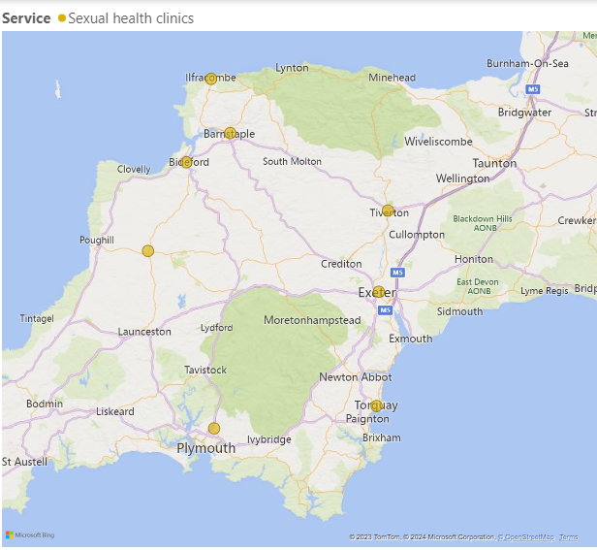

Condom Distribution Service collection/registration points are shown in figure 5.2. The service has transitioned from a paper-based approach to an electronic system. This enables more robust monitoring of activity and alerts to be raised regarding potential risks. Furthermore, young people 16+ can receive condoms by post.

To enable under 16 access and choice for all young people, provision is in place for young people to register and collect condoms from sites across Devon. Some of these sites are not openly available to the general public but are more focused, for example youth offending teams and supported housing.

Notably since the last Health Needs Assessment in 2017, the roles and availability of key front line workers, from allied professionals, has changed. This has impacted on the face to face delivery of services, including condom distribution. For example, the capacity of Youth Services and School Nursing to deliver regular drop-in clinics on school sites.

Figure 5.2 – Condom Distribution Service

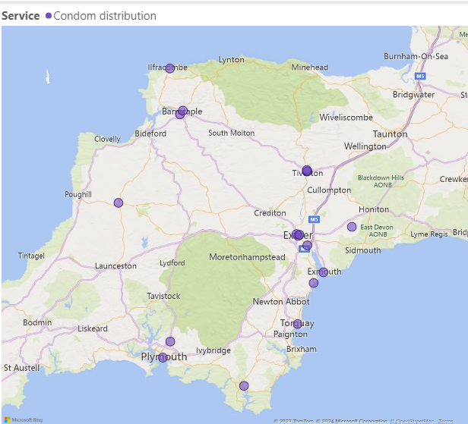

Chlamydia screening for people of all ages is available from sexual health clinics (Figure 5.3). For young people aged under 24 years, testing kits are available from pharmacies (Figure 5.4); some youth service settings, schools and FE colleges. Screening is also available from GP practices. For 16-24 year olds, testing kits for use at home are also available online via [www.freetestme](http://www.freetestme/).

Figure 5.3 – Chlamydia Screening

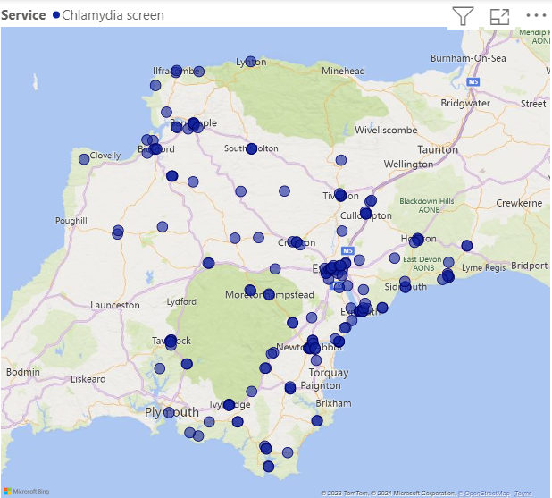

Pharmacies offer chlamydia screening and advice to young people aged 16-24 in addition to emergency contraception and advice. Locations of pharmacies offering these services are shown in figure 5.4. Although the map shows the sites of the services currently commissioned in pharmacies, access to the service may be limited by the staff that are trained and able to deliver the service. The service will only be available at times when these trained staff are available.

Figure 5.4 – Emergency Hormonal Contraception & Chlamydia Screening

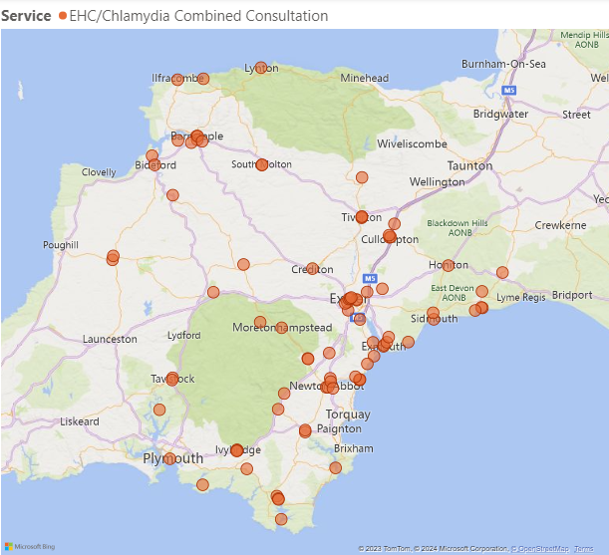

Appropriately trained doctors and nurses in general practices are able to provide Long-Acting Reversible Contraception to patients via a contract with public health. IUD and contraceptive implants insertion and removal are available in the practices highlighted in figures 5.5 and 5.6. Although the map shows the sites of the services currently commissioned in general practices, access to the service may be limited by the staff that are trained and accredited to deliver the service. The service will only be available at times when these trained staff are available.

Figure 5.5 – Intrauterine device insertion/removal

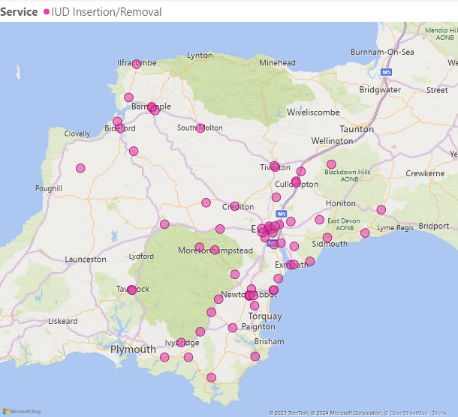

Figure 5.6 – Implant insertion/removal

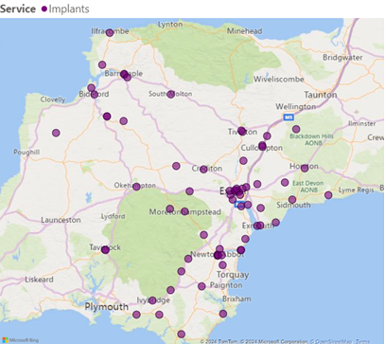

# 6. Variation in Outcomes in Sexual and Reproductive Health - A Toolkit to Explore Inequalities at a Local Level

This section uses existing data about sexual and reproductive health indicators, to understand where variation occurs and inform ways to reduce inequality and improve outcomes. The good overall picture for Devon can mask inequalities, which need to be addressed by interventions that do not risk widening these existing inequalities.

**1 Sexually Transmitted Infections in sexually active adults and young people**

1.1 Sexually Transmitted Infection (STI) Testing and Diagnosis

The 2022 STI testing rate (excluding chlamydia for those aged under 25) for Devon was 2,945 per 100,000 population. This is higher than the average rate for similar local authority areas to Devon, known as CIPFA neighbours. The recent trend has been increasing and getting better for Devon.

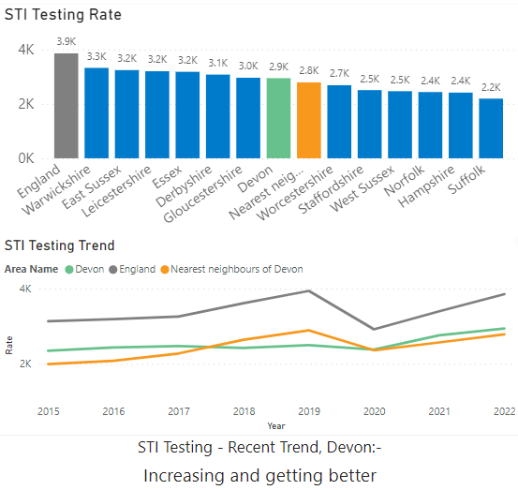

Testing rates and diagnosis rates are closely linked. The STI positivity figure shows new STI diagnosis (excluding chlamydia in those aged under 25) as a percentage of people who have had one or more tests for STI infections among the population. The STI positivity rate for Devon in 2022 was 4.8%, this is lower than the average CIPFA neighbour rate of 5.5%, the recent trend for Devon shows no significant change. A higher testing rate with a lower positivity rate could suggest that that right people may not be being tested.

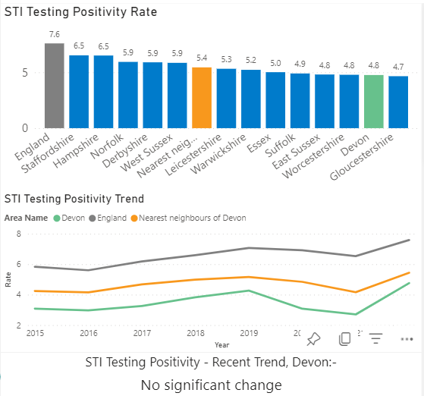

In 2022 there were 4,191 new STI diagnoses among people accessing sexual health services in Devon. This equates to a rate of 515 per 100,000 population, which is higher (worse) than the average CIPFA neighbour rate of 426 per 100,000 population. Devon’s recent trend is decreasing (getting better).

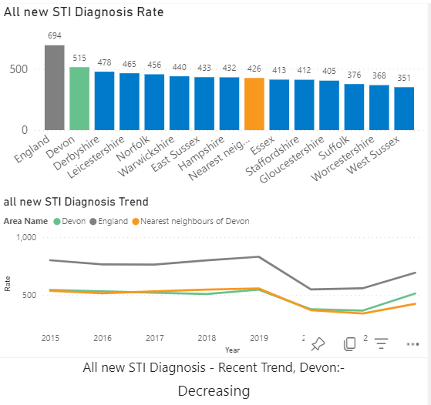

Users of the Service during 2022 were mapped by Lower Super Output Area and compared against areas of deprivation. Darker areas on the maps indicate higher numbers of service users, and deprivation respectively. Comparing these two maps highlights the areas of greater need, with lower than expected numbers of service users. In the north of the county, areas within Barnstaple, Bideford and Ilfracombe and in the South areas within Exmouth, Teignmouth and Newton Abbot show lower representation and higher deprivation, which could indicate access issues. Note that areas of this map need caution in interpreting due to the lack of data from Plymouth’s sexual health service, accessed by residents of West Devon and South Hams.

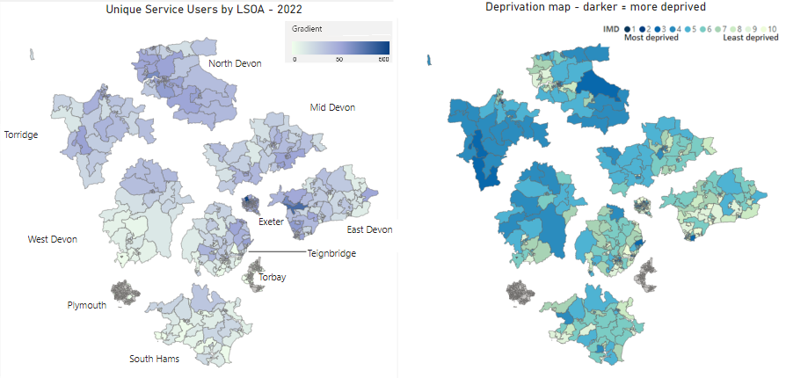

Characteristics of unique service users in 2022 are shown in the tables below and as a percentage of the overall population.

Unique service users are the individual users of the service who are counted as a single user irrespective of the number of times they have used the service in that year e.g., one individual may have multiple attendances but will be counted as one unique service user.

|  |  |  |  |  |
| --- | --- | --- | --- | --- |
| **Sex** | No. of Unique service users | Percentage of unique users split by sex | Devon Population per Census 2021 | Unique service users as a percentage of the Devon Population |
| Male | 8,289 | 38% | 394,026 | 2.1% |
| Female | 13,325 | 62% | 417,625 | 3.2% |
| Not Known | 41 | 0% |  |  |
| Total | 21,655 | 100% | 811,651 | 2.7% |

Around 2.7% of Devon’s population used the service in 2022, 62% of these were female.

|  |  |  |  |  |
| --- | --- | --- | --- | --- |
| **Sexual orientation** | No. of Unique service users | Percentage of unique users split by sexual orientation | Devon Population per Census 2021 | Unique service users as a percentage of the Devon Population |
| Heterosexual/Straight | 13,849 | 64% | 612,432 | 2.3% |
| Gay/Lesbian | 1776 | 8% | 8820 | 20.1% |
| Bisexual | 1033 | 5% | 9985 | 10.3% |
| Other/Not Known | 4997 | 23% | 52,225 | 9.6% |
| Total | 21,655 | 100% | *683,462 | 3.2% |

*\* Sexual orientation in census is recorded for ages 16+*

64% of service users in 2022 were recorded as heterosexual or straight. 8% of service users were recorded as gay or lesbian and this represented service use by 20.1% of Devon’s gay and lesbian population overall.

|  |  |  |  |  |
| --- | --- | --- | --- | --- |
| **Age** | No. of Unique service users | Percentage of unique users split by age | Devon Population per Census 2021 | Unique service users as a percentage of the Devon Population |
| Ages <15 | 33 | 0% | 119,802 | 0.0% |
| Ages 15-24 | 14,154 | 65% | 89,079 | 15.9% |
| Ages 25-34 | 3,719 | 17% | 84,564 | 4.4% |
| Ages 35-44 | 1,826 | 8% | 86,262 | 2.1% |
| Ages 45-54 | 1,072 | 5% | 105,013 | 1.0% |
| Ages 55-64 | 577 | 3% | 117,533 | 0.5% |
| Ages 65+ | 266 | 1% | 209,398 | 0.1% |
| Not Known | 8 | 0% |  |  |
| Total | 21,655 | 100% | 811,651 | 2.7% |

65% of service users in 2022 were aged between 15 and 24, which represents 15.9% of Devon’s population aged 15-24.

|  |  |  |  |  |
| --- | --- | --- | --- | --- |
| **Ethnicity** | No. of Unique service users | Percentage of unique users split by ethnicity | Devon Population per Census 2021 | Unique service users as a percentage of the Devon Population |
| Asian | 189 | 1% | 11,830 | 1.6% |
| Black | 138 | 1% | 2,474 | 5.6% |
| White | 16,918 | 78% | 782,444 | 2.2% |
| Mixed | 480 | 2% | 10,980 | 4.4% |
| Other | 178 | 1% | 3,880 | 4.6% |
| Not Known | 3,752 | 17% | 43 |  |
| Total | 21,655 | 100% | 811,651 | 2.7% |

Whilst acknowledging that different groups within the population will have different levels of need, this does show areas where the service is being well utilised. For example, by younger people, and the gay and lesbian population. It should be noted that a high proportion of young people live in Exeter (likely to be due to University of Exeter population) followed by Teignbridge.

1.2 Chlamydia

Chlamydia is the most commonly diagnosed bacterial sexually transmitted infection in England and causes avoidable sexual and reproductive ill-health. Rates are substantially higher in young adults than any other age group.

The National Chlamydia Screening Programme (NCSP) promotes opportunistic screening to sexually active young people aged under 25 years. In June 2021 changes to the programme were announced with a focus on reducing reproductive harm of untreated infection through opportunistic screening offered to young women aged under 25 years. However, locally the policy hasn’t changed.

The chlamydia detection rate among under 25 year olds is a measure of chlamydia control activity. The recommended rate of at least 2,300 per 100,000 residents aged 15-24 year olds, would be expected to produce a decrease in chlamydia prevalence. In 2022 Devon’s rate was 2,077 per 100,000 population aged 15-24 which is the highest (better) rate when compared to CIPFA neighbours.

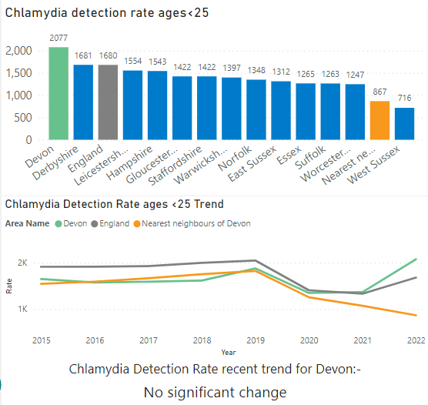

Across Devon there is disparity in chlamydia detection rates in 15-24 year olds per 100,000. The areas of Devon that show higher rates are in West Devon, the west of Torridge, parts of East Devon, Exeter, and the northwest of Teignbridge. The maps below show chlamydia detection rates alongside deprivation. Whilst there is some cross over between the chlamydia detection rates and the most deprived areas in Devon, there are also deprived areas with lower detection rates. In particular North Devon and Torridge which could indicate a need for more testing in these areas.

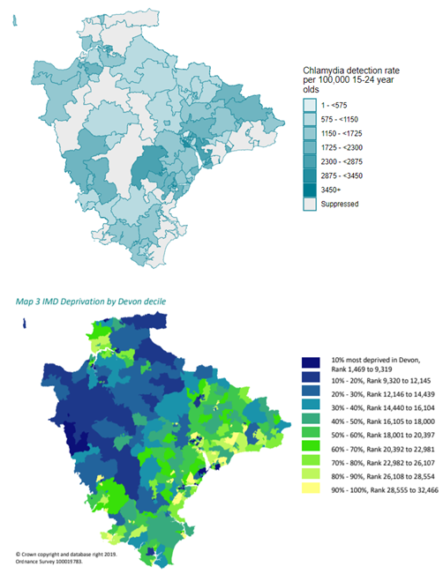

1.3 Gonorrhoea and Syphilis

Gonorrhoea causes avoidable sexual and reproductive ill-health and is used as a marker for rates of unsafe sexual activity. This is because the majority of cases are diagnosed in sexual health clinics, and consequently the number of cases may be a measure of access to sexually transmitted

infection (STI) treatment. Infections with gonorrhoea are also more likely than chlamydia to result in symptoms.

When high rates of gonorrhoea and syphilis are observed in a population, it suggests ongoing transmission is occurring. The UKHSA has conducted an in-depth examination of the national epidemiology of syphilis from 2010-2019, in alignment with the Syphilis Action Plan (2019) to tackle the rising cases of syphilis.

Syphilis disproportionately affects men of who sex with men (MSM) representing 75% of cases in England. However, this is higher in Devon, with MSM representing 83.8% of the syphilis cases in 2022. Additionally, although in Devon the demographic of Black, Mixed, Asian, and other ethnicities represents only 3.6% of the population, these ethnicities make up 7.9% of the all the syphilis cases in 2022 (GUMCAD Surveillance data) suggesting that in Devon both MSM and Black, Mixed, Asian, and other non-white population groups are disproportionately affected.

In 2022, the syphilis diagnostic rate for Devon is 5.0 per 100,000, which is similar to the CIPFA neighbour rate, and significantly lower (better) than the England rate of 15.4 per 100,000. The trend in Devon currently shows no significant change.

Devon ranks 104th (out of 147 UTLAs/UAs) in 2022 for gonorrhoea diagnoses per 100,000 with a rate of 78 compared to the rate of 146 in England. Devon has seen a large increase (getting worse) from the rate of 20 per 100,000 in 2021, which is also reflected nationally with the England rate rising from 97 in 2021 to 146 per 100,000 in 2022. However, it is too early to tell whether this is an ongoing increasing trend and should be monitored.

1.4 HIV

HIV is associated with significant mortality, serious morbidity and high costs of treatment and care. The infection is still frequently regarded as stigmatising and has a prolonged ‘silent’ period during which it often remains undiagnosed.

People diagnosed promptly with HIV and who start Anti-retroviral therapy (ART) early can now expect near normal life expectancy. Use of ART has also resulted in substantial reductions in acquired immunodeficiency syndrome (AIDS) and deaths in the UK. (UKHSA, HIV: surveillance, data and management, 2023)

HIV diagnosed prevalence rate is benchmarked against set thresholds and categorised into the following groups: <2 (low), 2 to 5 (high) and ≥5 (extremely high). These values have been determined by developments in national testing guidelines. In 2022, the HIV diagnosed prevalence rate per 1,000 population aged 15 to 59 in Devon was 0.9, this is lower than the CIPFA neighbours average of 1.2. Devon is therefore not classed as a high HIV prevalence local authority (diagnosed prevalence rate >2).

Late diagnosis is the most important predictor of morbidity and mortality among those with HIV infection. If a person newly diagnosed with HIV has a CD4 cell count of less than 350 cells/mm3 within 91 days of first diagnosis, this is defined as a late diagnosis. In Devon between 2020 and 2022, 50.0% of new HIV diagnoses were classified as late. This is higher (worse) than the England rate of 43.3% and the CIPFA neighbour rate of 46.5%.

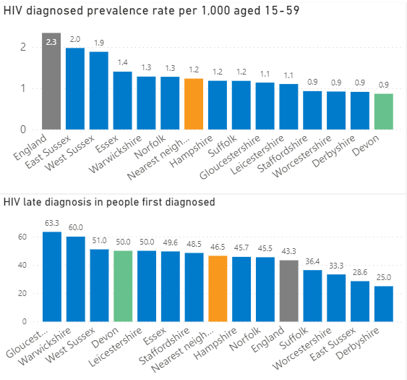

Coverage of HIV testing for Devon in 2021 shows that the total eligible sexual health service attendees that received a test is 56.1%. This is better than the England average of 45.8% but is a decrease of 12% since 2020. Current recommendations are that gay and bisexual men should be tested for HIV at least once a year and every 3 months if they are having unprotected sex with new or casual partners. For 2021, the percentage of gay, bisexual and MSM in Devon who had tested more than once in the previous year was 42.1%, similar to 45.3% in England. (OHID, SPLASH report).

HIV late diagnosis figures by sexual orientation is shown in the table below:

|  |  |  |
| --- | --- | --- |
| HIV Late Diagnosis 2019-21 | Devon | England |
| Total | 61.5% | 43.4% |
| Gay, bisexual and other MSM | 61.5% | 31.4% |
| Heterosexual men | 50.0% | 58.1% |
| Heterosexual and bisexual women | 60.0% | 49.5% |

Devon has higher (worse) rates of late diagnosis than England in each group except for heterosexual men. Although HIV prevalence is low in Devon, more needs to be done to reduce the rate of late diagnosis and improve the outcomes for these individuals.

The most recent available data for Devon shows that in 2020 the highest proportion of people living with diagnosed HIV are of White (84%), Black African and other ethnic groups (both 7%). In terms of probable routes of infection, sex between men (59%) and sex between men and women (35%) were the exposure groups with the highest proportion of people living with diagnosed HIV. (SPLASH supplementary report).

Specialist sexual health services were commissioned to deliver HIV pre-exposure prophylaxis (PrEP) in 2020. PrEP is a medicine that people at increased risk of HIV can take to prevent them getting HIV. When taken as prescribed, PrEP is highly effective at preventing HIV. In 2022, 98% of PrEP activity episodes were in men. Gay and bisexual men made up 96% of PrEP activity episodes overall, and 82% of PrEP activity was in white males. Awareness of PrEP among the MSM population is generally good but more work is required to improve awareness of PrEP among the non MSM population locally.

**2 Reproductive health and planned pregnancy**

2.1 Teenage Pregnancy

Most teenage pregnancies are unplanned and around half end in an abortion[11]. Like all parents, teenage mothers want to do the best for their children and while some manage very well, for many their health, education and economic outcomes remain disproportionately poor[12]. In addition, teenage parents can experience judgement, hostility and stigmatisation in their everyday lives[13]. Young mothers - including those up to the age of 25 - are at particular risk of poor mental health.

In 2021 the Under 18’s conception rate in Devon was 10.0 per 1,000 females aged 15-17, this is lower (better) than the CIPFA neighbour average.

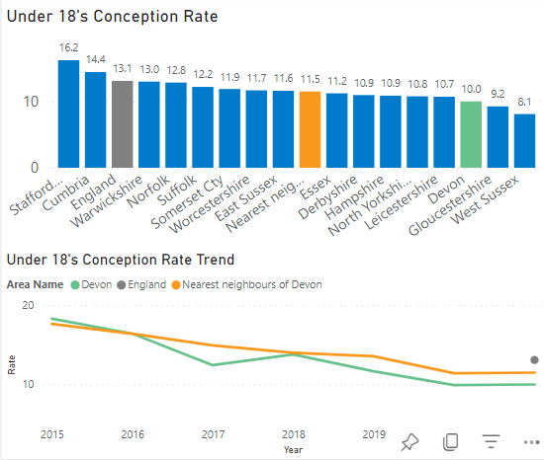

The ward level map shows little variation across wards, and there are no wards in Devon that have significantly higher rates compared to England. When comparing the county of Devon against itself, although much of the region has no significant difference, there are a few very small pockets with significantly higher teenage conception in mid and east Devon (OHID, SPLASH report).

The district in 2021 with the highest under 18 conception rate is North Devon, followed by Torridge. This is a change from the last needs assessment in 2017 whereby Teignbridge had the highest rate.[14]

2.1.1 Teenage Pregnancy Risk Factors

There are several risk indicators for teen pregnancy including children in care, children in low-income families, average attainment 8 scores and 16 to 17 years olds not in education employment or training.

Attainment 8 measures the achievement of a pupil across 8 qualifications (OHID, 2023). The average attainment 8 score in 2021/2022 in Devon was 49.1% comparable to England 48.7%. However, the average attainment 8 score of children in care in Devon is just 20.2%, ranking Devon in the 2nd worst quintile in England (DfE, OHID 2023).

In Devon 6.4% of 16- to 17-year-olds are not in education, employment, or training (NEET) or whose activity is not known, a similar value to England 5.2%. There has also been no significant change in the trend of this data in Devon (DfE, 2023).

The number of children in care in Devon is however significantly better than in England at 56 per 10,000 compared 70 in England (DfE, Children looked after in England 2023). 17.7% of Devon’s children are in relative low-income families, which is significantly better than 19.9% in England (OHID, 2023).

2.2 Access to Contraception

A strategic priority is to ensure access to the full range of contraception is available to all. An increase in the provision of long-acting reversible contraception (LARC) is a proxy measure for wider access to the range of possible contraceptive methods and should also reduce rates of unintended pregnancy. LARC methods, such as implants, the intra-uterine system (IUS) or the intrauterine device (IUD), are highly effective as they do not rely on daily compliance and are more cost effective than condoms and the pill. However, the intention is to encourage choice rather than to promote LARC methods at the expense of other contraceptive methods (OHID, Fingertips 2023).

In 2021, Devon’s total prescribed LARC excluding injections rate was 64.3 per 1,000, higher (better) than the CIPFA neighbour average of 50.0 per 1,000. Although the most recent year shows an increase (getting better), the overall trend for Devon is considered to be decreasing. There are signs that it may be recovering but it is too early to say.

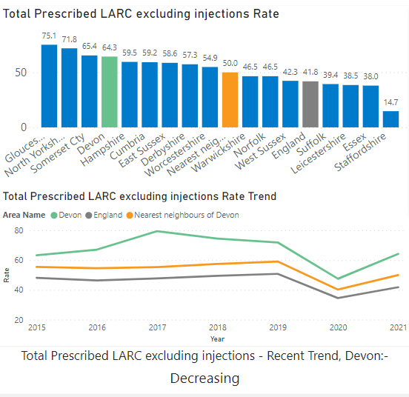

Further review shows that in 2021 the GP prescribed LARC rate was 37.9 per 1,000 whilst the Sexual Health Services prescribed LARC rate was lower at 26.5 per 1,000. The Devon SPLASH report notes that this is a likely reflection of the more rural and semi-rural settlements within Devon, resulting from primary care services being more accessible than specialist sexual health services which are located within larger cities.

Local Primary Care Network (PCN) crude rates were calculated from GP reported figures for the financial year 2021/22 by totalling LARC fits (contraceptive and non-contraceptive use) per 1,000 females aged 15-44 registered in respective practices. There was wide variation in rates across PCNs with the highest in West Devon and Culm Valley, and the lowest in North Devon, Torridge and the east of East Devon.

2.3 Access to Abortions

The abortion rate is an indicator of access to good quality contraceptive services and advice, and also of issues with the type of contraceptive method used.

In 2021, Devon’s total abortion rate was 12.9 per 1,000 females aged 15-44. This is the lowest (better) rate of all the CIPFA neighbour authorities. Devon’s recent trend for total abortions shows no significant change.

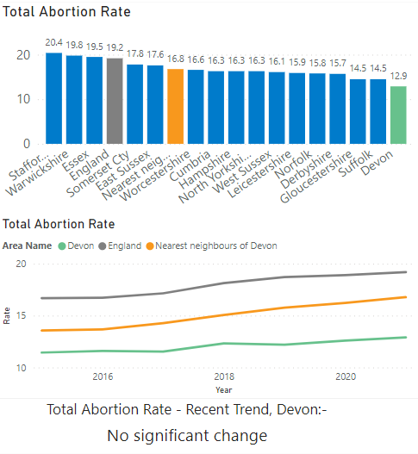

Over a quarter of England abortions in the under 25 age group are repeat abortions. In 2021, Devon had an under 25’s repeat abortion rate of 17.3, this represents the percentage of abortions in women aged under 25 years who has had a previous abortion in any year. There is no significant change in the Devon trend for under 25’s repeat abortions.

In 2021, Devon had an under 25’s abortion after a birth rate of 20.1. This represents the percentage of women aged under 25 years having an abortion who have previously had a birth. The Devon rate is lower (better) than the average CIPFA neighbour rate and the England rate of 26.0. There has been no recent significant change in Devon’s trend for this indicator.

Nationally, rates of abortions are increasing amongst the older age groups and abortions amongst the over 25’s account for an increasingly large proportion of women having terminations. In 2021, Devon had an over 25’s abortion rate of 11.6 per 1,000 women aged 25-44 years. This is lower (better) than the England rate of 17.9 per 1,000, and lower (better) than the CIPFA neighbour average. The Devon trend rate has been increasing (getting worse) in recent years, reflecting the trend also seen nationally.

A further examination of provisional abortion statistics by age group, January to June 2022, shows that abortions in those aged under 25 made up 40% of the total abortions, and those 25 and over made up 60% of the abortions carried out[15]. This could indicate missed opportunities to provide effective contraception. Revised finalised figures for 2022 will be published in Spring 2024.



2.4 Emergency Hormonal Contraception (EHC)

EHC is available, free of charge, to 13-24 year olds from participating pharmacies. Between Oct 2018 and Dec 23, there were 10,428 provisions of EHC from pharmacies across the Devon County Council area. Activity varies widely, from none in many pharmacies to over 1,000 in the busiest,

with a third of the total EHC provision being provided by just two pharmacies in Exeter. The majority of young women accessing this service were between 16 and 24 years of age. As expected, due to the population size, most users lived in Exeter followed by Teignbridge. When asked how they found the service, 39% reported by word of mouth and nearly 18% from previous use. As well as EHC, 87% were also offered a chlamydia testing kit, but a kit was only supplied to 35% of users.

**3 Sexual health in most at-risk or vulnerable populations**

3.3 Access to services for most at-risk or vulnerable groups

Some demographic groups, who are at a higher risk of poor sexual health, face stigma and discrimination which can impact on their ability to access services. There is a need to consider main groups from an inclusion health perspective; failure to do so could lead to a widening of inequalities[16]. The main groups identified were substance misuse service users, people with learning disabilities, women at risk of sexual exploitation and travelling communities. To explore if sexual health services are being targeted to, or reached by these groups, a number of key frontline staff were interviewed, and their responses collated.

Awareness of local sexual and reproductive health services varied across the different organisations. If staff had knowledge of services, it was of the Specialist Sexual Health Service Hubs in Barnstaple and Exeter ‘Walk in Centre’ which is positive. The interviews however highlighted a gap in awareness about the wider sexual health system across Devon. Some organisations had pathways to the specialist service and were able to accompany clients to appointments. There were good examples shared whereby clinic sessions were adapted to meet the needs of people with Autism (quiet clinics) however there was a gap in understanding if this offer was available in all specialist sexual health sites.

Key frontline staff take a holistic approach to supporting people they work with. However, sexual health tends to only be discussed if it is raised by clients rather than as part of proactive conversations. Those staff that were more proactive had a special interest in sexual health and the confidence to start conversations.

Access to local sexual health training varied, with some accessing training outside of Devon. Local training provided by The Eddystone Trust had been accessed by a number of frontline staff. In addition, the Together Drug and Alcohol Service had recently completed bespoke training on Sexual Health and Chemsex. All those interviewed mentioned concerns around healthy relationships, consent and reproductive health which could indicate a skills gap. Resources to enable key frontline staff to have conversations with the people they work with need to be tailored for different groups. This includes providing accessible information for people living with a learning disability and those with literacy challenges.

*“It can be difficult to have conversations around sexual health, some service users will have the right words but may not know what they truly mean.”*

*“Sex education still being a taboo subject, so people with learning disabilities are not necessarily learning”.*

Key frontline staff described previous provision within their service being able to deliver information and education workshops. Examples included trained workers within their organisations distributing condoms through the condom distribution scheme. However, restructuring of organisations and the

COVID-19 pandemic has impacted on the capacity to deliver some of these services equitably across Devon.

When asked if their clients were able to access local sexual health services, the response from organisations varied. The NHS Learning disabilities team felt that people they work with are accessing services, particularly for contraception. However, the other organisations were either not aware or didn’t feel people they worked with were accessing sexual health services.

Those interviewed felt that some groups were at risk of falling through the gaps when accessing traditional service pathways. In particular women who have experienced domestic abuse or sexual violence and traveller communities. This is due to barriers including booking systems, form filling, waiting times and formal settings.

*“It is difficult for the women when they have built trust in one setting to then access another setting that doesn’t reflect the same ethos of working or hold the same trusted relationships.”*

*“Women tend to feel comfortable if already engaged with a service and*

*having built trust.”*

Several organisations reported that it can be challenging for at risk and vulnerable groups to move between services. For example, the Together Drugs and Alcohol service described missed opportunities when their clients attend appointments.

*“Clients take risks around their sexual heath, exchanging sexual favours to access drugs but not reporting it or addressing their sexual health needs”.*

Those interviewed also highlighted that at risk and vulnerable clients are less likely to attend appointments due to self-care not always being a priority. Often other unmet needs must be dealt with first, before a conversation about sexual health can take place. For example, providing women with access to clean underwear, sanitary products, somewhere to shower and food.

Only two organisations reported examples of partner services delivering sexual health provision for those most at risk. These included postnatal contraception at time of delivery through maternity and termination of pregnancy services.

Overall, the responses have highlighted a need for more proactive engagement, flexible pathways and delivery models to be put in place and promoted, to reach these at risk and vulnerable populations recognising the wider needs which are priority to people. Currently, some access is dependent on key frontline staff facilitating or advocating on behalf of people they support. Further exploration is required for other groups such as people in the criminal justice system; black and minority ethnic communities, migrants including Refugees and Asylum Seekers and those with a disability who don’t meet the threshold of services.

# 7. Local insights from key populations

# Young People – aged under 25 years

Insights with young people were completed by:

* Social Insight – ‘Let’s talk about sex with Gen Z’
* Eddystone Trust - care experienced young people
* Devon Sexual Health – condom card users
* Public Health - young people and services in West Devon / South Hams
* Devon Children and Young People's Health and Wellbeing Survey – pupils from participating secondary schools reaching 3,077 pupils in years 8 and 10.

The various insights with young people demonstrated a significant knowledge gap especially about sexually transmitted infections (STI). Young people had little understanding of the different STI, rates and risks. There was a belief that they were not relevant and can be treated easily and effectively so aren’t that serious. There was poor awareness of risks due to repeat infections with Chlamydia or long-term risks of STIs. There was also a lack of understanding regarding the sexual health services that are available to them. None of those from the area, were aware of the online STI testing services available to West Devon and South Hams residents.

The experience of relationship and sex education (RSE) in school was reported as either poor or non-existent including ‘Queer’ experiences of sex. Sources of information are social media / influencers as well as friends. Despite this young people were very willing to engage openly in these conversations and described seeing little visibility of ‘Queer’ culture in Devon. Young people reported a fear of being ‘outed’ and disowned by their family. In addition, there was fear around the threat of violence and hate crime.

***“What do I need for gay girl sex?”***

***“No-one ever talks about STI’s. Ever.”***

Young people reported that their motivation for using condoms is to protect against pregnancy and not protection from STI. Due to their limited knowledge and poor awareness of STIs, their perceived risk is low which equates to unrealistic optimism of being at risk. The social norm is that if a young woman is on the pill, it is acceptable not to use a condom. This insight has highlighted a need to re-position condoms as the primary way to prevent STIs – not just to prevent pregnancy. Although there was a commonly held belief that it is everyone’s responsibility to carry condoms, the insight work suggested that in reality this does not happen as much as it could, and it is not a social norm for women. There was also a gap highlighted around females having the skills and confidence to challenge male partners to engage in good sexual health behaviours.

***‘It’s easier to get rid of an STI than a baby’.***

***‘They [condoms] take away the feeling’.***

Young people have established buying practices for condoms, such as pharmacies and supermarkets, and awareness of the c-card scheme varied between groups. In the Health-Related Behaviour Survey, developed by the Schools Health Education Unit (SHEU) Survey, 8% of pupils responded that they have heard of the C-card scheme and 21% of pupils responded that they know where they can get condoms free of charge (SHEU survey, 2021). While the West Devon / South Hams Young people were familiar with the C-card Scheme and gave positive feedback. Younger ages (17-18 years) expressed a preference for remote / digital access to services as this would help to reduce their embarrassment.

The insights also highlighted the importance of a positive first contact with a service as being critical for continued engagement and confidentiality. This was particularly important for the care experienced young people but relevant to all.

There was also a clear message that any campaigns which are to be targeted at young people must be driven by young people - and not “older people”. Both shock tactics and myth busting are proven not to work.  Therefore, messages need to be supportive and positive with a focus on behaviour reward for self-care, taking control and boundary setting.

In addition to targeting young people, messages should also be directed to their parents / carers and those who engage with care leavers to reduce the risk of misinformation.

***“When you see a poster created by older people, you can just tell”.***

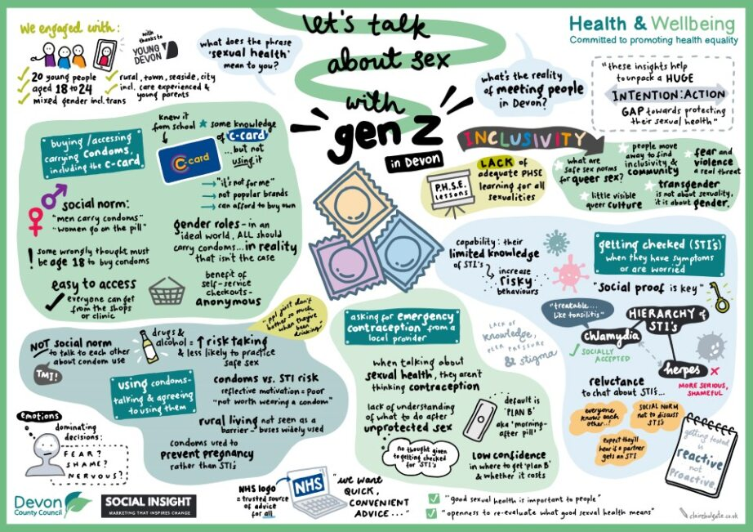

**An infographic summary of research insight 18-24 conducted by Social Insight (2023)**

The feedback from a group of young people in West Devon / South Hams, was that they preferred to have clinics local to them. This was because traveling outside of their local area was both costly and difficult for a magnitude of reasons. All participants felt that evening and weekends were the most accessible time for them to attend a sexual health clinic, as well as the majority preferring walk-in services over appointments.

Whilst the insights and surveys were inclusive of those more vulnerable to poor sexual health outcomes, further work is required to gain insight from young people from black and minority ethnic communities, those not in education employment or training (NEET), young offenders, and unaccompanied refugee and asylum seekers.

# People involved in or at risk of sex work

The Eddystone Trust, engaged with women involved in or at risk of sex work. An invite to participate in a survey was promoted through websites used to advertise their services. In addition, interviews were held at a homeless hostel and CoLab.

* Women in Devon involved in sex work are at greater risk of poor sexual health outcomes due to factors such as multiple sexual partners, experiencing sexual violence and drug use.
* Challenging wider lifestyle circumstances such as homelessness can increase their risk of becoming involved in prostitution.
* Sexual health does not appear to be a priority until something is clearly wrong (e.g., symptoms of an STI present, physical harm has been experienced).
* Disclosing involvement in sex works appears difficult and can be perceived as stigmatising. In turn, this may lead to not accessing the sexual health services and support that they require.
* Factors such as domestic abuse and sexual violence can further increase barriers to access as they can lead to low self-worth, meaning women in particular do not prioritise themselves and their health.

# Men Who Have Sex with Men

The Eddystone Trust, who provide targeted prevention interventions within the community, spoke with men at Public Sex Environments (PSEs). They were invited to participate in a survey and interviews to understand local sexual health attitudes and behaviours. It is important to acknowledge that no individuals interviewed as part of this work, or encountered on outreach, used the term ‘MSM’ to identify themselves.

* Whilst a number of men were willing to participate in interviews, they provided short answers and demonstrated social desirability (answering in a way they believed the researchers wanted them to). This indicates feelings of discomfort in relation to opening up about their sexual identity and activity.
* In men considered to be MSM in Devon, there is a large degree of fear surrounding being 'outed' for their sexual preferences/activity. This leads to secrecy and a reluctance to discuss these topics with others. These findings suggest that men who attend PSEs tend not to be comfortable discussing their sexual activity and may not be truthful when disclosing their sexual identity to others.
* Despite acknowledging that sexual health and other medical services are confidential, for many of the participants, the fear of going into a clinic or accessing sexual health support and encountering somebody they knew is a barrier. Perceptions around rurality and the belief ‘everyone knows everyone’ can be a driver for fear.
* Where individuals are provided with immediate tools and solutions to access sexual health support, these served as motivators to invoke action and engagement. For example, immediate access in saunas, tests provided on outreach and via posters with QR codes displayed at PSE sites.

# Swingers

The Eddystone Trust provided insights from research they conducted with people engaging in 'swinging'. They invited people in Devon to complete an online survey via a website which people use to connect and meet to have sex. They also spoke with people who were members of a closed swinging group in an in-person focus group and people using PSEs.

* There is a vast difference between the motivations and behaviours of the various sub-groups of those engaging in swinging behaviour. For example, members of the closed swinging group (e.g., predominantly single women and mixed couples) valued interpersonal relationships and everyone gets tested for STIs before becoming a member. However, other groups appeared to be motivated by instant gratification and preferred to have sex that was both casual and anonymous. Messaging around safer sex should be tailored around varied motivators for engaging in swinging behaviour.
* Respondents to the online survey demonstrated a 'say do gap' with regard to their intentions and subsequent actions in relation to their sexual health. While the majority felt their sexual health was extremely, very or somewhat important, just over half of people reported having accessed sexual health services within the last year and nobody reported using condoms every time they had sex. Only a few respondents felt they could talk with any sexual partner about condoms, which may suggest condom use is not preferred or prioritised by these groups. Half of respondents had not heard of PrEP and only two respondents who self-identified as women said yes, suggesting there is work to be done to raise awareness of PrEP for cis-gendered women.

# 8. Service user views

# Contraception Survey - Devon County Council 2022

A decline in LARC provision was identified during the Covid 19 pandemic, particularly in Primary Care settings. A survey was designed to understand how this may have impacted on residents. The survey ran over 7 weeks during Summer 2022 and received a total of 247 responses. 94% of respondents identified as female, with 5.2% as non-binary, transgender, prefer not to say accounted for the other percentage. Of these, 84% identified as heterosexual, 9.3% as bisexual 6% identifying as lesbian / other / prefer not to say. This indicates that not all service users identify as either female or heterosexual. This is important when developing inclusive services to reach the diverse range of contraception users in Devon. Furthermore, only 1.6% of respondents were of non-white ethnicity which is under representative of this population in Devon. Approaches to gathering the views of these populations needs to be considered to ensure services are culturally sensitive.

The data and themes from this survey illustrated some key concerns by respondents which are outlined below:

* access to services -which included locations and opening hours, as well as difficulty making appointments.

***‘Needs to be more accessible - GP surgeries need to offer all forms of contraception again especially in rural areas.’***

* patient choice - particularly the opportunity to discuss the full range of contraception on offer and availability at their chosen location.

***‘More expansive conversations about the types of contraception that is available. I have a yearly pill review in which I usually feel shut down when I ask other options to be explained’.***

* knowledge / training need – particularly about inclusivity

***‘There's no gender neutral language used nor any check as to how you'd like to be referred to and "woman" is defaulted to’.***

***‘GPs to have wider knowledge not just rely on the pill’.***

A full summary of the findings from this survey can be found Appendix 3.

# Sexual and Reproductive Health Services Consultation – Devon County and Torbay Councils 2023

A survey was designed to capture the views of Devon residents on sexual and reproductive health services. This ran for 7 weeks during September and October 2023 and was completed by 265 respondents. Of these, **250 were residents** and **15 responded on behalf of an organisation**. **75% of respondents lived in the Devon County Council area**, and 24% from Torbay Council area. The majority of respondents identified as female (75%) with 17% as male, 5% as gender fluid / non-binary, and the remaining percentage answered other. Of these, 74% identified as heterosexual, 10% as bisexual, 4.5% each as gay and pansexual, 2% as lesbian and the remaining percentage as other. A total of 4 respondents identified as mixed ethnicity, 3 as Black or Black British and 1 as Asian or Asian British and 1 as other. 95% of respondents identified their ethnic group as white. The majority of respondents were between 25 and 54 years of age.

* When asked how often they had travelled to a sexual health service or clinic in the last 12 months, 53% of respondents replied not at all, 30% replied yearly and 10% quarterly.
* Over half of those who attended had travelled less than 3 miles.
* Over 80% agreed that sexual health and contraception services should be available as part of the same appointment.
* Given a choice, most respondents would prefer weekday evening and Saturday morning opening times.
* The main reasons given for attending a sexual health clinic were due to symptoms of a sexually transmitted infection, for contraception, and for a sexual health check-up.
* Reasons given that would prevent respondents from accessing services related to availability, travel, knowledge and stigma.
* 60% of respondents felt they had enough information to access the sexual health services they needed. For those who answered no, more visible information online was required which could be accessed via NHS websites and online searches.

A full summary of the findings from this survey can be found in the Appendix 4.

# Insight Research 2023

Social Change were commissioned to undertake insight research with adults at risk of poorer sexual health outcomes. A total of **175 respondents**, representing a range of locations and demographics, completed an insight survey. Of these, **21 people** responded to the invitation to take part in an interview. The following behavioural insights were identified from a review of the key findings.

There is a reluctance to take proactive action to support sexual health, with people waiting until they think they are at risk and/or there is an issue before considering accessing services. This is likely influenced by their own perceptions of risk around their situations and fear of stigma when accessing services.

While people feel their sexual health is important, many are not willing to do more than they need to, only looking towards services when they think they are at risk/there is an issue. This reluctance may be due to people feeling they already have the knowledge they need to help themselves or concerns around stigma.

People rely on their own knowledge first and foremost when deciding whether to access services, and would prefer to build on this either prior to, or instead of, attending services. If they don’t know enough about their issue or available services, they are unlikely to feel confident in accessing services. However, if they have a good level of knowledge, they feel they can appropriately assess their risk, resolve the issue themselves if they are able and feel confident to know which services to access.

Social factors can have a significant influence on encouraging or discouraging people from accessing services. People are worried about the repercussions of accessing services to support their sexual health because of longstanding stigma surrounding the topic. When people have social circles which are open about sexual health and related discussions, they are far more comfortable and willing to attend services.

People want services that are inclusive, quick, easy and convenient to access. Accessing services can be a significant step for people concerned about judgement and stigma. This means they will quickly disengage if the effort to get through to a service is felt to outweigh the benefits. Different things work for different people, and this applies to both the promotion of services and the delivery of them. Having a mixture of promotional activities and means of service delivery will help widen the reach and accessibility. This requires putting appropriate processes and training in place to ensure trauma-informed delivery that uses inclusive language and provides reassurance for patients.

# 9. Key findings and considerations

Sexual health outcomes in Devon are generally good. The variation in outcomes toolkit and local insights have highlighted some particular areas of focus. These are:

* Sexually Transmitted Infection (STI) Testing and Diagnosis

Testing rates and diagnosis rates are closely linked. The STI positivity rate for Devon is lower than the average CIPFA neighbour and the recent trend for Devon shows that positivity is decreasing. This below average positivity rate, with a higher than average testing rate, needs further exploration to ensure that the right people are being tested and all services are delivered to BASHH standards.

* Access to services for most at-risk or vulnerable groups

The responses received from key frontline staff, highlighted the need for more proactive pathways to effectively reach at risk and vulnerable populations. These individuals may fall through the gaps when accessing traditional service pathways due to booking systems, form filling, waiting times and formal settings. For men who have sex with men (MSM) there is a need for individually tailored and discreet support and access to services. Currently, some access to the sexual health system is dependent on frontline staff facilitating or advocating on behalf of people they support. There is an opportunity to strengthen education and support in community settings and environments. With appropriate training, staff who already have trusted relationships within these environments can engage in holistic conversations including safer sex including access to PrEP, contraception, and healthy relationships.

The insight research also highlighted the need for improved appointment booking tools and processes. Current processes are not working for many residents and are acting as a deterrent to them engaging with services.

* Lower Reach and Awareness of Services to the Most Deprived Areas – Particularly in Areas of Rurality

This was evidenced by STI testing, including Chlamydia and access to Long-Acting Reversible Contraception (LARC). The expected higher number of service users from areas of increased deprivation were not always evident, which may indicate access issues. This was particularly true in the North of the county and needs further exploration. North Devon and Torridge also had the lowest levels of LARC provision when mapped by primary care networks.

* Awareness raising with at risk groups

The insight work undertaken by Social Insight and Social Change highlighted a ‘say-do’ gap between sexual health being important to individuals and a reluctance to take proactive action to support their own sexual health. There was a lack of knowledge of sexually transmitted infections and understanding of the available sexual health services. Condoms need to be re-positioned as the primary way to prevent STIs – not just to prevent pregnancy. Any awareness raising needs to challenge perceptions of risk and fear of stigma when accessing services and preventative tools. Messages for young people, need to be driven by young people. They need to be supportive and positive, with a focus on behaviour reward for self-care, taking control and boundary setting.

* Decreasing Rate of Long-Acting Reversible Contraception (LARC) Prescribing

For women, access to LARC varies across Devon, with some of the lowest levels of provision in areas with the highest levels of deprivation. Difficulties accessing LARC was highlighted as a key theme from the contraceptive services survey. There is a need to continue joint working between local authority commissioners, Integrated Care Board and primary care, private providers and FRSH faculty directors to improve access to LARC with a focus on the areas with highest deprivation as a priority. Topics for further exploration could include developing a system wide workforce plan and testing innovative models of delivery.

* Increasing Abortion Rate for Over 25s

This national trend is also being seen in Devon. Further exploration is needed to understand and learn from the experiences of over 25s accessing abortions and ensuring equitable access to contraception. This includes access to contraception in termination of pregnancy services and maintaining pathways to services which provide contraception.

* High Rate of Late Diagnosis of HIV

Although numbers are low, Devon continues to have a high rate of late HIV diagnosis. Further exploration is needed to learn from missed opportunities in sexual health screening, testing and prevention.

* Gaps in provision

While there are currently many touch points for sexual health information, advice and services across Devon, within the sexual health pathway, there are opportunities to improve these interactions for service users. For example, greater integration of services and flexible extended opening times.

Devon has a large rural population, with many areas a long distance from the larger urban areas where sexual health services are generally more accessible. New technologies and services delivered online are increasingly available which may help address this access issue. There is a need to further innovate and embed digital technologies to services and prevention to address challenges in provision across Devon’s large geographical footprint.

To respond to future challenges in provision, Devon would benefit from a sexual health network(s) of key partners to work together as a system using sector led improvement tools to regularly review provision and implement the changes required to deliver good sexual provision across the area.

* Future Insight Work

Further insight is required for other keys groups such as people in the criminal justice system, black and minority ethnic communities, migrants including Refugees and Asylum Seekers.

**Authors**

Abenaa Gyamfuah-Assibey (Public Health Commissioning Manager-Sexual Health)

Louise Cox (Senior Public Health Intelligence Analyst)

Amanda Emmett (Advanced Public Health Practitioner)

Eleanor Lyons (ST1 Public Health Registrar)

**Acknowledgments**

This needs assessment was led by Abenaa Gyamfuah-Assibey with support from the public health sexual health and commissioning team. The author(s) would like to thank all those who contributed to the development of this needs assessment.

# Appendix 1

National Sexual & Reproductive Health Policy

A number of key national sexual and reproductive health policy papers are outlined below. Whilst this list is not intended to be exhaustive it does provide the policy context for how sexual and reproductive health provision should be delivered locally.

**A Framework for Sexual Health improvement in England (2013)**. Following the changes to the Health & Social Care Act in 2012 this document set outs the strategic direction for commissioning sexual and reproductive health services in England: [A Framework for Sexual Health Improvement in England - GOV.UK (www.gov.uk)](https://www.gov.uk/government/publications/a-framework-for-sexual-health-improvement-in-england) *It was expected that this document will be replaced by a new national Sexual Health strategy in 2022 but at the time of publication this has yet to be released.*

**Making it work: a guide to whole system commissioning for sexual health, reproductive health and HIV (2015).** This guide was published for commissioners of sexual health, reproductive health and HIV services in local government, clinical commissioning groups (CCGs) and NHS England to support them with the changes outlined in the Health & Social Care Act and emphasised the need for collaborative commissioning to meet the sexual and reproductive needs of local populations: [Commissioning sexual health, reproductive health and HIV services - GOV.UK (www.gov.uk)](https://www.gov.uk/government/publications/commissioning-sexual-health-reproductive-health-and-hiv-services)

**Syphilis: Public Health England Action Plan (2019)** In response to a rise in syphilis cases in England, Public Health England published a syphilis action plan to address this need. The actions in this plan are aimed at clinicians, public health specialists, specialty societies and commissioners of specialist sexual health services and focus on the key affected populations: [Syphilis: Public Health England action plan - GOV.UK (www.gov.uk)](https://www.gov.uk/government/publications/syphilis-public-health-england-action-plan)

**Women’s Health Strategy for England (2022).** This strategy provides a ‘life course’ approach to improving the health and wellbeing of women and girls in England and resetting how the health and care system listens to women. women’s health. The strategy addresses a number of health inequalities relating to sexual and reproductive health and sets out the key principles for Women’s Health Hubs.: [Women’s Health Strategy for England - GOV.UK (www.gov.uk)](https://www.gov.uk/government/publications/womens-health-strategy-for-england)

**Towards Zero: the HIV Action Plan for England - 2022 to 2025 (2021)**. This action plan outlines how the Government are committed to achieving zero new HIV infections and ending HIV related deaths by 2030 by delivering on a number of objectives: [Towards Zero - An action plan towards ending HIV transmission, AIDS and HIV-related deaths in England - 2022 to 2025 - GOV.UK (www.gov.uk)](https://www.gov.uk/government/publications/towards-zero-the-hiv-action-plan-for-england-2022-to-2025/towards-zero-an-action-plan-towards-ending-hiv-transmission-aids-and-hiv-related-deaths-in-england-2022-to-2025)

**Relationships Education, Relationships and Sex Education (2019)** This statutory guidance outlines how schools are required to teach young people relationships education and relationships and sex education: [Relationships and sex education (RSE) and health education - GOV.UK (www.gov.uk)](https://www.gov.uk/government/publications/relationships-education-relationships-and-sex-education-rse-and-health-education)

**National Chlamydia Screening Programme (2021)** In 2021 the National Chlamydia Screening Programme shifted its focus from opportunistically screening young people for chlamydia to young women only. These changes reflected evidence that chlamydia leads to significant harm to reproductive health and that opportunistic screening of women can effectively reduce these harms: [Changes to the National Chlamydia Screening Programme (NCSP) - GOV.UK (www.gov.uk)](https://www.gov.uk/government/publications/changes-to-the-national-chlamydia-screening-programme-ncsp)

**Teenage Pregnancy Update (2018)** This guidance document outlines how progress has been made since the publication of the Teenage Pregnancy Strategy and what further steps need to be taken to continue this trend: [Good progress but more to do: teenage pregnancy and young parents | Local Government Association](https://www.local.gov.uk/publications/good-progress-more-do-teenage-pregnancy-and-young-parents)

**What Good Sexual and Reproductive Health and HIV Provision Looks Like (2019)** This guidance document outlinescore guiding features of what a good quality sexual health, reproductive health and HIV (SH, RH and HIV) provision looks like in any defined place. It was published to facilitate the collective efforts of local organisations and wider society (the system) towards improvements in their population sexual, reproductive health and HIV outcomes: [What Good Looks Like | ADPH](https://www.adph.org.uk/resources/what-good-looks-like/)

**NICE Guidance**

**Reducing sexually transmitted infections (NG221)** This guidance is for Commissioners of sexual health services, Providers of sexual health services, including GPs who offer level 1 or level 2 sexual health services and abortion services and Healthcare professionals and others involved in delivering or signposting to sexual health services. This includes voluntary organisations and advocacy groups that provide or have an interest in STI prevention. This guideline covers interventions to prevent sexually transmitted infections (STIs) in people aged 16 and over.

**Contraceptive services for under 25s (PH51)** is for NHS and other commissioners, managers and practitioners who have a direct or indirect role in, and responsibility for, contraceptive services. This includes those working in local authorities, education and the wider public, private, voluntary and community sectors.

**Long-acting reversible contraception (CG30)** is about long-acting reversible contraception (LARC). It offers best-practice advice for all women of reproductive age who may wish to regulate their fertility using LARC methods.

**HIV testing (NG60)**: increasing uptake among people who may have undiagnosed HIV. This guidance covers how to increase the uptake of HIV testing in primary and secondary care, specialist sexual health services and the community. It describes how to plan and deliver services that are tailored to the local prevalence of HIV, promote awareness of HIV testing and increase opportunities to offer testing to people who may have undiagnosed HIV.

**HIV testing (QS157).** This quality standard covers interventions to improve the uptake of HIV testing among people who may have undiagnosed HIV. It focuses on increasing testing to reduce undiagnosed infection in people at increased risk of exposure. It describes high-quality care in priority areas for improvement.

# Appendix 2

**Sexual and Reproductive Health System**

**Funding and commissioning responsibilities for Sexual Health Services**

The funding and commissioning responsibilities of local government, Integrated Care Board (formally the CCG) and NHS England are set out in the Health and Social Care Act 2012[17] The graphic below aims to briefly outline this. Full guidance can be found here [Commissioning local HIV sexual and reproductive health services - GOV.UK (www.gov.uk)](https://www.gov.uk/guidance/commissioning-regional-and-local-sexual-health-services).

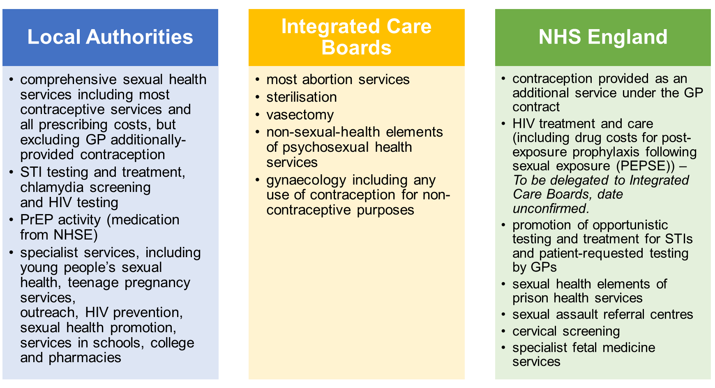

**Sexual and reproductive health clinical services** are described in three distinct levels, the elements of which are outlined in the links below:

* [Level 1 Sexual Health Service (datadictionary.nhs.uk)](https://www.datadictionary.nhs.uk/nhs_business_definitions/level_1_sexual_health_service.html)
* [Level 2 Sexual Health Service (datadictionary.nhs.uk)](https://www.datadictionary.nhs.uk/nhs_business_definitions/level_2_sexual_health_service.html)
* [Level 3 Genitourinary Medicine Service (datadictionary.nhs.uk)](https://www.datadictionary.nhs.uk/nhs_business_definitions/level_3_genitourinary_medicine_service.html)

The management of STIs are outlined as levels 1-3 as in the BASHH Standards for the management of STIs (2019) The Royal Devon University Hospital Trust is the main sexual health and reproductive service provider, delivering integrated services across the North, East, Exeter and mid-Devon areas. The present service operates as a “hub and spoke” model with specialist Level 3 sexual health and reproductive centres (hubs) in Exeter and Barnstaple, in addition to other satellite services (spokes). This is supplemented by integrated service provision in South Devon (Torbay and Southern Devon NHS Foundation Trust) and by separate providers in the West Devon area (University Hospital Plymouth). The main clinics are in Exeter, Barnstaple, Torbay and Plymouth and there are two spoke clinics in Holsworthy and Tiverton. Spoke clinics were closed due to Covid-19. On reopening, securing appropriate clinic spaces is a challenge. Some clinics offer young people drop in’s, but most are accessed by appointment only. The exception is Barnstaple where people have the option to walk in.

The main clinics offering a daily service of both contraception and sexual health services are in Barnstaple, Exeter, Torbay and Plymouth. Consultations take place via telephone and test kits can be ordered via clinician following a consultation. This contrasts with Plymouth where test kits for all 16+ can be ordered online. For 16-24 year olds testing kits for use at home are also available online via [www.freetestme](http://www.freetestme).

**Community Prevention Services**

The Eddystone Trust use evidence-based prevention approaches to support individuals and communities to enact positive sexual and reproductive health. Sexual health training is available free to anyone working in Devon.

**Condom distribution for under 25- year-olds**

Preventx coordinate the Devon condom distribution service for under 25 year olds which includes online ordering of condoms by post.

**Long-Acting Reversible Contraception and Chlamydia Screening**

GPs prescribe contraception and in addition can offer Long-Acting Reversible Contraception (IUDs and implants) once they have met the required competencies. They also provide chlamydia screening for under 25 year olds.

**Emergency Hormonal Contraception for under 25year olds and Chlamydia Testing**

Pharmacists who have met the required standards can provide free emergency contraception to anyone aged 13-25 years. Chlamydia self-testing kits are also available in pharmacies.

**Young Women First and Sexual Health Promotion for Young People**

Young Devon and The Zone provide targeted support to vulnerable young people. This includes provision of condoms and chlamydia self-test kits.

# Appendix 3

**Contraception Survey 2022 Summary**

The survey ran over 8 weeks during Summer 2022 and received a total of 247 responses.

**Demographics**

95% of respondents identified as female, with 2.4% as trans/non-binary, and the remaining percentage answered prefer not to say/other.

Of these, 84% identified as heterosexual, 9% as bisexual and 6% identifying as lesbian / other / prefer not to say.

96% of respondents identified as white ethnicity and 2% answered prefer not to say/other. There were no respondents from Asian or Asian British groups, only 2 from mixed or multiple ethnic groups, and only 1 from Black, Black British, Caribbean, or African groups.

Respondents were from across the Devon County Council area with 35% living in or around Exeter.

The ages of respondents were well spread out and reached the age ranges intended.

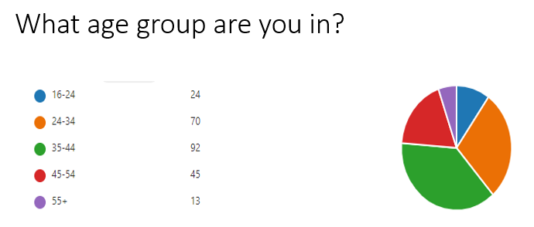

**Contraception insights**

The most predominant method of contraception currently being used amongst survey respondents was the oral contraceptive pill (34.4%), followed by both condoms and IUS (16.6%), none (13%) and implants (9%). When combined (implant, IUS + IUD and injection), LARC accounted for 34% of current methods used by the survey respondents in Devon.

16% of respondents said their current method of contraception was not their preferred method. When these respondents were asked what is stopping them from using their preferred method, reasons included being unable to get an appointment for a coil fit and lack of other options:

*‘Unavailable at GP since Covid and long waiting lists at clinic’*

*‘I would like to have another Mirena coil but there is a 6 month wait in my local GP practice.’*

*‘It’s not that it isn’t by preferred method, but I’ve been talking the pill continuously since I was 14 and have never been offered another option or even had a discussion about it with a nurse or GP’.*

*‘I would prefer my partner to have a vasectomy however I feel there is very little information readily available’.*

Of the respondents currently using contraception, just over half usually go to their GP, 26% use specialist contraceptive clinic and 11% go to a pharmacy. The remaining percentage answered other and online. Of these respondents, 82% were happy with the location where they get their contraception. Reasons given by the 18% who were not happy with the location included not being available at GP / unable to get appointment with GP, distance from home / travel, and limited opening hours / phone appointments:

*‘The GP cannot offer me the coil and seems disinterested in my issues with the pill’.*

*‘Service is split between two locations. I do not drive, and they couldn’t offer it within walking distance’.*

*‘Limited opening hours that are the same as my working hours. Can’t take time off work to attend appointments for contraception’.*

*‘…since Covid they changed to telephone appointments where they would ring you back at any point throughout the day. This just was not convenient with my work’.*

When asked where else they may prefer to get their contraception from, 29% preferred pharmacy, 27% their GP, 22% specialist clinic and 16% online.

Given a choice of factors to consider when choosing contraception, the following were the top three ‘very important’ factors – confidence / trust in service (76%), choice of methods (53%) and convenient location (51%). The least important factor was an anonymous service.

The final questions were free text responses, asking ‘what do you think needs to happen to make sure all the people in Devon can get the contraception that works best for them?’ and ‘please tell us anything else you would like to say about contraceptive services in Devon’. There were 192 responses to the first question and 99 responses to the second.

These responses have been grouped into themes with representative quotes from respondents. A common theme was **access to services** which included locations and opening hours, as well as difficulty making appointments.

*‘Convenient locations and convenient opening times’*

*‘More appointments outside normal working hours - before 9am, after 5pm*

*‘Accessible professional help, no hassle booking and repeat prescriptions direct via a pharmacy’.*

*‘Not restricted opening hours, when you work full time, trying to take a triage phone call during the day is nearly impossible, as it is booking one, as you have to call in the morning only’.*

*‘Make more services available online. It can be embarrassing to have to go in and discuss delicate issues face to face and online services makes it a lot more comfortable for some people. Even just being able to book an appointment online can help’.*

Another common theme was **patient choice,** particularly the opportunity to discuss the full range of contraception on offer and availability at their chosen location.

*‘Doctors need to listen more to their patients when they say they aren’t happy with the contraception they are currently using. Explore all options.’*

*‘All contraceptives should be available wherever you go to get contraception’.*

*‘More expansive conversations about the types of contraception that is available. I have a yearly pill review in which I usually feel shut down when I ask other options to be explained’.*

*‘There seems to be a real gap for women with period issues who want to find methods that work for them - GP not interested and hard to see a specialist’.*

This theme continued with many respondents reporting difficulties accessing their contraception of choice in primary care.

*‘Needs to be more accessible - GP surgeries need to offer all forms of contraception again especially in rural* *areas’.*

*‘All GPs should be able to discuss and provide services for all methods of contraception including implant and coil’.*

*‘Improved & increased provision through GP surgeries, these are often easier to travel to/**access’.*

There were some disappointing comments from respondents, whose experiences had not been positive, suggesting a need for better **knowledge / staff training** – particularly aboutinclusivity.

*‘There's no* *gender neutral language used nor any check as to how you'd like to be referred to and "woman" is defaulted to. I get referred to as a woman or lady all the time because I have a uterus.’*

*‘I’ve had a nurse insist only women menstruate, to my face, while clearly identifying as a man.’*

*‘GPs to have wider knowledge not just rely on the pill’.*

*‘Trained GPs in women's health, so all ages are catered for, at different times of the menstrual life’.*

*‘Sensitivity training for all staff is key. A safe place where people won't feel ‘judged for their choices.’*

The final theme was **publicity and awareness raising,** including how to access contraception free of charge.

*‘Clinics to be well advertised so people know where to go.’*

*‘Better marketing and awareness raising of provision available to captive audiences such as college students, youth clubs, bus stops, GP videos etc and perhaps via social media targeted Facebook adds’.*

*‘Early education about the services that are available so that young people are aware of where to go, and so that parents and carers are fully informed too as it should be an open subject within families.’*

*‘Make more adults aware they can get free contraception and advice. Condoms are expensive’.*

# Appendix 4

**Sexual and Reproductive Health Survey 2023 Summary**

The survey ran for 7 weeks during September and October 2023 across Devon County and Torbay Council areas. There were a total of 265 responses.

**Demographics**

75% of respondents lived in the Devon County Council area, and 24% from Torbay Council area.

75% of respondents identified as female, 17% as male, 5% as gender fluid / non-binary, and the remaining percentage answered other.

74% identified as heterosexual, 10% as bisexual, 4.5% each as gay and pansexual, 2% as lesbian and the remaining percentage as other.

95% of respondents identified their ethnic group as white. A total of 4 respondents identified as mixed ethnicity, 3 as Black or Black British and 1 as Asian or Asian British and 1 as other.

16% of respondents considered themselves to have a disability.

The majority of respondents were between 25 and 54 years of age.

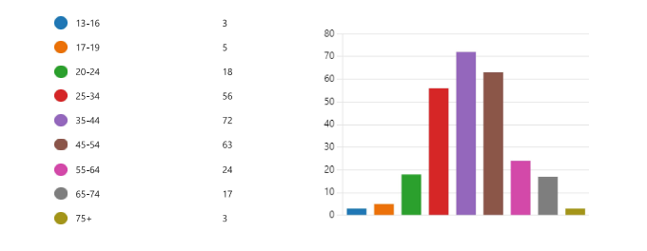

When asked how often they had travelled to a sexual health service or clinic in the last 12 months, 53% of respondents replied not at all, 30% replied yearly and 10% quarterly. Over half of those who attended had travelled less than 3 miles. Over 80% agreed that sexual health and contraception services should be available as part of the same appointment. Given a choice, most respondents would prefer weekday evening and Saturday morning opening times.

When asked to rate options, respondents preferred an all age clinic, GP practice and online for contraception and/or a sexual health service.

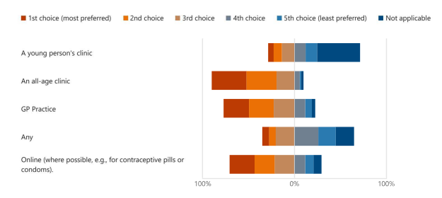

The preferred options for accessing contraception were specialist service, GP practice, online and pharmacy.

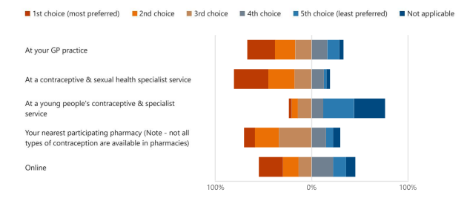

The preferred options for testing and treatment for a sexually transmitted infection were specialist service, online and GP practice.

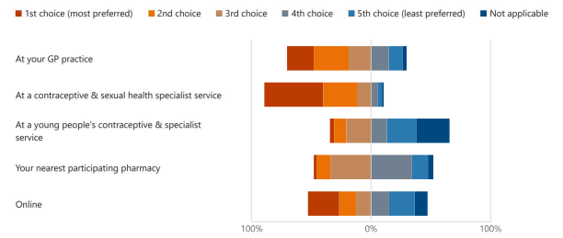

The main reasons given for attending a sexual health clinic were due to symptoms of a sexually transmitted infection, for contraception, and for a sexual health check-up.

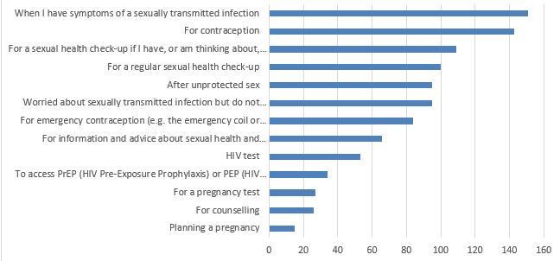

Reasons given that would prevent respondents from accessing services related to availability, travel, knowledge and stigma.

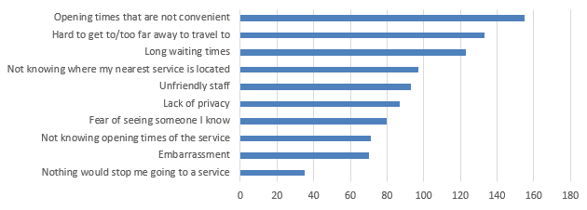

Preferred options for any online sexual health service were testing kits, advice and condoms. Routine contraception was added by 165 respondents.

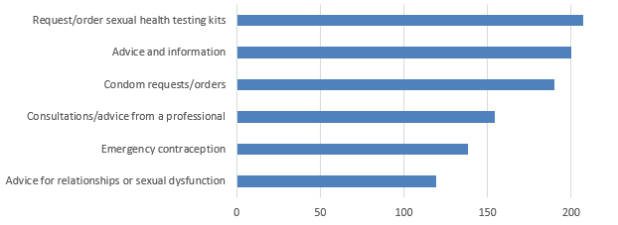

60% of respondents felt they had enough information to access the sexual health services they needed. For those who answered no, more visible information online was required which could be accessed via NHS websites and online searches. Also, clearer

signposting to services was needed, both online and through publicity in public places such as GP surgeries, colleges and bars. Less than half of respondents were aware of the Devon Sexual Health website, and a third were aware of The Eddystone Trust website.

Over half of the respondents took the time to answer the final question and provided comments about contraception and sexual health services in Devon and Torbay. There were some common themes particularly around access to services. A number of respondents were unclear about which services they could use and were confused by age limits.

*Being 29 I don't know what services are open to me in my age range. I am a bit confused whether the sexual health screening service is available to all ages.*

*As someone over 30 and in a* *long term relationship I felt the website alienated me and was not made for me when I had an issue.*

*I'm in my early 30's and dating. When I have a new sexual partner, I would like to be able to access STI testing as this has always been the advice (even with no symptoms). Once I turned 26 services became very difficult to access.*

The location of clinics was another access issue raised by respondents, particularly for those living in market towns or rural areas.

*Being situated in a large town, it would be useful if we had a privately located clinic somewhere (like we used to in Exmouth) on Imperial Road.*

*The drop-in clinic at Newton Abbot was* *really good, it’s now too difficult to get to Torquay easily to be seen.*

*If you live outside a major city or town, they seem very hard to access. Most of my friends regularly have pregnancy scares. I've had to use my own money for pregnancy tests for my friends. I don't feel very supported as a sexually active teenager in rural Devon.*

Another access issue highlighted was the difficulty in booking appointments and the barriers caused by phone lines.

*Please make it more accessible to call, you* *have to call in 9-5 hours and first come first serve. When you have a job which doesn't allow this, it made it almost completely inaccessible. It is also hard because you need a private space to have that conversation and there isn't always one in work hours.*

*Really positive experience with staff when I've used the services but* *really large barriers to access. Phone line only to book appointments. Phone line rarely picked up and when it is you are advised to phone at 8.30am the next day to get an initial appointment.*

*Online booking would be* *really useful as it’s so tricky to get through to the clinic on the phone.*

Feedback from respondents who had used services was mixed with some reporting very positive, and others very negative experiences.

*Excellent service, staff are extremely professional, and knowledgeable.*

*Love Devon sexual health service. It is brilliant. Friendly*

*staff. Never had a problem.*

*The services are great! Easiest services I have accessed, and the staff are just fantastic. Knowledgeable, friendly and professional*

*I think the staff need to be a lot more empathetic and understanding of everyone’s individual situation.*

*I feel thoroughly let down by the service received from my GP*

*I found it* *really difficult to access one single service when I needed a termination of pregnancy.*

While some respondents would prefer to access services online, others felt that face to face delivery was a necessity.

*It’s vital to be able to talk to experienced members of staff about sexual health. It’s extremely important. Has a huge impact if it goes online.*

*Services primarily need to be face-to-face. Online does not work for sexual health issues.*

*It would be useful if much more was moved online to avoid unnecessary visits. I have paid to use Lloyds online services before just to avoid unnecessary waits and visits, and found this quick, efficient and private.*

*I would like an online ordering service* *similar to Somerset.*

1. [Variation in outcomes in sexual and reproductive health in England 2021 (publishing.service.gov.uk)](https://assets.publishing.service.gov.uk/media/60955c3de90e073573036703/SRH_variation_in_outcomes_toolkit_May_2021.pdf)
2. [Interpersonal & Gender-based Violence & Abuse - Safer Devon](https://eur02.safelinks.protection.outlook.com/?url=https%3A%2F%2Fsaferdevon.co.uk%2Finterpersonal-gender-based-violence-abuse%2F&data=05%7C02%7CAbs.Gyamfuah-Assibey%40devon.gov.uk%7Cccd891a8355243a8f53908dc1e6d5357%7C8da13783cb68443fbb4b997f77fd5bfb%7C0%7C0%7C638418702105009535%7CUnknown%7CTWFpbGZsb3d8eyJWIjoiMC4wLjAwMDAiLCJQIjoiV2luMzIiLCJBTiI6Ik1haWwiLCJXVCI6Mn0%3D%7C0%7C%7C%7C&sdata=3qXauWUGduOQiBnOgdCyjK5mxJ0UozycROzXbepAMeg%3D&reserved=0)
3. [CoLab Women — CoLab Exeter](https://www.colabexeter.org.uk/colab-women)
4. Mercer CH, Clifton S, Riddell J, et al Impacts of COVID-19 on sexual behaviour in Britain: findings from a large, quasi-representative survey (Natsal-COVID) Sexually Transmitted Infections 2022;98:469-477. <https://sti.bmj.com/content/98/7/469>
5. [STI rates remain a concern despite fall in 2020 - GOV.UK (www.gov.uk)](https://www.gov.uk/government/news/sti-rates-remain-a-concern-despite-fall-in-2020)
6. [Towards Zero: the HIV Action Plan for England - 2022 to 2025 - GOV.UK (www.gov.uk)](https://www.gov.uk/government/publications/towards-zero-the-hiv-action-plan-for-england-2022-to-2025)
7. [Women’s Health Strategy for England - GOV.UK (www.gov.uk)](https://www.gov.uk/government/publications/womens-health-strategy-for-england)
8. [Devon Joint Strategic Needs Assessment Summary - Devon Health and Wellbeing](https://www.devonhealthandwellbeing.org.uk/jsna/overview/)
9. [Integrated Sexual Health Services: A suggested national service specification](https://assets.publishing.service.gov.uk/government/uploads/system/uploads/attachment_data/file/1143246/Integrated-sexual-health-service-specification-2023.pdf)
10. [Deprivation Dashboard - Devon Health and Wellbeing](https://www.devonhealthandwellbeing.org.uk/public-health-dashboards/deprivation-dashboard/)
11. [Sexual and Reproductive Health Profiles - Data - OHID (phe.org.uk)](https://fingertips.phe.org.uk/profile/sexualhealth/data#page/6/gid/8000057/pat/6/par/E12000009/ati/401/are/E07000042/iid/20401/age/173/sex/2/cat/-1/ctp/-1/yrr/1/cid/4/tbm/1/page-options/car-do-0)
12. [Your parents' support framework (publishing.service.gov.uk)](https://assets.publishing.service.gov.uk/media/5cb85bc640f0b649e47f2983/PHE_Young_Parents_Support_Framework_April2019.pdf)
13. Owens, R. (2022). 'It's the way they look at you': Why discrimination towards young parents is a policy and practice issue. *Children & Society*, 36, 1280–1295
14. [Conceptions in England and Wales - Office for National Statistics](https://www.ons.gov.uk/peoplepopulationandcommunity/birthsdeathsandmarriages/conceptionandfertilityrates/bulletins/conceptionstatistics/2021#conceptions-by-area-of-usual-residence)
15. Abortion statistics for England and Wales: January to June 2022 - GOV.UK (www.gov.uk)
16. [Variation in outcomes in sexual and reproductive health in England 2021 (publishing.service.gov.uk)](https://assets.publishing.service.gov.uk/media/60955c3de90e073573036703/SRH_variation_in_outcomes_toolkit_May_2021.pdf)
17. [Health and Social Care Act 2012 (legislation.gov.uk)](https://www.legislation.gov.uk/ukpga/2012/7/contents)