Easy Read Version:
Starting and Developing Well Information
 | Population: About a quarter of Devon's population is aged 0-24 years. This number is expected to stay the same.
 | Health: Maternal and infant health is improving due to better healthcare and early support. However, more work is needed to reduce smoking and hospital visits for infants.
 | School Readiness: Most children are ready for school by the end of reception, but those on free school meals are less prepared. There is room to improve academic success and reduce absenteeism, especially for vulnerable groups like children in care.
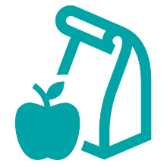 | Habits: Children's diet, sleep, food intake, and physical activity need improvement. Nearly 1 in 5 households in Devon have very low food security. Excess weight is a concern for primary (1 in 4) and secondary (1 in 3) school children, especially among disadvantaged children.
 | Mental Health: Children with poor mental health have worse health outcomes. Hospital admissions for mental health issues, self-harm, and injuries are high among children and young people in Devon, particularly for vulnerable groups. Bullying and body image issues are also common.
 | Unemployment: Devon's unemployment rate is low, but some areas have higher rates, affecting family stability and children's wellbeing. Rural and coastal areas have fewer job opportunities. Child poverty is rising in Devon, though still lower than the national average.
 | Housing: Almost half of Devon's population lives in poor housing conditions. Rural areas are particularly affected.
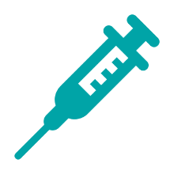 | Vaccination: More efforts are needed to improve vaccination rates to meet NHS targets and ensure better public health.

