Easy Read Version:
Population Well Information
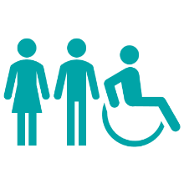 | What does this mean?  Population means the number of people living in Devon and what their lives look like. This helps plan health, housing, jobs, and services.
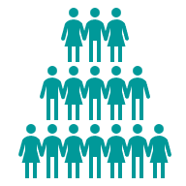 | How many people live in Devon?  - About 833,000 people live in Devon.  - The population will grow to 879,000 by 2030 and 926,000 by 2040.
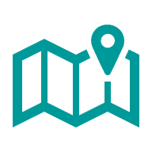 | Where do people live?  - About half of people live in rural areas.  - Towns like Exeter and Barnstaple are busy and attract younger people.  - Coastal towns like Torquay and Exmouth have more older people and tourists.
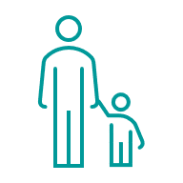 | Age  - Devon has more older people than most places in England.  - By 2043, 1 in 3 people will be over 65.  - There are fewer children and young people compared to other areas.
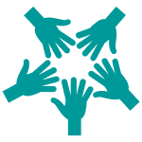 | Diversity  - Most people in Devon are White British (92.6%).  - Other ethnic groups are very small compared to the national average.  - Nearly 45% have no religion and 47% are Christian.
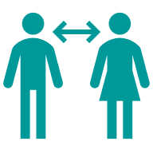 | Gender and Identity  - About 51% are male and 49% are female.  - Around 2.6% identify as lesbian, gay, or bisexual.  - About 0.3% identify as transgender.
 | Challenges  - Older people often need more health and care support.  - Rural areas can have poor transport and internet.  - Some people feel isolated or struggle to access services.  - Young people often leave Devon for jobs and education.
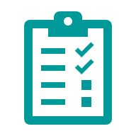 | What needs to happen?  - Plan for more older people and better housing.  - Improve transport and digital access.  - Support young people with jobs and education.  - Make services inclusive for everyone, including ethnic minorities, LGBTQ+, and neurodiverse people.  - Reduce health inequalities and support vulnerable groups.

