Easy Read Version:
Deprivation Information
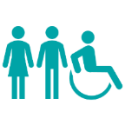 | What is Deprivation?  Deprivation means not having the things you need to live a healthy and happy life. This can include money, housing, transport, education, and access to services.
 | How is Deprivation Measured?  The government uses something called the Index of Multiple Deprivation (IMD). It looks at things like:  Income and jobs  Health  Education  Crime  Housing  Access to services
 | What does this mean for Devon?  - About 31,100 people (4%) live in areas that are among the most deprived in England.  - The most deprived area in Devon is Ilfracombe Town Centre, where nearly 30% of people have very low income.  - Other areas with high deprivation include parts of Barnstaple, Exeter, and some rural and coastal communities.
 | Hidden Rural Poverty  - Devon looks wealthy, but many rural areas have hidden poverty.  - People in rural areas often face low wages, high housing costs, and poor transport.  - Some rural areas in Devon are more deprived than rural areas in other parts of England.
 | Housing and Fuel Poverty  - Many homes in Devon are old and hard to heat.  - People often have to choose between heating and eating.  - Poor housing can make people ill and increase fuel poverty.
 | Transport Problems  - Some people cannot afford transport or live far from services.  - This makes it hard to get to jobs, schools, and healthcare.
   | Digital Exclusion  - Some people do not have good internet or devices.  - This makes it hard to access services, education, and jobs.
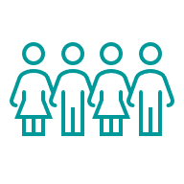 | Child Poverty and Social Mobility  - 1 in 8 children in Devon lives in poverty.  - In some areas, like parts of Barnstaple, this is over 33%.  - Children in poverty often find it harder to do well at school and get good jobs later.
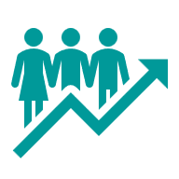 | Health Inequalities  - People in deprived areas live 15 years less than people in the least deprived areas.  - They are more likely to have poor mental health and long-term illnesses.
 | Cost of Living  - Many families struggle with rising food and energy costs.  - Some people use food banks or skip meals.
 | What needs to happen?  - Focus help in areas like Ilfracombe, Barnstaple, and parts of Exeter.  - Improve housing, transport, and digital access.  - Reduce child poverty and help families find good jobs.  - Make healthcare easier to access for everyone.  - Work with communities to design local solutions.

