Easy Read Version:
Climate Information
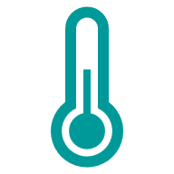 | What is Climate Change?  Climate change means the weather is changing in ways that affect our health and daily life. There are more heatwaves, floods, and storms. This can make life harder for everyone, especially older people, children, and those with health problems.
 | Why does it matter for health?  - Hot weather and floods can make people ill or even cause deaths.  - Bad air quality can make breathing problems worse.  - Climate change can affect mental health and cause stress and anxiety.  - It can make food and water more expensive and harder to get.
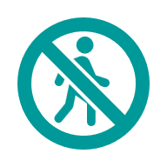 | What are the main risks?  - Extreme Weather: Heatwaves, storms, and floods can damage homes and roads and stop services.  - Air Quality: Hot weather makes air pollution worse, which can harm lungs and hearts.  - Infectious Diseases: Warmer weather can spread bugs like ticks and mosquitoes that carry illnesses.  - Mental Health: Worry about climate change and disasters can cause anxiety and depression.  - Food and Water: Climate change can make food and water harder to get and more costly.
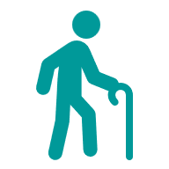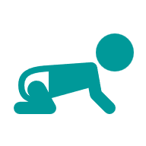  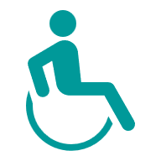 | Who is most at risk?  - Older people  - Babies and children  - People with long-term health problems  - People without good housing or enough money
 | What needs to happen?  - Make homes safer from heat and floods.  - Improve emergency plans for floods and heatwaves.  - Help communities prepare and stay safe.  - Reduce pollution and protect nature.  - Share clear information about climate risks and health.
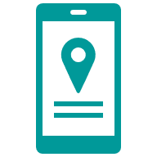 | Local examples:  - People in Dawlish and South Hams worry about flooding and losing homes.  - Some social housing tenants struggle with very hot homes in summer.  - Communities use village halls and churches as cool spaces during heatwaves.  - Young people say they feel anxious about climate change.
 | What can you do?  - Keep homes cool and safe.  - Use water carefully and check flood plans.  - Join local groups that help with climate action.

