Easy Read Version:
Building Blocks of Health Information
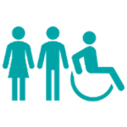 | What is inequality?  Inequality means some people have fewer chances to live a healthy life. It happens because of things like who they are, where they live, and how much money they have.
 | Protected Characteristics: People may face unfair treatment because of age, disability, race, gender, religion, or sexual orientation. This can affect their health, housing, jobs, and access to services.
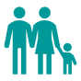 | Socio-Economic Deprivation: People with low income, poor housing, or little education often struggle with food, transport, and healthcare. These problems can lead to worse health and shorter lives.
 | Inclusion Health and Vulnerable Groups: Groups like homeless people, migrants, and those with mental illness face big challenges. They often feel excluded and have poor access to services. Their life expectancy can be 30–40 years lower than average.
 | Geography: Where people live matters. Rural and coastal areas often have fewer services, poor transport, and digital exclusion. This leads to worse health outcomes.
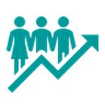 | Life Expectancy in Devon: Women live longer than men, but spend more years in poor health. People in poorer areas live shorter lives. In some parts of Devon, there is a 15-year difference in life expectancy.
 | Building Blocks of Health: Everyone needs things like safe housing, good food, transport, and healthcare. Some groups struggle to get these, which affects their health.
 | What People Say: People want services that are kind, inclusive, and designed with them. They talk about stigma, poor access, and the need for better support.
 | What’s Missing? We need more local data, more stories from people, and better understanding of how different inequalities combine. Services need to be easier to reach and more joined-up.
 | Devon’s Priorities  - Do more local research  - Improve data and mapping  - Design services with communities  - Make services easier to access  - Check what works and improve it

