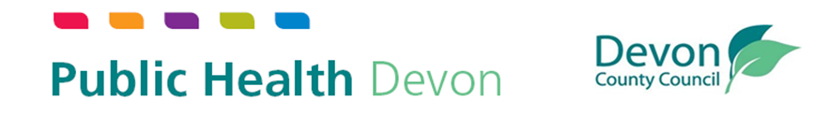

Devon Drug and Alcohol Strategic Partnership:
Annual Report 2024/25

- Introduction

  - This report covers the period April 2024 to end March 2025.

  - The Devon Drug and Alcohol Strategic Partnership (DDASP) continues to deliver the ambitions of the national drug strategy, From Harm to Hope (2023–2033), focusing on:
- Increasing numbers of people in treatment.
- Reducing alcohol and drug-related deaths.
- Improving continuity of care for people engaged in the criminal justice system.
- Reducing supply and demand for illicit substances.

  - The Partnership is chaired by the Director of Public Health and includes representation from treatment providers, Devon and Cornwall Police, NHS partners, probation, and the voluntary sector.

  - There is a public partnership page available here Devon Drug and Alcohol Strategic Partnership - Devon Health and Wellbeing.

  - Figure 1 show the Partners involved.

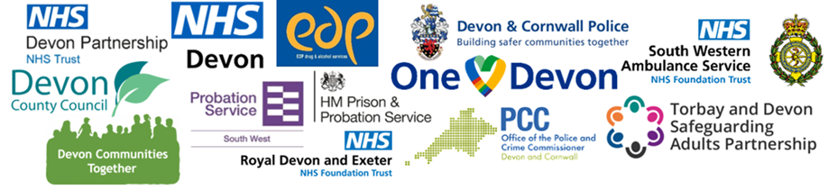
Figure 1: Partners that make up the Devon Drugs and Alcohol Strategic Partnership.

- Data, Intelligence and Needs Assessment

  - This year saw the establishment of a Devon Drugs and Alcohol Data Dashboard, aligned to the National Combating Drugs Outcomes Framework. These tools strengthen our ability to monitor progress and respond to emerging trends.

  - It also saw the publication of the Annual Public Health Report 2024-25 – Turning the Tide: Tackling alcohol harm in Devon and an associated Alcohol Harm Reduction dashboard.

  - A refresh of the DDASP Drug and Alcohol Needs Assessment was worked on during 2025, and completed and published in 2025/26.

- Delivery Update

Reducing drug-related deaths and harm

  - Preventing drug-related deaths remains a priority. In 2024/25, 35 individuals in treatment died, representing 3% of the treatment population which is higher than the previous year.

Actions taken include:
- Appointment of drug related death’s coordinator enabling us to stand up a Preventions of Drug and Alcohol Related Harms review panel (PDARH) from 25/26
- Expansion of Naloxone training and distribution across services and community partners.
- Piloting provision of Nitazine test strips via treatment services as a harm reduction measure. This pilot was then evaluated alongside arising evidence base to inform next steps.
- Maintaining opiate safe clinics to prevent treatment drop-off.
- Strengthening intelligence through the Local Drug Information System (LDIS).
We continue to promote harm reduction messages:
- Go slow and dose low.
- Avoid using alone—have Naloxone available.

System-wide initiatives
The Inclusion Health Partnership has progressed implementation of the NHSE Inclusion Health Framework across the Integrated Care Board, improving access for people with complex needs, including those in rural and coastal communities.

The Ilfracombe Poverty Truth Commission became operational in late 2024 when, following months of preparatory work, the full commission was formed (Civic and Community Commissioners). Three themed working groups were formed to explore: housing, adult education and employment, and humanising services. One-to-One meetings enable commissioners to encounter and understand each other’s world. Working groups created recommendations and co-designed solutions to implement change.

In 2024, BtheChange and Intercom Trust were commissioned to review the accessibility of drug and alcohol services in Devon. They produced the following reports. BtheChange Report: ‘Accessibility of Drug and Alcohol Services to Ethnically Diverse Communities in the Southwest of England, April 2024 (Unpublished), and Intercom Trust ‘LGBT+ Accessibility Evaluation & Development: Substance Misuse Services in Devon’, March 2024 (unpublished). Recommendations from the report have been taken forward by commissioners and providers through the contracting relationship.

Since 2020, a collective of stakeholders with a shared commitment to support those facing multiple disadvantages has been connecting and collaborating through the SCAA (System Change Action Alliance) in Exeter and North Devon. They have been working to strengthen the MARMM process at pilot phase (Multi Agency Risk Management Meeting) by sharing thematic learning through Partnership groups such as the Local Care Implementation Partnership and to elicit system change.

The Devon Communities Together research project; Breaking Barriers: Access to Drug & Alcohol Treatment & Support Services in Rural Devon (published March 2025) Breaking Barriers, highlighted the critical link between housing and recovery, especially in rural and coastal towns in Devon. We continue to work with housing authorities to develop effective housing and treatment pathways within the highly challenging context of Devon’s chronic housing shortage (see Devon Housing Commission Report – Devon Community Housing Hub).

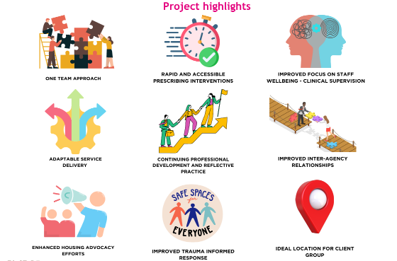
The Evaluation of the System Transformation and Recovery (STaR) Test and Learn project, commissioned in March 2022, was carried out between October 2024 and January 2025. STaR targets those at risk of homelessness with substance misuse challenges and limited access to services, with specialised wrap around support. The project highlights are listed in Figure 1. Challenges and lessons have been iteratively reviewed and fed into service development. Themes include service identity and belonging, communication, addressing barriers to wider health care, improving access to psychological support and data and intelligence.
Figure 1: Highlights of the STaR project identified via evaluation

This year also saw the implementation of a joint initiative called Operation Vapour, led by Devon and Cornwall Police in collaboration with Public Health and Education partners. Operation Vapour provided an opportunity for schools to submit confiscated vapes to the police, which were then tested by Bath University to better understand the contents of vapes circulating in school environments. In March, several schools across Devon took part, and the findings revealed that a small but significant number of vapes contained illicit substances. Two substances of concern identified through Operation Vapour were Spice and THC (tetrahydrocannabinol). Resources were developed for schools and the designated safeguarding leads. A Youth Vaping Partnership Working Group has now been established to facilitate partnership working on this topic.

- Increasing Engagement in Treatment

- Adults: As of March 2025, 2575 adults were in structured treatment, an increase of 12.2% since March 2024.
- Young People: 242 young people engaged in treatment, reflecting a 13% increase on 24/25.
- Prison Leavers: The proportion of prison leavers with a continued treatment need picked up in the community within three weeks in the year ending March 2025 remained relatively stable at 53%; this is a slight decrease from the year prior (58%) but maintained a marked improvement on the March 2022 baseline of 35%.
- Tier 4 Services: 16 individuals accessed residential rehabilitation through the commissioned drug and alcohol services (and funded by Public Health Devon) and 8 inpatient detox placements. A further 19 individuals were placed at Bosence Farm via the Inpatient Detox Consortia funding administered by Cornwall on our behalf.

- Improving Treatment and Recovery Outcomes

In terms of treatment progress, the measure below refers to each individual’s status in their latest treatment journey in the rolling 12 month period between 2024 and 2025. Devon continues to perform above national averages for opiate and/or crack pathways but below the national average for alcohol, and non-opiate pathways. (NDTMS data April 2024 to March 2025).

- 52% of those in treatment in Devon for all substances showed substantial progress. This compares to 47% in England.
- 61% of those in treatment in Devon for opiate and crack pathways showed substantial progress compared to 46% in England.
- 44% of those in treatment in Devon for alcohol only showed substantial progress compared to 51% nationally.
- in 24/25, 90% of young people reported successfully completing treatment at treatment exit. This compares to 85% in England and 87% in the South West for the same period.

- Challenges

- Housing insecurity remains a major barrier to recovery, as highlighted in the Breaking Barriers report and the Devon Housing Commission Report – Devon Community Housing Hub which provides a comprehensive analysis of the housing challenges faced in Devon (Chapter 5 focuses specifically on supported housing and temporary accommodation)
- Pharmacy closures and workforce shortages impact supervised consumption, Naloxone and Needle and Syringe Provision.
- Rurality limits service accessibility, this is particularly challenging due to limited outreach capacity within the available funding envelope and Devon’s dispersed need; Delivering a service across a highly rural area on a proportionately low public health grant allocation remains a constant challenge as highlighted by Breaking Barriers: Access.
- Synthetic opioids present an ongoing risk, requiring rapid response, intelligence and harm reduction reach beyond opiate users.
- Workforce recruitment and retention remain critical challenges; Workforce recruitment and retention remain key challenges to the adult treatment and recovery services for Together and STaR, which has places pressure on caseload sizes and, in turn, service users outcomes.
- Wait times; in 24/25 69% of people in treatment waited under three weeks to start treatment. This is a slight reduction on the year prior (From 73%) but a significant improvement to the 2022 baseline (41%).
- Partnership working and engagement: The board has experienced challenges in maintaining consistent attendance and engagement from key partners, such as Devon Partnership Trust. Other partners, such as NHS Devon, have highlighted the need to review ways of working in light of significant organisational change. More broadly, even where there is shared intent for joint working—for example on co-occurring mental health and substance use—partners have struggled to allocate sufficient capacity to progress this work. Within the context of already strained health and social care systems, this has had, and will continue to have, a significant impact on the partnership’s ability to deliver against its objectives.

- Involving People with Lived Experience

Progress includes:
- The lived experience group ‘Common Ground’ has been developing in Exeter supported by CoLab a place based charity hosting a multi-agency hub in Exeter.
- Across Devon peer researcher roles have been operationalised to find out more about the experiences and views of people with lived experience of substance misuse.
- Within the system work has been ongoing to strengthen involvement in service design and evaluation.

Next steps:
- New research governance frameworks have been developed and the next steps are to illuminate and bring together the processes and pathways of involving people with lived experience into a governance frameworks. This will enable us to expand participation in strategic decision-making in a consistent, transparent and trauma informed way.

- Local Priorities for 2025/26

There are thirteen local priorities for the period 2025-2028 which sit under the 3 national priorities of the delivery plan. The Devon delivery plan can be found on the Devon Health and Wellbeing webpages.

Key priorities for 2025/26 include: establishing the PDARH process to prevent drug and alcohol related deaths, developing a partnership communications strategy, developing further governance and processes for involving people with lived experience in the partnership, expanding access to naloxone and developing co-occurring conditions joint working protocol between drug services and the statutory mental health provider.

- Support Available

For anyone living within Devon County Council’s boundary who has concerns about their own or a loved one’s use of alcohol or other drugs:
- WayThrough (Together) Drug & Alcohol Service (Adults): Waythrough Drug and Alcohol Service (Together) Support in Devon
Tel: 0800 233 5444
E-mail: sw_together@waythrough.org.uk
Web: www.waythrough.org.uk/find-support-near-me/together/
- Y-SMART (Children & Young People): 01271 388162 | y-smart@devon.gov.uk
- STaR (The System Transformation and Recovery) project Phone: 01392 202055, Address: Wat Tyler House, 3 King William St, Exeter, EX4 6PD

- References

- HM Government (2021). From harm to hope: A 10-year drugs plan to cut crime and save lives.
- Office for Health Improvement and Disparities (2023). Drugs strategy national outcomes framework.
- Devon Communities Together (2025). Breaking Barriers: Access
to Drug & Alcohol Treatment & Support Services in Rural Devon.
- Devon County Council (2024). Annual Public Health Report 2024/25. Annual Public Health Report 2024-25 – Turning the Tide: Tackling alcohol harm in Devon.
- BtheChange (April 2024) Report: ‘Accessibility of Drug and Alcohol Services to Ethnically Diverse Communities in the Southwest of England (Unpublished).
- Intercom Trust (March 2024) Report ‘LGBT+ Accessibility Evaluation & Development: Substance Misuse Services in Devon’ (unpublished).

