

Accommodation and Support Joint Strategic Needs Assessment for Mental Health

April 2010

Contents

- The Strategic Context

- The Local Context

- Accommodation and support needs

- Strategic approach to meeting accommodation and support needs

- Financial and commissioning implications

Appendix 1 - Detailed Deprivation Maps
Appendix 2 - Extract from Care First6 – Care Homes and Enabling Services for people supported during 2008/09

1. The Strategic Context

1.1 The purpose of this document

This document is intended to set out the JSNA (Joint Strategic Needs Assessment) on accommodation and support for people with mental health problems. The government requires local authorities and PCTs to produce a JSNA to describe the future health, care and wellbeing needs of the local population and the strategic direction of services to help meet these needs.

The concept of an accommodation and support JSNA has been developed by Devon’s Supporting People Team to complement the broader health and social care focused JSNA. This type of JSNA is being developed in Devon in recognition of the importance played by accommodation and support services in responding to the well being of the population and in providing services that focus on early intervention and prevention.

The production of this JSNA has involved consultation with key stakeholders and an analysis of the available data on mental health, accommodation and support. Three Devon wide consultation events were arranged by Be Involved Devon to provide feedback on the JSNA and involved a mixture of people using and providing services, as well as carers, family members and mental health workers.

This document will form the basis of a strategic approach on accommodation and support for people with mental health problems.

1.2 National Approach

For the past 10 years the National Framework for Mental Health Services has been in place for adults up to age of 65. It has set out national standards, national service models, local action and national underpinning programmes for implementation and a series of national milestones to assure progress with performance indicators to support effective performance.

The Department of Health’s New Horizon’s programme is now consulting on what will be the next stage of mental health policy in England. New Horizons is proposing a new whole population approach. The focus of this approach is on prevention and maintaining good mental health in the whole population.

1.3 Devon’s approach

Devon Primary Care Trust (DPCT) and Devon County Council (DCC) currently commission a range of services designed to respond to the mental health and wellbeing needs of adults in Devon. All services are commissioned within the context of the vision created in 2008 by a range of people interested in the strategic planning of mental health and wellbeing services (Devon Local Implementation Team). This vision is as follows:

“We will create a comprehensive and cohesive mental health system founded on the promotion of good mental health and wellbeing for our local population. Services will be delivered increasingly within mainstream primary and community settings. People who need services to be delivered in specialist facilities will be enabled to maintain and regain their health, wellbeing and support networks. The services will be based on the principles of recovery, self help, prevention, early intervention, mainstream and social inclusion. The services will be characterised by their quality, convenience and commitment to empower everyone.”

All commissioned services will be evaluated from 2009 on how well they support personal outcomes for recovery and wellbeing, enhance recovery from the perspective of the people using the services and meet recovery standards. Devon recognises the link between accommodation and support and recovery and aims to continue to build on joint and collaborative commissioning, planning, provision and evaluation approaches in relation to accommodation and support.
2. The Local Context

2.1 Introduction

This section of the JSNA for accommodation and support provides the local context showing the overall prevalence of mental ill health in Devon, the needs of specific groups, the use of existing housing and support services and the use of residential care.

2.2 Prevalence of Mental Ill Heath in Devon

The population aged 18 to 64 in Devon is projected to increase, as shown in the table below, although not as sharply as the population aged 64 and over.

District Council  Population 18-64 | 2008 | 2010 | 2015 | 2020 | 2025
EDDC | 73,600 | 74,600 | 76,400 | 79,100 | 81,500
Exeter | 85,200 | 89,400 | 96,100 | 101,100 | 105,800
Mid Devon | 45,400 | 46,600 | 49,100 | 51,500 | 53,500
North Devon | 54,900 | 55,600 | 56,600 | 58,500 | 60,300
South Hams | 49,400 | 49,800 | 48,800 | 49,000 | 49,200
Teignbridge | 74,300 | 75,200 | 76,500 | 78,300 | 80,300
Torridge | 38,800 | 39,700 | 40,900 | 42,500 | 44,300
West Devon | 30,700 | 31,000 | 31,600 | 32,200 | 33,100

The table below shows the prevalence of common mental health problems in the population aged 18 to 64 in Devon based on ONS data. This includes depression and neurotic disorder.

District Council | 2008 | 2010 | 2015 | 2020 | 2025
EDDC | 17,656 | 17,853 | 18,329 | 18,971 | 19,600
Exeter | 20,357 | 21,342 | 22,927 | 24,095 | 25,249
Mid Devon | 10,948 | 11,183 | 11,761 | 12,332 | 12,856
North Devon | 13,112 | 13,278 | 13,578 | 13,987 | 14,414
South Hams | 11,841 | 11,888 | 11,695 | 11,723 | 11,761
Teignbridge | 17,827 | 18,046 | 18,324 | 18,790 | 19,242
Torridge | 9,280 | 9,475 | 9,867 | 10,154 | 10,603
West Devon | 7,368 | 7,394 | 7,582 | 7,755 | 7,895

The table shows that a significant number of people are predicted to have mental health problems in Devon.

2.3 Deprivation

The association between rates of mental illness and certain population characteristics, notably poverty unemployment and social isolation is well established. For the planning of future mental health services it is useful to have quantitative estimates of the extent to which deprivation rates are likely to vary between different parts of the county.

The map below illustrates the levels of deprivation across Devon. Those areas that fall within the most deprived 20% nationally are mainly in the districts of Exeter and North Devon, although there are two areas in Teignbridge and one in each of Mid Devon, South Hams and Torridge. See appendix 1 for more detail.
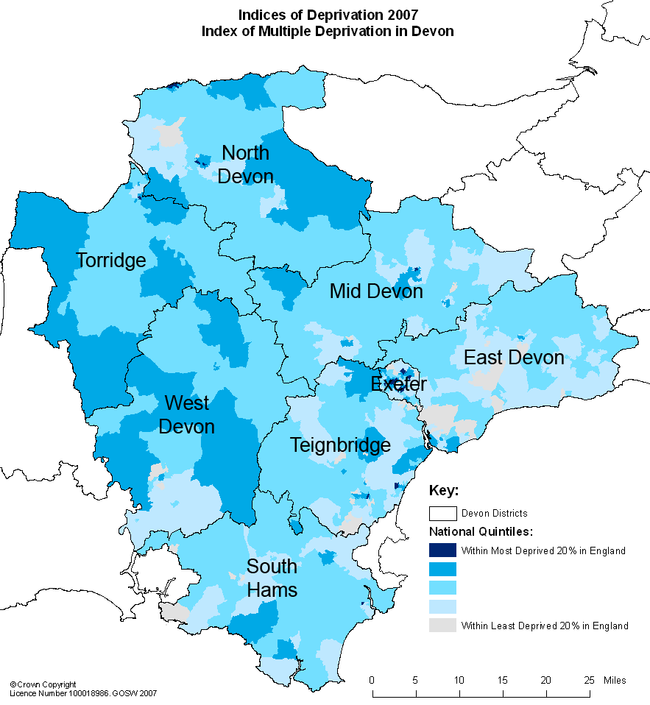

The most prevalent form of deprivation in Devon relates to barriers to housing and services, and the living environment, with geographical barriers to housing and services being particularly prominent i.e. travel distance to GPs, supermarkets, post office.

2.4 Care Programme Approach and ACS services

The NHS Mental Health Minimum Dataset shows the number of people who spent days on the Care Programme Approach during 2007/08. The CPA supports people with long term mental health needs, with those with more complex needs on the enhanced CPA and others on the standard CPA. The CPA provides the link to care management once an individual has been discharged from hospital.

During 2007/08 there were 16,080 people in contact with mental health services in Devon of which:
- 1,179 were on the enhanced CPA
- 1,332 were on the standard CPA
- 186 had no CPA and were admitted to hospital
- 1,292 had no CPA and were not admitted to hospital
- 12,091 had no CPA and no care needs

Adult Community Services data shows that 3,047 people with mental health problems were helped to live at home during 2007/08.

2.5 Mental health and older people

The most common mental health problems in older people are depression and dementia. The accommodation and supports needs of older people with mental health problems have been incorporated into the JSNA for Older Persons Housing and Support Services.

Depression affects proportionately more older people than any other demographic group. This is because older people face more events and situations that may trigger depression: physical illness, debilitating physical conditions, bereavement, poverty and isolation. The majority of people who have depression make a full recovery after appropriate treatment, and older people are just as responsive to treatment as younger people. Support services can help older people address some of the causes of depression such as social isolation, financial problems, or difficulties with their accommodation.

Dementia can be difficult to diagnose in the early stages: the person experiences small changes to their everyday functioning, for example in concentration, decision making and short-term memory. In the middle stages, the person becomes more confused and forgetful and in the late stages of dementia, a person may be unable to remember familiar faces and objects or to express themselves or understand what is being said to them. Older people with dementia can continue to live at home with support, but may need to move to specialist accommodation such as extra care housing.

Devon | 2008 | 2010 | 2015 | 2020
People aged 65 and over predicted to have depression lowest estimate | 16,060 | 16,850 | 19,490 | 23,740
People aged 65 and over predicted to have depression highest estimate | 24,090 | 25,275 | 29,235 | 32,610
People aged 65 and over predicated to have dementia | 12,054 | 12,488 | 13,970 | 16,036

2.6 Mental health, homelessness and drug and alcohol problems

It is important to point out that there is an overlap between homelessness and mental health, as a significant proportion of people who are homeless also have mental health problems. This JSNA includes some data on those who are homeless with mental health problems, but there is a larger group who are living in temporary accommodation, and have mental problems, on which only a limited amount of data is available.

There is also a close co-relation between mental health problems and drug and alcohol use. Many people who experience recurring homelessness can have dual diagnosis and some existing mental health accommodation based services have been identified as services that can potentially meet these needs.

2.7 Mental Health and Young People

Young People aged 16 to 25 experience profound changes that move them from the world of the child to the world of the adult. Research evidence shows that adolescent mental health is deteriorating in the UK over the past 25 years. Mental health services need to offer young people support who are struggling to achieve psychological maturity as well as those that are suffering from a severe, and potentially enduring, mental illness.

Dedicated services for young people are not universally available. The only statutory mental health service that is available for this age group is the Early Intervention Psychosis Team. For service users experiencing other forms of mental illness services for under 18s are provided by CAMHS (Child and Adolescent Mental Health Services) in many areas, but once an individual has moved to adult services the model is the same for service users across the entire age range 18-65.

2.8 Supporting People services

Access to decent housing, and establishing and maintaining independent living, is an important factor for people’s emotional well being. The Supporting People programme funds housing support services to enable vulnerable people to live more independently, either in accommodation based services or by providing support in their own homes (e.g. to prevent tenancy breakdown). In Devon the programme delivers 179 accommodation based units and 338 floating support units for people with mental health problems.

Devon County Council will be merging the funding for Supporting People and for Enabling Service to create a new budget for community based support services. These services will ensure a more integrated approach to providing support to vulnerable people to live independently.

Staffing levels

Many of the accommodation based units have a relatively intensive level of staffing compared with typical a Supporting People service, with over half providing each resident with 9 or more hours support per week. However, as these staffing levels do not deliver 24 hour cover they cannot be defined as high support services. The remaining accommodation based services provide low support services.

Floating support services can also provide quite an intensive level of support to service users, with about a third of services providing each user with 9 or more hours support per week.

Access to support services

Of the 370 people with mental health problems, who accessed Supporting People services during 2008/09, 51% (189) were on the Care Programme Approach and were therefore known to mental health professionals. In addition another 28 clients from other clients groups were on the CPA.

Prior to receiving support services most service users were living independently, either in social housing (32%) or private rented accommodation (13%) or owner occupied housing (6%). A significant proportion were living in temporary accommodation, either with family or friends (13%), in supported housing (12%) or other temporary accommodation. A smaller proportion had moved out of hospital (5%) and residential care (4%). Therefore, the picture shows a significant number living in their own homes needing support, with others living in insecure accommodation or moving out of institutional care.

The vast majority of referrals (55%) to housing support services came through the Community Mental Health Teams (or their equivalent in Devon). The remainder of referrals came from a number of different sources including voluntary organisations, the health service, Adult Community Services, self referrals and local housing authorities.

During 2008/09 about 70% of people with mental health problems accessed floating support services, with the other 30% accessing accommodation based services. Their profile shows that approximately 55% were male and 45% female, and 97% were of White British origin with 3% from another ethnic group.

Performance and Outcomes

Accommodation based services for mental health show a high level of utilisation at 96%, with floating support showing 110% utilisation (figures above 100% show the service is meeting the needs of more service users than it has been contracted for). This indicates a continuing demand for these types of services.

Supporting People services are monitored using National Indicators 141 and 142. For the most recent quarter the data shows that 80% of service users in short term mental health services had made a planned move to independent living, which is greater than that for comparator authorities (71%), and 97% had maintained independent living in long term services, compared to 98% for comparator authorities.

2.9 Residential care

The community care statistics for 2008 shown in the table below summarises the use of care homes for people with mental health problems by similar authorities in the South West per 100,000 of the population. The rate for Devon County Council is relatively high (at 38 per 100,000) when compared to other authorities in the South West. Each bar in the table shows the number of residential care placements made by each authority.

Council supported residents 18-64 years with mental health
problems. Rate per 100,000 of the population aged 18-64
75
170
25
55
55
0
5
10
15
20
25
30
35
40
Cornwall
Devon
Dorset
Gloucestershire
Somerset
Source: Community Care Statistics 2008

3. Accommodation and support needs

3.1 Introduction

This JSNA uses available data to establish an indication of the unmet accommodation and support needs of people with mental health problems across Devon. The approach adopted is based on a CLG model for estimating the housing and support needs of vulnerable people.

The model uses prevalence data to estimate number of people in Devon who have mental health problems and this has been defined as the ‘population at risk’. As only a small proportion of the population at risk will require accommodation and support services, needs data has been used from a number of sources to estimate the ‘population in need’. The unmet need is the number of people with mental health problems in need after the supply of accommodation and support services has been taken into account. The need for residential care has been calculated separately as the CLG model does not define this provision as a housing option.

The results of this approach and the data used are set out below. The supply data has been based on existing services rather than reconfigured services.

3.2 Population at risk

The population at risk of mental ill health has been based on the prevalence rates for different types of mental illness for the population aged 18-64, as shown in the table below.

District Council | Predicted to have depression | Predicted to have a neurotic disorder | Predicted to have a personality disorder | Predicted to have a psychotic disorder | Total
EDDC | 1,880 | 12,148 | 3,224 | 404 | 17,656
Exeter | 2,167 | 13,966 | 3,755 | 469 | 20,357
Mid Devon | 1,166 | 7,521 | 2,010 | 251 | 10,948
North Devon | 1,396 | 9,013 | 2,402 | 301 | 13,112
South Hams | 1,261 | 8,138 | 2,170 | 272 | 11,841
Teignbridge | 1,898 | 12,267 | 3,254 | 408 | 17,827
Torridge | 988 | 6,381 | 1,698 | 213 | 9,280
West Devon | 784 | 5,055 | 1,359 | 170 | 7,368

The population at risk is quite significant as the prevalence rates for mental ill health are quite high. Not all those within in the population at risk will require accommodation or support services, as many will be adequately accommodated and may receive support from a number of different sources. The population at risk simply identifies the number of people who are anticipated to experience mental health problems, some of whom may need accommodation and support.

The above figures do not include people who are over aged 65 and over, as this group has been included within the JSNA for Older Persons Housing and Support services and the Extra Care Housing commissioning strategy. As there is an interface between accommodation and support services for older people and services for people with mental health problems, the table below provides an indication of the number of older people with mental health problems in the next age band.

District Council | Predicted to have mental health problems (aged 65-69)
EDDC | 1485
Exeter | 742
Mid Devon | 693
North Devon | 907
South Hams | 825
Teignbridge | 1221
Torridge | 709
West Devon | 528

3.3 Population in need

The population in need of accommodation and support is drawn from a number of sources which are:

- Devon Partnership NHS Trust - Number of people with mental health problems who are ready to move out of residential care with appropriate support;
- Devon Partnership NHS Trust - Number of people with mental health problems who could be prevented from moving into residential care;
- P1E data (annual) - Number of people with mental health problems who are homeless and accepted as in priority need by each housing authority;
- SP Client Record System (CRS) – Number of people with mental problems who were rough sleepers, or living in temporary accommodation, or moved out of hospital and accessed SP services (averaged over 2 years); the number who accessed floating support services (averaged over 2 years);
- Care First6 data on those living in care homes and those in receipt of enabling services.
- Strategic Housing Market Assessments – data from the household survey showing the number of people with mental health problems who live in independent housing and who experience housing problems.

Of the 192 clients living in residential care homes it has been estimated that about 110 need to remain there for the foreseeable future, 50 where move on is possible and 32 who are ready for move on (17%). The analysis of the Care First6 system shows that there are 161 living in residential care homes in the county of Devon, with remainder placed in other authorities (see Appendix 2).

New placements in residential care homes are mainly made under Section 117, with a lot of individuals having associated drug and alcohol problems or aspergers syndrome. There are about 30 placements into residential care homes each year, of which about 50% could be placed in high support housing if this were available.

During 2007/08 107 people were formally detained in hospital under the Mental Health Act in Devon and 288 informally. This is a substantial reduction compared to 2006/07 figures (477 and 1,007 respectively). The Crisis Resolution Teams work towards minimising the length of stay in hospital and can also prevent hospital admissions. The Supporting People CRS data shows that 23 people per year (on average) received support services immediately following hospital discharge.

The number of people living in temporary accommodation who need support is based on CRS data (128) and likely to be an underestimate; however no other robust was available for the JSNA. The number of rough sleepers with mental health problems (16) has been apportioned between North Devon and Exeter as these areas have the most significant numbers.

There is a significant number of people with mental health problems living in independent housing, who need access to floating support services to sustain their accommodation, or who may require accommodation based services. Most of these individuals will be in contact with secondary mental health services. This need is difficult to quantify and has been estimated as follows:

- The SHMA household survey reported that about 1% of the population living in independent housing had a long term mental problems (this works out to about 4,512 people in Devon aged 18-64, and does not include those living in residential care homes, accommodation based support services, rehabilitation units or detained in hospital).

  - As the SHMA shows that 16% of population live in unsuitable housing (because of overcrowding, mortgage problems, needing support, disrepair, harassment etc) we have applied this percentage to the figure of 4,512 to obtain an indication of those with long term mental health problems that may require support with their housing (721). Only some of these individuals receive support services.

  - CRS data and Care First6 data shows the number of people living in independent housing who accessed enabling or floating support services during 08/09. Most of these individuals needed support with daily living skills to live independently – some may have had housing problems (and therefore overlapped with group above). The Care First data shows that 115 people in Devon received enabling services and this has been abated to 98 people to take account of the overlap with SP. The CRS data and Care First data shows a total of 652 people with mental health problems were in need and received enabling or floating support services during 08/09 (this figure takes account of the turnover for floating support services during the year).

Using the SHMA calculation it is also estimated that about 70 people with mental heath problems, aged 65 to 69 and who are living in independent housing, need floating support services (not including those with dementia).

The table below shows the estimated annual need for accommodation and support services based on the needs analysis (the SHMA data has been apportioned to the districts on the basis of the population aged 18-64).

District Council | Diverted from residential care | Ready to move from residential care homes | Statutorily homeless – mental health | Number living in independent housing who received enabling or support during the year | Number living in independent housing who need support with housing problems | Living in temporary accommodation or moved out of hospital and need support | Rough sleepers with mental health problems | Total
EDDC | 1 | 2 | 4 | 71 | 112 | 25 | 0 | 215
Exeter | 5 | 12 | 11 | 181 | 130 | 29 | 10 | 378
Mid Devon | 1 | 3 | 3 | 58 | 69 | 15 | 0 | 149
North Devon | 4 | 4 | 5 | 155 | 84 | 19 | 6 | 277
South Hams | 1 | 1 | 1 | 28 | 75 | 17 | 0 | 123
Teignbridge | 2 | 6 | 2 | 56 | 113 | 25 | 0 | 204
Torridge | 1 | 2 | 2 | 54 | 59 | 13 | 0 | 131
West Devon | 1 | 1 | 6 | 49 | 79 | 18 | 0 | 154

3.4 Supply

The current supply of housing support services funded by Supporting People is shown in the table below. This shows 179 accommodation based units and 338 floating support units across Devon. The cross authority units have been apportioned across the districts partly on the basis of their service remit and partly on a per head of population basis.

District Council | Accom Based | Floating Support | Cross Auth FS | Enabling  Contracts | Sub total FS & En | Total
EDDC | 11 | 14 | 20 | 9 | 43 | 54
Exeter | 82 | 52 | 53 | 14 | 119 | 201
Mid Devon | 9 | 0 | 29 | 4 | 33 | 42
North Devon | 48 | 68 | 19 | 22 | 109 | 157
South Hams | 15 | 0 | 12 | 8 | 20 | 35
Teignbridge | 14 | 0 | 24 | 12 | 36 | 50
Torridge | 0 | 0 | 17 | 23 | 40 | 40
West Devon | 0 | 28 | 2 | 6 | 36 | 36

Devon Partnership NHS Trust has funded enabling contracts to delivery non-personal social care services to individuals subject to the Care Programme Approach – these services are similar to Supporting People support services and have been included within the analysis of supply. Enabling contracts fund services such as support to improve daily living skills and are subject to a needs and financial assessment. As an individual can receive an enabling service as well as an SP service, the supply of enabling services has been abated to take account of this overlap (based on data supplied by DCC).

In addition there are six people who have been placed in SWAPS (South West Adult Placement Service. These placements have been treated as cross authority services in the model.

  - Unmet Needs

To calculate unmet needs, the data on needs has been adjusted to take account of the following:

- Service balance – the model defines the balance of need between accommodation based and floating support services. It has been assumed that most people with mental health problems require floating support with only 10% requiring accommodation based services – this assumption is underpinned by the proposed accommodation and support strategy and is supported by research which shows that most people prefer to receive support services in their own homes.
- Deflation factor – it is clear that there is some overlap in the data on needs, particularly between those in receipt of enabling and/or support living in independent accommodation and those in independent accommodation who require services. A deflation factor of 25% has been applied
- Utilisation – utilisation levels have an impact on capacity and current utilisation figures have been included;
- Turnover – the model includes current turnover levels;
- Cross authority adjustment – the model includes inward and outward migration figures of people with mental health problems accessing housing and support services in Devon. 98% of referrals are host (i.e. from Devon).

The analysis that results is shown for each district council. The figures in brackets show a shortfall in supply and the figures without brackets show an oversupply (based on the assumption that only 10% of those in need require accommodation based services).

 | Net Need (under)/over supply
District Council | Accom Based | Floating support/ enabling services
EDDC | 1 | (63)
Exeter | 60 | (68)
Mid Devon | - | (41)
North Devon | 32 | (28)
South Hams | 8 | (40)
Teignbridge | 2 | (65)
Torridge | (8) | (25)
West Devon | (9) | (40)

It is more useful to analysis the (under)/over supply by network area to avoid any distortions that may have resulted by apportioning cross authority floating support services to each district. This is shown in the table below:

 | Net Need (under)/over supply
Network area |  | Accom  Based | Floating support/enabling | Net (under)/over supply*
Exeter, East and mid Devon |  | 61 | (172) | (111)
North |  | 24 | (53) | (29)
Teign, South Hams and West Devon |  | 1 | (145) | (144)
* this table does not take account of the six units of Adult Placements

The data on the population at risk, population in need and supply of housing support services can be used to project unmet needs, taking into account the growth in the non elderly adult population. The projections for the whole Devon are shown below for the period up to 2015 (the model can make projections to 2026).

The model shows an over supply of accommodation based services and an under supply of floating support services, as the existing supply profile has been incorporated into the model. Should these services become reconfigured, with accommodation based services being re-modelled as floating support, then the under and oversupply figures will change (see Page 19 to view the impact of reconfiguring these services).

The model shows that the overall need is greater than the supply of services. As the population in need increases, in line with the overall increase in the population at risk, then the shortfall in supply also increases.

3.6 The need for residential care

It is clear from the needs analysis that there will be a continuing need for residential care in the future. There are currently 192 people living in care homes of which 33 could step down to high support accommodation.

Therefore, based on the assumption that the population in residential care could reduce by 17% each year, the reductions would be as follows:

 | Numbers moved of out residential care p.a.
2010 | 33
2011 | 27
2012 | 23
2013 | 18
2014 | 16

However, any reduction in the use of care homes needs to be offset by new admissions to care homes by the panel. Also, there is a projected increase in the population at risk and this is likely to result in slightly more people being referred to the panel over time. The net effect is shown in the table below.

 | Estimated numbers in residential care
2010 | 174
2011 | 159
2012 | 146
2013 | 137
2014 | 129

The critical factor in achieving the reduction in the use of care homes is to have sufficient capacity within high support accommodation based services to enable people to move out of residential care and to allow the panel to divert individuals to this type of provision.

4. Strategic approach to meeting accommodation and support needs

4.1 Introduction

The strategic vision for mental health services is to promote accommodation and support services which are based on the principles of recovery, prevention, early intervention, social inclusion and personalisation. To achieve this vision Devon will develop accommodation and support services which:

- Support people disadvantaged by the social and economic effects of mental health problems to achieve and maintain good quality accommodation as an essential precondition of personal wellbeing. This will include home ownership and rental within secure tenancies. This support will comprise:

- Access to information and advice in relation to accommodation only and accommodation and support;
- Community based support services focused on recovery.

  - Recognise that some people will require extended periods of intensive support. This may be a consequence of the severity of the experience of mental health problems or a feature of transition from longer term hospitalisation or care in a higher support environment. This support will comprise:

- High support designated accommodation, available for periods up to 2 years on a licence agreement
- High support accommodation which is able to support transition between care environments through the provision of respite care and support.

  - Support people with mental health problems and their families in times of crisis or increased distress. The aim will be to respond to personal choice and circumstances by providing alternatives to the disruptive impact of hospitalisation where this can be avoided. This will also reduce the risk of loss of accommodation at such times of distress. This support will comprise:

- Community based mental health services able to respond in a timely way by increasing support throughout the 24 hour period.
- Support provided in the person’s home by specialist mental health services working in collaboration with community based support providers.
- The ready availability of short term respite accommodation provided across the range of provision. This will include planned and short-notice respite provision in accommodation based support schemes, residential and nursing home care.
- The availability of respite accommodation and support attached to established ‘communities of support’ such as peer support networks and commissioned community network services.
- Accommodation only respite to provide short breaks for people with mental health problems and their supporters.

- Support people who need extended periods of intensive support in a specialist environment. This support should have inbuilt capacity to maintain contact and offer respite after discharge. It will include:

- Residential care based recovery for periods usually up to 24 months;
- Residential care based recovery on a longer term for people who need this option;
- Residential nursing care and recovery.

The intention of this approach is that fewer people will be in longer term residential care, short term residential care will level out and potentially reduce and that there will be an increase of people with mental health problems living in independent social and private rented housing with community based support and respite provision.

The response from the consultation events generally supported this strategic approach and considered that this approach was already beginning to happen. The events considered that good communication was the key to the success of the strategy, both between agencies as well as between agencies and individuals who use the services.

4.2 Proposed approach to accommodation and support in Devon

The proposed approach to accommodation and support involves a core and cluster approach within each network area. The core will involve the development of intensively staffed accommodation based services and the cluster will involve the provision of community based floating support, both for those who move on from accommodation based services as well as people who have less complex mental health problems.

Core services

The purpose of the core accommodation services is to meet the needs of those with complex mental health problems and to divert them from moving into residential care. The core accommodation based services will also help individuals currently living in residential care to step down from this type of provision.

The core accommodation based services are intended to provide short term highly intensive supported accommodation to enable people with mental health problems to recover and move onto a more independent setting.

These services are intended to provide on site staffing cover that is more intensive than that provided by existing accommodation based services. The intention is that each individual will have their own package of services according to their assessed needs, to supplement the core services provided by the high support accommodation. This would include access to specialist mental health advice from health care professionals.

One of the challenges has been to identify suitable properties in which to locate the core accommodation based services. The intention is to have core services in each network area in Devon, accommodating a total of 40 service users.

There are issues with the size and design of the properties that have potentially been identified for the core services, as they need to be as self-contained as possible and accommodate about 10 service users each. Furthermore, there are issues of coverage as no suitable core service has been identified for the south and west of Devon.

Cluster services

The intention is remodel all other accommodation based services as community based floating support services, as well as retain the existing community based floating support services. This approach will provide a much stronger emphasis on recovery and moving towards independence. It will also mean that the capacity of community based floating support services will be increased so that more people can receive support in their own homes, potentially preventing tenancy breakdown and loss of accommodation.

There will be a number of characteristics to the community based floating support services including:
- some services will need to provide long term support as a small proportion of individuals may require this support on a regular basis over a long period of time;
- some services will need to provide very intensive support, particularly for those that step down from the high support accommodation based services.
- all services will need to have inbuilt flexibility to respond to changing need

The intention is to combine Supporting People services and enabling services into a single budget to provide community based support services – this will involve an integrated contract with providers. Participants in the consultation exercise felt that floating support should provide a more holistic service and that integrated contracts may address this concern.

Remodelling proposals

The current remodelling proposals are set out in the table below. Enabling services are included as the intention is to integrate these with floating support services.

Network area | Local authority | Dual Diag | Accom  Based* | Floating Support | Cross Auth FS | Enabl  ing** | Total  FS &  Enab
Exeter, East and mid Devon | EDDC |  |  | 25 short | 29 | 9
 | Exeter | 14 | 20 | 103 short | 33 | 14 | 235
 | Mid Devon |  |  | 0 | 18 | 4
North | North Devon | 23 | 10 | 67 short  8 long | 21 | 22 | 156
 | Torridge |  |  | 0 | 15 | 23
Teign, South Hams and West Devon | South Hams |  |  | 1 short  14 long | 19 | 8
 | Teignbridge |  | 10 | 14 short | 29 | 12 | 142
 | West Devon |  |  | 19 short  8 long | 12 | 6
* The number of proposed units is based on the proposed strategy
** Enabling service agreements have been abated where they are provided together with FS

The proposals shown in the table have emerged from an analysis of the current services to assess the extent to which they could be reconfigured to meet the proposed strategy. An accommodation based service in North Devon, and another in Exeter, have been identified as potentially suitable for integrated contracts to deliver services to people with dual diagnosis – these services are shown in a separate column in the table.

A number of remodelling options are currently being considered to deliver the core accommodation services in each network area. It is proposed that there will be three core accommodation services, one within each of the three network areas. The intention is that there will be 20 units in Exeter (in two separate properties), 10 units in North Devon and 10 units in South Devon.

There are a number of risks associated with moving from accommodation based services to floating support services. In particular the existing accommodation may no longer be available to meet the future housing needs of this client group – these risks are explored in 4.4. to 4.6.

4.3 Impact of the proposed strategy on projected needs

The proposed accommodation and support strategy is likely to have a considerable impact on meeting the needs identified. This is because there will be a much greater throughput of service users, both for accommodation based services as well as the community based floating support services. This throughput will increase the capacity of services to meet unmet needs.

The projections below show how this approach could impact on the unmet need for community based support services.

The table shows that by reconfiguring most of the existing accommodation based services as community based floating support, it is possible to meet the need for high support accommodation as well as deliver a greater volume of community based floating support services. Overall there is no actual increase in the supply of services, simply a remodelling from one type of service to another.

The real impact on meeting needs results from increasing the throughput of service users through the high support accommodation services onto community based support services. The projections in the table assume an average length of stay in the core accommodation services of 9 months. Should the average length of stay be longer then the supply of core accommodation based services would need to increase.

The combination of greater efficiencies, by creating a clearer pathway to independence, and increasing the capacity of community based support services, will reduce the overall level need (as people are moving through the services faster). Despite these changes the table shows that there is still likely to be a shortfall in meeting the need for community based support services.

As the population at risk is projected to increase, with no increase in supply, the shortfall will become greater over time. One potential option to address this shortfall is to invest any savings from the reduction in the use of residential care to increase the capacity of community based support services.

  - Key Issues

A number of key issues have arisen as a result of the strategic proposals and these need to be addressed. These are as follows:

- Identifying suitable core services and their capacity

Although a number of potential core services have been identified they are not necessarily fit for purpose (see design requirements below). Either these services need to be remodelled or other accommodation needs to be obtained. However, any new housing scheme will take time to develop and may encounter planning problems – therefore using existing accommodation may be more appropriate. Also a core accommodation based service for the south of the county needs to be identified.

It is estimated that core services will be need to accommodate about 47 people annually to divert people from residential care and to provide a step down from residential care. Assuming that on average residents will stay for 10 months (some shorter and some longer) then 40 units of accommodation will be sufficient. However, if the average stay is a year then 47 units will be needed. The table below shows the relationship between length of stay, number of service users and capacity.

Number of service users pa | Average length of stay | Number of units required
40 | 12 | 40
47 | 10 | 40
47 | 15 | 59
54 | 15 | 81
The numbers will increase slightly as the population increases, however over time the number needing to step down from residential care will decrease as the residential care population diminishes.

Some concerns were raised by participants in the consultation events about the conflict between moving people on and the need to support people in choosing their own pace and path to recovery.

  - Designing accommodation based services that are suitable

The design of accommodation based services is an essential component in helping people recover. The evidence shows that people with mental health problems do not like living in large institutions and prefer smaller domestic environments. Therefore an outline design brief for a remodelled, or new, accommodation based service, is as follows:
- Shared units (or each cluster flat) no larger than 5 bedspaces;
- Each unit (cluster flat) to have its own living room, bathroom and kitchen area;
- The maximum number of bedspaces in each accommodation based scheme to be no more than a total of 10-12;
- Communal areas in each accommodation scheme to enable residents to meet and an area for food preparation.

  - 24 hour cover

The current proposals involve day time cover being provided to residents with each receiving an individual package of support, where they have more intense needs. Some of the existing services are quite intensively staffed while others are not; however no services provide 24 hour cover.

As the proposed strategy is dependent on core accommodation based services providing an alternative to residential care, it is essential to have a debate about whether or not 24 hour cover is required. This could simply involve support staff being ‘on call’ in case of an emergency, or it could involve a member of staff ‘sleeping in’ each night.

  - Medium support accommodation based services

There has been some discussion about whether there is a need for medium support accommodation based services, to enable people to step down from higher support accommodation based services. It has been concluded that this ‘step down’ could be provided more effectively using intensive community based support services for individuals moving into their own accommodation.

- Tenure

Tenure is an important factor in moving from accommodation based services to community based support services. Where an accommodation based service has granted residents Assured Periodic Tenancies, and the support charge is included in the tenancy agreement, then this funding would need to be separated out. This process will require consultation with the tenants, with the support element moved into a community based support contract. The residents would continue to remain in the accommodation and receive community based support, determined by a needs assessment. Where an individual has been granted an Assured Shorthold Tenancy then it is unlikely that the support element is part of the tenancy agreement.

- Integrated services

The participants in the consultation events considered that the success of the strategy is dependant on fully integrated, responsive and flexible services, which generally were thought not to exist. In particular doubt was expressed about mental health services being in a position to provide a rapid response, leaving a gap between community based support services and specialist mental health services. These issues, therefore, needs to be addressed as part of the process of change.

- Short term needs

The consultation events raised the issue of the need to address the requirement for respite and crisis provision. Some participants were concerned that the proposed reduction in residential care might make it difficult to respond to short term needs, leaving a gap between hospital and home. Devon Partnership Trust is currently looking at a range of options around respite.

4.5 Access into independent accommodation

The vision for the future is one where the core accommodation based services are freed up by moving people onto independent housing options. District Councils will have a role to play, however there is insufficient social housing to meet all the move on needs. Access to the private rented sector will be crucial to ensure that individuals can move on from core services, as well as those who need to move on from other services e.g. the rehab units.

Two accommodation officers have been appointed to increase access to move on accommodation in two network areas, with these posts employed by Devon Partnership NHS Trust. Exeter, Mid and East Devon have a long standing part time accommodation officer post employed by DCC. This is now supplemented by a contract with Community Action Aid to provide a full time role for this network area. These officers have an essential role in making referrals to housing and support services, obtaining accommodation from private sector landlords and having a focus on moving people out of residential care or accommodation based support services that they no longer require.

Other sources of private sector accommodation may need to be explored including the use of rent deposit schemes. The future success of the strategy will depend on the ability to obtain access to private sector accommodation, so that community based support services can be linked to individuals to help them sustain their tenancies.

The consultation events highlighted that more dispersed accommodation might mean increased isolation for individuals. The need for shared flats was highlighted, where individuals can provide mutual support.

4.6 Use of existing accommodation

The proposed strategy involves breaking the link between accommodation and support for a number of existing accommodation based services and remodelling these services as floating support.

It will be essential to retain the use of existing accommodation for people with mental health problems as this is an important housing resource. Where the accommodation is owned by an RSL it can be treated as ‘designated housing’ as it has been specifically funded for this client group. There may need to be a ‘support agreement’ between the RSL and the support provider, whereby the support provider agrees to provide community based support to individuals who are accommodated in this provision and who are assessed as requiring support. This would almost make this arrangement akin to a ‘supported living’ scheme, whereby the support would not be tied to the accommodation.

To make effective use of existing accommodation there are a number of issues to resolve. First, some of the accommodation is likely to be unpopular and may result in high voids where support is no longer linked to the bricks and mortar. The remedy to this problem is either for the landlord to improve/remodel the accommodation, or for the accommodation to be used for another client group. Second, RSLs may not wish to carry out the housing management functions involved with this accommodation (as these functions would be more specialist and time consuming than those required for general needs housing) – if this is the case then a specialist managing agent may need to be sought. Third, where the accommodation is owned by a private landlord they may withdraw the accommodation if the support is no longer linked to the building (and they are no longer the support provider).

Therefore, the negotiations in relation to retaining the accommodation will need to be carried out on a scheme by scheme basis. There will a number of options that will need to be considered for each scheme – for instance where a specialist RSL owns the property and provides the support service, it may be able to separate the housing management and support functions internally and provide these services separately.

4.7 Pathways into and through services

Currently there is a care pathway for people with mental health problems who move through the services provided by the Community Care Trust. Following an initial assessment an individual can receive care services in the community or move into one of the specialist residential units. These individuals can move in and out of these services based on a self directed approach. The community mental health services can be accessed on a 24 hour basis. This pathway is based on a recovery approach and helps individuals towards independence. Individuals who move out of the core accommodation services will be able to access these community mental health services.

The community mental health services provided by the Community Care Trust can also link people into other specialist services, including the accommodation officers and/or community based support services (i.e. floating support). Some individuals need advice and support with their housing and/or help with obtaining accommodation; however 77% of their clients (a total of 477 people over 15 months) live in secure independent accommodation and receive much of their support through the community mental health services provided.

It is clear that there are currently multiple access routes to accommodation and support services, as individuals may be referred from district councils, the panel, the Community Care Trust, specialist rehab units etc. It may be necessary to restrict access to the core services so that they can focus on preventing residential care or stepping down from residential care. However, the community based support services may need to continue receive referrals from a number of referral sources to respond quickly to tenancy breakdown, as well as support those that move on from the core services. There is a question about whether these referrals should be co-ordinated through a single point and, if so, what that single point should involve – this issue is currently being considered by Devon Supporting People Team.

4.8 Self directed support

The care and support packages that will be developed for individuals that move into the core accommodation services will be tailored to meet their assessed needs. The resources to deliver these packages will include Supporting People funding, enabling funding, transformation grant and a health input. The core accommodation services will need to be commissioned under a contract with a provider as they will be providing short term services. However, it is envisaged that there will be considerable scope for users to define their needs and have tailored services, as well as be supported to access other services (e.g. education, training, leisure etc).

The intention is to continue to commission short term community based support services from providers to enable a flexible response, based on person centred planning principles. However, where service users are eligible for social care services, under FACS, they will be able to access a direct payment to purchase the care services they need. Potentially service users that require longer term community based support services could receive a direct payment, as part of a personal budget, to purchase these services. This approach would need to be underpinned by a single assessment process that incorporates a community based support assessment that is linked to an integrated resource allocation system.

4.9 Reduction in the use of residential care

The proposed changes will have an impact on the need for residential care for the 18-64 group. As the prevention approach begins to have an impact there will be less placements required in residential care. The aim of the strategy is to bring the use of residential down to a level of less than 20 places per 100,000 of the population aged 18-64 – this would bring the use of long term residential care in Devon down to about 90 places.

5. Financial and commissioning implications

  - Introduction

The financial context for the Supporting People programme is changing with the removal of the ring fence from April 2010 and the integration of the programme into Area Based Grants. Furthermore, there are a number of financial considerations in relation to the introduction of the proposed accommodation and support strategy. These are largely related to revenue funding; however there are implications for capital funding where accommodation needs to be remodelled.

There are also issues related to the detailed commissioning and procurement of these services to align them with the proposed strategy. These issues are currently being considered by Devon County Council.

  - Strategic Financial Issues

The estimated full year SP grant expenditure for mental health for 2009-10, based on current contract commitments and allowing for a DCC inflationary increase is:

 | 2009-10
Mental Health | £3,125,682

In the financial year 2009-10 the SP programme grant was classified as a ‘non-ring fenced’ specific grant. However from April 2010 the Supporting People grant forms part of the Area Based Grant, which will give the authority greater freedom about how the funding can be used.

As the grant for the SP programme is reducing in real terms each year, the Joint Commissioning Body took a decision in 2009 to identify efficiencies across the programme. This will involve a guaranteed and a non-guaranteed amount for service providers. The potential savings, or non-guaranteed amount, is estimated as follows for the next two financial years:

 | 2010-11 | 2011-12
Mental Health | £108,470 | £150,861

There are a number of factors that are unknown at this stage, including the future level of the Devon Supporting People grant based on the Supporting People Distribution Formula and the outcome of the next 3 year Comprehensive Spending Review.

The contracts for enabling services were about £792,457 for 2009/10 and could potentially increase should savings to the residential care budget be generated by the proposed strategy. The intention is to combine SP and enabling funding into a single budget for community based support services. A governance structure will need to be developed for these contracts to ensure accountability for the commissioning of these services and to introduce a robust auditing process for monitoring the quality and outcomes of the services.
5.3 Benchmarking Spend

A benchmarking exercise was carried out using SP spend data from a number of neighbouring county authorities in the South West to understand how Devon’s mental health housing support budget compares.

The table below shows an analysis of the SP budget from mental health in each authority, first by the number of household units and then per 1,000 of the population aged 18-64.

County | SP Budget 08/09  £ | Cost per unit  £ | Budget per 1,000 population 18-64.  £ | Number of units per 100,000 18-64
Cornwall | 1,852,455 | 167 | 5,762 | 66.25
Devon | 3,061,084 | 114 | 6,771 | 114.36
Dorset | 1,141,362 | 151 | 4,997 | 63.49
Gloucestershire | 2,786,543 | 226 | 7,821 | 66.52
Somerset | 2,704,699 | 200 | 8,714 | 83.76

The table shows that Devon’s budget for housing support services for people with mental health problems is about average, when compared with other similar authorities on a per head of population basis. However, the number of units delivered in Devon (per 100,000 of the population) is much greater than any of the comparator authorities. The higher unit costs of other authorities are difficult to explain, using this analysis, and could be the result of providers charging higher rates, or because the provision is much more intensively staffed, or both.

5.4 Re-Modelling

Funding of £360,000, recurring for three years, has been earmarked by Devon Partnership NHS Trust to provide pump priming funding to move people out of, and provide an alternative to, residential care. This funding will be invested in providing high support accommodation based services to increase the level of staffing and to link staff with specialist clinical advice from a health professional. The funding has been made available through central government transformation grant for the personalisation agenda.

There is a question about where the on-going funding will come from for meeting the costs of the high support accommodation based services. Apart from existing SP funding for these services, the only other source of funding will be the savings as a result of reducing the use of residential care. If these savings are to be used to jointly fund these services then an integrated contract would be required between Devon County Council and the provider.

5.5 Capital funding implications

There may be capital funding implications for remodelling the accommodation element of the ‘core’ services.

Where a property is owned by an RSL then potentially a combination of capital funding from the Homes and Communities Agency (HCA) and private finance can be used to remodel a property to make it fit for purpose. The RSL would need to bid for the funding from the HCA and contain the loan repayments within their existing rental income stream. Where the provider is a private landlord then potentially they could source a suitable property on the open market.

Where a new scheme needs to be developed, as a new build or rehabilitated property, then the county will need to work with the district council in supporting an RSL bid for capital funding for a new development. The development would need to obtain planning consent, which may generate local opposition. The timescales for a developing a new scheme could take up to 2 years (and sometimes longer).

5.6 Commissioning and Procurement

This JSNA proposes a strategic direction of travel for the future commissioning of accommodation and support services for people with mental health problems. The detailed commissioning plans, and the approach to the procurement of these services, will need to be developed by DCC, in consultation with relevant partners, once the JSNA has been finalised.

Where services are funded by both Supporting People and by Adult Social Care integrated contracts may be the most efficient way in which to procure these services from a single budget for community based support services. Devon County Council has already developed integrated contracts for other services as this approach simplifies the level of monitoring required and reduces the number of financial transactions. Again the use of integrated contracts will be the subject of the more detailed commissioning plans.

Appendix 1
Detailed deprivation maps

The maps below provide a greater level of detail of the most deprived districts.
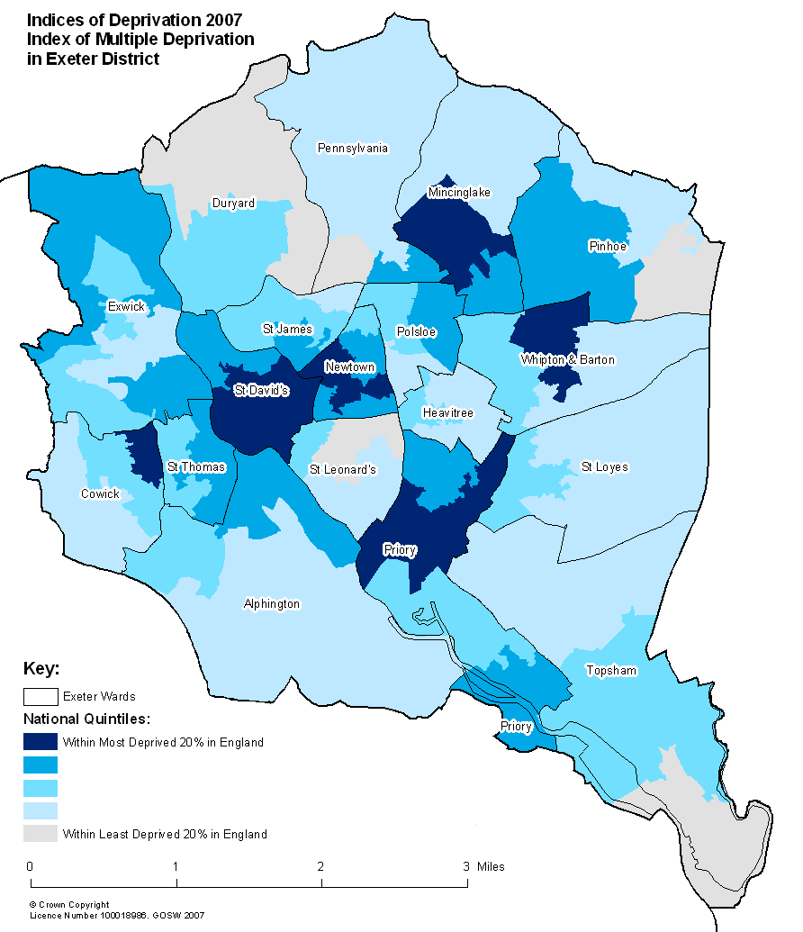
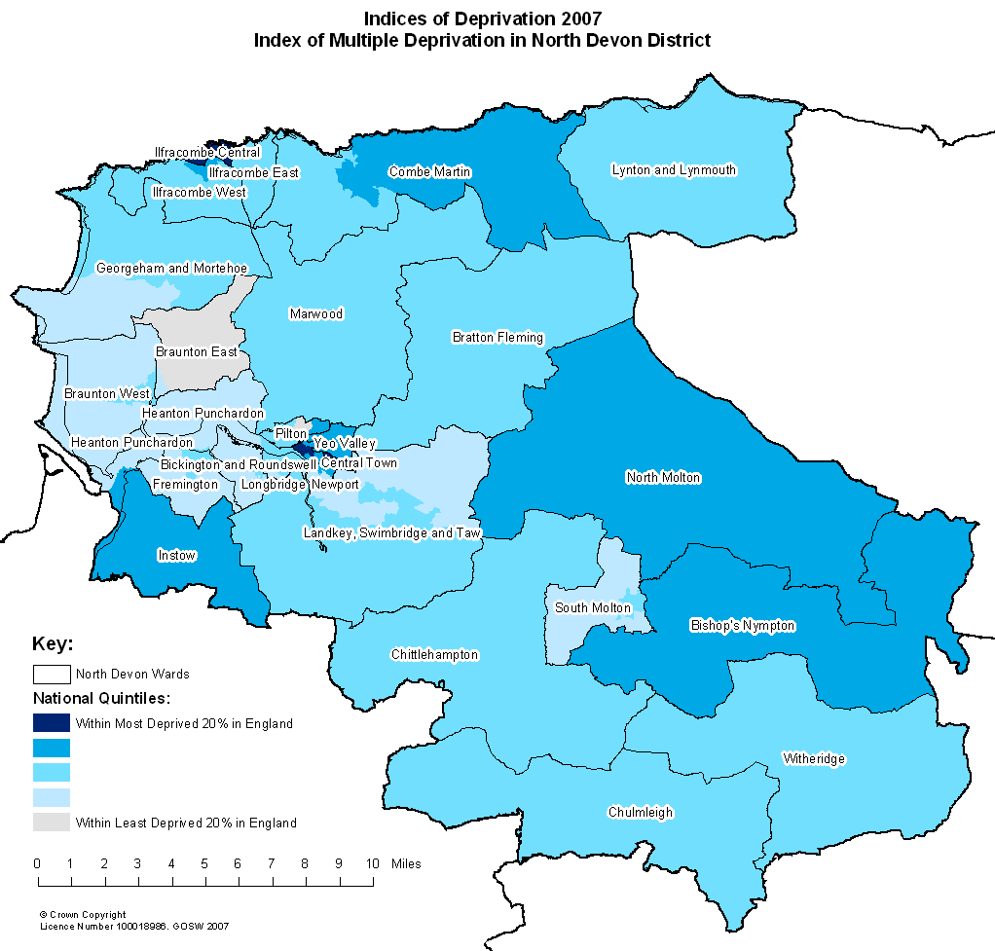

Appendix 2

Extract from Care First6 – Care Homes and Enabling Services for people aged 18-64 supported by the local authority during 2008/09

District | Market town | Res care | Enabling
Teignbridge | Ashburton/Buckfastleigh
East Devon | Axminster |  | 1
North Devon | Barnstaple | 13 | 15
Torridge | Bideford Northam | 9 | 20
North Devon | Braunton |  | 1
Mid Devon | Crediton | 1 | 3
Mid Devon | Cullompton | 6
South Hams | Dartmouth |  | 3
Teignbridge | Dawlish | 15 | 3
Exeter | Exeter | 72 | 21
East Devon | Exmouth | 2 | 8
Torridge | Great Torringdon |  | 3
Torridge | Holsworthy | 2 | 2
East Devon | Honiton | 4
North Devon | Ilfracombe | 6 | 9
South Hams | Ivybridge |  | 1
South Hams | Kingsbridge | 1
North Devon | Lynton Lynmouth
Teignbridge | Mortonhampstead
Teignbridge | Newton Abbott | 12 | 9
West Devon | Okehampton | 3 | 2
East Devon | Ottery St Mary
East Devon | Seaton | 1
East Devon | Sidmouth
North Devon | South Molton |  | 1
West Devon | Tavistock |  | 5
Teignbridge | Teignmouth | 2
Mid Devon | Tiverton | 9 | 1
South Hams | Totnes | 3 | 5
 | Plymouth | 2 | 1
 | Torquay | 9 | 1
 | Paignton | 6
 | Out of county | 14
 |  | 192 | 115

PANSI data
PANSI data
Each person is only counted once
Social Services Performance Assessment: Adults 2007-08
POPPI data
A unit is a bedspace in an accommodation based service or a floating support placement
CLG – Impact on the need for Supporting People services arising from population growth (to be published)
The Exeter and Torbay SHMA (covering Exeter, East Devon, Mid Devon and Teignbridge) provided the most detailed information on these needs and the findings have been applied to the whole of Devon
Respite residential care is not included in these figures
NHS Information Centre – National Minimum dataset
Care First6 extract for 2008/09 showing those aged 18-64 who received enabling services during the year
Existing accommodation based services identified for remodelling/replacement: 26 units in Exeter and 18 in North Devon
The table includes the supply of dual diagnosis accommodation based services as well as the 40 core accommodation units.
The average length of stay will need to be slightly reduced to take account of the fact that the utilisation levels will be under 100% due to voids.

