

Children’s Trust

Children and Young People Needs Assessment

2010

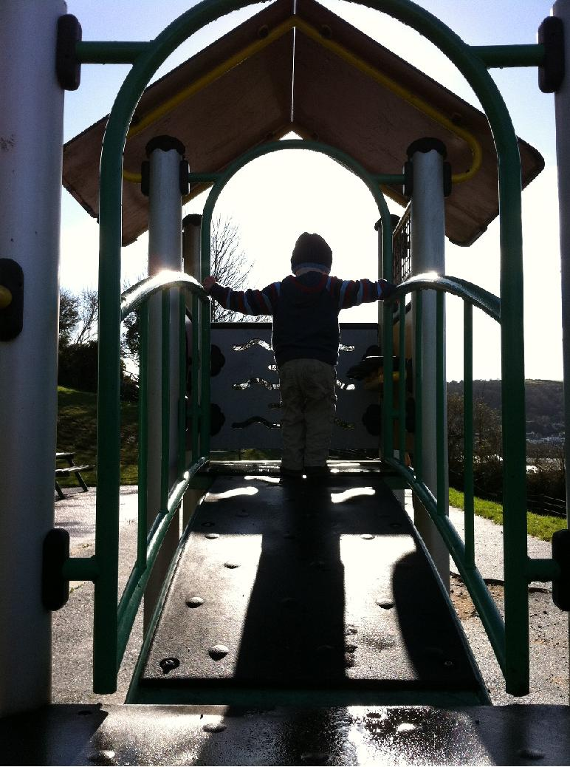

VERSION 2



Contents:

1 Foreword 5
2 Introduction 6
3 Key Findings 8
Level One – Universal 10
4 Demographics 10
4.1 Population 10
4.2 Services 10
4.3 Pupil Characteristics 12
4.4 English as an Additional Language 13
4.5 Ethnicity 14
4.6 Distinct Ethnic Groups – Roma, Gypsy and Travellers 16
4.7 Gay Lesbian Bi-Sexual and Transgender (GLBT) 16
5 Be Healthy 17
5.1 Life Expectancy at Birth 17
5.2 Morbidity Prevalence 18
5.3 Low Birth Weight 18
5.4 Infant mortality 19
5.5 Parental Smoking and Smoking during Pregnancy 19
5.6 Breastfeeding 20
5.7 Childhood Immunisations 21
5.8 Sexual Health - Chlamydia 22
5.9 Child Healthy Weight 23
6 Achieve Economic Wellbeing 24
6.1 Mosaic Profiles 24
6.2 Average Household Income 25
6.3 Average House Prices 25
6.4 Index of Multiple Deprivation 26
6.5 Income Deprivation Affecting Children Index (IDACI) 27
6.6 Children Living in Poverty 29
6.7 Child Wellbeing Index 32
6.8 Fuel Poverty 34
7 Stay Safe 35
7.1 Young people as victims of crime 35
7.2 Children Injured or Killed in Road Traffic Collisions 36
7.3 Fire 37
7.4 Bullying 39
8 Enjoy and Achieve 40
8.1 Achievement at Foundation Stage (age 4-5) 40
8.2 Achievement at Key Stage 1 (age 6-7) 41
8.3 Achievement at Key Stage 2 (age 10-11) 42
8.4 Achievement at Key Stage 3 (age 13-14) 43
8.5 Achievement at Key Stage 4 (GCSE) 44
8.6 Variation in Attainment by Pupil Characteristics at KS2 45
8.7 Variation in Attainment by Pupil Characteristics at GCSE 46
8.8 Children in Care Attaining 5+ GCSEs incl. English and Maths 46
8.9 Contextual Value Added Scores 47
8.10 Private Education 48
8.11 Education Outside School: Home Education 48
8.12 Education Outside School: Alternative Provision 48
8.13 Unauthorised Absence/ Persistent Absence 49
8.14 School Exclusions 50
9 Make a Positive Contribution 51
9.1 Engagement in extracurricular activities 51
Level Two – Children and Young People with Additional Needs 52
10 Enjoy and Achieve 52
10.1 Special Educational Needs 52
10.2 Teenage Conceptions 54
10.3 Teenage Parents 56
10.4 Young Carers 58
11 Achieve Economic Wellbeing 59
11.1 Free School Meals 59
11.2 Young people not engaging in employment, education or training (NEET) 60
11.3 Youth Unemployment 62
12 Stay Safe 63
12.1 Common Assessment Framework (CAF) 63
Level Three and Four – Specialist and Acute Needs 64
13 Be Healthy 64
13.1 Children and Young People’s Emotional and Mental Health 64
13.2 Suicide and Self Harm 65
13.3 Substance Misuse in Young People (Drug and Alcohol) 65
14 Strengthening Families 67
14.1 Substance Misuse in Parents – Alcohol 67
14.2 Substance Misuse in Parents - Drugs 67
14.3 Mental Health Needs in Parents 68
14.4 Physical and Learning Disabilities in Parents 68
14.5 Children of Offenders 69
14.6 Refugees, Asylum Seekers and Immigrant Families 70
15 Stay Safe 71
15.1 Missing Persons 71
15.2 Children Referred to Social Services 72
15.3 Children with a Child Protection Plan 72
15.4 Children in Care 73
15.5 Private Fostering 73
15.6 Unaccompanied Asylum Seeking Children 74
15.7 Forced Marriage 74
15.8 ‘Honor’ Based Violence 74
15.9 Female Genital Mutilation (FGM) 74
15.10 Domestic Violence and Abuse 75
15.11 Family Support Services 77
15.12 Young Homelessness 78
15.13 Homelessness and Risk of Homelessness in Families 80
15.14 Young Offenders 81
15.15 Youth Anti Social Behaviour 83
16 Appendices 84
16.1 Datasets planned for subsequent inclusion: 84
16.1.1 Demographic 84
16.1.2 Be Healthy 84
16.1.3 Stay Safe 84
16.1.4 Enjoy and Achieve 84
16.1.5 Achieve Economic Wellbeing 84
16.1.6 Make a Positive Contribution 84
16.2 Abbreviations and Acronyms 85
16.3 Devon Geographies 86
16.4 Statistical Neighbours 87
16.5 MOSAIC Group Descriptions, with hyperlink to detailed profile 88
16.6 References 89

Tables:

Table 1: Child and Young Person Population (2009, FHSA) 10
Table 2: Provision of Education Places and Institutions, Devon January 2009 11
Table 3: Pupil Characteristics Summary, Devon Maintained Schools (January 2010) 12
Table 4: Pupil Characteristics Summary, Devon Maintained Schools (2008/09) DRAFT 12
Table 5: Pupils' First Language Group - Devon LA Maintained Schools (January 2010) 13
Table 6: Specified Languages (Other than English) - Devon LA Maintained Schools (Jan 2010) 13
Table 7: Ethnicities within Devon Schools (January 2010) 14
Table 8: Statistical Neighbour Comparisons: Black Minority Ethnic Pupils (Jan 2010) 15
Table 9: Traveller Type Autumn Term 2009 (Snapshot of those known to GRT Services in Devon) 16
Table 10: Devon Towns Ranked by Levels of Childhood Immunisation, 2008/9 21
Table 11: Prevalence of underweight, overweight and very overweight children, Reception Year, 2008/09 23
Table 12: Prevalence of underweight, overweight and obese children, Year 6, 2008/09 23
Table 13: Average Household Income (2008 and 2009) 25
Table 14: Average House Prices in Devon (Q1, 2009) 25
Table 15: District Summary of Indices of Multiple Deprivation (IMD 2007) 26
Table 16: Children Living in Income Deprivation 27
Table 17: Children Living in Income Deprived LSOA’s 27
Table 18: Children living in Poverty NI 116 (2008) 29
Table 19: Percentage of Children living in poverty by Ward - highest 20 based on under 16s (2008) 29
Table 20: Children living in Poverty NI 116 (2006-2008) 31
Table 21: Child Wellbeing Index Average Scores (smaller number = better wellbeing) 32
Table 22: Young People as Victims of Crime (covering financial years 2006/07, 2007/08 and 2008/09) 35
Table 23: Household Composition for Accidental Dwelling Fires (2009/10) 37
Table 24: Foundation Stage Profile Results, 2009 40
Table 25: Key Stage 1 Results by Learning Community, 2009 41
Table 26: Key Stage 2 Results by Learning Community, 2009 42
Table 27: Key Stage 3 Results by Learning Community, 2008 43
Table 28: Key Stage 4 (GCSE), 2009 44
Table 29: Variation in Attainment by Pupil Characteristics at KS2 (2009) 45
Table 30: Variation in Attainment by Pupil Characteristics at GCSE (KS4) 2009 46
Table 31: Key Stage 1-2, 2-4 and 3-4 Contextual Value Added Scores – 2009 47
Table 32: Education other than at School: Pupil Referral Units (Snapshot January 2010) 48
Table 33: Characteristics of Persistent Absence (More than 64 sessions missed during 2008/09) 49
Table 34: Unauthorised Absence in the 2008/09 (DCC Maintained Schools) 49
Table 35: Reasons for Permanent and Fixed Term Exclusions 2008/09 50
Table 36: Permanent and Fixed Term Exclusions 2008/09 (DCC Maintained Schools) 50
Table 37: Devon Youth Service, Registered Young People and Active Participants, Aged 13 to 19 (1 April 2008 to 31 March 2009). 51
Table 38: Distribution of Special Educational Needs Conditions by Age Group (May 2010 Snapshot) 52
Table 39: Under 16 Conception Number and Rate 2002-2004 to 2005-2007 54
Table 40: Under 18 Conception Number and Rate 2001-03 to 2006-2008 55
Table 41: Ward Under 18 Conception Number and Rate 2005-2007 55
Table 42: Estimated Number of Teenage Mothers (2007-2009) 56
Table 43: Young Carers Receiving a Service from Devon Young Carers Project (2009/10) 58
Table 44: Eligibility for Free School Meals (Jan 2010) 59
Table 45: 16 – 18 Not in Education, Employment or Training (NEET) by District (January 2010) 61
Table 46: Vulnerable Groups EET and NEET in Devon (Snapshot, November 2010) 61
Table 47: Youth Unemployment (2000 – 2007) 62
Table 48: Estimated number of disorders by sex for children aged 11-16 (2009) 64
Table 49: Under 18 Alcohol or Drug Related Hospital Admissions by Age, Devon (Apr 2005 to Mar 2009) 65
Table 50: Under 18 Drug-Related Hospital Admissions by Cause of Admission, Devon (Apr 2005 to Mar 2009) 65
Table 51: Under 18 Alcohol-Related Hospital Admissions by Main Cause of Admission, Devon (Apr 2005 to Mar 2009) 66
Table 52: Alcohol Related Hospital Admissions in under 19’s (2005/06 – 2009/10) 66
Table 53: Adults aged 18-64 predicted to have an alcohol problem, by gender (2010) 67
Table 54: Adults aged 18-64 predicted to have a drug problem, by gender (2010) 67
Table 55: Adults aged 18-64 predicted to have a mental health disorder (2010) 68
Table 56: Children of Prisoners Estimates for Oct 2009 for Devon Prisons 69
Table 57: Children of Prisoners Estimates for Devon Children (2009) 69
Table 58: Offenders on Probation living with Children: by broad offence type (August 2009) 70
Table 59: Reported Missing Persons aged <18 (Devon County) 71
Table 60: Missing Persons aged <18 by Risk Category (Devon County) 71
Table 61: Missing Persons aged <18 by Days Missing (Devon County) 71
Table 62: Children in Care and with a Child Protection Plan by District (31st Dec 2009 Snapshot) 72
Table 63: Children in Care in Devon by Age (snapshot at 30 September 2009) 73
Table 64: Number of notifications of new private fostering arrangements received (year to 30 Sept 2009) 73
Table 65: Number of Reported Domestic Abuse Incidents where children were present (2006/07-2009/10) 76
Table 66: No. Complex Cases receiving Family Support Services (08/2009 – 04/2010) 77
Table 67: Statutory Homelessness Acceptances for 16-17 year olds and 18-21 year old care leavers 78
Table 68: Young People presenting as homeless to Devon Districts (July 09- Dec 09) 79
Table 69: Homelessness and Temporary Accommodation (July 2008 and June 2009) 80
Table 70: First Time and Persistent Youth Offenders (rate per 1,000 aged 10-17) by District 2008 81
Table 71: Devon’s Closest Demographic Neighbours 87

Figures:

Figure 1: Devon Population Projections for 2008-2028 10
Figure 2: Location of Independent and LA Maintained Schools within Devon (by Learning Community) 11
Figure 3: Broad Ethnicity of Non-White British Pupils within Devon Maintained Schools (2008-09) by Learning Community 15
Figure 4: Variation in life expectancy at Birth by Ward across Devon (2004 – 2008) 17
Figure 5: Low Birth Weight Babies (<2500 grams/ 5.8lbs) (2008) 18
Figure 6: Rate of Infant Mortality in Infants Under 1 Year (2004-06) 19
Figure 7: Mothers Initiating Breastfeeding as a Percentage of Maternities in Devon (2009) 20
Figure 8: Aged 5 MMR Estimated Uptake by LSOA 2007/08 22
Figure 9: Mosaic Profiles of Devon Districts (2007) 24
Figure 10: Indices of Multiple Deprivation (IMD 2007) Devon at LSOA 26
Figure 11: Income Deprivation Affecting Children Index (IDACI 2007) Devon 28
Figure 12: Percentage of Children living in poverty by LSOA (2008) 30
Figure 13: Variation in CWI Housing Scores Devon (a higher score indicates poorer housing) 33
Figure 14: Estimated Fuel Poverty in Devon by LSOA (2008) 34
Figure 15: Children aged under 19 Seriously Injured or Killed in Road Traffic Collisions 1999 to 2009 36
Figure 16: Location of Children Aged under 19 Injured or Killed in Road Traffic Collisions 2006-2008 36
Figure 17: Accidental Dwelling Fires by Ward: Households with Children 2009/10 37
Figure 18: Behaviour Incidents on School Transport (2008/09) 39
Figure 19: Distribution of Known Conditions in Children Supported by Devon (May 2010) 53
Figure 20: SEN in DCC Maintained Schools by School LLC (2008/09) 53
Figure 21: Devon Under 18 conception rate 2004-06 per 1,000 female population aged 15-17 56
Figure 22: Percentage of Young People aged 0-15 who provide unpaid care (2001 Census) 58
Figure 23: Percentage of Roll Eligible for Free School Meals: by School Attended (Spring Term 2010) 60
Figure 24: CAFs per 1,000 0-19 yr olds to 01/04/2010 63
Figure 25: Identifying girls and young women at risk of Female Genital Mutilation 74
Figure 26: First Time and Persistent Youth Offenders (rate per 1,000 aged 10-17) by Devon Town 2008 81
Figure 27: First Time Youth Offender Rate (per 1,000 aged 10-17) 2007-2009 by Devon Ward 82
Figure 28: Map of Devon Geographies 86
Figure 29: Devon Geographies 87

The Devon Children’s Trust is a partnership between social care, education, health, community, voluntary, and justice services working together to make a difference for Devon’s children and young people. www.devonchildrenstrust.org.uk

This document has been produced by Devon County Council Children’s Services; proud partner of the Devon Children’s Trust.

For further information, or to pass on comments and suggestions, please contact Dr Gemma Hobson, Strategic Commissioning Team, Devon County Council on (01392) 382079 or gemma.hobson@devon.gov.uk

Foreword

Introduction

The Aim of this Needs Assessment is to provide an accurate and concise assessment of the needs of children across Devon, focusing on services, strategies and investment to improve outcomes for children and young people and their families. This Needs Assessment will also provide an analysis of information and data to show the health and well-being status of local communities and will help to define where inequalities exist.

Rationale for Needs Assessment

The Children Act 2004 introduced a new approach to meeting the needs of children and young people, focusing on better outcomes. It established a duty on Local Authorities to make arrangements to promote cooperation between partner agencies in order to improve children’s well being, and a duty on key partners to take part in the co-operation arrangements. In accordance with Government guidance, Devon has established a Children’s Trust which includes all stakeholders involved in improving outcomes for children and young people. The undertaking of a thorough needs analysis as a starting point for planning local change for children is a Government expectation. The Devon Children and Young People’s Plan 2008-2011 is the strategic lead response to the identification of priorities to improve outcomes for children.

The Children’s Green Paper ‘Every Child Matters’ (2003) initiated the five outcomes for children and young people as the components of well-being and the purpose of cooperation between agencies. Being healthy; staying safe; enjoying and achieving; making a positive contribution and achieving economic well-being provide the new focus and are central to the programme of change for all children from maternity to age 19, and up to age 25 for those with severe special educational needs.

This Needs Assessment provides information to support the review of the priorities of the Children and Young People’s Plan and the Local Area Agreement 2008 – 2010 and should inform the commissioning strategies for Children’s Services from all Children’s Trust Partners. It is also part of the Joint Strategic Needs Assessment required of Devon County Council and NHS Devon. The data that is in this document provides big chunks of information. It requires questioning, analysis and additional information to become the intelligence we require. This step is needed to ensure that we do not overlook the obvious and make false assumptions. Year on year the needs assessment must become more sophisticated and fine tuned. We have limited resources, assessing need is the first step for commissioning. The Needs Assessment provides valuable information for those who are involved in the designing and purchasing of services to ensure appropriate local solutions to the local circumstances.

Children and families who are ‘in need’ tend to be disadvantaged in some way or another. For example, they may be poorly skilled, unemployed or living on a low income; they might live in poor housing, a deprived area or in areas experiencing high levels of crime; they may live in rural areas and have difficulty accessing certain types of services; or, they may be disabled, misuse substances or even just unhealthy.

This needs analysis will:

- Build up a picture of life in Devon for children and young people
- Support the delivery of better health, social care, education and wellbeing outcomes for children and young people living in Devon
- inform the next stages of the commissioning cycle
- Aid better decision-making
- Underpin the Children and Young People’s Plan, the Local Area Agreement and local outcomes and targets
- Increasingly we will include qualitative information to support the quantitative evidence base.

It is hoped that this analysis will provide a basis for better, more focused information about the needs of children and young people in their local areas. The assessment will address the following areas around current circumstances of children and young people living or attending school in Devon
- What makes children and young people’s lives more difficult and how can we make it better?
- Which specific groups of children and young people are disadvantaged?
- How many children and young people are living in poverty?
- How many children and young people have Special Educational Needs?
- Which families need strengthening?
- Address the overriding priority of safeguarding.
- What help do children and young people who are disadvantaged want and need?
- Which communities need the most support?

Challenges around data:

There is a significant amount of data that already exists in Devon and many facets of it are made use of this in this document. The collection of the data has presented some areas of challenge, and some data is difficult to focus or interpret due to:
- Not all data is available in the format that is needed to divide easily into the local geographies.
- Trend data is not always available;
- Comparative information is not available;
- There is sensitivity about some indicators:
- Small numbers – particularly in high level need data
- Risk of communities or groups feeling stigmatised
- Various population estimates have been used in this assessment: Social Care national and comparator data with statistical neighbours uses the population estimates from Office of National Statistics (as required for statutory reporting requirements; population figures 0 – 19 were extracts from the Family Health Services Authority estimates; and School population figures were taken from the school census returns.
- Many data cuts for the purposes of this analysis will not match published data sets because of differing dates and the use of Devon specific geographies such as Local Learning Communities or Market Towns.

This document needs is to be seen alongside the voice of the child which is part of the overall needs assessment.

Document Structure:

Insert Need pyramid and a paragraph to explain how the document is structured e.g. around the need pyramid and then around the 5 themes of be healthy, stay safe etc.

Key Findings

(Click on the underlined section to be taken to the relevant section of the document)

- 143,902 children and young people aged 0-18 (birth to one day before their 18th birthday) live in Devon. 19% of the total population of Devon were aged under 18 with 25% of the under 18 population aged under 5 (35,449).

- Population projections suggest that over the next 20 years (2008-2028) the numbers of 0-19 year olds will slowly rise by 11,800 (7.2%). There are variations within this, the largest rise being in the 5-9 year olds 16%, whereas the 15-19 age group is currently falling and is only predicted to rise by 1.3% over the 20 year period.

- 2,043 (2.1%) pupils speak one of the 97 languages, other than English, spoken as a first language by children and young people in DCC Maintained Schools (Jan 2010). The largest group is Polish (334 pupils, 0.3%) with small but significant numbers of children who speak Arabic, Bengali, German, Chinese, Malayalam, Spanish and Tagalog as a first language.

- 4,934 (5.2%) of statutory school age pupils identify their ethnicity as being from BME groups (Jan 2011) an increase of 0.3% since January 2009. Of these 1916 are white (excluding White British) (2.1%), 1388 (1.6%) are Mixed, 422 (0.5%) Asian or Asian British, 146 (0.2%) Black or Black British, 187 (0.2%) are Chinese and 607 (0.7%) from other ethnic backgrounds. The highest percentage of young people from BME groups is St Sidwells (43%) whilst 36 schools do not have any BME pupils recorded.

- Life expectancy at birth in Devon is high at 81.3 years compared to the UK average of 78.8 (2004-08). At a ward level there is a difference of approximately 13 years between the lowest life expectancy in North Devon’s Ilfracombe Central Ward (74.4 years) and the highest life expectancy in West Devon’s Chagford Ward (87.9).

- The childhood immunisation uptake rate is high in Devon. However, Totnes, Ashburton, Buckfastleigh and Moretonhampstead have consistently low uptake rates which are well below the National and Regional average (2008/09).

- 30.4% of Devon children had been identified as overweight or very overweight by the end of year 6 (10 and 11 yr olds). In Exeter the percentage of very overweight children (14.2% in Reception and 20.2% in Year 6) is well over the National average of 9.6% in Reception and 18.3% in Year 6.

- 15.2% of Devon children aged under 16 are living in Poverty well below the National average of 22.4%. At a ward level the highest percentages of children under 16 living in poverty are in St Davids Exeter (31.6%) and Ilfracombe Central (31%) with the lowest in Buckland Monachorum (3.7%) and Yarty (5.4%).

- Average house prices in Devon were £220,351 (Apr-Jun 2009). Whilst the average household income was £22,559 (ASHE 2008). House prices in Devon are around 10 times the average yearly income of residents.

- 21 children were seriously injured and 2 killed in road traffic collisions in 2009. Overall the 30 deaths and 164 serious injuries in adults and children represented a 62% reduction compared to 1998.

- In Devon there were 1,250 conceptions in under 18’s with 50% leading to abortion (2005-07). The 266 under 18 conceptions in Exeter (4.8%) was well above the National (4.1%) and the Devon (3.1%) percentages.

- 227 of the Devon teenage conceptions were to under 16’s with 62% leading to abortion. Abortion rates in under 16’s range from 83% in South Hams to 55% in Exeter (2004-06).

- 52% of pupils in Devon schools achieved 5+ A*-C grades inc. English and Mathematics at GCSE in 2009 which is in line with the National Average of 51%.

- There are variations in attainment at GCSE level based on pupil characteristics. In 2009 23% of young people at DCC maintained schools eligible for free school meals completed their GCSE’s with 5 A*-C’s inc Eng and Maths this is substantially lower than those not eligible for free school meals (54%). Of those with Special Educational Needs only 8% of those with a Statement and 17% of those at School Action Plus achieved 5 A*-C’s inc Eng and Maths compared to 62% of those with no special needs.

- In Devon 3.8% of maintained secondary pupils were persistently absent from school in the Autumn and Spring Terms of 2009/10 compared to 4.3% of pupils nationally. At maintained primary level this was 1.3% compared to 1.8% nationally. 17,822 pupils (21%) had at least one session of unauthorised absence, 413 pupils (0.5%) had at least 5 weeks of unauthorised absence (2008/09)

- In 2008/09 there were 2,453 young people excluded from school, a total of 5,368 incidences. 10 young people were excluded for over 30 days, and 50 for over 20 days, during the academic year. The most common reason for exclusion was verbal abuse/threatening behaviour against an adult (1,358 incidences).

- 10,334 (10.8%) of pupils were eligible for Free School Meals in January 2010 (which is lower than the National average of 16.2%) an increase of 0.8% from January 2009. The highest eligibility is in the Central and Chestnut Learning Community with 19.4% of pupils known to be eligible for free school meals in contract to only 4.0% of pupils in the Ottery St Mary Learning Community.

- 22,246 pupils in maintained schools were recorded as having special educational needs (23.3% of the total roll). Of these 3,118 had a Statement and 6,380 were at School Action Plus (Jan 2010).

- 1,042 (5.9%) 16-18 year olds were Not in Education, Employment or Training in June 2009. 66.4% of teenage mothers were recorded as NEET as were 40.5% post compulsory school age young offenders.

- 492 under 18’s were reported missing to the police in the 6 months Nov08 to Apr09. 9 of these were high risk cases (e.g. very young child or missing from hospital). All were found alive.

- There were 601 children in care 31/12/09. In 2008/09 Devon had a lower rate than nationally with 37 per 10,000 being subject to a plan compared to 55 in England and 45 for the South West.

- 418 children were subject of a child protection plan child protection plan at 31 March 2010, an increase from 303 children at 31 March 2009, a rise of 38.0%. This equates to a rate of 28.8 per 10,000 under 18 population compared with 20.8 per 10,000 in 2008/09. 16.3% of children becoming subject of a child protection plan in year to 31 March 2010 were doing so for a second or subsequent time.

- Over a fifth of reported violent crime incidents in Devon are domestic violence related, 2006-09 financial years there were almost 27,000 recorded domestic crimes. Over 13,000 of these with children present, just under half of all domestic abuse incidents.
- In Devon 207 (62%) of the applications accepted for assistance, being unintentionally homeless and in priority need were from households with dependent children. 1,329 (80%) households living in temporary accommodation were living with dependent children (07/08 to 06/09).

- Devon Youth Offending Team worked with 1402 youth offenders in 2008, of these 860 of these were first time offenders, 400 repeat offenders and 142 were persistent offenders. In 2009 the number of first time offenders dropped to 635.

Level One – Universal

Demographics

Population

In 2009 there were 163,360 children and young people aged 0-19 (birth to one day before their 20th birthday) were living in Devon. 21% of the population in Devon were aged under 20 with 19% aged under 18 (143,902) with 25% of the under 18 population aged under 5 (35,449).

Table 1: Child and Young Person Population (2009, FHSA)

Area | Age Group (Years) |  |  |  | Total Population aged 0-19 | Total Population
Area | 0 to 4 | 5 to 9 | 10 to 14 | 15 to 19 | Total Population aged 0-19 | Total Population
East Devon | 5,457 | 6,270 | 7,466 | 7,424 | 26,617 | 135,643
Exeter | 6,249 | 5,529 | 5,833 | 8,490 | 26,101 | 121,374
Mid Devon | 4,158 | 4,285 | 4,887 | 4,814 | 18,144 | 78,728
North Devon | 4,719 | 4,948 | 5,754 | 6,104 | 21,525 | 97,519
South Hams | 3,593 | 4,196 | 4,971 | 5,216 | 17,976 | 86,667
Teignbridge | 5,892 | 6,404 | 7,483 | 7,793 | 27,572 | 129,562
Torridge | 2,927 | 3,194 | 3,769 | 4,040 | 13,930 | 65,301
West Devon | 2,454 | 2,632 | 3,177 | 3,232 | 11,495 | 53,911
Devon County Council | 35,449 | 37,458 | 43,340 | 47,113 | 163,360 | 768,705
Source: FHSA Population Estimates 2009

Population projections from ONS suggest that over the next 20 years (2008-2028) the numbers of 0-19 year olds will slowly rise by 11,800 (7.2%) to 176,100. There are age variations within this, the largest rise being in the 5-9 year olds 16%, whereas the 15-19 age group is currently falling and is only predicted to rise by 1.3% over the 20 year period.

Figure 1: Devon Population Projections for 2008-2028

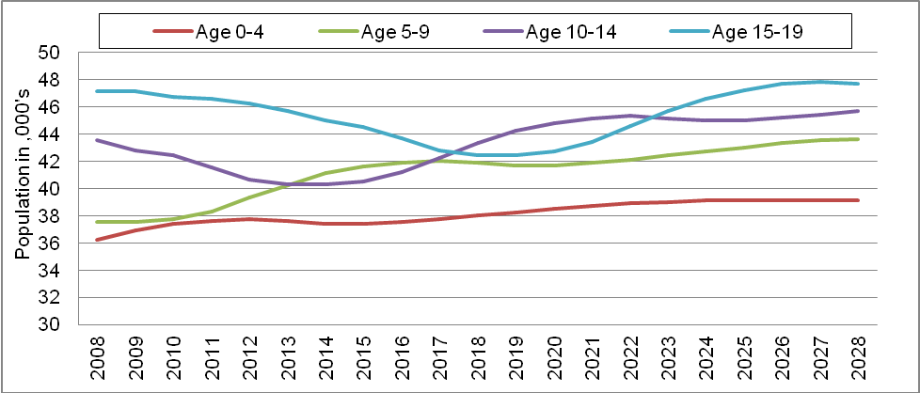
Source: ONS 2008-based Subnational Population Projections

Services

There is significant variation in the size and type of educational provision in Devon. It varies from the individual childminder to the University of Exeter, from many small, two class primary schools to some of the biggest secondary schools in the country. Devon also has a larger than common number of independent special schools.

As of January 2009 Devon had 372 maintained schools including 37 secondary schools, 316 primary schools, ten special schools, two nursery schools and seven pupil referral units with a total of 95,852 pupils. Independently from DCC, Devon has three further education colleges and the University of Exeter. There is a significant variance in the sizes of these institutions from isolated rural schools with fewer than 20 pupils to Exmouth Community College with over 2,500 pupils and the further education colleges with even greater numbers.

Table 2: Provision of Education Places and Institutions, Devon January 2009

Type | Number of Pupils (January 2009) | No. of Settings (January 2009)
Childminders | unknown | 850
Pre-schools and playgroups | unknown | 267
Nursery (LA Maintained) | 148 | 2
Private Nursery (Day, Nursery Schools, Nursery Units of Schools) | unknown | 137
Primary Schools (LA Maintained) | 51,942 | 316
Secondary Schools (LA Maintained) | 42,811 | 37
Independent Schools (inc Independent Specials) | 8,113 | 44
Special Schools (LA Maintained) | 784 | 10
Pupil Referral Units | 167 | 7
Devon LA Maintained Total | 95,852 | 372
Total All Pupils | over 103,965 | 1670
Source: DCSF School Census January 2009; Devon Early Years and Childcare audit 2009; Ofsted

Figure 2: Location of Independent and LA Maintained Schools within Devon (by Learning Community)

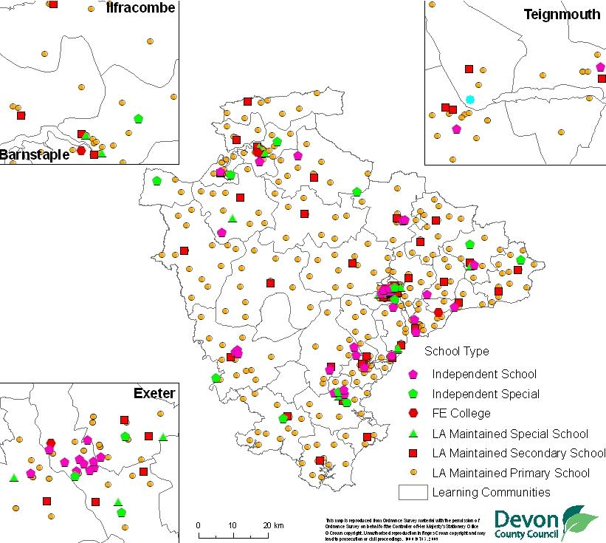
Source: DCC Strategic Commissioning (© Crown Copyright. All rights reserved. Devon County Council. 100019783 2009)

Early years provision from DCC includes 43 Children’s Centres in addition to offering support, and funding, to childminders and other private childcare providers.

Social care services for children include 261 foster carers, four children’s homes (including one for respite care) and one secure unit. In July 2009 there were 550 children in care for which Devon was the funding authority.

Devon Primary Care Trust commissions and plans national health services and primary care. Acute hospital services in Devon are provided by two Foundation Trusts and one NHS Trust. Child and Mental Health Services are provided by Devon Primary Care Trust.

Pupil Characteristics

Table 3: Pupil Characteristics Summary, Devon Maintained Schools (January 2010)

Characteristics | Number of Pupils | Percentage
Pupils Eligible for Free School Meals | 10,334 | 10.8%
Children in Care | 465 | 0.5%
Ethnicity (non-White British)~ | 4,934 | 5.2%
Gypsy Roma Traveller * | 215 | 0.2%
First Language (other than English)~ | 2,043 | 2.1%
Special Educational Needs | 22,246 | 23.3%
All Pupils on Roll in Devon LA Maintained Schools | 95,675 | 100.0%
Source: DCSF School Census (January 2010), * Source: Travellers Education Service
~Excludes information not obtained and refused
Note: Ethnicity and First Language are not collected for pupils in Nursery Schools

Table 4: Pupil Characteristics Summary, Devon Maintained Schools (2008/09) DRAFT

Group | Number of on roll 2008/09 | % of those on roll in 2008/09
Eligible for Free School Meals | 9808 | 10.0
Looked After Children | 455 | 0.5
Traveller | 235 | 0.2
Black Minority Ethnic | 4990 | 5.1
English as a Second Language | 1996 | 2.0
Special Educational Needs | 21,388 | 21.9
Not in any of the Need Groups Above | 66,776 | 68.3
Total Pupils | 97,836 | 100

English as an Additional Language

In Devon a total of 2,043 pupils (2.1%) speak one of the 97 languages, other than English, spoken as a first language by children and young people in DCC Maintained Schools, The main language spoken in Devon is English (91,964, 96.1%), followed by Polish (334, 0.3%) (DCSF Jan 2010 School Census). There are also small but significant numbers of children who speak Arabic, Bengali, German, Chinese, Malayalam, Spanish and Tagalog as a first language.

Interestingly, whilst there is a strong link between belonging to a Black Minority Ethnic group and English as an Additional Language (92%), 7% of those speaking English as an Additional Language are recorded as White British (based on the 2008/09 Maintained School Roll).

Table 5: Pupils' First Language Group - Devon LA Maintained Schools (January 2010)

Area | African | Arabic | Asian | European (Excl. English) | Indian | Other Languages | Other (i.e. Refused and Unknown) | English (and Believed to be English) | Total Pupils on Roll
East Devon | 8 | 10 | 28 | 152 | 32 | 83 | 257 | 16,523 | 17,093
Exeter | 26 | 160 | 53 | 291 | 112 | 161 | 189 | 11,623 | 12,615
Mid Devon | 5 | <5 | 21 | 94 | 9 | 44 | 106 | 9,928 | 10,208
North Devon | 19 | 12 | 6 | 91 | 43 | 46 | 207 | 12,799 | 13,223
South Hams | 17 | 10 | 24 | 89 | 19 | 26 | 156 | 11,322 | 11,663
Teignbridge | 8 | <5 | 20 | 100 | 26 | 57 | 291 | 15,906 | 16,412
Torridge | <5 | <5 | <5 | 32 | <5 | 11 | 155 | 7,491 | 7,694
West Devon | <5 | <5 | <5 | 48 | 6 | 27 | 144 | 6,372 | 6,604
Devon | 89 | 197 | 158 | 897 | 247 | 455 | 1,505 | 91,964 | 95,512
Devon % | 0.09% | 0.21% | 0.17% | 0.94% | 0.26% | 0.48% | 1.58% | 96.29% | 100.0%
Source: DCSF School Census January 2010, excludes children under 5

Table 6: Specified Languages (Other than English) - Devon LA Maintained Schools (Jan 2010)

Number of Pupils | Language Spoken
Over 50 | Polish (334 pupils); Arabic (133); Bengali (91) Malayalam (85); German (82); Spanish (71); Tagalog/ Filipino (68); French (62); Chinese (54); Filipino (54);
40 to 49 | Chinese (Cantonese)
30 to 39 | Portuguese; Russian; Turkish; Tagalog; Ebira
20 to 29 | Italian; Lithuanian; Slovak; Thai; Bulgarian; Swedish; Dari; Persian; Dutch/Flemish; Korean
10 to 19 | Chinese (Mandarin/Putonghua); Panjabi; Urdu; Persian/ Farsi; Japanese; Tamil; Czech; Hungarian; Shona; Afrikaans; Farsi/ Persian (Any Other);
1 to 9 | Greek; Nepali; Danish; Efik-Ibibio; Swahili (Any Other); Arabic (Any Other); Serbian/ Croatian/ Bosnian; Romanian; Ukranian; Bengali (Any Other); Hindi Pashto/ Pakhto; Sinhala; Gujarati; Arabic (Iraqi); Hebrew; Chinese (Any Other); Finnish; Latvian; Indonesian/Bahasa; Indonesia; Norwegian; Portuguese (Brazil); Welsh/Cymraeg; British Sign Language; Malay/ Indonesian; Acholi; Amharic; Caribbean Creole English; Hausa Manding/Malinke (any other); Sotho/ Sesotho; Swahili/ Kiswahili Tswana/ Seswana; Kurdish; Mongolian (Khalkha); Albania/ Shqip; Estonian; Greek (Cyprus); Italian (Any Other); Romanian (Romania); Malay (Any Other); Chichewa/Nyanja; Manding/ Malinke; Teso/ Ateso; Xhosa; Yao/ Chiyao (East Africa); Yoruba Zulu; Maltese; Chinese (Hakka); Basque/ Euskara; Catalan; Greek (Any Other); Kazakh; Portuguese (Any Other); Serbian; Kannada Katchi; Konkani; Oriya; Pahari (Pakistan); Bemba; Fijian; Malagasy Vietnamese; Visayan/ Bisaya ;
Source: DCSF School Census January 2010, excludes children under 5

Ethnicity

Overall in January 2011 4,934 (5.2%) of statutory school age pupils identify their ethnicity as being from BME groups an increase of 0.3% since January 2009. Of these 1916 are white (excluding White British) (2.1%), 1388 (1.6%) are Mixed, 422 (0.5%) Asian or Asian British, 146 (0.2%) Black or Black British, 187 (0.2%) are Chinese and 607 (0.7%) from other ethnic backgrounds. The highest percentage of young people from BME groups is St Sidwells (43%) whilst 36 schools do not have any BME pupils recorded. Pupils from a BME, especially if their first language is not English, may have learning and attainment barriers to their progress which are distinct from their white British classmates.

Table 7: Ethnicities within Devon Schools (January 2011)
Ethnic Group | Number | Percentage
British | 83399 | 93.5%
Eastern European | 637 | 0.7%
Western European | 555 | 0.6%
Other Mixed | 464 | 0.5%
White & Asian | 422 | 0.5%
Other White | 339 | 0.4%
White & Black Caribbean | 290 | 0.3%
Irish | 229 | 0.3%
White & Black African | 212 | 0.2%
Other | 206 | 0.2%
Indian | 193 | 0.2%
Filipino | 175 | 0.2%
Bangladeshi | 120 | 0.1%
Arab | 114 | 0.1%
African | 103 | 0.1%
Other Chinese | 102 | 0.1%
Hong Kong Chinese | 85 | 0.1%
Other Asian | 77 | 0.1%
Gypsy/ Roma * | 73 | 0.1%
Turkish/ Turkish Cypriot | 51 | 0.1%
Afghan | 42 | 0.0%
Thai | 39 | 0.0%
Pakistani | 32 | 0.0%
Caribbean | 28 | 0.0%
Greek/ Greek Cypriot | 27 | 0.0%
Other Black | 15 | 0.0%
Malay | 13 | 0.0%
Iranian | 11 | 0.0%
Japanese | 7 | 0.0%
Traveller of Irish Heritage * | 5 | 0.0%
Refused or Not Obtained | 1143 | 1.3%
Source: DCSF Census (Jan 2011)
Note: No data is available for Nursery Schools. As there is no requirement for ethnicity to be collected for pupils below statutory school age the DCSF chose to exclude this data even if it was available in Schools' MIS systems
*There is a considerable amount of under-subscribing in these categories

The figure below illustrates the percentage of children in DCC maintained schools who are not from a White British background.

Figure 3: Broad Ethnicity of Non-White British Pupils within Devon Maintained Schools (Jan 2011) by Learning Community

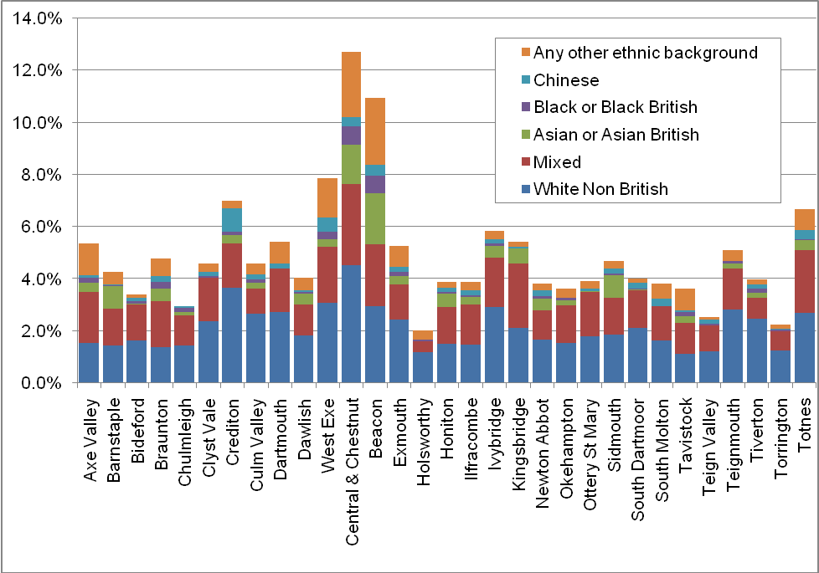
Source: DCSF School Census (Jan 2011), excludes nursery pupils

The number of children and young people in Devon from BME groups is slowly and steadily rising, with a higher proportion of those a Primary level being recorded as BME than at Secondary level. The percentage change in BME pupils for the past year has been 0.3% at both Primary and Secondary level. At Primary level this has risen from 5.6% in 2008 to 5.9% in 2011 and at Secondary level from 4.0% to 4.3%.

Table 8: Statistical Neighbour Comparisons: Black Minority Ethnic Pupils (Jan 2010)

 | Primary |  | Secondary
 | No. BME Pupils | % of all pupils BME | No. BME Pupils | % of all pupils BME
Cornwall | 1,483 | 4.8% | 1,263 | 4.0%
Devon | 2,413 | 5.7% | 1,841 | 4.3%
Dorset | 1,225 | 6.2% | 1,513 | 5.1%
East Sussex | 2,933 | 10.0% | 2,218 | 8.1%
Gloucestershire | 4,937 | 13.9% | 4,600 | 11.6%
Herefordshire | 760 | 7.4% | 562 | 5.6%
Norfolk | 4,276 | 9.0% | 3,212 | 6.5%
Shropshire | 875 | 5.2% | 921 | 5.5%
Somerset | 1,752 | 6.0% | 1,533 | 4.9%
Suffolk | 4,015 | 11.6% | 4,095 | 8.0%
Worcestershire | 2,825 | 9.2% | 2,788 | 7.6%
ENGLAND | 823,380 | 25.5% | 695,610 | 21.4%
Source: DfE: Schools, Pupils and their Characteristics: January 2010 (table excludes special schools and PRUs)

Distinct Ethnic Groups – Roma, Gypsy and Travellers

There are two Gypsy sites provided by Local Authorities and Registered Social Landlords in Devon which are in Moor Lane Sowton Exeter (12 pitches all occupied) and Elbury Close Broadclyst East Devon (8 pitches of which 5 are occupied). The Roma, Gypsy and Traveller young people supported by services live in a much wider area than these two sites including illegal sites and residential property.

This group of children are known to be hard to reach group. They are frequently low achievers academically and improving outcomes for them is a high priority for CYPS and the DCSF. They are made up of a variety of distinct ethnic and lifestyle groups as listed below:

Table 9: Traveller Type Autumn Term 2009 (Snapshot of those known to GRT Services in Devon)

Traveller Type | Total
Fairground Traveller | 81
Gypsy Traveller | 167
Irish Traveller | 51
New Traveller | 121
Roma/ Welsh Traveller/ Not Recorded | 10
Total | 430
Source: GRT, EMS One Database Nov 2009

In the Autumn Term 2009 430 Gypsy, Roma and Traveller children and young people had been offered support through the Gypsy, Roma Traveller Achievement Service. 215 of these were on roll in DCC Maintained Schools of which 196 had recorded attendance. Of these 430 children and young people 102 were below school age, 224 of primary age, 104 secondary school age.

Gay Lesbian Bi-Sexual and Transgender (GLBT)

The exact number or percentage of the population who are gay or lesbian is unknown, however, Stonewall reports that the Government is using the figure of 5-7% of the population (aged over 16).

If this national trend in adults is reflected in the school age population within DCC Maintained schools 5% to 7% would represent an estimate of between 4,900 and 6,900 pupils in 2009/10.

Nationally 6 out of 10 lesbian and gay schoolchildren experience homophobic bullying and many contemplate suicide as a result.

National research suggests that in any school of 1,000 pupils there are likely to be 6 who will experience transgenderism throughout their lives (GIRES 2008). If this ratio is applied to Devon this would equate to just under 600 pupils. There are likely to be others who have a transgender parent or close relative.

Be Healthy

Life Expectancy at Birth

In general life expectancy at birth in Devon is high 81.3 years compared to the UK average of 78.8, but there are areas of low life expectancies spread across Devon which may be cause for concern. The map below indicates, not unexpectedly, that (for 2004-08) the pattern of life expectancy is subject geographical variation across the county with the urban centres such as Barnstaple and Exeter having a life expectancy that falls well below the English average. At a ward level there is a difference of approximately 13 years between the lowest life expectancy in North Devon’s Ilfracombe Central Ward (74.4 years) and the highest life expectancy in West Devon’s Chagford Ward (87.9). Life expectancy has increased in Ilfracombe Central by 1.5 years since 1999-2003 but it remains consistently lower than the rest of Devon.

Figure 4: Variation in life expectancy at Birth by Ward across Devon (2004 – 2008)

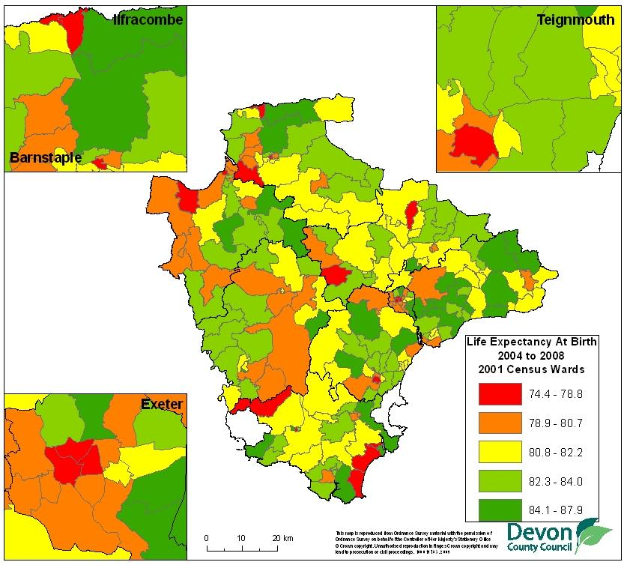
Source: ONS (2009), Devon PCT Public Health (© Crown Copyright. All rights reserved. Devon County Council. 100019783 2009)

Morbidity Prevalence

When looking to the registered conditions that the Devon population has, Devon has higher prevalence rates of the following conditions than the England average;

Chronic Heart Disease; Heart Failure; Stroke; Hypertension; Epilepsy; Childhood Cancer; Asthma; Chronic Kidney Disease; Mental Health; Long Term Conditions; Ante/Postnatal depression; Cystic Fibrosis; Palliative Care;

Whilst the rates of most of these conditions are not significantly higher than the England average, there is significant variation across Devon. In addition to the conditions mentioned above, the rates of patients who are on GP registers and who smoke are higher in Devon than England with a rate of 22.1% in Devon compared to 19.5% in England. Some of these conditions may be avoidable, or improved by early intervention, and it may be desirable to target services at an early stage in children’s’ lives to reduce this prevalence.

In 2007 there were 79 deaths among children and young people in Devon (aged under 25) of these 32 (40%) were children under the age of one.

Low Birth Weight

Low birth weight is either associated with low weight for gestational age or pre term babies. The major causes of low birth weight are smoking, drug and alcohol use, poor nutrition in pregnancy and genetic factors. It is more common among women from disadvantaged backgrounds and mothers aged under 17.

Of the 7,130 live and still births in Devon in 2008 there were 456 with a birthweight of < 2500 grams (6.4%) and 84 (1.2%) with a birthweight of < 1500 grams. This is lower than the England average (7.5% and 1.4% respectively) and in line with the South West average (6.5% and 1.2%). At the District level both Exeter and Torridge have a higher than average percentage low birthweight births (7.8% and 7.5%).

Figure 5: Low Birth Weight Babies (<2500 grams/ 5.8lbs) (2008)

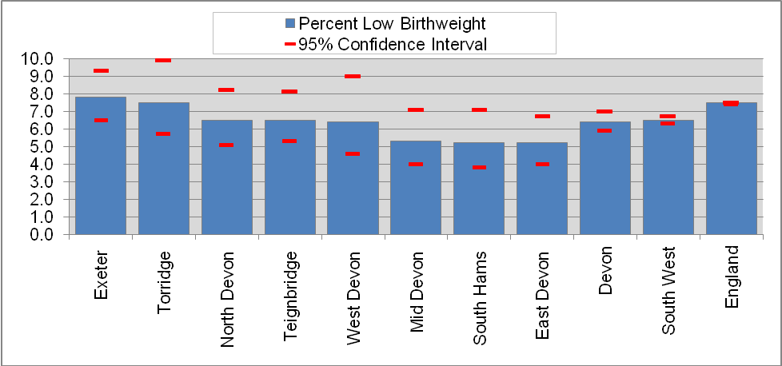
Source: National Statistics and nchod, 2009

Low birth weight babies are at increased risk of death, severe lung and other long-term health difficulties, including deficits in growth, deafness, diabetes and heart disease. They are also at much greater risk of having learning difficulties. Nationally those of extremely low birthweight (less than 1,000 grams) are 200 times more likely to die as an infant than those of normal birthweight, whilst those just below the low birthweight threshold (2,000 to 2,500 grams) are 5 times as likely to die as an infant as those of normal birthweight (Department of Health, 2007).

Infant mortality

Infant mortality is often used as an indicator of the general health of the population. This is because it is affected by the main determinants of health such as income, education, access to preventive health care and health services. Nationally there are marked differences in infant mortality between social groupings with a 19% gap between average infant mortality (4.9 deaths per 1,000, 3 year average rate 2002-04) and the mortality rate of those born to a father in a routine or manual occupation (5.9 deaths per 1,000) (DoH). There are also higher infant mortality rates in the babies of mothers born in Pakistan or the Caribbean, babies born to mothers aged under 20 and where the birth was registered by the mother alone.

There were 83 deaths in infants aged under 1 year in Devon from 2006-08. This gives Devon an infant mortality rate of 3.9 per 1,000 live births, which was lower than those for the South West (4.1) and England and Wales (4.8). At a District level the rates in both North Devon and Torridge are above the England Average at 6.7% and 5.6% (note: these are based on very small numbers of deaths).

Figure 6: Rate of Infant Mortality in Infants Under 1 Year (2004-06)
Source: National Statistics and nchod

Parental Smoking and Smoking during Pregnancy

Parental smoking is also harming the health of many thousands of children in Devon. Around 120,000 adults in Devon smoke, of which an estimated 45,000 (38%) are parents with dependent children.

Women who smoke during pregnancy have a substantially higher risk of miscarriage than those who do not smoke. Smoking can also cause complications in pregnancy and labour, including ectopic pregnancy, bleeding during pregnancy, premature detachment of the placenta and premature rupture of the membranes (National Institute for Health and Clinical Excellence, 2008). For the babies smoking in pregnancy increases infant mortality by about 40% and more than 25% of the risk of sudden unexpected death in infancy is due to smoking.

Smoking levels in women in Devon are slightly below the regional and national average (12.1% compared to 14.2 and 14.3% in 2007/08). Women under the age of 35 are more likely to smoke during pregnancy. Nationally, this is a particular problem in teenagers, 45% of whom smoke during their pregnancy. There is some evidence to suggest that in the period immediately prior to conception; the levels of smoking in Devon are around 25% (similar to national data). However, rates vary considerably across Devon. Smoking rates on delivery are highest in teenagers (34%) and women 20-24 (24%) - around twice the rate of older women (Devon PCT commissioning information team).

Breastfeeding

Breastfeeding is known to be associated with positive health outcomes such as reduced risk of breast and ovarian cancer in the mother and reduced chance of eczema, gastro-intestinal and respiratory infections in the child. Infants who are not breastfed are also five times more likely to be admitted to hospital with infections in their first year of life. World Health Organisation research shows that in developed countries, young mothers, those in low-income groups or those who cease full-time education at an early age are least likely to continue breastfeeding for a period of time sufficient to give health gain.

Within Devon PCT 74% of new mothers were known to have initiated breastfeeding in 2008/09 (Source: Devon PCT commissioning information team) this compares to around 70% nationally. At 6-8 weeks this dropped to 47.4% (Q4 2008/09 Source: Devon child health systems). Historic data is not available for the 6-8 weeks measure as it is a new indicator for 2008/09. Nationally low maternal age, low educational attainment and low socio-economic position continue to have a strong impact on patterns of infant feeding with 65% of UK women from managerial and professional occupations were breastfeeding at six weeks, compared to only 32% of those from routine and manual groups (2005 data from Bolling et al, 2007)

Overall breastfeeding rates are similar to the national average overall but there is a 10% variation in breastfeeding uptake across Devon, even when deprivation is taken into account. This geographical variation may be due to variations in breastfeeding support.

Figure 7: Mothers Initiating Breastfeeding as a Percentage of Maternities in Devon (2009)

Source: Devon NHS, 2009

Childhood Immunisations

The table below ranks the market and coastal towns in Devon and Exeter according to the percentage uptake of key childhood immunisations (with the three poorest performing towns for each vaccination highlighted in red), uptake rates are then combined to give an overall rank for uptake. This reveals that the lowest levels of uptake in the county are seen in areas along the A38 corridor, with Totnes, Ashburton, Buckfastleigh and Moretonhampstead having consistently low uptake rates which are well below the national average, this may be a cause for concern. Low uptake rates are also evident in Ilfracombe in North Devon. There is no direct association between immunisation uptake, with deprived areas exhibiting both high uptake (Bideford) and low uptake (Ilfracombe), with the same being true of less deprived areas. This suggests that the factors associated with poor uptake are likely to be local in nature.

Table 10: Devon Towns Ranked by Levels of Childhood Immunisation, 2008/9
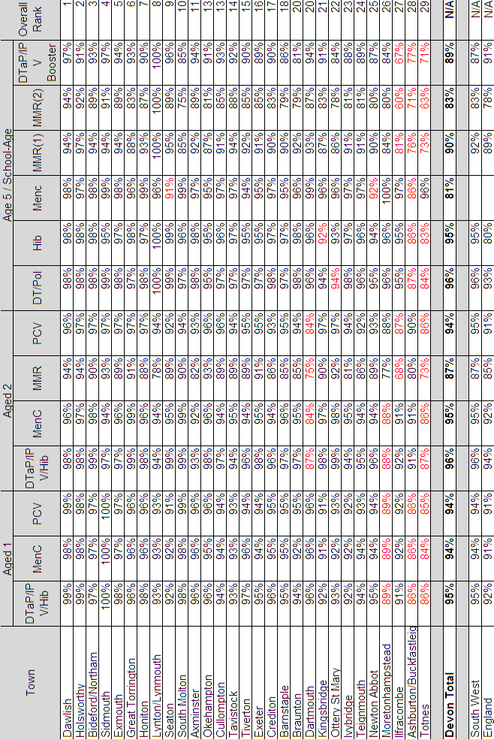
Source: Devon PCT: COVER Quarterly Vaccination Returns, 2009
The figure below shows uptake rates by geographic area across the county for MMR at age five, revealing the wide variation in uptake rates both between areas. These variations, and the resultant low uptake rates in many areas, place unimmunised children at greater risk from infectious diseases.

Nationally, the number of measles cases has increased significantly. In 1998, there were 56 confirmed cases compared with 1370 cases in 2008 (Health Protection Agency, 2009). There was an outbreak of measles in Cornwall between April and June 2008 and there was a cluster of cases in Buckfastleigh early in 2009.

Figure 8: Aged 5 MMR Estimated Uptake by LSOA 2007/08

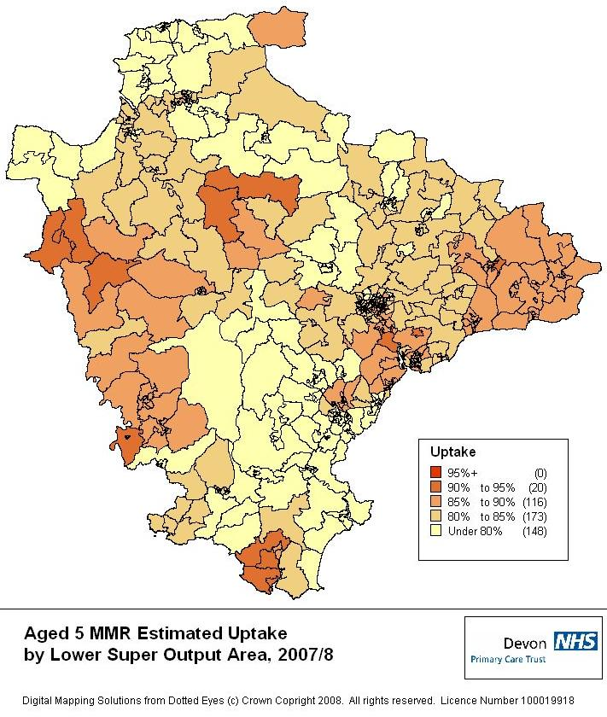
Source: Devon PCT 2009 (© Crown Copyright. All rights reserved. Devon PCT 100019918 2009)

Sexual Health - Chlamydia

Chlamydia is often asymptomatic so a large proportion of cases remain undiagnosed, but infection can be diagnosed easily (young people can do the test themselves easily in their own home), and treated effectively. Young people (16-24 years old) are the age group most at risk of being diagnosed with a sexually transmitted infection (other than HIV).While young people only represent 12% of the total population, they accounted for nearly half of all sexually transmitted infections diagnosed in genitourinary medicine (GUM) clinics across the UK in 2007.

For 2008/09 Devon PCT reported 330 positive Chlamydia tests (6.6%) in those aged 15-24 which is slightly better than the average England positive infection rate of 7.3% (based on Devon PCT reports to NCSP).

Child Healthy Weight

According to the Department of Health, the prevalence of obesity has trebled since the 1980s and if the number of obese children continues to rise, children will have a shorter life expectancy than their parents. Should current trends continue, at least one-fifth of boys and one-third of girls will be obese by 2020.

The Department of Health estimate that the cost of obesity, for both adults and children, is up to £3.7 billion per year, including £49 million for treating obesity, £1.1 billion for treating the consequences of obesity, and indirect costs of £1.1 billion for premature death and £1.45 billion for sickness absence. The cost to the economy of obesity plus overweight individuals is estimated at up to £7.4 billion per year (DoH ,2004).

Childhood obesity in Devon is a recognised problem. In 2008/09 within primary schools 30.4% of children have been identified as very overweight or overweight by the end of year 6 (10 and 11 yr olds). Also, among over 16 year olds, more than 52,000 adults are recorded on GP registers as clinically obese. These figures may be an under representation of the true picture due to difficulty in acquiring consent and associated lack of reporting.

Table 11: Prevalence of underweight, overweight and very overweight children, Reception Year, 2008/09
Area | Underweight | Healthy weight | Overweight | Very Overweight
Area | Prevalence | Prevalence | Prevalence | Prevalence
East Devon | 1.1% | 79.0% | 13.1% | 6.8%
Exeter | x | x | 18.2% | 14.2%
Mid Devon | x | x | 17.4% | 9.7%
North Devon | x | x | 14.8% | 9.1%
South Hams | 1.1% | 74.1% | 14.0% | 10.8%
Teignbridge | x | x | 15.2% | 9.6%
Torridge | x | x | 13.9% | 9.3%
West Devon | x | x | 18.1% | 8.5%
Devon | 0.5% | 74.3% | 15.4% | 9.8%
England | 1.0% | 76.2% | 13.2% | 9.6%
Source: National Child Measurement Programme: 2008/09 school year, headline results
Where underweight suppressed for small numbers healthy weight is also suppressed

Table 12: Prevalence of underweight, overweight and obese children, Year 6, 2008/09

Area | Underweight | Healthy weight | Overweight | Very Overweight
Area | Prevalence | Prevalence | Prevalence | Prevalence
East Devon | 1.1% | 69.6% | 15.0% | 14.3%
Exeter | 0.6% | 65.0% | 14.2% | 20.2%
Mid Devon | x | x | 14.0% | 13.8%
North Devon | 1.2% | 68.8% | 14.0% | 16.0%
South Hams | 1.3% | 69.4% | 15.8% | 13.5%
Teignbridge | 0.8% | 69.1% | 13.1% | 17.0%
Torridge | 1.4% | 67.4% | 13.4% | 17.8%
West Devon | x | x | 15.2% | 16.4%
Devon | 1.0% | 68.6% | 14.3% | 16.1%
England | 1.3% | 66.1% | 14.3% | 18.3%
Source: National Child Measurement Programme: 2008/09 school year, headline results
Where underweight suppressed for small numbers healthy weight is also suppressed

Achieve Economic Wellbeing

Mosaic Profiles

Devon as a county is more rural than the national average: In Devon almost 25% of households fall into MOSAIC group K – People living in rural areas far from urbanisation, this is compared to the national picture of 5%. There is significant variation across the county with up to 75% of households falling under this group in remote rural areas such as Holsworthy. Primarily this group is made up of those in rural areas where life has not been influenced by urban consumption patterns. Each Mosaic group is split into a series of types and households within Mosaic Group K include a combination of the following types: villagers living away from major population centres, incoming visitors who may have a second home in places of great natural beauty and scattered farmers in more sparsely populated and isolated areas. This rural household composition may present challenges in the access to services across health and social care.

Code | Title
A | Career professionals living in sought after locations
B | Younger families living in newer homes
C | Older families living in suburbia
D | Close-knit, inner city and manufacturing town communities
E | Educated, young, single people living in areas of transient populations
F | People living in social housing with uncertain employment in deprived areas
G | Low income families living in estate based social housing
H | Upwardly mobile families living in homes bought from social landlords
I | Older people living in social housing with high care needs
J | Independent older people with relatively active lifestyles
K | People living in rural areas far from urbanisation
- | Non Residential
- | Uncoded

Figure 9: Mosaic Profiles of Devon Districts (2007)
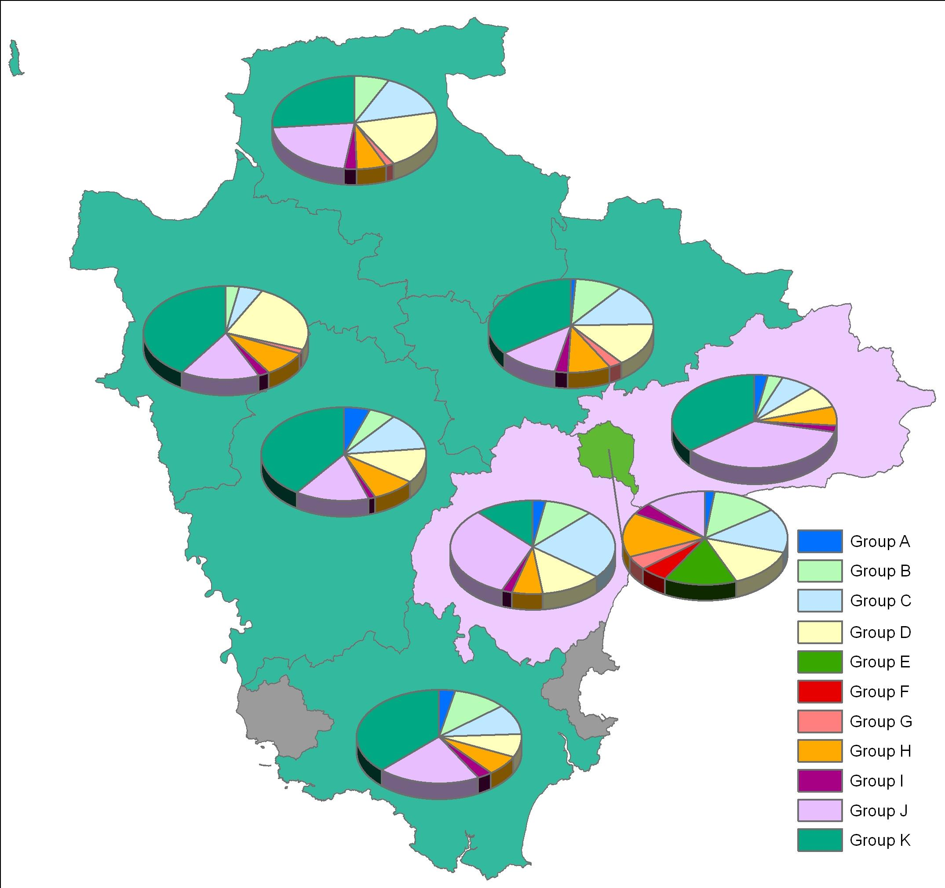
Source: Devon Strategic Intelligence and Mosaic 2007 (© Crown Copyright. All rights reserved. Devon County Council. 100019783 2009)

Average Household Income

Average household income in Devon is lower than the national average. Unemployment is lower than the national average which results in many people being employed but on lower than average incomes. In contrast to this there are also many wealthy families as Devon is an attractive place to live. In rural areas the mixed nature of the housing means that struggling families can be hidden in predominantly wealthy areas with little apparent need.

Table 13: Average Household Income (2008 and 2009)

Area | Mean Income 2008 (£) | Mean Income 2009 (£) | % Change 2008-2009 | Median Income 2008 (£) | Median Income 2009 (£) | % Change 2008-2009
East Devon | 30,678 | 31,761 | 3.5 | 26,173 | 27,250 | 4.1
Exeter | 30,801 | 31,532 | 2.4 | 26,182 | 26,946 | 2.9
Mid Devon | 30,932 | 31,829 | 2.9 | 26,478 | 27,328 | 3.2
North Devon | 29,206 | 29,717 | 1.7 | 24,970 | 25,602 | 2.5
South Devon | 32,145 | 32,615 | 1.5 | 27,379 | 27,976 | 2.2
Teignbridge | 31,359 | 32,392 | 3.3 | 26,650 | 27,671 | 3.8
Torridge | 28,019 | 28,800 | 2.8 | 24,172 | 24,958 | 3.3
West Devon | 31,158 | 31,947 | 2.5 | 26,737 | 27,570 | 3.1
Devon (DCC) | 30,622 | 31,442 | 2.7 | 26,112 | 26,973 | 3.3
Source: DCC Strategic Intelligence, data derived from CACI’s Paycheck product for 2009

Average House Prices

Rises in house prices relative to incomes can put substantial pressures on households leading to an inability to access suitable affordable housing. Figures from the Annual Survey of Hours & Earnings 2008 indicate that house prices in Devon are around 10 times the average yearly income of residents.

Table 14: Average House Prices in Devon (Q1, 2009)

Area | Number of Sales 2009 Jan to Jun | Average House Price Jan-Mar 2009 (£) | Average House Price Apr-Jun 2009 (£)
South Hams | 470 | £254,703 | £274,608
West Devon | 597 | £251,318 | £216,474
East Devon | 454 | £231,045 | £247,690
North Devon | 521 | £208,319 | £199,548
Teignbridge | 470 | £197,450 | £210,051
Mid Devon | 419 | £195,220 | £202,579
Exeter | 481 | £180,367 | £197,582
Torridge | 498 | £178,217 | £200,165
Devon County Council Area | 3910 | £212,402 | £220,351
South West | 28841 | £200,715 | £225,929
Source: Land Registry of England and Wales, period January to June 2009

Index of Multiple Deprivation

The Index of Multiple Deprivation 2007 combines a number of indicators, chosen to cover a range of economic, social and housing issues, into a single deprivation score for each Lower Super Output Area (LSOA) in England, allowing each area to be ranked relative to one another according to their level of deprivation. The Index relates to all people but is a good indicator of the general deprivation affecting households containing children and young people.

Whilst Devon has low levels of overall deprivation at the County and District level, this masks significant variation at smaller geographical scales in both urban and rural areas. There are 21 LSOA’s in Devon in the top 20% most deprived LSOAs in England. There is a correlation between increasing deprivation and a reduced life expectancy at birth in different parts of Devon.

Table 15: District Summary of Indices of Multiple Deprivation (IMD 2007)
Area | Distribution by National Deprivation Quintile |  |  |  |  | Total LSOA's
Area | 1 (20% Most Deprived LSOA's) | 2 | 3 | 4 | 5 (20% Least Deprived LSOA's) | Total LSOA's
Exeter | 11 | 17 | 20 | 20 | 5 | 73
North Devon | 5 | 17 | 20 | 14 | 2 | 58
Teignbridge | 2 | 21 | 29 | 24 | 8 | 84
Mid Devon | 1 | 11 | 17 | 12 | 2 | 43
South Hams | 1 | 6 | 18 | 15 | 9 | 49
Torridge | 1 | 15 | 17 | 4 | 0 | 37
East Devon | 0 | 7 | 26 | 34 | 15 | 82
West Devon | 0 | 7 | 15 | 7 | 2 | 31
Devon Total | 21 | 101 | 162 | 130 | 43 | 457
Source: IMD 2007
Figure 10: Indices of Multiple Deprivation (IMD 2007) Devon at LSOA
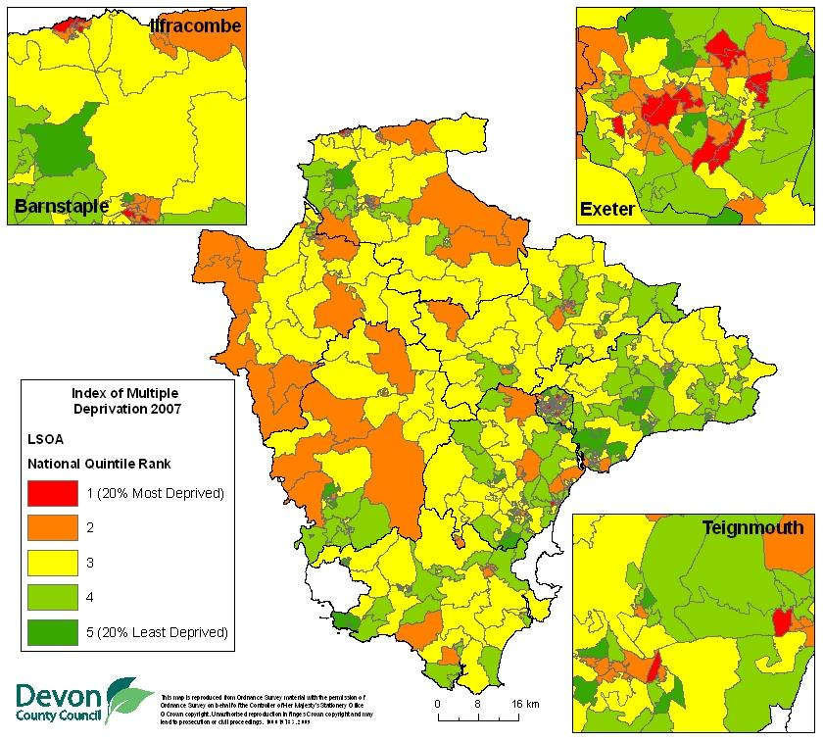
Source: IMD 2007 and DCC IDS (© Crown Copyright. All rights reserved. Devon County Council. 100019783 2009)

Income Deprivation Affecting Children Index (IDACI)

Income Deprivation Affecting Children Index (IDACI) – has been produced alongside the Indices of Deprivation 2007. IDACI is a subset of the Income Deprivation Domain of the Index of Multiple Deprivation, and shows the percentage of children (aged 0-15) in each Lower Layer Super Output Area (LSOA) that live in families that are income deprived. Income Deprivation is defined as either households receiving Income Support/ Income based Jobseeker's Allowance/ Pension Credit or those not in receipt of these benefits but in receipt of Working Tax Credit/ Child Tax Credit with an equivalised income below 60 per cent of the national median before housing costs. The IDACI is the proportion of children 0–15 living in such households as a proportion of all children 0–15.

The index is calculated based on:
- Children aged 0-15 in households claiming Income Support (Source: DWP, 2005)
- Children aged 0-15 in households claiming Income-Based Job Seekers’ Allowance (Source: DWP, 2005)
- Children aged 0-15 in households claiming Pension Credit (Guarantee) (Source: DWP, 2005)
- Children aged 0-15 in households claiming Working Tax or Child Tax Credit whose equivalised household income (excluding housing benefits) is below 60 per cent of the median before housing costs (Source: HMRC, 2005)
- Children aged 0-15 in households claiming Child Tax Credit (who are not eligible for
- Income Support, Income-Based Job Seeker’s Allowance, Pension Credit or Working Tax Credit) whose equivalised income (excluding housing benefits) is below 60 percent of the median before housing costs (Source: HMRC, 2005).

An IDACI score of, for example 0.24 means that 24% of children aged less than 16 in that LSOA are living in families that are income deprived. LSOAs are also given a rank, 1 is assigned to the most deprived LSOA and a rank of 32,482 is assigned to the least deprived LSOA in England. The most and least deprived LSOA’s in Devon are in Exeter: in St Davids 53% (which places it in the 10% most deprived LSOA’s) and in Duryard 3% (which places it in the 5% least deprived LSOA’s).

Table 16: Children Living in Income Deprivation
Area | No. of Children Living in Income Deprivation | Total No. of Dependent Children aged 0-15 | % Living in Income Deprivation
East Devon | 2,717 | 20,922 | 13%
Exeter | 3,489 | 18,273 | 19%
Mid Devon | 1,936 | 14,049 | 14%
North Devon | 3,156 | 16,686 | 19%
South Hams | 2,092 | 14,361 | 15%
Teignbridge | 3,420 | 22,089 | 15%
Torridge | 1,910 | 11,235 | 17%
West Devon | 1,171 | 9,189 | 13%
Devon Total | 19,891 | 126,804 | 16%
Source: IDACI 2007 and ONS population estimates for 2005 used in IDACI and IMD
In Devon 16% (an estimated 19,891 children and young people aged 0-15) are living in income deprived households. This is less than the South West average of 17% (approximately 154,200) and the England average of around 22% (roughly 2.2 million children). Services should be targeted at these areas to break the intergenerational cycle of deprivation.
Table 17: Children Living in Income Deprived LSOA’s
IDACI Score In: | Number of LSOAs | Total Number of Children Resident
Most Deprived 10% in England | 1 | 126
Most Deprived 15% in England | 7 | 3,018
Most Deprived 20% in England | 5 | 1,674
Not in 20% Most Deprived in England | 444 | 121,986
Devon LSOA Total | 457 | 126,804
Source: IDACI 2007 and ONS population estimates for 2005 used in IDACI and IMD

There are 13 LSOA’s in Devon in the 20% most deprived areas in England by IDACI 4818 children aged 0-15 live in these areas. These LSOA’s are located in Exeter (St Davids, Priory x 2 and Mincinglake); Barnstaple (Forches & Whiddon Valley x 2 and Yeo Valley); Ilfracombe (Central x 3); Teignmouth (Teignmouth West); Exmouth (Littleham); Newton Abbot (Bushell).

Figure 11: Income Deprivation Affecting Children Index (IDACI 2007) Devon

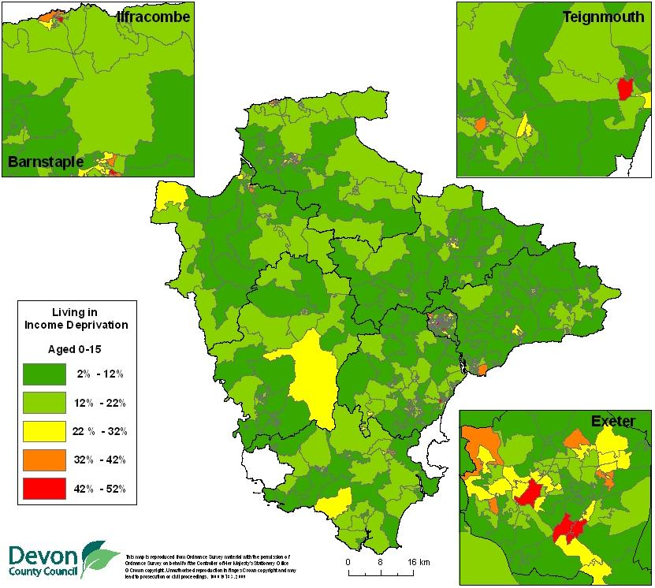
Source: IDACI 2007 and IDS (© Crown Copyright. All rights reserved. Devon County Council. 100019783 2009)

Children Living in Poverty

Poor children’s life chances are dependent upon a complex combination of low household income, a lack of equal opportunities and social exclusion. While some children who grow up in low-income households will go on to achieve their full potential, many others will not. Poverty places strains on family life and excludes children from the everyday activities of their peers. Many children experiencing poverty have limited opportunities to play safely and often live in overcrowded and inadequate housing, eat less nutritious food, suffer more accidents and ill health and have more problems with school work leading to low educational attainment as these children become adults they are more likely to be in poorly paid employment or economically inactive continuing the poverty cycle.

All Local Authorities are required to address Child Poverty and are being measured via national Indicator N116: Proportion of Children in Poverty. The percentage of Children in Poverty (NI116) is calculated by the number of children living in families in receipt of CTC whose reported income is less than 60 per cent of the median income or in receipt of IS or (Income-Based) JSA, divided by the total number of children in the area (determined by Child Benefit data).

Table 18: Children living in Poverty NI 116 (2008)
Area | Children in families in receipt of CTC (<60% median income) or IS/JSA |  | % of Children in "Poverty"
Area | Under 16 | All Children | Under 16 | All Children
East Devon | 2,355 | 2,715 | 11.6% | 11.3%
Exeter | 3,185 | 3,540 | 17.7% | 17.0%
Mid Devon | 1,810 | 2,010 | 12.8% | 12.2%
North Devon | 2,710 | 3,080 | 16.4% | 15.8%
South Hams | 1,785 | 2,075 | 13.2% | 12.7%
Teignbridge | 3,075 | 3,505 | 14.6% | 14.1%
Torridge | 1,775 | 2,015 | 16.7% | 16.1%
West Devon | 1,155 | 1,295 | 13.3% | 12.6%
Devon | 17,850 | 20,235 | 14.6% | 14.0%
South West | 148,325 | 166,845 | 16.5% | 15.8%
England | 2,068,970 | 2,341,975 | 21.6% | 20.9%
Source: NI116 Proportion of Children in Poverty, DWP 2010

Table 19: Percentage of Children living in poverty by Ward - highest 20 based on under 16s (2008)
Ward | District | Children in families in receipt of CTC (<60% median income) or IS/JSA |  | % of Children in "Poverty"
Ward | District | Under 16 | All Children | Under 16 | All Children
St David's | Exeter | 170 | 175 | 33.1% | 30.9%
Ilfracombe Central | North Devon | 275 | 300 | 31.9% | 30.5%
Lydford | West Devon | 80 | 95 | 30.4% | 28.7%
Priory | Exeter | 590 | 655 | 28.5% | 27.7%
Forches and Whiddon Valley | North Devon | 340 | 375 | 28.9% | 27.7%
Teignmouth West | Teignbridge | 305 | 345 | 27.5% | 26.6%
Yeo Valley | North Devon | 240 | 275 | 26.4% | 25.3%
Dartmouth Townstal | South Hams | 145 | 160 | 26.6% | 25.3%
Bideford East | Torridge | 265 | 300 | 24.9% | 23.7%
Totnes Bridgetown | South Hams | 155 | 190 | 23.5% | 23.3%
Mincinglake | Exeter | 280 | 305 | 24.1% | 23.1%
Central Town | North Devon | 185 | 205 | 24.4% | 22.9%
Bideford South | Torridge | 250 | 290 | 22.2% | 22.2%
South Brent | South Hams | 115 | 130 | 22.7% | 21.5%
Exmouth Littleham | East Devon | 200 | 235 | 21.6% | 21.4%
Axminster Rural | East Devon | 95 | 110 | 21.0% | 20.9%
St James | Exeter | 100 | 105 | 23.1% | 20.6%
Exwick | Exeter | 400 | 445 | 21.0% | 20.5%
Whipton & Barton | Exeter | 320 | 365 | 20.9% | 20.4%
Ashburton and Buckfastleigh | Teignbridge | 295 | 340 | 20.9% | 20.3%
Source: NI116 Proportion of Children in Poverty, DWP 2010

In 2008 a total of 118 LSOA’s in Devon had a higher percentage of children living in poverty than the South West average (16.5%) with 67 of these higher than the England average (21.6%). At a ward level the highest percentages of children under 16 living in poverty are in St Davids Exeter (33.1%) and Ilfracombe Central (31.9%) with the lowest in the West Devon wards of Buckland Monachorum and Burrator (both only 4.5%).

Figure 12: Percentage of Children living in poverty by LSOA (2008)

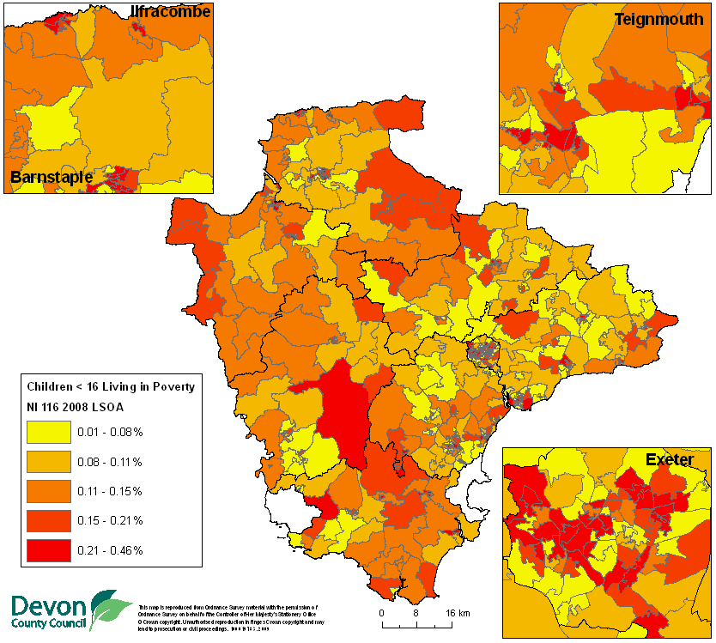
Source: Department for Work and Pensions, 2010 Snapshot data as of 31/08/2008 (NI 116 Proportion of children in poverty) (© Crown Copyright. All rights reserved. Devon County Council. 100019783 2009)

Based on changes to NI 116 for 2006-2008 Child Poverty has declined over the last three years both Nationally (-0.2%) and in Devon (-0.6%) for those aged under 16. For dependent children aged under 20 child poverty has actually risen slightly over the last three years both at a National and Regional level. In contrast to this child poverty has been successfully reduced across Devon both in absolute terms (a fall of 370 children) and in percentage terms (-0.4%), the only exception to this being an additional 80 children (0.2%) in Teignbridge living in poverty.

Table 20: Children living in Poverty NI 116 (2006-2008)
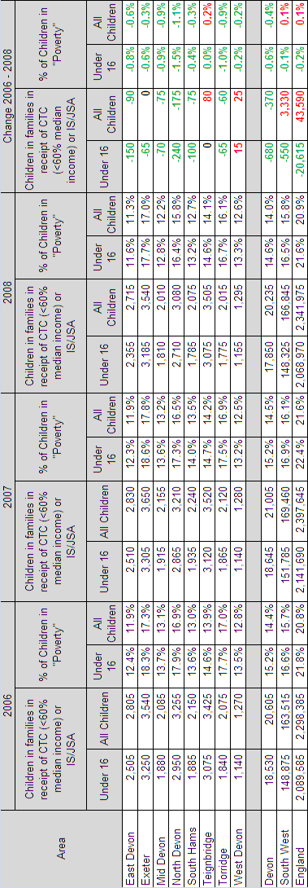

Child Wellbeing Index

Child well-being is generally represented by how children are doing in a number of different domains of their life. At national and international level these domains have included those covered in the CWI. There are no comprehensive national sources of data on other domains of well-being that could have been included –relations with family and friends, civic participation or behaviour and risks. Scores are presented at Lower Super Output Area so they will reflect local pockets of need or low wellbeing scores. In a rural community the index is useful as it includes how accessible facilities and services are for young people, not just the recognised measures of poverty or deprivation used in other Indexes.

The seven domains included in the CWI are:
• Material well-being (exactly the same as IDACI)
• Health (emergency hospital attendances, outpatient attendances, DLA)
• Education (KS scores, GCSE scores, school absences, proportion remaining in education post 16 and post 21)
• Crime (Burglary, Theft, Criminal damage and Violence rates weighted against total 0-5 pop)
• Housing (shared accommodation, lack of central heating, overcrowding, and concealed homelessness) all based on 2001 Census
• Environment (distance to school, air quality, access to leisure and sports facilities, natural environment, road accidents)
• Children in need (income and education deprivation model used to predicate)

Table 21: Child Wellbeing Index Average Scores (smaller number = better wellbeing)

Local Authority | CWI average score | Material well-being average score | Health and disability average score | Education average score | Crime average score | Housing average score | Environment average score | Children in need average score
East Devon | 90.33 | 0.13 | -0.38 | 11.85 | -0.91 | 22.04 | 17.74 | 0.02
Exeter | 181.48 | 0.19 | 0.51 | 34.25 | -0.12 | 39.37 | 11.55 | 0.03
Mid Devon | 119.01 | 0.14 | -0.33 | 20.82 | -0.62 | 29.85 | 19.65 | 0.02
North Devon | 129.84 | 0.19 | -0.06 | 20.43 | -0.49 | 24.54 | 19.39 | 0.02
South Hams | 108.13 | 0.15 | 0.15 | 8.64 | -0.94 | 25.51 | 21.01 | 0.02
Teignbridge | 128.41 | 0.15 | 0.05 | 17.21 | -0.45 | 32.02 | 18.15 | 0.02
Torridge | 139.97 | 0.17 | -0.36 | 22.41 | -0.83 | 32.75 | 24.19 | 0.02
West Devon | 120.07 | 0.13 | -0.12 | 15.54 | -0.94 | 28.76 | 25.19 | 0.02
Devon (DCC) | 127.02 | 0.16 | -0.05 | 18.96 | -0.63 | 29.30 | 18.84 | 0.02
Rutland (Best CWI Average Score) | 50.55 | 0.07 | -1.02 | 5.54 | -0.59 | 5.60 | 19.60 | 0.01
Manchester (Worst CWI Average Score) | 358.78 | 0.48 | 0.84 | 50.62 | 1.11 | 30.50 | 43.27 | 0.06

Children spend a great deal of their lives at home. Therefore the house that they live in can have a profound impact on their well-being. A higher score indicates poorer housing.

Figure 13: Variation in CWI Housing Scores Devon (a higher score indicates poorer housing)

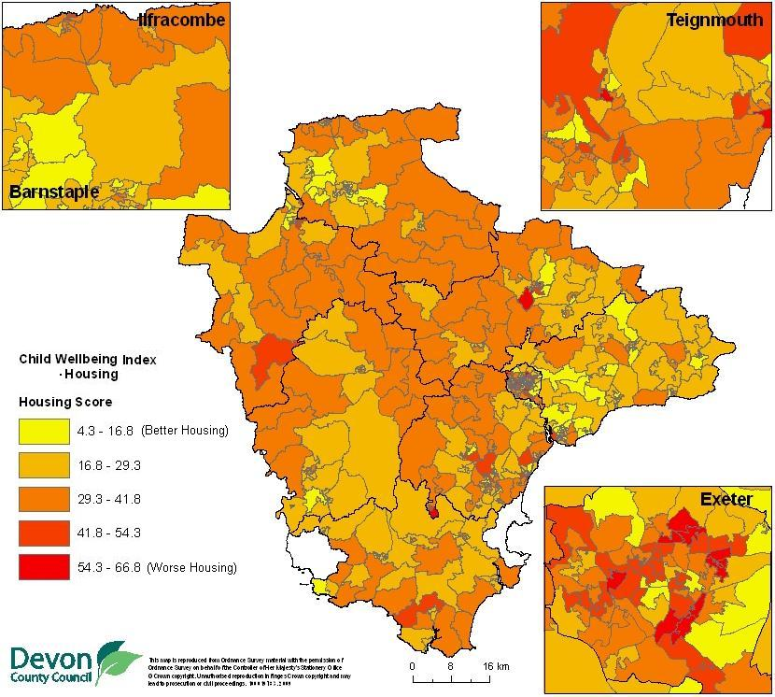
Source: DCC IDS, CWI LSOA Scores (© Crown Copyright. All rights reserved. Devon County Council. 100019783 2009)

Fuel Poverty

Fuel Poverty indicators from the Centre for Sustainable Energy based on the 2003 English House Condition Survey (EHCS). They show how the national level of fuel poverty in England in 2003 was distributed at small area level. It is important to note that the FPI only predicts the level of fuel poverty in individual areas and does not take into account local circumstances. The Centre for Sustainable Energy predicts that fuel poverty has, at the very least, doubled since 2003, due to the substantial rise in fuel prices over this period. However, a more recent index has not been produced.

The official Government definition of fuel poverty states that a household is in fuel poverty if, in order to maintain a satisfactory heating regime (satisfactory varies depending on household type but it is basically 21°C in the living room and 18°C in the other occupied rooms with variations in the amount of time heating to account for people leaving the home to go to work etc.) the household needs to spend more than 10% of its income on all household fuel use. 'Income' in this case includes Housing Benefit, Income Support for Mortgage Interest Relief (ISMIR) and Council Tax Benefit. Council Tax payments are deducted from 'income'.

England Average Fuel Poverty is 6.13% of Households. The Southwest average is slightly higher at 6.18% of Households with Devon being even higher with an average of 6.33% of households in Fuel Poverty. Within Devon the lowest predicated level of fuel poverty is 4.85% (an LSOA within the Honiton St Michael’s ward in East Devon) and the highest is 8.48% (an LSOA within the Polsloe ward of Exeter).

Figure 14: Estimated Fuel Poverty in Devon by LSOA (2008)

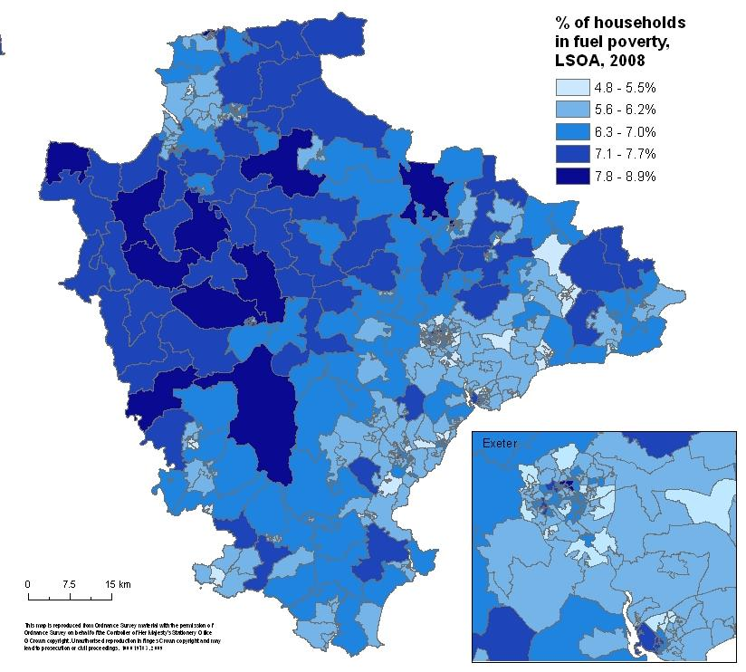
Source: Centre for Sustainable Energy and DCC IDS
NOTE: It is important to note that the FPI only predicts the level of fuel poverty in individual areas. It does not take into account local circumstances. (© Crown Copyright. All rights reserved. Devon County Council. 100019783 2009)

The Centre for Sustainable Energy Fuel states that poverty has, at the very least, doubled since 2003, not least due to the substantial rise in fuel prices. This must be taken into account when interpreting FPI scores for individual areas, and bear in mind, also, that the increase in fuel poverty has been uneven, and varies according to household types and tenure.

Stay Safe

Young people as victims of crime

Criminal offences are defined in law and the police in England and Wales are required to apply the National Crime Recording Standard and Home Office counting rules to ensure a consistent approach to recording crime. Seemingly similar incidents can be classified into different offences depending on the circumstances of the incident. For example, property stolen from someone’s person could be classified as an offence of robbery if the offender used violence, or the threat of violence, to steal or as theft from the person if property was simply taken without the victim being aware (e.g. pick-pocketing). In addition, an attempt to steal would also be classified as an offence even if it were unsuccessful.

In 2006/07 3,287 crimes were reported in Devon (excluding Torbay and Plymouth) where a young person (aged under 19) was the primary victim, for 2007/08 this fell to 2,837 and 2008/09 this fell again to 2,623.

Table 22: Young People as Victims of Crime (covering financial years 2006/07, 2007/08 and 2008/09)

Victim's Age Group | Crime Group |  |  | Total
Victim's Age Group | Sexual | Theft | Violent | Total
Aged 0 to 4 | - | - | 117 | 137
Aged 5 to 9 | 75 | 40 | 212 | 327
Aged 10 to 15 | 312 | 542 | 1,484 | 2,338
Aged 15 to 19 | 286 | 2,297 | 3,350 | 5,933
Devon Total | 690 | 2,882 | 5,163 | 8,735
Source: Devon and Cornwall Police Force's Crime Information System, May 2009
NOTE: The figures in the table above relate to reported crime, and refer to the date at which the crime is reported rather than the offence date. Many crimes, particularly sexual ones, may be reported significantly after the date of the offence.

Although the questions are slightly different across adult and young person surveys it is possible to make some general comparisons around crime reporting. Finding from the BCS 2009 suggest that children and young people are less likely than adults to report crimes to the police 37 per cent of adult victims of personal crime reported the incident to the police compared to 22% of child victims (where the child in law crime was believed by the child to be a crime). The majority of reported crimes involved violence (42% for adults and 32% for children). For theft from the person only 10% of crimes were reported to the police compared to 30% for adults (Walker et al 2009).

There are a variety of reasons for this low level of reporting in comparison to adults. Research (Roe and Ashe, 2008) has highlighted that children are frequently involved in low-level incidents which may involve an offence in law (e.g. as one child deliberately pushing over another with an intention to hurt) but not be viewed by participants, or others, as serious enough to amount to crime. Many of such incidents are unlikely to come to the attention of the police or be recorded as crimes. Other research has also shown that children can also be victims of serious incidents of violence, theft and damage to personal property that are not reported to the police. For example, children frequently suffer from extreme types of violence that are traditionally excluded from criminological concern, such as physical attacks by siblings (Finkelhor and Dziuba-Leatherman, 1994).

Children Injured or Killed in Road Traffic Collisions

The 30 deaths and 164 serious injuries in adults and children in 2009 represented a 62% reduction compared to 1998. These involved 21 children under 16 years of age who were seriously injured and 2 killed. The reduction in deaths and serious injuries is part of a long term downward trend showing that road safety in Devon continues to be a success story. Road casualty reduction is a long term process, with a lot of contributory factors, but a number of initiatives have helped with this reduction; the Devon Country Mile project, camera and police enforcement, Learn2Live presentations for young people and safety education such as our Driving Safer for Longer scheme are all playing a vital part in achieving these improvements.
Figure 15: Children aged under 19 Seriously Injured or Killed in Road Traffic Collisions 1999 to 2009
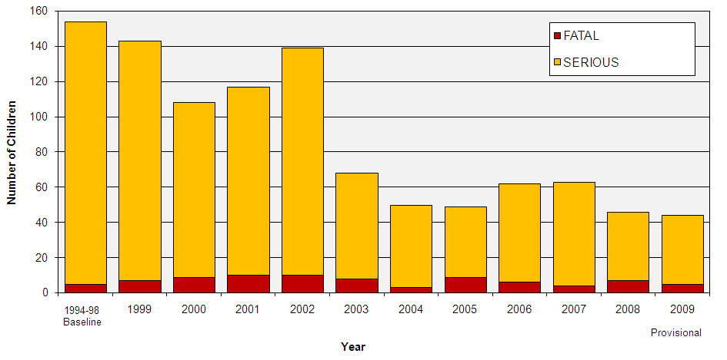
Source: STATS-19 collision data collected by Devon and Cornwall Police (2010)

Figure 16: Location of Children Aged under 19 Injured or Killed in Road Traffic Collisions 2006-2008
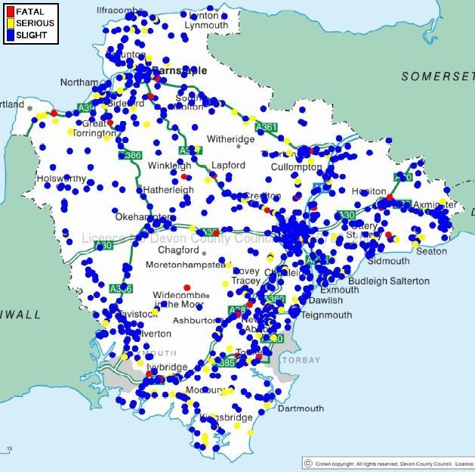
Source: STATS-19 collision data collected by Devon and Cornwall Police (Sept 2009) (© Crown Copyright. All rights reserved. Devon County Council. 100019783 2009)

Fire

In 2009/10 Devon and Somerset Fire & Rescue Service attended 1209 accidental dwelling fires. Whilst the majority (over 75%) of these were in households without children, 305 were at households had children. Of those with children in the household 112 of these fires were within the Devon County Council Area, with 78 in Plymouth, 30 in Torbay and 85 in Somerset. There is considerable variation in rates of incidents between different household compositions, with households consisting of a Lone Parent and Children experiencing over 8% fires despite making up less than 4.5% if households. Those households with two adults and children had slightly more fires than expected with 14% of fires compared to 12% of the population. However households with more than two adults and children make up over 7% of households but experienced less than 3% of accidental dwelling fires.

Table 23: Household Composition for Accidental Dwelling Fires (2009/10)

Composition of Household | Number of Households | % of Households | No. of Accidental Dwelling Fires | % of Accidental Dwelling Fires
Lone Parent | 26,894 | 4.35% | 98 | 8.11%
Two Adults and Children | 79,051 | 12.80% | 172 | 14.23%
More than Two Adults and Children | 44,596 | 7.22% | 35 | 2.89%
No Children | 467,165 | 75.63% | 904 | 74.77%
Total (Devon, Somerset, Torbay and Plymouth) | 617,706 | 100% | 1,209 | 100%
Source: Devon and Somerset Fire and Rescue 2010

Figure 17: Accidental Dwelling Fires by Ward: Households with Children 2009/10

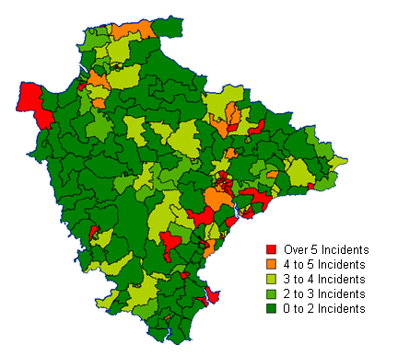
Source: Devon and Somerset Fire and Rescue 2010 (© Crown Copyright. All rights reserved. Devon County Council. 100020113)

- Devon & Somerset Fire & Rescue run several schemes to reduce fire related injuries and criminal activity for children and young people.

- Devon & Somerset Fire & Rescue Service’s FireSetters Scheme has been running since 1995 and is designed to advise children and young people with firesetting behaviour. The aim of the Scheme is to help children and young people understand and control the feelings and circumstances that lead them to set fires through a series of visits and educational exercises at the child’s home or other neutral venue. 89 FireSetter referrals were made for young people in Devon in 2009/10. 39 of these cases have been closed and 50 were still open at the end of June 2010. On average one FireSetter referral would lead to 3 or 4 visits by FireSetter Advisers.

- Phoenix is a six month programme, primarily designed to reduce fire risk and fire related crime within local communities by working with 'at-risk' young people between the ages of 15-18 years. In 2009/10 2 Phoenix Courses were run in Devon reaching a total of 24 young people.

- In Devon last year Devon and Somerset Fire and Rescue Service carried out over 400 schools talks, from Keystage 1 to Keystage 4. These talks reached over 12,000 children.

- Over 5000 KS2 children attended multi agency Junior Life Skills events in Devon last year.

- 1,100 16-18 year olds attended multi agency sessions in Exeter and North Devon primarily focused on Road Safety.

Bullying

Bullying is an issue for many young people (MORE TEXT HERE)

Exclusions for Bullying

In 2008/09 there were 56 exclusions from DCC Maintained Schools for Bullying in addition to 141 exclusions for Verbal abuse/threatening behaviour against a pupil and 954 exclusions for Physical assault against a pupil.

(MORE TEXT HERE)

Bullying on School Transport

In recent years concerns have increased about behaviour on school transport. This is linked to what young people have told us about bullying being an issue for them; and we also know that bullying often relates to being seen as "different", and is therefore an important aspect of our strategies to promote Equality and Diversity.

Since September 2008 a database has been maintained by the Education Transport Team to record all incidents of bad behaviour on school transport. The six schools with the most incidents of bad behaviour reported were Axe Valley Community College, Clyst Vale Community College, Ilfracombe Community College, Tavistock Community College, Queen Elizabeth Community College and Pilton Community College. However, it should be noted that whilst these schools have the most recorded incidents of behaviour on school transport this may well be because they are proactive in reporting these incidents to the Transport Team in an effort to resolve them effectively. The number of pupils travelling in relation to the number of incidents must also be taken into consideration and these are all large schools. The main types of behaviour incident on school transport were Throwing Items (63), Physical Bullying (52), Damage to Vehicle (40), Not Following Safety Instructions (40), Not Wearing Seatbelt (35), and Verbal Abuse of Driver (33). Clearly many of these incidents are potentially very dangerous because at the very least the driver is distracted and pupils not wearing seatbelts is illegal. Damage to buses is also a very serious concern to contractors.

Figure 18: Behaviour Incidents on School Transport (2008/09)

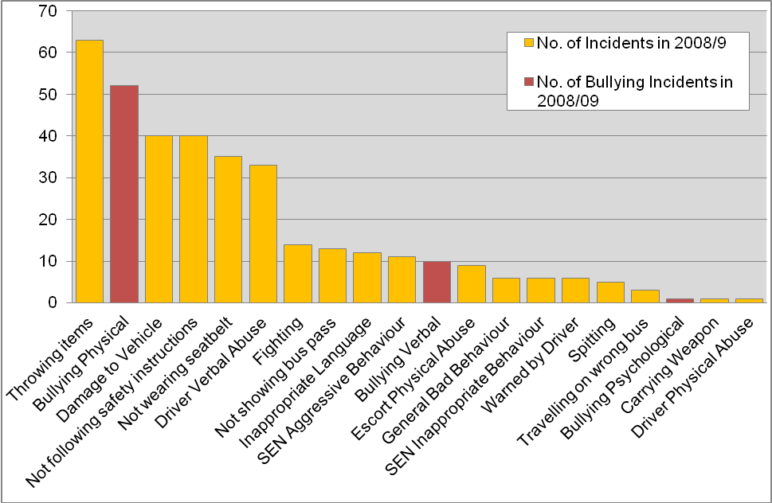
Source: Education Transport Team (from TRAMS) 2010

Enjoy and Achieve

Achievement at Foundation Stage (age 4-5)

Foundation Stage Profiles are based on in classroom teacher assessment. The Early Years Outcome Duty Threshold Target ‘Achievement of at least 78* points across the Early Years Foundation Stage with at least 6** in each of the scales in Personal Social and Emotional Development and Communication Language and Literacy’. The percentage of children this has risen to 47% from 43% in 2008 (Target 48%) but we are still below the national score of 52%. The gap between the lowest 20% and the median of the rest has fallen to 34% from 35.2% in 2008 (Target 32%), this is in line with the national gap of 33.9%.

Table 24: Foundation Stage Profile Results, 2009
Learning Community | a) % 6+ on all PSE scales | b) % 6+ on all CLL scales | c) % 6+ All PSE and CLL scales | d) % Total score 78 or more | e) % 6+ in all PSE and CLL and 78 or more | f) Median Point score | g) Average score of lowest 20% | h) % gap between f & g
Dawlish | 50.8 | 44.4 | 33.7 | 62.0 | 33.7 | 83.0 | 44.4 | 46.6
West Exe | 59.6 | 39.1 | 34.1 | 63.1 | 34.1 | 84.0 | 54.1 | 35.6
Bideford | 57.4 | 40.2 | 36.0 | 57.7 | 35.6 | 81.0 | 51.4 | 36.5
Tiverton | 58.2 | 44.0 | 39.0 | 61.3 | 39.0 | 83.0 | 55.6 | 33.1
Crediton | 68.9 | 43.7 | 40.3 | 63.1 | 40.3 | 83.0 | 58.5 | 29.5
Axe valley | 62.9 | 48.0 | 40.6 | 70.3 | 40.6 | 85.5 | 55.8 | 34.7
Central & Chestnut | 62.8 | 45.7 | 42.1 | 68.4 | 42.1 | 87.5 | 49.2 | 43.8
Exmouth | 58.5 | 46.9 | 42.2 | 64.5 | 42.2 | 85.0 | 54.3 | 36.1
Barnstaple | 64.9 | 48.2 | 43.7 | 69.6 | 43.7 | 87.0 | 53.0 | 39.0
Culm Valley | 59.5 | 52.8 | 43.9 | 70.6 | 43.9 | 87.0 | 57.2 | 34.2
Beacon | 66.8 | 49.2 | 45.4 | 66.8 | 45.2 | 87.0 | 53.4 | 38.6
Chulmleigh | 64.5 | 56.4 | 45.5 | 74.5 | 45.5 | 87.0 | 55.0 | 36.8
Okehampton | 71.0 | 49.7 | 45.6 | 72.0 | 45.6 | 88.0 | 62.3 | 29.2
Newton Abbot | 67.4 | 54.0 | 47.0 | 72.0 | 47.0 | 86.0 | 59.4 | 31.0
Honiton | 68.0 | 53.5 | 47.7 | 73.8 | 47.7 | 87.0 | 53.0 | 39.1
South Molton | 72.1 | 52.3 | 47.7 | 73.9 | 47.7 | 89.0 | 55.2 | 38.0
Clyst Vale | 72.1 | 55.0 | 48.1 | 75.2 | 48.1 | 91.0 | 62.6 | 31.3
Teignmouth | 67.4 | 56.0 | 49.1 | 70.9 | 49.1 | 89.0 | 54.5 | 38.7
Kingsbridge | 67.3 | 60.8 | 50.3 | 75.2 | 50.3 | 86.0 | 63.1 | 26.6
Ivybridge | 76.6 | 54.8 | 50.4 | 77.4 | 50.4 | 89.0 | 66.2 | 25.7
Tavistock | 72.6 | 56.5 | 52.4 | 77.7 | 52.4 | 89.0 | 61.0 | 31.5
South Dartmoor | 71.1 | 56.4 | 52.9 | 73.8 | 52.9 | 90.0 | 62.2 | 30.9
Ilfracombe | 65.0 | 60.4 | 53.8 | 73.1 | 53.8 | 90.0 | 59.4 | 34.0
Dartmouth | 75.0 | 62.5 | 54.2 | 80.6 | 54.2 | 90.0 | 66.6 | 26.0
Sidmouth | 73.6 | 58.5 | 54.7 | 77.4 | 54.7 | 92.0 | 67.8 | 26.3
Ottery St Mary | 65.7 | 67.9 | 55.7 | 82.9 | 55.7 | 89.5 | 64.2 | 28.3
Teign Valley | 78.3 | 60.0 | 56.1 | 80.0 | 56.1 | 91.0 | 61.1 | 32.8
Totnes | 76.2 | 61.0 | 57.1 | 76.7 | 57.1 | 91.0 | 63.4 | 30.3
Torrington | 72.9 | 67.8 | 57.6 | 86.4 | 57.6 | 89.0 | 70.2 | 21.2
Holsworthy | 80.2 | 62.3 | 58.5 | 80.2 | 58.5 | 89.5 | 68.3 | 23.7
Braunton | 84.5 | 73.2 | 69.0 | 88.0 | 69.0 | 91.0 | 72.1 | 20.8
Devon | 67.1 | 52.4 | 46.9 | 71.3 | 46.9 | 87 | 57.2 | 34.2
Source: Devon Learning and Development Partnership 2010

Achievement at Key Stage 1 (age 6-7)

The following information is based on achievement by pupils on roll at schools in the Learning Communities. In most cases the majority of the pupils on roll will also live in the LLC area but there are some schools that are very popular and attract pupils from outside of their area.

The expected level of attainment at KS1 is to achieve at level 2 and pupils are assessed in the abilities in reading, writing, maths and science. The assessments are determined by teacher assessment together with a county wide moderation process. For reading, 85.5% of pupils achieved this in Devon. The lowest performing LLC pupils only achieved 78.9% in reading whilst the best performing LLC pupils achieved a 93.7% pass rate. This compares to the national average of 84%.

Table 25: Key Stage 1 Results by Learning Community, 2009

LLC | 2009 KS1 Reading % level 2+ results | 2009 KS1 Reading % level 3+ results | 2009 KS1 Writing % level 2+ results | 2009 KS1 Writing % level 3+ results | 2009 KS1 Maths % level 2+ results | 2009 KS1 Maths % level 3+ results | 2009 KS1 Science % level 2+ results | 2009 KS1 Science % level 3+ results
Axe valley | 93.2 | 33.5 | 87.4 | 20.4 | 96.6 | 32.5 | 93.0 | 21.8
Barnstaple | 83.2 | 25.4 | 79.5 | 13.7 | 90.2 | 23.4 | 92.6 | 22.8
Bideford | 79.5 | 24.4 | 76.6 | 11.9 | 90.8 | 19.5 | 87.1 | 15.9
Braunton | 81.0 | 20.7 | 79.3 | 11.2 | 94.0 | 19.8 | 94.0 | 30.2
Chulmleigh | 90.8 | 27.6 | 86.7 | 8.2 | 93.9 | 27.6 | 96.9 | 19.0
Clyst Vale | 84.5 | 23.9 | 83.2 | 11.0 | 92.9 | 14.2 | 93.5 | 9.1
Crediton | 87.4 | 30.9 | 79.2 | 13.0 | 89.9 | 25.6 | 93.9 | 32.2
Culm Valley | 86.0 | 27.2 | 83.8 | 13.6 | 91.2 | 21.7 | 94.4 | 22.7
Exmouth | 85.7 | 27.0 | 80.5 | 13.0 | 88.8 | 16.6 | 88.4 | 23.9
Holsworthy | 85.3 | 28.0 | 82.5 | 14.0 | 88.8 | 22.4 | 88.4 | 17.7
Honiton | 84.4 | 38.3 | 83.7 | 17.0 | 84.4 | 28.4 | 85.8 | 28.6
Ilfracombe | 91.3 | 31.7 | 86.9 | 18.0 | 95.1 | 28.4 | 92.9 | 32.2
Ottery St Mary | 92.8 | 41.7 | 92.8 | 29.5 | 96.4 | 40.3 | 94.2 | 38.5
Sidmouth | 93.7 | 25.4 | 94.4 | 13.5 | 98.4 | 24.6 | 96.0 | 16.7
South Molton | 81.2 | 26.7 | 77.2 | 12.9 | 93.1 | 24.8 | 94.0 | 23.0
Tiverton | 80.7 | 21.8 | 76.8 | 7.9 | 88.9 | 25.0 | 86.8 | 13.3
Torrington | 85.9 | 26.8 | 81.0 | 12.0 | 89.4 | 23.2 | 97.0 | 14.8
Dartmouth | 90.4 | 23.3 | 83.6 | 9.6 | 89.0 | 24.7 | 90.1 | 21.5
Dawlish | 86.2 | 30.3 | 80.0 | 8.7 | 90.8 | 21.0 | 88.5 | 20.7
Central & Chestnut | 82.8 | 27.7 | 80.1 | 10.5 | 91.6 | 21.6 | 91.7 | 20.5
Beacon | 86.5 | 30.4 | 82.4 | 16.6 | 92.1 | 26.0 | 92.3 | 24.9
West Exe | 81.3 | 24.9 | 77.9 | 7.3 | 88.6 | 15.9 | 89.8 | 14.2
Ivybridge | 87.3 | 29.4 | 84.3 | 12.4 | 91.0 | 23.4 | 94.2 | 22.7
Kingsbridge | 87.7 | 25.2 | 81.3 | 11.0 | 89.0 | 23.2 | 90.3 | 20.0
Newton Abbot | 87.7 | 28.4 | 84.9 | 10.5 | 91.0 | 21.6 | 94.7 | 19.4
Okehampton | 83.9 | 25.9 | 78.2 | 7.8 | 92.2 | 17.1 | 94.8 | 17.1
South Dartmoor | 87.8 | 30.9 | 84.6 | 12.8 | 91.0 | 21.8 | 86.7 | 21.9
Tavistock | 88.7 | 35.3 | 85.3 | 20.9 | 92.1 | 24.7 | 96.1 | 25.0
Teignmouth | 87.8 | 30.6 | 82.8 | 15.6 | 93.3 | 18.9 | 95.5 | 17.6
Teign Valley | 83.1 | 30.3 | 83.6 | 11.3 | 91.3 | 26.7 | 93.2 | 26.5
Totnes | 78.9 | 24.6 | 78.5 | 10.5 | 86.8 | 19.7 | 90.8 | 20.6
Devon | 85.5 | 28.2 | 81.9 | 13.0 | 91.0 | 22.8 | 92.3 | 21.7
National | 84 | 26 | 81 | 12 | 89 | 21 | 89 | 22
Source: Devon Learning and Development Partnership - 2010

Achievement at Key Stage 2 (age 10-11)

The expected level of attainment at KS2 is level 4 and pupils are tested in their ability in English, Maths and Science at the end of the primary phase. Overall, Devon pupils achieved at or above the national average in all three subject areas, and the numbers reaching level 5 was also at or above the national average.

Table 26: Key Stage 2 Results by Learning Community, 2009

LLC | 2009 KS2 English % level 4+ results | 2009 KS2 English % level 5+ results | 2009 KS2 Maths % level 4+ results | 2009 KS2 Maths % level 5+ results | 2009 KS2 Science % level 4+ results | 2009 KS2 Science % level 5+ results
Axe valley | 86.2 | 37.2 | 84.1 | 42.3 | 93.3 | 56.5
Barnstaple | 81.6 | 25.1 | 82.4 | 30.9 | 89.5 | 36.2
Bideford | 79.4 | 21.8 | 73.8 | 26.2 | 83.8 | 35.5
Braunton | 73.2 | 14.2 | 70.1 | 27.6 | 89.0 | 33.1
Chulmleigh | 88.7 | 32.0 | 88.7 | 44.3 | 93.8 | 50.5
Clyst Vale | 90.7 | 41.7 | 84.1 | 47.7 | 96.0 | 61.6
Crediton | 85.2 | 37.3 | 86.6 | 35.9 | 94.3 | 48.3
Culm Valley | 82.5 | 28.8 | 79.8 | 32.5 | 92.7 | 44.0
Exmouth | 85.5 | 29.3 | 82.0 | 36.7 | 90.8 | 45.5
Holsworthy | 84.9 | 27.4 | 81.5 | 40.4 | 95.9 | 38.4
Honiton | 73.5 | 22.8 | 77.2 | 38.6 | 89.9 | 51.9
Ilfracombe | 86.0 | 19.1 | 80.5 | 28.4 | 92.1 | 36.3
Ottery St Mary | 94.1 | 57.9 | 92.1 | 45.4 | 98.7 | 65.1
Sidmouth | 81.5 | 35.6 | 85.6 | 39.7 | 92.5 | 52.1
South Molton | 80.0 | 40.0 | 89.5 | 37.9 | 93.7 | 54.7
Tiverton | 72.6 | 20.1 | 73.2 | 24.4 | 87.3 | 38.8
Torrington | 75.3 | 27.1 | 67.5 | 25.9 | 82.5 | 25.3
Dartmouth | 87.1 | 35.3 | 85.9 | 35.3 | 94.1 | 37.6
Dawlish | 85.3 | 29.9 | 79.1 | 40.3 | 91.0 | 47.4
Central & Chestnut | 77.5 | 27.0 | 76.1 | 34.1 | 88.4 | 41.0
Beacon | 78.5 | 28.8 | 77.0 | 28.8 | 83.6 | 35.6
West Exe | 77.7 | 25.2 | 79.9 | 30.9 | 89.2 | 39.5
Ivybridge | 85.6 | 31.5 | 84.0 | 36.8 | 93.1 | 47.2
Kingsbridge | 83.8 | 34.1 | 83.8 | 39.7 | 89.9 | 51.4
Newton Abbot | 79.6 | 30.0 | 79.8 | 37.8 | 88.4 | 44.6
Okehampton | 76.6 | 21.3 | 73.6 | 22.8 | 92.9 | 44.2
South Dartmoor | 83.3 | 28.8 | 79.5 | 32.6 | 91.2 | 49.3
Tavistock | 81.6 | 31.8 | 80.5 | 36.2 | 88.9 | 44.6
Teignmouth | 81.5 | 32.6 | 83.1 | 36.0 | 89.9 | 39.3
Teign Valley | 81.6 | 28.4 | 79.2 | 36.8 | 90.8 | 43.6
Totnes | 72.5 | 24.3 | 74.5 | 27.5 | 86.1 | 37.1
Devon | 81.3 | 28.9 | 79.9 | 34.0 | 90.0 | 43.3
National | 80 | 29 | 79 | 35 | 88 | 43
Source: Devon Learning and Development Partnership - 2010

Achievement at Key Stage 3 (age 13-14)

2008 was the final year that pupils had to take statutory assessment tests at this level. The expected level of attainment at KS3 was level 5 and pupils were tested in their ability in English, Maths and Science before they proceeded to study for their GCSEs at the end of KS4. Devon pupils achieved well above the national average of pupils achieving level 5 as well as those achieving level 6.

Table 27: Key Stage 3 Results by Learning Community, 2008

LLC | 2008 KS3 English % level 5+ results | 2008 KS2 English % level 6+ results | 2008 KS3 Maths % level 5+ results | 2008 KS3 Maths % level 6+ results | 2008 KS3 Science % level 5+ results | 2008 KS3 Science % level 6+ results
Axe valley | 90.6 | 70.0 | 93.1 | 81.6 | 91.0 | 69.7
Barnstaple | 69.6 | 34.7 | 71.0 | 52.0 | 65.8 | 38.8
Bideford | 70.8 | 24.8 | 80.3 | 60.3 | 71.4 | 35.6
Braunton | 75.7 | 37.8 | 83.8 | 70.9 | 85.1 | 53.4
Chulmleigh | 79.0 | 44.4 | 65.5 | 51.5 | 84.7 | 52.4
Clyst Vale | 68.6 | 17.7 | 80.0 | 61.7 | 78.3 | 47.4
Crediton | 80.5 | 40.6 | 82.4 | 60.5 | 78.1 | 44.9
Culm Valley | 89.2 | 54.9 | 91.2 | 65.7 | 85.2 | 50.5
Dartmouth | 65.4 | 24.7 | 74.1 | 55.6 | 69.1 | 32.1
Dawlish | 68.6 | 13.8 | 68.5 | 47.6 | 70.6 | 33.7
Exeter - Beacon | 67.1 | 34.3 | 74.6 | 56.5 | 70.2 | 42.5
Exeter - Central & Chestnut | 49.3 | 23.9 | 52.8 | 37.3 | 55.0 | 29.6
Exeter - West Exe | 60.1 | 22.8 | 62.9 | 38.7 | 61.7 | 24.2
Exmouth | 80.5 | 45.2 | 80.5 | 61.3 | 73.7 | 42.2
Holsworthy | 78.8 | 35.8 | 80.8 | 66.2 | 77.5 | 47.9
Honiton | 76.0 | 22.1 | 83.1 | 67.9 | 74.3 | 45.2
Ilfracombe | 60.2 | 18.0 | 74.3 | 48.5 | 57.8 | 28.6
Ivybridge | 84.1 | 46.2 | 84.1 | 71.3 | 80.2 | 50.4
Kingsbridge | 83.2 | 40.9 | 79.8 | 60.1 | 80.3 | 50.5
Newton Abbot | 77.9 | 40.0 | 76.2 | 53.6 | 71.1 | 36.8
Okehampton | 84.1 | 45.3 | 85.8 | 59.9 | 80.6 | 48.3
Ottery St Mary | 88.8 | 50.6 | 88.8 | 69.1 | 83.1 | 51.7
Sidmouth | 79.0 | 25.4 | 83.9 | 64.2 | 89.1 | 50.0
South Dartmoor | 81.8 | 37.9 | 78.9 | 59.3 | 73.9 | 38.6
South Molton | 72.9 | 27.8 | 78.2 | 59.4 | 80.5 | 50.4
Tavistock | 75.3 | 29.5 | 80.4 | 58.9 | 72.7 | 41.0
Teign Valley | 83.5 | 37.1 | 84.4 | 65.0 | 82.3 | 46.0
Teignmouth | 84.8 | 42.1 | 73.6 | 54.5 | 72.5 | 40.4
Tiverton | 70.6 | 25.0 | 75.0 | 49.2 | 69.8 | 33.9
Torrington | 76.1 | 33.3 | 82.2 | 65.7 | 77.5 | 47.4
Totnes | 75.7 | 33.0 | 79.0 | 63.0 | 72.1 | 48.2
Devon | 75.7 | 35.9 | 78.6 | 59.7 | 74.4 | 43.1
National | 73 | 33 | 77 | 57 | 71 | 41
Source: Devon Education Services - 2009

Achievement at Key Stage 4 (GCSE)

Attainment at this level is based on the end of statutory schooling exams, whether in academic or vocational subjects. Achievement is published by the grades achieved in GCSE exams (or the equivalent of), and the level of ‘good’ achievement. Nationally attainment is determined by the government as achieving 5 GCSEs (or equivalent) at grade C or above and including English and Maths. In 2009 results rose for both 5 A-C inc Eng and Maths (49.5 to 51.6%) and 5 A-C (63.4 – 65.8) although the gap between the two widened to 14.2%. Devon pupils generally achieved at or above the national average although attainment in 5 or more passes at grade C or above in any subject fell below the national average.

Table 28: Key Stage 4 (GCSE), 2009
District | School | % 5 or more grade A-C's including maths & english | % 5 or more grade A-C's | % 5 or more grade A-G's | % At Least One Qualification | Average Total Points Score per Student | Capped Average Total Points Score per Student
East Devon | Exmouth Community College | 55.90 | 68.40 | 88.92 | 98.58 | 387.91 | 307.82
East Devon | Clyst Vale Community College | 57.38 | 67.76 | 96.17 | 100.00 | 406.37 | 325.01
East Devon | The King's School | 67.60 | 76.54 | 98.32 | 100.00 | 405.21 | 345.11
East Devon | Sidmouth College | 54.05 | 68.92 | 95.27 | 100.00 | 423.35 | 332.41
East Devon | Honiton Community College | 41.62 | 56.65 | 95.95 | 100.00 | 401.02 | 305.60
East Devon | Colyton Grammar School | 100.00 | 100.00 | 100.00 | 100.00 | 731.59 | 461.75
East Devon | The Axe Valley Community College | 50.00 | 69.86 | 92.47 | 99.32 | 361.21 | 307.27
Exeter | West Exe Technology College | 42.08 | 69.50 | 96.91 | 99.23 | 458.72 | 314.77
Exeter | ISCA College of Media Art | 29.17 | 37.50 | 89.58 | 97.92 | 333.46 | 268.40
Exeter | St. Peter's CofE Aided School | 68.44 | 79.92 | 97.54 | 100.00 | 474.33 | 347.10
Exeter | St. Lukes (CofE) Science & Sports College | 39.25 | 67.20 | 90.86 | 97.85 | 403.84 | 306.52
Exeter | St. James School | 38.36 | 57.53 | 93.15 | 100.00 | 403.72 | 301.40
Mid Devon | Queen Elizabeth's Community College | 45.22 | 62.13 | 97.43 | 99.26 | 408.14 | 312.82
Mid Devon | Tiverton High | 37.97 | 58.23 | 91.56 | 100.00 | 375.47 | 294.14
Mid Devon | Cullompton Community College | 41.86 | 51.16 | 88.37 | 96.90 | 381.08 | 279.26
Mid Devon | Uffculme School | 77.84 | 85.41 | 99.46 | 100.00 | 498.12 | 364.33
North Devon | Ilfracombe Media Arts College | 40.99 | 55.41 | 92.34 | 99.10 | 403.26 | 294.14
North Devon | Braunton School and Community Coll. | 58.74 | 76.92 | 96.50 | 100.00 | 426.60 | 335.04
North Devon | Pilton Community College | 51.40 | 63.29 | 96.50 | 98.95 | 357.93 | 315.74
North Devon | The Park Community School | 43.90 | 60.98 | 98.61 | 100.00 | 428.89 | 318.30
North Devon | South Molton Community College | 44.25 | 57.52 | 100.00 | 100.00 | 366.00 | 309.90
North Devon | Chumleigh Community College | 59.65 | 78.07 | 99.12 | 100.00 | 431.38 | 339.58
South Hams | Kingsbridge Community College | 66.51 | 75.35 | 94.42 | 100.00 | 453.16 | 342.88
South Hams | Ivybridge Community College | 64.10 | 79.49 | 98.29 | 99.43 | 494.82 | 356.14
South Hams | Dartmouth Community College | 33.77 | 57.14 | 93.51 | 97.40 | 384.89 | 294.40
South Hams | King Edward VI Community College | 53.44 | 69.23 | 96.76 | 99.60 | 371.30 | 327.90
Teignbridge | Dawlish Community College | 39.88 | 54.17 | 90.48 | 98.21 | 347.01 | 289.00
Teignbridge | Teignmouth Community College | 56.67 | 71.67 | 91.67 | 98.33 | 409.82 | 315.89
Teignbridge | Teign School | 55.70 | 66.67 | 95.36 | 99.16 | 397.78 | 317.40
Teignbridge | Coombeshead College | 45.15 | 54.85 | 91.42 | 97.76 | 343.34 | 286.66
Teignbridge | Newton Abbot College | 43.95 | 58.60 | 92.36 | 100.00 | 344.57 | 289.53
Teignbridge | South Dartmoor Community College | 60.29 | 75.74 | 95.96 | 99.63 | 417.95 | 335.80
Torridge | Holsworthy Community College | 50.00 | 60.96 | 98.63 | 100.00 | 383.92 | 314.23
Torridge | Great Torrington Com Sch Sports Coll | 54.34 | 73.41 | 94.80 | 100.00 | 420.47 | 326.43
Torridge | Bideford College | 43.38 | 52.94 | 92.65 | 99.63 | 345.29 | 293.46
West Devon | Okehampton College | 61.70 | 73.19 | 97.87 | 99.57 | 425.15 | 339.26
West Devon | Tavistock College | 49.48 | 61.17 | 94.16 | 98.28 | 376.87 | 313.65
 | Devon LA Average | 51.67 | 65.76 | 94.04 | 98.87 | 405.02 | 316.54
 | National Average | 51.02 | 69.60 | 93.58 | 98.71 | 417.33 | 318.56
Source: Devon LDP, 2010 (excludes special schools due to small numbers of entrants)

Variation in Attainment by Pupil Characteristics at KS2

Performance at KS2 in English and Mathematics is in line with National results at an all pupil level, eligible for free school meals and first language. Due to the small numbers involved it is not possible to establish whether the variation in performance across ethnic groups is significant. Encouragingly, whilst performance at No SEN and School Action is in line with the National Average, at School Action + and Statemented Devon pupils are substantially outperforming the National cohort.

Table 29: Variation in Attainment by Pupil Characteristics at KS2 (2009)

Characteristics | Devon |  | England
Characteristics | Number of eligible pupils | % of pupils achieving level 4 or above in English and Mathematics | Number of eligible pupils | % of pupils achieving level 4 or above in English and Mathematics
Free School Meals | 818 | 54 | 92,750 | 53
Not eligible for Free School Meals | 6,720 | 75 | 472,580 | 75
First language is English | 7,409 | 73 | 488,130 | 73
First language is other than English | 132 | 64 | 76,570 | 65
White | 7,281 | 73 | 457,520 | 73
Mixed | 100 | 82 | 21,400 | 73
Asian | 34 | 68 | 47,090 | 70
Black | 14 | 86 | 26,210 | 64
Chinese | 9 | 56 | 1,910 | 82
Male | 3,870 | 70 | 290,470 | 69
Female | 3,690 | 76 | 276,880 | 74
No Special Educational Needs | 5,579 | 87 | 423,791 | 85
School Action | 1112 | 38 | 79512 | 38
School Action Plus | 553 | 31 | 43927 | 26
Statement | 294 | 22 | 18095 | 13
All pupils | 7,550 | 73 | 567,350 | 72
Source: DCSF: KS2 Attainment by Pupil Characteristics, in England 2008/09, first statistical release April 2010

Variation in Attainment by Pupil Characteristics at GCSE

Children who grow up in poverty are more likely to leave school without qualifications. In 2008 21% of Young People at DCC maintained schools known to be eligible for free school meals completed their GCSE’s with less than 5 A*-G’s, this is dramatically higher than those not eligible for free school meals (6%). As part of “Narrowing the Gap” theme in the CYPP the aim is to bring about further improvements for these students.

Table 30: Variation in Attainment by Pupil Characteristics at GCSE (KS4) 2009

Characteristics | Devon |  | England
Characteristics | Number of eligible pupils | % Achieving 5+ A*-C grades inc. English and Mathematics | Number of eligible pupils | % Achieving 5+ A*-C grades inc. English and Mathematics
Free School Meals | 599 | 23 | 74,000 | 27
Not eligible for Free School Meals | 7,104 | 54 | 502,220 | 54
First language is English | 7,605 | 52 | 517,060 | 51
First language is other than English | 93 | 53 | 57,610 | 50
White | 7,461 | 52 | 479,840 | 51
Mixed | 77 | 56 | 16,820 | 51
Asian | 20 | 60 | 40,870 | 54
Black | 7 | 43 | 23,240 | 45
Chinese | 13 | 46 | 2,220 | 73
Male | 4,010 | 47 | 293,340 | 47
Female | 3,700 | 57 | 283,090 | 55
No Special Educational Needs | 5,793 | 62 | 439,500 | 62
School Action | 1,172 | 26 | 75,640 | 21
School Action Plus | 467 | 17 | 38,730 | 13
Statement | 271 | 8 | 22,350 | 6
All pupils | 7,700 | 52 | 576,430 | 51
Source: DCSF: GCSE Attainment by Pupil Characteristics, in England 2008/09, first statistical release April 2010

Gypsy Roma Travellers account for small numbers of those taking GCSE’s (9 in 2009) and as such it would be potentially misleading to provide a breakdown of KS scores. Over a three year period 2007-09 Gypsy Roma Traveller young people performed more poorly at KS4 with 21% of GRT Achieved 5+ A*-C grades inc. English and Mathematics compared to 49% of the total cohort. Over the same period 29% GRT left with less than 5 GCSE’s A-G compared to only 7% of the total cohort.

Children in Care Attaining 5+ GCSEs incl. English and Maths

It is a priority within the Children and Young People’s Plan to improve outcomes for children in care. This will involve schools as well as a number of other services. The attainment differences between Children in Care and those in the wider community are currently a high priority. As a result, this measure is one of the new national indicators for the 2008/09 reporting year (NI 101). It measures children in care who achieved 5+ GCSEs at grade A*-C, including English and Maths. The cohort comprises only those children who have been in care continuously for at least 12 months at 30 September. Before making any judgements on performance it is important to note that this cohort of children in care is very small - usually in the range of 45-70 children in care in year 11 each reporting year.

The percentage of children leaving care in the year to 31 March 2010 aged 16 or over, who had attained at least 5 GCSEs at grade A*-C on leaving care, was 10.0%. This is little changed on Devon's 2008-09 outturn of 10.1% (note this is based on a very small cohort).

Contextual Value Added Scores

Pupils’ levels of progress are shown as a Contextual value added score (CVA) which considers an individual pupils social economic, home and community background, and the progress that each pupil should make between key stages. The benchmark is a score of ‘0’, that is that pupils have made the progress expected. Progress by Devon pupils is generally lower than the national average in English Maths and Science. The Learning Community where the pupils make the lowest level of progression is Braunton and the Learning Community where pupils’ progress above the national average is Sidmouth.

Table 31: Key Stage 1-2, 2-4 and 3-4 Contextual Value Added Scores – 2009

LLC | 2009 KS1 - 2 English CVA | 2009 KS1 - 2 Maths CVA | 2009 KS1 - 2 Science CVA | 2009 KS2 - 4 Capped Total Points Score CVA | 2009 KS2 - 4 Number A*-C CVA
Axe valley | 0.28 | -0.07 | 0.06 | 10.18 | 0.73
Barnstaple | -0.08 | 0.09 | 0.00 | -2.25 | -0.76
Bideford | -0.10 | -0.62 | -0.56 | -2.90 | -0.90
Braunton | -1.44 | -1.53 | -1.01 | -3.41 | 0.19
Chulmleigh | 0.16 | 0.16 | 0.18 | 1.01 | 0.43
Clyst Vale | 0.77 | 0.84 | 0.95 | -3.77 | -0.53
Crediton | 0.31 | 0.09 | 0.07 | -11.33 | -0.66
Culm Valley | -0.14 | 0.01 | 0.03 | -1.03 | 0.46
Exmouth | 0.15 | 0.29 | 0.07 | -13.24 | -0.36
Holsworthy | 0.10 | 0.40 | 0.12 | -0.05 | -0.30
Honiton | -0.55 | 0.31 | 0.65 | -19.87 | -1.03
Ilfracombe | 0.07 | 0.07 | -0.01 | -30.94 | -1.07
Ottery St Mary | 0.58 | 0.05 | 0.38 | -7.44 | -1.23
Sidmouth | -0.11 | 0.31 | 0.17 | -3.14 | -0.35
South Molton | 0.12 | 0.46 | 0.66 | 0.24 | -0.78
Tiverton | -0.33 | -0.08 | 0.20 | -3.46 | -0.64
Torrington | -0.35 | -0.98 | -1.17 | 7.72 | 0.33
Dartmouth | 0.35 | 0.41 | 0.00 | 17.64 | 0.31
Dawlish | 0.17 | 0.19 | 0.37 | -23.92 | -1.34
Central & Chestnut | -0.01 | -0.12 | 0.07 | -3.50 | -0.91
Beacon | 0.55 | 0.31 | -0.08 | 15.52 | 0.69
West Exe | 0.08 | 0.42 | 0.12 | 30.72 | 1.24
Ivybridge | -0.16 | -0.02 | -0.08 | 26.77 | 1.62
Kingsbridge | 0.27 | 0.42 | 0.37 | 5.32 | 0.51
Newton Abbot | -0.38 | -0.22 | -0.33 | -20.36 | -0.97
Okehampton | -0.71 | -0.78 | 0.36 | 10.42 | 0.03
South Dartmoor | 0.00 | -0.30 | 0.03 | 9.43 | 0.01
Tavistock | -0.39 | -0.32 | -0.37 | -24.10 | -1.42
Teignmouth | -0.03 | 0.36 | -0.13 | 2.15 | 0.41
Teign Valley | -0.37 | -0.38 | -0.38 | -5.75 | -0.70
Totnes | -0.40 | -0.39 | -0.28 | 7.20 | -0.59
Devon | -0.07 | -0.03 | -0.04 | -0.96 | -0.22
National | 0.00 | 0.00 | 0.00 | 0.00 | 0.00
Source: Devon Learning and Development Partnership – 2010, based on Fischer Family Trust School Extended model’ – ‘FFT SX’

Private Education

There are 44 independent schools within Devon attended by approximately 8,113 pupils. Of these schools 13 are independent special schools with approximately 450 pupils on roll (January 2009). A limited number of these children and young people will be known to DCC through Children in Care, with a Child Protection Plan, Children in the Entertainment Industry or Special Educational Needs support (approximately 200). The ongoing circumstances of the remaining children and young people may be unknown to our services.

Education Outside School: Home Education

In England, the law (Education Act, Great Britain, Statutes, 1996) states that while education is compulsory, school is not, and parents/carers may choose to educate their children at home for a variety of reasons. Responsibility for providing a child with a suitable education rests with the parents, who can decide to home educate their child at any stage. Local Authorities have a duty to identify children not receiving a suitable education but no duty to monitor home education. They may intervene, however, if education provision appears unsuitable and may request a home visit, or evaluate provision by alternative means (DCSF, 2007).

Parents may decide to exercise their right to home educate their child from a very early age and children may not have been previously enrolled in school in which case parents are not required to register or seek approval to educate their child at home. Registration is only a requirement for those who have been in a maintained school previously so there will be many other home educated children for which we have no details.

The DCC Education Out of School team provides services for those in Home Education. In 2008/09 674 children and young people in Devon were registered for elective home education (number on EHE register at some point during the academic year).

Education Outside School: Alternative Provision

The DCC Education out of school team covers Hospital Education, Link Education, PRU and Home Education. As a snapshot, in January 2009 17 children and young people were being educated in at a hospital education unit. There are two hospital education bases in Devon, one at the Royal Devon and Exeter Hospital and a service at Barnstaple Hospital. All of these 17 are all duel-registered with a School. Over the course of an academic year the hospital education service estimates that they teach 200 individual children and young people, some for just a half day and some for the whole year, these are split roughly evenly between primary and secondary age. Of the other PRUs 150 pupils 24 were dual-registered with a DCC maintained school.

Table 32: Education other than at School: Pupil Referral Units (Snapshot January 2010)

Location | Number on Roll
The Grenville Centre | 49
Barnstaple Tutorial Unit | 24
The Voyager PRU | 15
Oak Valley | 20
Exeter EOTAS | 20
The Yeo Centre | 14
Hospital Education Service | 13
Devon PRU Total | 155
Source: DCSF SLASC returns January 2010

Unauthorised Absence/ Persistent Absence

Absence from school affects pupils’ educational outcomes and life chances and should therefore be avoided. CYPS and schools are working to reduce the incidences of absence, particularly for those pupils where it can be avoided. Some pupils are persistently absent as a result of poor health or due to accidents.

Persistent absence in Devon has been defined as more than 64 sessions (which translates to 32 days) absence over the academic year. In the 2008/09 terms 2,078 young people were persistently absent from Devon maintained schools (2.1% of the total cohort).

Table 33: Characteristics of Persistent Absence (More than 64 sessions missed during 2008/09)

Group | Number of those Persistently Absent | % of those Persistently Absent
Eligible for Free School Meals | 621 | 29.9%
Looked After Children | 20 | 1.0%
Traveller | 38 | 1.8%
Black Minority Ethnic | 116 | 5.6%
English as an Additional Language | 41 | 2.0%
Special Educational Needs | 1,052 | 50.6%
Not in Any of the Need Groups Above | 710 | 34.2%
Total Persistent Absent | 2,078 | 100.0%
Source: DCSF School Census Spring 2009 and Summer 2009; EMS ONE
Note: % will not sum to 100 as some children will be in more than 1 need group

In Devon 3.8% of maintained secondary pupils were persistently absent from school in the Autumn and Spring terms of 2009/10 compared to 4.3% of pupils nationally. At maintained primary level this was 1.3% compared to 1.8% Nationally.

Table 34: Unauthorised Absence in the 2008/09 (DCC Maintained Schools)

17,822 pupils (21%) had at least one session of unauthorised absence
1,763 pupils (2%) had at least 2 weeks of unauthorised absence
413 pupils (0.5%) had at least 5 weeks of unauthorised absence
Source: Derived from DCSF School Census Spring 2009, Summer 2009, Autumn 2009; EMS ONE
Data warning: This is based on those in DCC Mainstream and Special Schools for the 2008/09 academic year. It does not yet contain those who are on the roll of more than 1 school at the same time and is also missing some who were in the school system for less than 1 term

School Exclusions

Most school exclusions happen at secondary rather than primary level. CYPS and schools are working together to reduce the level of exclusions through a programme of managed moves from one secondary school to another, aiming to keep pupils at schools and in full time education. The rate of permanent exclusions in Devon schools is above the English average, with 0.12% of the school population being permanently excluded in 2008/09. The number of pupils receiving fixed term exclusions is also very slightly above the national average, at 4.96% at the end of 2008/09. This compares to 0.09% and 4.89% across England.

In 2008/09 there were 2,453 young people excluded, a total of 5,368 incidences. 10 young people were excluded for over 30 days, and 50 for over 20 days, during the academic year. The most common reason for exclusion was verbal abuse/threatening behaviour against an adult (1,358 incidences).

Table 35: Reasons for Permanent and Fixed Term Exclusions 2008/09

Exclusion Reason | No. Of Incidents
Verbal abuse/threatening behaviour against an adult | 1,358
Other | 1,316
Physical assault against a pupil | 954
Persistent disruptive behaviour | 902
Physical assault against an adult | 234
Drug and alcohol related | 166
Verbal abuse/threatening behaviour against a pupil | 141
Damage | 116
Bullying | 56
Theft | 52
Racist abuse | 39
Sexual misconduct | 34
All Exclusions (Fixed Term, Lunch and Permanent) | 5,368
Note: This data covers only DCC Maintained Schools
Source: DCSF School Census Autumn 2008, Spring 2009 and Summer 2009;

Table 36: Permanent and Fixed Term Exclusions 2008/09 (DCC Maintained Schools)

Group | Number of CYP with Fixed Term Exclusions | % of those with Fixed Term Exclusions | Number of CYP with Perm Exclusions | % of those with Perm Exclusions
Eligible for Free School Meals | 591 | 24 | 46 | 38
Looked After Children | 85 | 3 | N/A | N/A
Gypsy Roma Traveller | 7 | <1 | <5 | -
Black Minority Ethnic | 83 | 3 | 6 | 5
English as a Second Language | 22 | 1 | <5 | -
Special Educational Needs | 1,403 | 57 | 85 | 70
Not in any of the Need Groups Above | 804 | 33 | 28 | 23
Total Excluded | 2,453 | 100 | 122 | 100
Source: DCSF School Census Autumn 2008, Spring 2009 and Summer 2009; EMS ONE, numbers less than 5 have been suppressed
Note: % will not sum to 100 as some children will be in more than 1 need group

Certain groups are more likely to be excluded from school than others. Around 10% of all pupils are eligible for free school meals but they account for over 24% of those excluded from school. No permanent exclusions are attributed to looked after children as they are covered by the managed moves programme to avoid this outcome.

Make a Positive Contribution

Engagement in extracurricular activities

In 2009 75.2% of year 10 students in Devon engaged in extracurricular activities in Devon compared to 69.5% nationally (this is based on young people in school year 10 reported participating in any group activity led by an adult outside school lessons (such as sports, arts, music or youth group) in the last four weeks based on the analysis of the weighted TellUs survey data). The TellUs survey is voluntary and the data are weighted and grossed up to match local area profiles based on school censes data. Within Devon there is a very poor response to TellUs4 with very few schools participating in 2009 – as a result this data is insufficient to form conclusions.

The recent positive activities audit (February 2010) has shown, through extrapolation that 8% (4,800) of young people volunteer on a regular basis giving an estimated 249,600 hours of service annually. A further 22% (13,200) have volunteered for more than 4 hours during the past year representing a minimum of 52,800 hours of service. (SOURCE)

17,345 young people (23%) voted in this year’s UK Youth Parliament electing 12 young people to serve all young people in Devon. (SOURCE)

Table 37: Devon Youth Service, Registered Young People and Active Participants, Aged 13 to 19 (1 April 2008 to 31 March 2009).

Area Team | Registered Young People | Active Participants Female | Active Participants Male | Total Participants | 13-19 Pop (FHSA Pop Estimates 2009) | % of Pop Active Participants with Devon Youth Service
East Devon | 1,551 | 450 | 629 | 1,079 | 9213 | 11.7%
Exeter | 1,857 | 526 | 812 | 1,338 | 7661 | 17.5%
North Devon | 1,522 | 535 | 564 | 1,099 | 7327 | 15.0%
South Hams/West Devon | 2,007 | 544 | 777 | 1,321 | 10259 | 12.9%
Teignbridge | 3,105 | 835 | 1,381 | 2,216 | 9424 | 23.5%
Torridge/Mid Devon | 1,546 | 445 | 608 | 1,053 | 10748 | 9.8%
Total | 11,618 | 3,335 | 4,771 | 8,106 | 54632 | 14.8%
Source: Devon Youth Service, 2009
NOTE: This data does not provide a full picture. Some teams are not yet up to date with entering sessional data for 2008/9. There have been no entries for 2008/9 for the participation team. This does not include any voluntary sector data.

The Training and Development Agency for Schools announced in January 2009 that there would be a new funding stream for economically disadvantaged children as well as children in care. This pot of money is for activities that these children would be unable to access without it and there is £300 per year for each child which should be used on 2 hrs a week activities in term time and 30 hrs per week in the holidays. This initiative will enable these children to participate in activities that may not otherwise be accessible or affordable to them, and therefore broaden and enrich their life experiences. There are 5 Learning Communities who are piloting this funding from April 2009. From 2010-2011 all Learning Communities will have this pot of money. To enable us to work out which children are economically disadvantaged as quickly as possible we used those children who are registered for Free School Meals whether or not they take them up as well as the number of children in care. The 5 Learning Communities piloting this funding stream have been allocated funds based on this data. Next year however the eligibility criteria may change.

Level Two – Children and Young People with Additional Needs

Enjoy and Achieve

Special Educational Needs

There are three levels of intervention to support pupils who are not making satisfactory academic progress as set out in the SEN Code of Practice. School Action is where a school formulates its own action to improve outcomes and involves schools producing Individual Education Plans (IEP). School Action Plus is the next stage of intervention where pupils do not make satisfactory progress on SA and includes support from external agencies. If these two interventions fail the school can request a Statutory Assessment and if successful a Statement of Educational Need will be prepared with directed support and targets. In addition, children with disabilities and severe learning difficulties will often have a Statutory Assessment upon starting school to ensure their Statement of Educational Needs directs them to the most appropriate school setting and they receive the additional support they need to get them to school.

A snapshot survey in May 2010 identified a population of 10,909 children and young people receiving services with at least level 2 needs (meaning that they have significant special educational needs that impact on their school and wider life). Of these level 2 children that are in DCC maintained schools 2,322 have a Statement and 6,369 are School Action+ (Jan 2010, DCSF Census). In addition to this there are 12,729 (Jan 2010, DCSF Census) children and young people categorised as School Action. School Action includes those with level 1 needs (meaning they have needs which impact upon their education and receive small amounts of targeted additional support with this intention of preventing them reaching level 2 need).

Table 38: Distribution of Special Educational Needs Conditions by Age Group (May 2010 Snapshot)

Primary Need | Age Group |  |  |  | All Ages | Percent
Primary Need | 0 to 4 | 5 to 9 | 10 to 14 | 15 to 19 | All Ages | Percent
Autistic Spectrum Disorder | 30 | 227 | 425 | 201 | 883 | 8.09%
Behaviour, Emotional & Social Difficulties | 42 | 731 | 1,323 | 699 | 2,795 | 25.62%
Hearing Impairment | 12 | 83 | 95 | 55 | 245 | 2.25%
Moderate Learning Difficulty | 27 | 445 | 732 | 240 | 1,444 | 13.24%
Multi-Sensory Impairment | 0 | 3 | 1 | 1 | 5 | 0.05%
Other Difficulty/Disability | 4 | 71 | 130 | 105 | 310 | 2.84%
Physical Disability | 29 | 218 | 274 | 124 | 645 | 5.91%
Profound & Multiple Learning Difficulty | 6 | 19 | 22 | 21 | 68 | 0.62%
Severe Learning Difficulty | 12 | 62 | 113 | 110 | 297 | 2.72%
Specific Learning Difficulty | 5 | 261 | 663 | 220 | 1,149 | 10.53%
Speech, Language and Communication Needs | 132 | 1,203 | 574 | 139 | 2,048 | 18.77%
Visual Impairment | 6 | 46 | 88 | 48 | 188 | 1.72%
Under Assessment | 0 | 0 | 2 | 0 | 2 | 0.02%
Blank | 222 | 98 | 216 | 294 | 830 | 7.61%
Total | 527 | 3,467 | 4,658 | 2,257 | 10,909 | 100.00%
Source: Capita EMS Spring 2010, DCC CSET, CYPIT, DCC Finance, DCSF School Census January 2010

Data by the DCSF twelve primary need categorisations, whilst not reflecting the complexity of need, is helpful in establishing a baseline of prevalence. There are a high number of children aged 0-5 with no primary diagnosis listed in the CSN database. This indicates we need to be thinking about facilities for early diagnostic/assessment services for this population so services and school places can be planned for them. There are large numbers of children 5-14 in three main primary need categories, BESD, ASD and Speech, Language and Communication Needs. Whilst it may initially appear that there are low numbers of children in other categories i.e. PMLD these children will have highly complex needs and require a number of services. Within the over 14s age group we still have significant number of complex children, many of them with profound physical difficulties. We know that a number of children in this age group become more challenging because of their age, physical development and the complexity of their conditions

This data only shows the primary condition, many will have secondary and even tertiary needs. It also only shows the children who are known to the education authority or health practitioners in Devon. Data by primary need categorisation, whilst not reflecting the complexity of need, is helpful in establishing a baseline of prevalence.

There is a desire to reduce the number of children needing to travel to non Devon establishments and for more to attend specialist facilities closer to their home. This should support them in being more closely associated with their local community and to reduce costs.

Figure 19: Distribution of Known Conditions in Children Supported by Devon (May 2010)
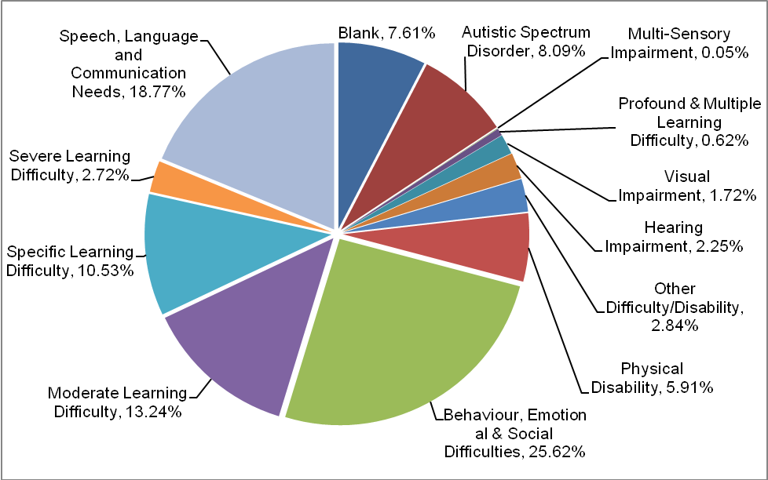
Source: Capita EMS Spring 2010, DCC CSET, CYPIT, DCC Finance, DCSF School Census January 2010

Figure 20: SEN in DCC Maintained Schools by School LLC (2008/09)
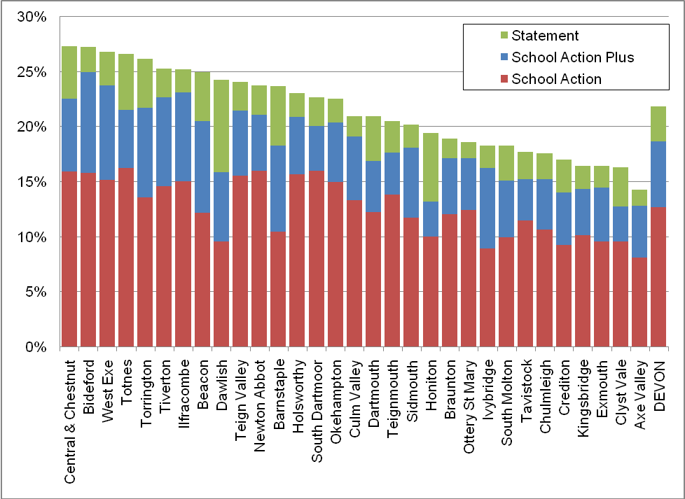
Source: DCSF School Census (Oct 08, Jan 09, May 09)

Teenage Conceptions

Health and Wellbeing implications of teenage conceptions:

Numbers of Teenage Conceptions:

The data are compiled by combining information from registrations of births and notifications of legal abortions. Conception data include pregnancies that result in: One or more live or still births (a maternity), or a legal abortion under the Abortion Act 1967. They do not include miscarriages or illegal abortions.

Teenage conception rates are expressed as follows:
Under 16: “per thousand females aged 13-15”
Under 18: “per thousand females aged 15-17”

The denominators (e.g. total female population aged 15-17 in an area) are obtained from ONS mid-year population estimates, derived from 2001 Census data. For under 18 conceptions a three-year age group only (15-17) is used as the denominator in the calculation as the vast majority of conceptions to under 18 year olds occur in this age group. Only about 5 per cent of under 18 conceptions are to girls aged 14 or under and to include younger age groups in the base population would produce misleading results (ONS).

Table 39: Under 16 Conception Number and Rate 2002-2004 to 2005-2007

Area of usual residence | 2002-2004 |  |  | 2003-2005 |  |  | 2004-2006 |  |  | 2005-2007
Area of usual residence | Number | Rate | % leading to abortion | Number | Rate | % leading to abortion | Number | Rate | % leading to abortion | Number | Rate | % leading to abortion
East Devon | 42 | 6.7 | 48 | 42 | 6.5 | 55 | 45 | 6.7 | 60% | 49 | 7.2 | 78%
Exeter | 45 | 8.4 | 47 | 39 | 7.3 | 41 | 38 | 7.1 | 55% | 48 | 9 | 58%
Mid Devon | 23 | 5.5 | 48 | 21 | 4.9 | 52 | 24 | 5.6 | 58% | 15 | 3.5 | 67%
North Devon | 29 | 5.6 | 55 | 29 | 5.6 | 52 | 26 | 5.1 | 58% | 21 | 4.2 | 52%
South Hams | 13 | 2.7 |  | 18 | 3.7 | 83 | 18 | 3.8 | 83% | 18 | 3.9 | 78%
Teignbridge | 36 | 5.2 | 81 | 40 | 5.7 | 75 | 46 | 6.5 | 72% | 53 | 7.6 | 59%
Torridge | 18 | 5 | 56 | 17 | 4.7 |  | 19 | 5.2 |  | 19 | 5.1 | *
West Devon | 5 | 1.7 |  | 6 | 2 |  | 11 | 3.6 |  | 14 | 4.5 | *
Devon County | 211 | 5.4 | 57 | 212 | 5.3 | 58 | 227 | 5.7 | 62% | 237 | 5.9 | 63%
South West | 1,777 | 6.3 | 57 | 1,836 | 6.5 | 60 | 1,843 | 6.5 | 61% | 1,900 | 6.7 | 61%
England | 22,132 | 7.8 | 57 | 22,201 | 7.7 | 58 | 21,984 | 7.7 | 58% | 22,518 | 7.9 | 60%
Source: Office for National Statistics and Teenage Pregnancy Unit
For conceptions leading to abortions, rates based on fewer than 10 events have been suppressed
Rates based on 1,000 girls aged 13-15

Both Teignbridge and East Devon have under 16 conception rates above the regional average. For 2005-07 all Devon Districts have an under 16 conception rate below the National average. Abortion rates in under 16’s range from 78% in South Hams and East Devon to 58% in Exeter. Lower abortion rates are linked to higher deprivation and greater social acceptance of young parenthood, although this link is less pronounced in the under 16 cohort than older groups.

Table 40: Under 18 Conception Number and Rate 2001-03 to 2006-2008

Area of usual residence | 2001-03 |  |  | 2004-06 |  |  | 2005-07 |  |  | 2006-08
Area of usual residence | Number | Rate | % leading to abortion | Number | Rate | % leading to abortion | Number | Rate | % leading to abortion | Number | Rate | % leading to abortion
East Devon | 150 | 24.7 | 59 | 193 | 30 | 59 | 213 | 32.3 | 63 | 236 | 34.8 | 61
Exeter | 270 | 51.3 | 39 | 256 | 46.9 | 38 | 266 | 48.2 | 41 | 260 | 47.3 | 42
Mid Devon | 127 | 32 | 46 | 112 | 26.2 | 39 | 110 | 25.5 | 42 | 115 | 26.2 | 43
North Devon | 161 | 32.4 | 46 | 169 | 32.2 | 45 | 144 | 27.6 | 49 | 143 | 27.9 | 47
South Hams | 93 | 21.3 | 45 | 96 | 20 | 61 | 99 | 20.6 | 58 | 93 | 19.7 | 54
Teignbridge | 204 | 32.1 | 53 | 223 | 31.3 | 58 | 241 | 33.5 | 54 | 266 | 37.3 | 55
Torridge | 105 | 32.6 | 47 | 93 | 25.6 | 46 | 102 | 27.3 | 42 | 112 | 29.8 | 40
West Devon | 56 | 21.2 | 45 | 73 | 24.6 | 49 | 75 | 24.5 | 53 | 73 | 23.4 | 48
Devon County | 1,166 | 31.6 | 47 | 1,215 | 30.4 | 49 | 1,250 | 30.9 | 50 | 1,298 | 32 | 50
South West | 9,530 | 35.5 | 46 | 9,706 | 33.8 | 48 | 9,961 | 34.3 | 49 | 10,038 | 34.6 | 50
England | 117,364 | 42.5 | 46 | 118,567 | 41.2 | 47 | 119,272 | 41.2 | 49 | 118,286 | 40.9 | 50
Source: Office for National Statistics and Teenage Pregnancy Unit

For 2006-08 the rate of teen pregnancy in Exeter (47.3) and Teignbridge (37.3) was higher than the regional average (36.6) with Exeter also above the national average (40.9).

Thirty wards in Devon have conception rates about the National average, the bulk of these are in Exeter and North Devon. At ward level the highest rate is in Ilfracombe Central in North Devon followed by St James, St Peter’s and Priory in Exeter. However, due to the small numbers involved, the vast majority of wards have the data suppressed to maintain confidentiality.

The table below shows the 20 wards across Devon with the highest rates of teenage conceptions, over the time period 2005-2007. “Hotspot” wards, which are in the highest 20% nationally for under 18 conceptions (rates equal to or higher than 53.3), are asterisked.

Table 41: Ward Under 18 Conception Number and Rate 2005-2007

District | Ward name | Wards ranked by rate of U18 conceptions | Wards ranked by no. of U18 conceptions
North Devon | Ilfracombe Central* | 1 | 7
Exeter | Priory* | 2 | 1
Teignbridge | Teignmouth West* | 3 | 4=
Exeter | St James* | 4 | 16=
East Devon | Axminster Rural* | 5 | 49
Exeter | Exwick* | 6 | 2
Teignbridge | Bushell * | 7 | 3
East Devon | Exmouth Town* | 8= | 8=
East Devon | Exmouth Littleham* | 8= | 6
Exeter | St Thomas* | 10 | 11
Exeter | St David's* | 11 | 56=
Mid Devon | Cranmore* | 12 | 20=
North Devon | Central Town* | 13 | 28=
East Devon | Exmouth Withycombe Raleigh | 14= | 4=
West Devon | Okehampton East | 14= | 28=
Exeter | Cowick | 16= | 14=
West Devon | Hatherleigh | 16= | 75=
Teignbridge | Buckland & Milber | 18 | 8=
Exeter | Pinhoe | 19 | 13
Mid Devon | Castle | 20 | 49=
Source: Office for National Statistics/ Teenage Pregnancy Unit supplied by NHS Devon

Figure 21: Devon Under 18 conception rate 2004-06 per 1,000 female population aged 15-17

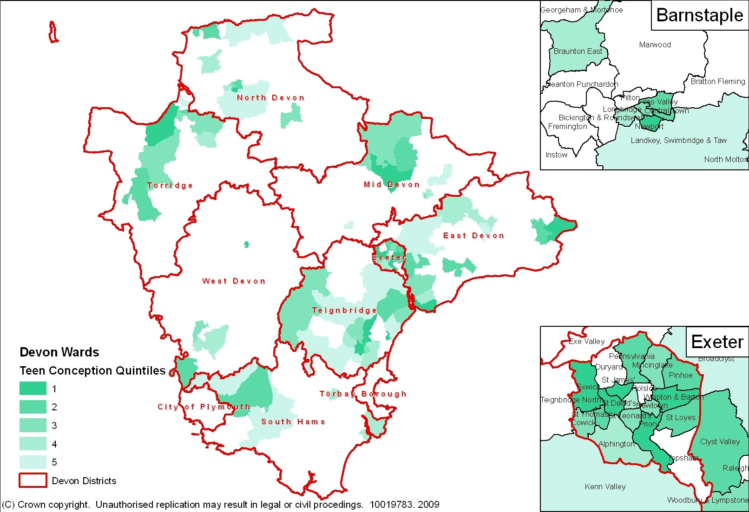
Source: Office for National Statistics/ Teenage Pregnancy Unit
Note: White areas are where the number of Conceptions was less than 5 per ward and the rate has been suppressed to retain confidentiality (© Crown Copyright. All rights reserved. Devon County Council 100019783 2009)

Teenage Parents

Numbers of Young Parents:

The number of teenage parents in Devon is unknown. There are likely to be very few teenage fathers as it is usual for the father to be older than the mother, as most teenage mothers are over 18 this means the vast majority of fathers will be over 20 at the time of their child’s birth.

Any estimate of the number of teenage mothers needs to take account not only of births to mothers under 20 occurring in the most recent year for which data are available but also any births occurring in previous years where the mother could still be under 20. For example, a 14 year old giving birth in 2004 will still be a teenage mother in 2009. Totals must also be adjusted to take account of mothers who have had more than one birth. ONS have produced estimates which suggest that there were 532 teenage mothers in Devon of which 20% were under 18.

Table 42: Estimated Number of Teenage Mothers (2007-2009)

Area | Mothers at end 2007 aged: |  |  | Mothers at end 2008 aged: |  |  | Mothers at end 2009 aged:
Area | Under 18 | Under 19 | Under 20 | Under 18 | Under 19 | Under 20 | Under 18 | Under 19 | Under 20
Devon (DCC) | 106 | 261 | 520 | 106 | 260 | 525 | 107 | 265 | 532
Plymouth | 65 | 159 | 323 | 59 | 153 | 317 | 66 | 157 | 315
Torbay | 34 | 75 | 146 | 37 | 83 | 154 | 37 | 87 | 165
England | 9,583 | 24,322 | 49,658 | 9,472 | 23,964 | 49,058 | 9,091 | 23,234 | 47,865
ONS (2011) Estimated prevalence of teenage mothers 2007, 2008 & 2009 (Estimates are derived from a DfE model using ONS VS2 births data by LA adjusted for parity)

The Department of Health has estimated that there were 1,397 teenage mothers across the Cornwall and Devon peninsula in 2009 which is very close to the ONS estimate shown above which, including Cornwall, shows an estimated 1,421 teenage mothers across the same area. In June 2009 873 teenage mothers were recorded on the Connections CCIS database, equivalent to 62.5% of the DoH estimate.

Outcomes for Young Parents and their children:

Statistically teenage mothers are shown to have significantly poorer outcomes in terms of social and mental health during the three years after the birth than older mothers or teenage non-mothers (Teenage Pregnancy Unit, 2004). Similarly, outcomes for their children are poorer.

- The majority of teenage pregnancies are unplanned and almost half end in abortion. In Devon about 8% of these are a second or subsequent abortion

- Half of all under 18 conceptions occur in the 20% most deprived wards

- Nationally 20% of teenage births to under 18’s are second pregnancies

- Among the most vulnerable girls the risk of becoming a teenage mother is almost 1 in 3

- Babies born to teenage mothers have a 63% increased risk of being born into poverty compared to babies born to mothers in their twenties.

- At age 30, teenage mothers are 22% more likely to be living in poverty than mothers giving birth aged 24 or over, and are much less likely to be employed or living with a partner

- Teenage mothers are 20% more likely to have no qualifications at age 30 than mothers giving birth aged 24 or over.

- Teenage mothers have three times the rate of post-natal depression of older mothers and a higher risk of poor mental health for three years after the birth

- The infant mortality rate for babies born to teenage mothers is 60% higher than for babies born to older mothers. The risk of stillbirth and a baby dying in the first six weeks of life is also around twice as high for women from deprived backgrounds.

- Teenage mothers are three times more likely to smoke throughout their pregnancy, and 50% less likely to breastfeed, than older mothers - both of which have negative health consequences for the child

- Children of teenage mothers and are more likely to have accidents and behavioural problems. They have lower academic attainment and are at higher risk of economic inactivity in later life

- Benefit payments to a teenage mother who does not enter employment in the first three years after birth can total between 19,000 and 25,000 over three years; the cost of a teenage pregnancy to the NHS alone is estimated to be £63m a year.

Young Carers

The Devon Young Carers project, which provides services for young carers aged 5-18, had 315 new referrals in Q1 – Q3 2009/10 with the total number of individual young carers receiving services at 741 (some carers receive more than one service). This figure is likely to represent only a small proportion of young carers. There were 1,098 carers aged 0-15 in the Devon County Council area according to the 2001 Census. Research by ONS around the Census suggested that only about 1 in 5 young carers in this age bracket were known about, which would give Devon an estimated potential 5,490 young carers aged 0-15 for 2001 in the Devon County Council area. Young carers may miss out on opportunities for example they may struggle more than their peers to find time or funds for social activities and their academic performance may be adversely affected by their caring responsibilities.

Table 43: Young Carers Receiving a Service from Devon Young Carers Project (2009/10)
Area | New Young Carers Active |  |  |  |  | Total 5-18 population | % Pop Active Young Carers
Area | Q1 | Q2 | Q3 | Q4 | Year to Date | Total 5-18 population | % Pop Active Young Carers
Teignbridge | 82 | 26 | 24 |  | 132 | 18,723 | 0.71%
South Hams and West Devon | 48 | 12 | 13 |  | 73 | 20,254 | 0.36%
East Devon | 60 | 36 | 21 |  | 117 | 18,418 | 0.64%
Exeter | 98 | 23 | 21 |  | 142 | 15,046 | 0.94%
Mid Devon | 60 | 16 | 5 |  | 81 | 12,129 | 0.67%
North Devon and Torridge | 116 | 36 | 44 |  | 196 | 23,883 | 0.82%
Devon Total (DCC) | 464 | 149 | 128 |  | 741 | 108,453 | 0.68%
Source: Devon Young Carers LC Reports 2009-10, FHSA 2009 Pop Estimates

Figure 22: Percentage of Young People aged 0-15 who provide unpaid care (2001 Census)
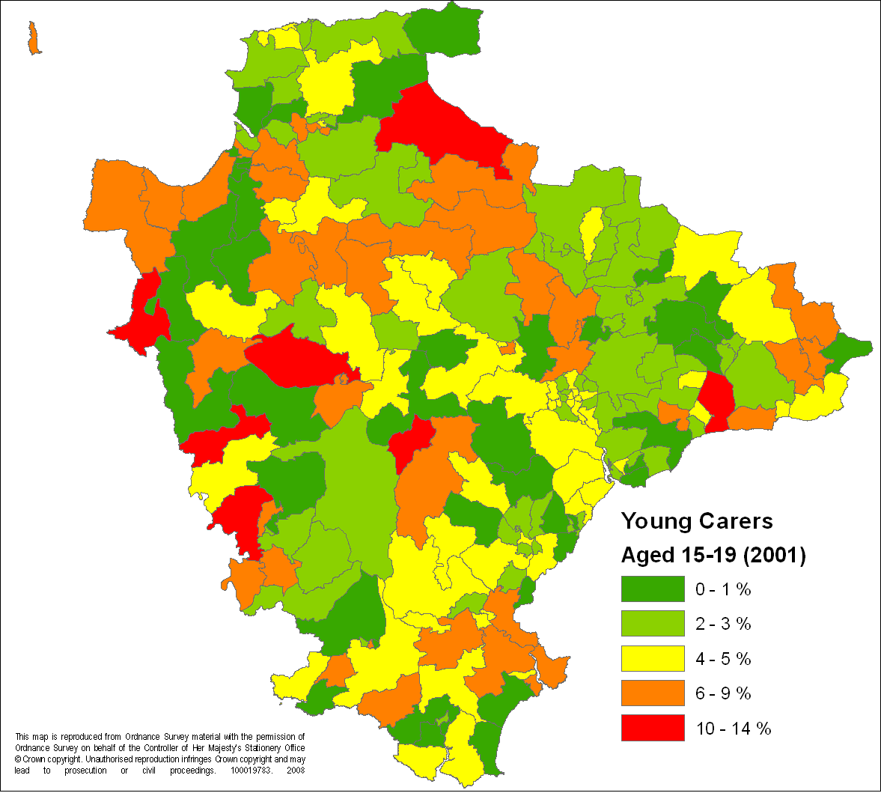
Source: ONS Census 2001, ONS (2003 ward boundaries) (© Crown Copyright. All rights reserved. Devon County Council 100019783 2009)

Achieve Economic Wellbeing

Free School Meals

Free School Meals have been used as a proxy measure for identifying deprivation in individual families. Whilst the use of this data has its flaws, it has the advantage of being ‘live’ and provides direct support to families in need. It also forms our only individual child level indicator of poverty. There is anecdotal information to suggest that families do not claim their entitlement due to the stigma attached to children receiving a free school meal or lack of knowledge about how to claim, and many young people whose parents apply for FSMs do not take up their entitlement. Take up of free school meals has increased in recent years due to an easier application process and the incentive to do so in order to access the extended schools scheme.

Parents do not have to pay for school meals if they receive any of the following:
- Income Support
- income-based Jobseeker's Allowance
- income-related Employment and Support Allowance
- support under Part VI of the Immigration and Asylum Act 1999
- the Guarantee element of State Pension Credit
- Child Tax Credit, provided they are not entitled to Working Tax Credit and have an annual income (as assessed by HM Revenue & Customs) that does not exceed £16,040
- Working Tax Credit during the four-week period immediately after their employment finishes or after they start to work less than 16 hours per week
- Children who receive Income Support or income-based Job Seeker's Allowance in their own right.

Table 44: Eligibility for Free School Meals (Jan 2010)

Sector | Area | Number on roll | No. pupils known to be eligible for free school meals | % eligible for free school meals
Nursery and Primary Schools | Devon | 52,041 | 6,031 | 11.6
Nursery and Primary Schools | South West | 368,920 | 47,820 | 13.0
Nursery and Primary Schools | England | 4,134,240 | 717,060 | 17.3
Secondary Schools | Devon | 42,740 | 4,107 | 9.6
Secondary Schools | South West | 324,430 | 30,880 | 9.5
Secondary Schools | England | 3,277,880 | 464,510 | 14.2
Special Schools | Devon | 1,035 | 192 | 18.6
Special Schools | South West | 7,570 | 2,130 | 28.1
Special Schools | England | 91,820 | 30,600 | 33.3
All Maintained Schools | Devon | 95,816 | 10,330 | 10.8
All Maintained Schools | South West | 700,920 | 80,830 | 11.5
All Maintained Schools | England | 7,503,940 | 1,212,170 | 16.2
Source: DCSF Indices of tables from schools, pupils and their characteristics, statistical first release May 2010 (based on school census returns Jan 2010)
Note: includes full time and part time pupils who are sole or dual registrations. Includes boarders.

10,334 (10.8%) of pupils were eligible for Free School Meals in January 2010 an increase of 0.8% from January 2009. The highest eligibility is in the Central and Chestnut Learning Community with 19.4% of pupils known to be eligible for free school meals in contract to only 4.0% of pupils in the Ottery St Mary Learning Community.

Figure 23: Percentage of Roll Eligible for Free School Meals: by School Attended (Spring Term 2010)

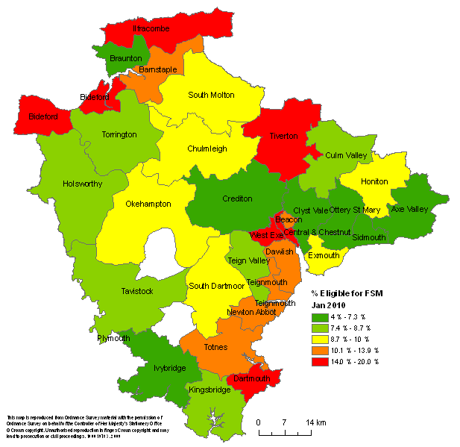
Source: DCSF School Census January 2010 (© Crown Copyright. All rights reserved. Devon County Council 100019783 2009)

Young people not engaging in employment, education or training (NEET)

The LGA and the Centre for Social Justice have jointly published a report that looks at ways of reengaging young people not who are NEET. Nationally the number of young people NEET aged 16-25 years is currently 16% (935,000) and is predicted to reach 1 million. Being persistently NEET between the ages of 16-18 can be a major predictor of later unemployment, low income, poor mental and physical health, criminal behaviour and associated other problems in later life.

Based on school attended the number of 16-18 year olds in Devon recorded as NEET has grown over the last few years from 5.9% in 2006-2007 of were recorded as NEET (1,245 young people) to 6.4% in 2007/08. For 2008/09 this number has been reduced with 1,236 young people (6.1%) being recorded as NEET. There has been an increase in those taking up learning but this has not entirely offset the effects of a fall in employment opportunities for young people in Devon.

Table 45: 16 – 18 Not in Education, Employment or Training (NEET) by District (January 2010)

Area | Number aged 16-18 | No. in Education Employment or Training (EET) | NEET | Not Known | In Learning | Job No Training | NEET %
East Devon | 3914 | 3498 | 162 | 41 | 3054 | 444 | 4.20%
Exeter | 3312 | 2768 | 275 | 38 | 2342 | 426 | 8.40%
Mid Devon | 2364 | 2062 | 125 | 29 | 1777 | 285 | 5.40%
North Devon | 3128 | 2709 | 159 | 15 | 2401 | 308 | 5.10%
South Hams | 4598 | 4191 | 144 | 36 | 3824 | 367 | 3.20%
Teignbridge | 4629 | 4161 | 161 | 45 | 3768 | 393 | 3.50%
Torridge | 1968 | 1797 | 108 | 4 | 1589 | 208 | 5.50%
West Devon | 1649 | 1472 | 65 | 18 | 1298 | 174 | 4.00%
Devon | 25562 | 22658 | 1199 | 226 | 20053 | 2605 | 4.69%
Source: Connections South West, 2010

Risk factors associated with NEET status have been well documented and the longitudinal ‘Youth Cohort Study’ has reported that only 2% of those who had five or more good GCSEs were NEET compared with 15% of those with five D to G grades and 28% of those with between one and four D – Gs. The same study reported that
27% of persistent truants and 16% of those entitled to free school meals were NEET. Whilst only 2% of young people whose parents were in professional occupations were NEET during this time period, this figure rose to 13% for those with parents in routine occupations.

Local and national research has shown that those most likely to be persistently not in education, employment and training (NEET) include:
• Children in care
• Care leavers
• Children with additional needs
• Young people with poor social skills or poor school attendance records
• Young offenders
• Young carers
• Teenage parents
• Young people who are excluded from school
• Young people brought up in workless households
• Young people with troubled home backgrounds.

Table 46: Vulnerable Groups EET and NEET in Devon (Snapshot, November 2010)

Group | Cohort | EET | NEET | Not Known | EET % | NEET %
16 - 19 Teenage Mothers | 358 | 108 | 226 | 24 | 30.2% | 67.7%
Age 19 Care Leavers | 91 | 39 | 22 | 29 | 42.9% | 35.5%
16 - 19 Learning Difficulties & Disabilities | 4,325 | 3,474 | 469 | 349 | 80.3% | 11.8%
16 - 18 Black Minority Ethnic | 470 | 420 | 32 | 12 | 89.4% | 7.0%
16 - 19 All | 30,638 | 25,126 | 1,679 | 3,763 | 82.0% | 6.2%
Source: Careers SW CCIS

Using 16-18 NEETs as a performance measure will change soon, with the Education and Skills Act 2008 legislated for the raising of the participation age so that from 2013 young people will need to remain in learning for one additional year and from 2015 to their eighteenth birthday.

Youth Unemployment

The adult unemployment rate in the south west more than doubled between June 2008 and June 2009 and 18 – 24 year olds accounted for 28.9% of all Jobseeker’s Allowance claimants whilst making up only 15.5% of the region’s working age population. This age group have been disproportionately affected by the recession and a number of policy initiatives have been put in place to try to combat the rapid rise in young people’s unemployment. These include the Future Jobs Fund, designed to offer jobs to 18 – 24 year olds who have claimed Jobseekers’ Allowance for at least 10 months and the ‘Backing Young Britain’ campaign, designed to encourage employers, including those in the public sector, to offer apprenticeships and other opportunities to younger workers.

Unemployed people aged 16 to 24 with data relating to April of each year. April is chosen as it is relatively unaffected by seasonal variations e.g. Christmas or summer work.

Table 47: Youth Unemployment (2000 – 2007)
District | 2000 | 2001 | 2002 | 2003 | 2004 | 2005 | 2006 | 2007
East Devon | 280 | 230 | 190 | 170 | 175 | 175 | 215 | 165
Exeter | 460 | 395 | 405 | 375 | 340 | 375 | 400 | 370
Mid Devon | 185 | 170 | 155 | 175 | 115 | 160 | 200 | 140
North Devon | 410 | 330 | 285 | 260 | 260 | 255 | 290 | 255
South Hams | 160 | 170 | 160 | 150 | 130 | 115 | 130 | 140
Teignbridge | 305 | 280 | 275 | 255 | 230 | 230 | 290 | 255
Torridge | 245 | 240 | 225 | 180 | 170 | 165 | 210 | 195
West Devon | 90 | 110 | 100 | 100 | 100 | 75 | 90 | 85
Devon County Council | 2,135 | 1,925 | 1,795 | 1,665 | 1,520 | 1,550 | 1,825 | 1,605
Plymouth | 1,480 | 1,095 | 1,270 | 1,360 | 1,100 | 1,340 | 1,525 | 1,345
Torbay | 555 | 620 | 560 | 575 | 480 | 465 | 565 | 540
County of Devon | 4,170 | 3,640 | 3,625 | 3,600 | 3,100 | 3,355 | 3,915 | 3,490
Source: Office for National Statistics

Stay Safe

Common Assessment Framework (CAF)

The CAF is a shared assessment tool for use across all children’s services and all local areas in England. It aims to help early identification of need and promote co-ordinated service provision. There have been 1,717 CAFs since the roll out of CAF in Devon to 1/04/2010. The rate of activity is increasing over time with 748 CAFs undertaken in the 12 months Jan 09 - Jan 10.

A research project is currently underway to examine the presenting needs of those receiving a CAF including the presence/ history of Domestic Violence, Drug and Alcohol Abuse (in young person or parents) and mental health problems (in young person or parents).

Figure 24: CAFs per 1,000 0-19 yr olds to 01/04/2010

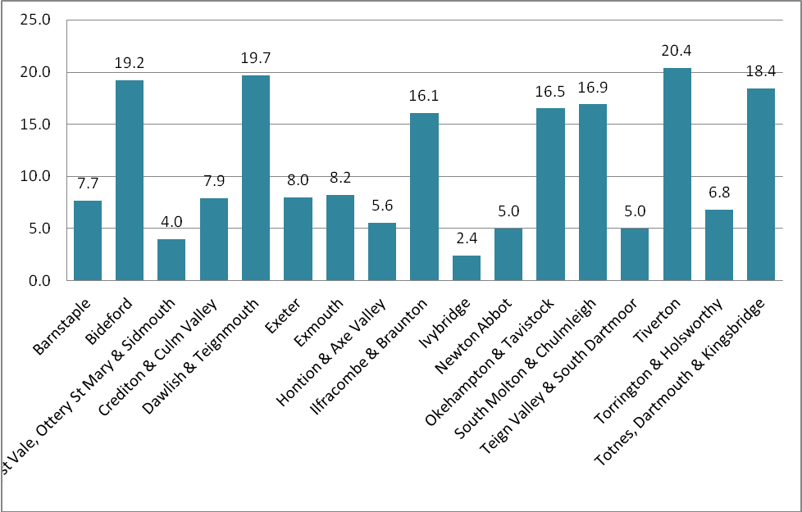
Source: CAF IT performance data April 2010
NOTE: there has been a phased roll-out of CAF across Devon and low rates may indicate a younger program

Level Three and Four – Specialist and Acute Needs

Be Healthy

Children and Young People’s Emotional and Mental Health

Good mental health and well-being is fundamental to the quality of life. Most children in Devon lead happy and healthy lives, but a minority are seriously troubled or disturbed. Nationally 10% of 5–16 year olds have clinically significant mental health difficulties — ranging from anxiety, depression, over activity, inattentiveness and anorexia — through to conduct disorders such as uncontrollable or destructive behaviour. The failure to tackle early signs of behavioural and emotional problems and conduct disorders in children results in increased offending, drugs use and violence. It was also estimated in the Good Childhood report that 60–70% of children with mental health problems do not use the relevant services.

According to the ONS mid year estimates for 2009, there were 98,090 children and young people aged 5 to 16 living in Devon. Using data from the most recent ONS survey (Meltzer et al, 2000), the following prevalence rates can be inferred: Conduct Disorders (5.3%) 5,199; Emotional Disorders (4.3%) 4,218; Being Hyperactive (1.4%) 1,373; Less Common Disorders (1.3%) 1,275

Between the ages of 11 and 16 the rates for both sexes are higher: Girls (10%) and boys (13%). The estimated number of disorders in those aged 11 to 16 year old in Devon are shown below:

Table 48: Estimated number of disorders by sex for children aged 11-16 (2009)

Disorder | Gender | Estimated Number
Conduct disorders | males | 3,014
Emotional disorders | males | 2,445
Hyperactive disorders | males | 796
Less Common disorders | males | 739
Conduct disorders | females | 1,502
Emotional disorders | females | 1,219
Hyperactive disorders | females | 397
Less Common disorders | females | 369
Source: CHIMAT CAMHS Needs Assessment (2009)

Nationally, within the general population there are some groups who are at an increased risk of having mental health needs. Among these groups are: Young People aged 16 and 17, homelessness, ethnic minority status, being a young parent, being a young carers, young offenders and persistent absentee pupils and those living apart from their father (which increased difficulties by 40%).

Within Devon the number of young people experiencing significant emotional and mental health difficulties, and the number receiving support, is hard to define. Current Child and Adolescent Mental Health Services (CAMHS) in Devon are limited in terms of their ability to interrogate the database that is used, which means that there is no definitive caseload figure for the service.

However, during a case-matching exercise in North Devon in January 2011 it was found that Northern Devon CAMHS had 789 open cases of which approximately 200 were children reviewed for medication (e.g. Ritalin annual reviews) and a smaller number those in long-term therapies, which are in a sense 'live' but may not be what would normally be described as active cases. The vast majority of the others will be actively worked. Northern CAMHS have been working over the last 2-3yrs to integrate L2 and L3 work; in order that families receive a responsive service this means that it is not possible to separate this caseload in to tier 2 and tier 3 cases.

Based on this exercise, it seems reasonable to assume a figure of around 3000+ children and young people as the typical CAMHS service caseload at any one time, as Northern Devon has usually been found to provide around 25% of the workload of most services to children and young people. It is not yet possible to indicate the proportion of those children and young people who will be over 10yrs of age, though CAMHS managers indicate that it could be between 50 and 75%. Figure 3 below shows the movement in the service-wide caseload, which is one report that can be produced from the database currently; without a baseline of overall caseload it is of limited value but it at least indicates the wide fluctuations in levels of demand on the service.

In addition, there are some voluntary sector agencies in Devon which provide counselling services to young people who are experiencing less acute forms of emotional ill-health. In 2009 for example, Young Devon provided a further 700 young people with short or longer-term support and assistance.

Suicide and Self Harm

Nationally suicide accounts for almost 12% of all deaths of people aged 15-19 years (20% of deaths from external causes), and is the second most common cause of death in young people after accidents (ONS Mortality Statistics 2008). Within Devon there have been 5 deaths from suicide and injury undetermined in those aged 15-19 over the last three years (2007-2009) representing 13% of deaths in that age group.

Based on national research it has been estimated that 7-14 per cent of adolescents will self-harm at some time in adolescence, and as many as 20-45 per cent of older adolescents say they have had suicidal thoughts.

Substance Misuse in Young People (Drug and Alcohol)

Substances are defined as illegal drugs, illicit prescription drugs, alcohol and volatile substances (NTA, 2005).

According to the 2006/07 British Crime Survey, the South West (11.1%) and the North West (11.0%) had the highest levels of any drug use amongst those aged 16-59 while the West Midlands (9.2%) and the Eastern region (9.1%) had the lowest levels (BCS, 2007).

Table 49: Under 18 Alcohol or Drug Related Hospital Admissions by Age, Devon (Apr 2005 to Mar 2009)

Age Group | No. Of Drug-Related Hospital Admissions | No. Of Alcohol-Related Hospital Admissions
13 and under | 29 | 65
Aged 14 | 12 | 87
Aged 15 | 24 | 103
Aged 16 | 26 | 309
Aged 17 | 40 | 331
Devon Total | 131 | 895
Source: Secondary Uses Service Commissioning Data Set, National Health Service, 2009

Table 50: Under 18 Drug-Related Hospital Admissions by Cause of Admission, Devon (Apr 2005 to Mar 2009)

Condition | Total
Mental and behavioural disorders due to use of cannabinoids | 39
Poisoning by narcotics and psychodysleptics (hallucinogens) | 25
Intentional self poisoning/expos to nonopiod analges antipy & antirheum | 21
Intentional self poisoning/expos narcotics and psychodysleptics (hallucinogens)NEC | 20
Mental and behavioural disorders due use other stimulants inc caffeine | 19
Drug use | 18
Mental and behavioural disorders due multiple/psychoact drug use | 11
Mental and behavioural disorders due to use of cocaine | 7
Family history of other psychoactive substance abuse | 7
Mental and behavioural disorders due to use of opioids | 6
Other | 25
Total Conditions as Cause of Admission (As multiple diagnoses appear, the incidence of these conditions is greater than the total number of admissions) | 198
Source: Secondary Uses Service Commissioning Data Set, National Health Service, 2009

Table 51: Under 18 Alcohol-Related Hospital Admissions by Main Cause of Admission, Devon (Apr 2005 to Mar 2009)

Main Alcohol Related Cause | Total
Mental and behavioural disorders due to use of alcohol | 377
Epilepsy and Status epilepticus | 163
Intentional self-harm/Event of undetermined intent | 102
Ethanol poisoning | 93
Road traffic accidents (driver/rider) | 51
Fall injuries | 34
Assault | 27
Liver Cirrhosis | 10
Cardiac arrhythmias | 7
Toxic effect of alcohol, unspecified | 7
Other | 25
Main Cause of Admission Total | 895
Source: Secondary Uses Service Commissioning Data Set, National Health Service, 2009

Younger age groups generally reported higher levels of drug use. In 2006/07, the 16 to 19 and the 20 to 24 year old age groups reported the highest levels of last year and last month use of any illicit drug. When considering Class A drugs, those aged 20 to 24 years had the highest rate of last year and last month use.

The 2006/07 BCS estimates that nationally 44.7 per cent of young people have ever used one or more illicit drugs, 24.1 per cent have used one or more illicit drugs in the last year and 14.3 per cent in the last month. The survey also estimates 16.3 per cent of those aged 16 to 24 have used a Class A drug at least once in their lifetime, 8.1 per cent have used at least one Class A drug in the previous year and 4.3 per cent in the past month (Murphy and Roe, 2007). As illustrated in the table below, based on these percentages it can be estimated that 19,337 16-24 year olds in Devon have used illicit drugs in the last year with 3,457 having done so in the last month.

Table 52: Alcohol Related Hospital Admissions in under 19’s (2005/06 – 2009/10)

Area | 2005/6 | 2006/7 | 2007/8 | 2008/9 | 2009/10 | Total
East Devon | 46 | 58 | 67 | 55 | 67 | 293
Exeter | 69 | 74 | 80 | 98 | 81 | 402
Mid Devon | 25 | 21 | 33 | 33 | 32 | 144
North Devon | 52 | 60 | 65 | 53 | 64 | 293
South Hams | 65 | 68 | 56 | 38 | 29 | 256
Teignbridge | 56 | 49 | 60 | 56 | 49 | 270
Torridge | 34 | 38 | 30 | 23 | 32 | 158
West Devon | 30 | 25 | 14 | 15 | 25 | 109
Devon Total | 377 | 394 | 406 | 371 | 377 | 1924
Source: Secondary Uses Service Commissioning Data Set, National Health Service, 2010

There were 421 young people were in drug treatment in 2008/09, the main drug for 161 of these was alcohol and for 209 it was cannabis. Children in Care amounted to 9% of those in treatment. In 2008/09 357 under 18’s were admitted to hospital with an alcohol related admission.

The implications for young people who substance misuse are that they are more likely to not attend school, not be in education or training post 16, are more prone to health issues later in life, and likely to be involved in ant-social behaviour and crime. Reducing substance misuse will lead to improved outcomes for individual young people, reduce anti-social behaviour, and improve community wellbeing.

Strengthening Families

Substance Misuse in Parents – Alcohol

Harmful drinking denotes the most hazardous use of alcohol, at which damage to health is likely. One possible outcome of harmful drinking is alcohol dependence, a cluster of behavioural, cognitive, and physiological phenomena that typically include a strong desire to consume alcohol, and difficulties in controlling drinking. It should be noted that a survey of the household population is likely to under-represent dependent adults, who are more likely to be homeless or in an institutional setting. Moreover, problem drinkers who do live in private households may, like problem drug users, be less available, able or willing to participate in surveys.

Based on national prevalence rates estimates from PANSI 6% of adults (aged 18-64) in Devon have alcohol dependency. Most recorded dependence was categorised as mild (5.4%), with relatively few adults reporting symptoms of moderate or severe dependence (0.4% and 0.1% respectively).

Table 53: Adults aged 18-64 predicted to have an alcohol problem, by gender (2010)

 | Estimated Number | % of the 18-64 Population
Devon: Males aged 18-64 predicted to have alcohol dependence | 19,227 | 8.7%
Devon: Females aged 18-64 predicted to have alcohol dependence | 7,389 | 3.3%
Devon: Total pop aged 18-64 predicted to have alcohol dependence | 26,616 | 6.0%
Source: www.pansi.org.uk version 4.0, Crown copyright 2010

Addaction South West received 2,500 referrals during 2009/10 of these 205 (8.2%) were living with partner and children, 58 (2.1%) were living alone with children and 7 pregnant women in treatment. It seems likely that this low figure reflects a low rate of disclosure with a far higher proportion of those referred actually being parents.

Substance Misuse in Parents - Drugs

Drug misuse has been defined as the use of a substance for purposes not consistent with legal or medical guidelines. In a small proportion of users, this may lead to dependence, a cluster of behavioural, cognitive, and physiological phenomena, such as a sense of need or dependence, impaired capacity to control substance-taking behaviour and persistent use despite evidence of harm.

Based on national prevalence rates estimates from PANSI 3.4% of adults aged 18-64 (4.5% of men, 2.3% of women) are predicted to be dependent on drugs. Most dependence was on cannabis only (2.5%), rather than other drugs (0.9%).

Table 54: Adults aged 18-64 predicted to have a drug problem, by gender (2010)

 | Estimated Number | % of the Population
Devon: Males aged 18-64 predicted to be dependent on drugs | 9,945 | 4.5%
Devon: Females aged 18-64 predicted to be dependent on drugs | 5,150 | 2.3%
Devon: Total population aged 18-64 predicted to be dependent on drugs | 15,095 | 3.4%
Source: www.pansi.org.uk version 4.0, Crown copyright 2010

Drug use and parenthood is a very sensitive issue. Not all drug services ask about children at assessment, and not all drug users may be prepared to give information about children early on in treatment (for example, for fear of official intervention). Consequently, the levels of missing data on the proportion of clients who are parents are considerable.

There were 1,481 adults in effective treatment in 2008/09, of which 340 (23%) were parents. This is lower than both the regional (26%) and national average (30%) for the same period (NTA). However, this only represents those who have received treatment, to measure effectiveness drug use in the general population is estimated. For 2008-09 the estimates indicate there are 2,197 problem users of opiates and/or crack cocaine (95% confidence interval 1,720 to 2,768) in the 15-64 year-old age group in Devon (NHS NTA Smoothed Prevalence Estimates). If the percentage of problem users who are parents in the wider population reflects that of the in treatment population then based on the previous methodology it could be estimated that around 250 children had a parent who was an opiates and/or crack cocaine problem drug user and not receiving treatment in 2008-09.

Mental Health Needs in Parents

Nationally as many as 9 million adults – 1 in 6 of the population – have a diagnosable mental health disorder and around 630,000 are in contact with specialised mental health services. While no official figures exist, of these, studies have estimated that up to 30 per cent have dependent children and 7 per cent live in lone parent households.

Common mental disorders (CMDs) are mental conditions that cause marked emotional distress and interfere with daily function, but do not usually affect insight or cognition. They comprise different types of depression and anxiety, and include obsessive compulsive disorder. Based on National prevalence rates estimates from PANSI 17.6% of adults (aged 18-64) in Devon have a diagnosable common mental disorder, with women (19.7%) more affected than men (12.5%).

Table 55: Adults aged 18-64 predicted to have a mental health disorder (2010)

Area | Number predicted to have a common mental disorder | Number predicted to have a borderline personality disorder | Number predicted to have an antisocial personality disorder | Number predicted to have psychotic disorder
East Devon | 11,836 | 332 | 253 | 294
Exeter | 13,077 | 365 | 287 | 325
Mid Devon | 7,225 | 202 | 157 | 180
North Devon | 8,580 | 240 | 185 | 213
South Hams | 7,936 | 222 | 171 | 197
Teignbridge | 11,895 | 333 | 253 | 296
Torridge | 6,217 | 174 | 134 | 155
West Devon | 4,966 | 139 | 107 | 123
Devon | 71,733 | 2,006 | 1,550 | 1,783
Source: PANSI based on ONS Population projections and Adult psychiatric morbidity in England, 2007: Results of a household survey

Local data is not currently collated for adults in treatment but a pilot is in place in North Devon from which some information on parental status is likely to be available in Autumn 2010. If the trends in Devon follow National prevalence trends then of the 479,548 adults aged 16-64 an estimated up to 80,000 (16.6%) could have a mental health disorder and up to 24,000 adults (30%) of these could be in families with dependent children (Data warning ESTIMATES).

Physical and Learning Disabilities in Parents

Parents with disabilities and their children may require additional support. Based on the results of the Labour Force Survey, about 12 per cent (1.7 million) of Britain’s 14.1 million parents are disabled (this definition of disability includes learning and physical disability as well as mental health and substance misuse) and 1.1 million households with dependent children have at least one disabled parent.

Based on National prevalence rates estimates from PANSI 10,752 (2.4%) adults aged 18-64 in Devon have a diagnosable learning disability. Of these a predicted 2,409 (0.5%) have a moderate or severe learning disability, this group are likely to be in receipt of support services. The percentage is slightly higher in younger adults due to increased survival rates of young people with severe and complex disabilities. It is not known how many of these adults are parents although a sample across a small number of Devon GP practises in 2009 indentified 1.7% of their clients with LD were parents. If this sample is representative of the wider adult population with LD then we might anticipate around 41 adults in Devon with a moderate or severe learning disability to be parents (Data warning ESTIMATES).

Based on National prevalence rates estimates from PANSI 48,996 (11%) adults aged 18-64 in Devon have a moderate (37,417: 8.4%) or severe physical disability (11,579: 2.6%). The percentages are higher in older age groups due to as many disabilities are associated with age, or increase in severity over time. It is not possible at this stage to estimate the number of parents in Devon who are physically disabled.

Children of Offenders

Having a parent imprisoned is likely to have negative effects on a child’s physical, emotional and social wellbeing, resulting in them being some of the most vulnerable in society. They are at risk of a number of poorer outcomes, including:
- Three times the risk of anti-social/delinquent behaviour compared to their peers
- Children are often subject to unstable care arrangements
- A higher level of social disadvantage than their peers
- About three times the risk of mental health problems compared to their peers.
- Increased risk of becoming offenders themselves (65% of boys with a convicted parent, go on to offend)

While there is a strong correlation between poorer outcomes and parental imprisonment, it is not proven that parental imprisonment causes poorer outcomes.

The Cabinet Office estimated that that there were 160,000 children with a parent in prison in 2005, this represents approximately 1.5% of all children. Applying the 1.5% prevalence of children whose parents are offenders to Devon's children’s population suggests there are could be approximately 2,400 children aged 0-19 in Devon whose parent may be imprisoned.

The table below was created using a snapshot survey during October 2009 of all prisoners in HMP Channings Wood (Newton Abbot). In addition to this was a survey of new arrivals to HMP Exeter (124 prisoners) during the same period. Collection processes are not yet sufficiently robust at HMP Exeter or HMP Dartmoor to produce any figures other than estimates.

Table 56: Children of Prisoners Estimates for Oct 2009 for Devon Prisons

 | Number of Prisoners | Number of Fathers | % of Prison Population | Fathers in Contact with Children | % of Fathers in Contact with Children | Number of Children
HMP Channings Wood | 728 | 272 | 37% | 181 | 67% | 537
HMP Exeter | 525 | 257 | 49% | 201 | 78% | 507
HMP Dartmoor | 646 | 239 | 37% | 160 | 67% | 471
Devon Prison Summary | 1899 | 768 | 40% | 542 | 71% | 1513
Source: Channings Wood all Prisoners Oct 09 snapshot; Exeter First Night Interviews of 124 prisoners during Oct 09
DATA WARNING: This is experimental data at this stage. All figures in Italics are ESTIMATES

The table above indicates that an estimated 1,513 children have a parent in prison in Devon. Of these around 10% children with a parent in Channings Wood and 50% children with a parent in Exeter are living in Devon.

Table 57: Children of Prisoners Estimates for Devon Children (2009)

 | Estimated No. of Devon Children with a parent in prison (based on 1.8 children per parent in prison) | Estimated % Devon Children with a parent in prison (based on 1.8 children per parent in prison)
All Prisoners | 768 | 0.53%
Father in Prison | 699 | 0.48%
Mother in Prison | 73 | 0.05%
Source: ONS Mid Year Population Estimates 2008, Ministry of Justice Prison Population Oct 2009; ONS Birth Rates and Local Research into Offender families
DATA WARNING: This is experimental data at this stage

In October 2009 there were 4,293 women in prison nationally. There are no women’s prisons in Devon, the nearest being HMP Eastwood Park (maximum capacity 362) near Bristol meaning that any children needing to visit their mother face at least 90 mile trip from Exeter. According to HM Inspectorate of Prisons typically around 60% of female prisoners are mothers.

Table 58: Offenders on Probation living with Children: by broad offence type (August 2009)

Broad Offence Type | Number of Offenders living with Children
Violent | 159
Theft | 90
Others | 40
Drugs | 38
Sexual | 28
Devon Total | 355
Source: Devon and Cornwall Probation OASys: Characteristics of Current Clients (sampled 25/08/2009)

These figures represent a snapshot of those offenders who were under supervision by Devon and Cornwall Probation Service as of 25/08/2009. This cohort includes those who have been put on probation rather than being jailed and those who have committed sufficiently serious crimes (such as sexual or extremely violent crimes) and have been released from prison on licence. According to the data collected 355 of the 1854 offenders were living with children at the time of conviction with 56 as the sole adult in households containing children.

Refugees, Asylum Seekers and Immigrant Families

These groups experience a range of key socio-economic and health inequalities, compounded by access issues, which may adversely affect their health and wellbeing. As these individuals and families are a disparate group who are typically hard to engage then providing an accurate picture of the numbers living and working in Devon is challenging.

Those with outstanding immigration issues such as asylum seekers, failed asylum seekers or illegal immigrants with temporary leave remain whilst their legal status is being established are required to use Contact Management (signing on at local Police Station either once a week or once a month). Based on the numbers using Contact Management within Devon there are currently (May 2010) 500 people signing with outstanding immigration issues of which approximately 350 are asylum seekers. Some of these 500 are parents but it has not been possible at this stage to identify how many or the number of dependent children in these families.

In addition to those following legal immigration processes, however, there will be some people within Devon that are not known to Immigration. This would be due to the fact that they are working illegally or have overstayed the conditions of entry and not yet come to the forces attention. The number of illegal immigrants living or working in Devon is an unknown quantity.

Stay Safe

Missing Persons

Young people who go missing are vulnerable to harm; particularly Internet Grooming, Sexual Exploitation, Drug Misuse, Crime, and Educational Disengagement.
- Around 70%, who go missing are already known to social care; either as a looked after child or with an allocated social worker.
- During this period all of these missing juveniles were successfully located.
- Most have some involvement in crime (as a victim or a perpetrator),
- Up to 80% are disengaged in education with poor aspirations

Table 59: Reported Missing Persons aged <18 (Devon County)

Date Range | Number of juvenile missing episodes reported in Devon | Number of individual juveniles involved | Number of juveniles reported missing once | Number of juveniles reported missing more than once
01/05/08 to 31/10/08 | 1032 | 519 | 360 | 159
01/11/08 to 28/04/09 | 871 | 492 | 362 | 130
Source: Devon and Cornwall Police COMPACT System

Table 60: Missing Persons aged <18 by Risk Category (Devon County)

Date Range | Number of individual juveniles involved | Number of Considered High Risk | Number of Considered Medium Risk | Number of Considered Low Risk
01/05/07 - 31/10/08 | 519 | 52 | 436 | 31
01/11/08 - 28/04/09 | 492 | 43 | 440 | 9
Source: Devon and Cornwall Police COMPACT System
High risk cases may include children under the age of 10; missing in a dangerous location such as a beach; missing from a hospital; considered to be suicide risk.

Table 61: Missing Persons aged <18 by Days Missing (Devon County)
Date Range | Number of juvenile missing episodes reported in Devon | Under 24 Hours | 24 to 48 Hours | 3 to 6 Days | 7 Days +
01/05/07 - 31/10/08 | 1032 | 757 | 186 | 72 | 17
01/11/08 - 28/04/09 | 871 | 703 | 112 | 32 | 24
Source: Devon and Cornwall Police COMPACT System
Intervention work by Devon BCU Missing Person Unit with selected young people who have gone missing has been extremly successful in reducing repeated missing insidences, on average by around 60%.

Children Referred to Social Services

There were a total of 1065 referrals for December-January 2009, which equates to a rate of 439.4 per 10,000 under 18 population, slightly down on 460.9 for October-November but higher than previous periods in 2008/09. The cumulative referral rate for 2008/9 so far has increased to 385.9 compared with the 2007/8 outturn of 350.2.

Children with a Child Protection Plan

A study conducted in 2000 for the National Society for the Prevention of Cruelty to Children
(NSPCC) based on the childhood experiences of a cohort of 18-24 year olds reported the following findings (Cawson et al, 2000)
▪ Seven percent of children experience serious physical abuse at the hands of their parents or carers during childhood.
▪ One percent of children experience sexual abuse by a parent or carer and another three percent by another relative during childhood.
▪ Five percent of children experienced sexual abuse by an adult stranger or someone they had just met.
▪ Six percent of children experience serious absence of care at home during childhood.
▪ Six percent of children experience frequent and severe emotional maltreatment during childhood.

Research for the NSPCC indicated that figures are likely to be substantially higher than the number of children with a child protection plan. The figures on for the CPR represent a snapshot of registrations whereas the NSPCC study covers a predicated prevalence across time periods. Abuse is often hidden for periods of time for a variety of reasons and as such remains absent from official records. The number of children with a child protection plan should potentially be used as a minimum benchmark of children at risk of problems as a result of abuse or neglect.

Table 62: Children in Care and with a Child Protection Plan by District (31st Dec 2009 Snapshot)

District (child's home postcode at period of care start date) | Under 18 population (2008 mid-year estimate - districts) | No. of Children In Care (31/12/2009) | Children in Care (Rate per 10,000 under 18 Pop) | No. of children with a Child Protection Plan (31/12/2009) | Child Protection Plan (Rate per 10,000 under 18 Pop)
East Devon | 24,216 | 79 | 32.6 | 43 | 17.8
Exeter | 20,803 | 175 | 84.1 | 101 | 48.6
Mid Devon | 16,576 | 39 | 23.5 | 42 | 25.3
North Devon | 18,845 | 75 | 39.8 | 54 | 28.7
South Hams | 16,139 | 50 | 31.0 | 18 | 11.2
Teignbridge | 24,998 | 83 | 33.2 | 54 | 21.6
Torridge | 12,905 | 41 | 31.8 | 24 | 18.6
West Devon | 10,678 | 30 | 28.1 | 22 | 20.6
Unknown or Non Devon Postcode | - | 29 | - | 9 | -
Devon | 145,160 | 601 | 41.4 | 367 | 25.3
Source: DCC Child Protection Performance Indicators Q4 2009/10 APA 2042SC and 2023SC
Note: A small number of children may be both in care and have a CPP

418 children were subject of a child protection plan at 31 March 2010, an increase from 303 children at 31 March 2009, a rise of 38.0%. This equates to a rate of 28.8 per 10,000 under 18 population compared with 20.8 per 10,000 in 2008/09. 16.3% of children becoming subject of a child protection plan in year to 31 March 2010 were doing so for a second or subsequent time.

Children in Care

Children in care are much more likely than the general population to have increased health and social care needs. 620 children (a rate of 42.7 per 10,000 under 18 population) were in care to Devon County Council at 31 March 2010, an increase from 539 a year earlier (a 15.0% increase). The most significant rise in numbers since 31 March 2009 is in respect of 16 and 17 year olds, following the 2009 Southwark Judgement: at 31 March 2009 20.8% of Devon's children in care were aged 16-17 years, a year later this percentage had risen to 31.6% of the care population.

Table 63: Children in Care in Devon by Age (snapshot at 30 September 2009)

Age | Number | Percentage
0 | 28 | 4.80%
1 | 24 | 4.10%
2 | 19 | 3.20%
3 | 14 | 2.40%
4 | 15 | 2.60%
5 | 14 | 2.40%
6 | 12 | 2.10%
7 | 16 | 2.70%
8 | 16 | 2.70%
9 | 23 | 3.90%
10 | 21 | 3.60%
11 | 27 | 4.60%
12 | 36 | 6.20%
13 | 47 | 8.00%
14 | 53 | 9.10%
15 | 72 | 12.30%
16 | 86 | 14.70%
17 | 62 | 10.60%
Total | 585 | 100.00%
Source: Carefirst, IDS

Private Fostering

In addition to children in fostering arrangements through a local authority, there are also children and young people in Devon being cared for under private fostering arrangements. A privately fostered child is defined as one under the age of 16 (18 if disabled) who is cared for by someone other than a parent or close relative for more than 28 days as defined in section 105 of the Children Act 1989. Private foster carers may be from an extended family, such as a cousin, a friend of the family, or other non-relative, or someone unknown who has advertised to offer to privately foster a child. Parents and carers have a legal duty to notify the local authority when entering into a private fostering arrangement, despite this legal duty notification rarely happens.

Privately fostered children are a diverse and potentially vulnerable group. Privately fostered children are diverse and include teenager’s sofa surfing, children sent from abroad to stay with another family whilst undertaking a summer school in Devon and children and young people fostered to allow their parents to work abroad. 29 children were in private fostering arrangements at 30 September 2009; numbers have remained relatively constant throughout the year.

Table 64: Number of notifications of new private fostering arrangements received (year to 30 Sept 2009)

Private Fostering | Jan - Mar 09 | Apr - Jun 09 | Jul - Sept 09
Number of Notifications | 76 | 60 | 76
Initial Visit Carried Out | 30 | 24 | 47
% of Initial Visits Carried out within 7 days | 35.5% | 23.3% | 42.1%
Source: Devon Performance Monitoring Report 2009-10 Q2 Child Protection
Note: This includes notifications that were received during the year but relate to arrangements that began/were scheduled to begin outside the year and those arrangements notified after the arrangement had already started.

Unaccompanied Asylum Seeking Children

The United Nations High Commissioner for Children defines unaccompanied children as: those who are separated from both parents and are not being cared for by an adult who, by law or custom, has the responsibility to do so. These children may be amongst the most traumatised and vulnerable children known to social services and as such are likely to require complex interventions.

Nationally 3,700 Unaccompanied Asylum Seeking Children started to be looked after during the year ending 31 March 2009, 100 of these in the South West. This measure has only been subject to statutory reporting since 2009. As of December 2009 there have been less than five recorded cases within Devon.

Forced Marriage

A forced marriage is a marriage lacking the free and full consent of both parties where duress is a factor. Forced marriages are different to arranged marriages. In an arranged marriage, the family will take the lead in arranging the match but couples have the choice as to whether or not to proceed with the marriage. With forced marriages there is no choice. Forced marriage is not condoned by any religion. It is a form of domestic violence and an abuse of human rights. Victims of forced marriage are often subjected to physical and emotional abuse and rape.

There have been two incidents of forced marriage reported to Devon and Cornwall Police (Source D&C Police 2010).

‘Honor’ Based Violence

‘Honour’ based violence (HBV) is a collection of practices used to control behaviour within families using the excuse of protecting perceived cultural and religious beliefs and/or ‘honour’. Women are predominantly (but not exclusively) the victims of HBV.

There have been two cases of honor based violence reported to Devon and Cornwall Police, and numerous other incidents of violence within a family which could be regarded within this definition (Source D&C Police 2010).

Female Genital Mutilation (FGM)

Female genital mutilation (FGM) comprises all procedures involving the partial or total removal of the female external genitalia or other injury to the female genital organs for non-medical reasons. There are four types of FGM ranging from a symbolic prick to the vagina to the fairly extensive removal and narrowing of the vagina opening. In the UK all forms of FGM are prevalent. Many girls and women die from the short term effects of FGM and many more suffer lifelong disability and may die from the long-term effects.

FGM may be performed between the age of a few days through to adolescence or young motherhood. Six to ten years is a commonly selected age. The figure below lists the difficulties of identifying females at risk of FGM and key risk factors.

Figure 25: Identifying girls and young women at risk of Female Genital Mutilation

This is difficult because:
• it happens only once
• parents may believe FGM is a good thing to do for their daughters
• the genitalia of girls are rarely examined
• it is not culturally acceptable for girls to talk openly about FGM.

There is a risk if:
• the girl’s mother or her older sisters have been cut
• mother has limited contact with people outside of her family
• the paternal grandmother is very influential within the family
• mother has poor access to information about FGM
• no one talks to the mother about FGM
• health, social service and education staff fail to respond appropriately
• communities are given the impression that FGM is not taken seriously by the statutory sector.
Source: Adapted from Foundation for Women’s Health, Research and Development (FORWARD) training pack.

Globally the majority of cases of FGM are carried out in 28 African countries. In some countries, (e.g. Egypt, Ethiopia, Somalia and Sudan), prevalence rates can be as high as 98 per cent. In other countries, such as Nigeria, Kenya, Togo and Senegal, the prevalence rates vary between 20 and 50 per cent. It is more accurate however, to view FGM as being practised by specific ethnic groups, rather than by a whole country, as communities practising FGM straddle national boundaries. FGM takes place in parts of the Arabian Peninsula, i.e. Yemen and Oman, and is practised by the Ethiopian Jewish Falashas, some of whom have recently settled in Israel (FORWARD, 2002). It is also reported that FGM is practised among Muslim populations in parts of Malaysia, Pakistan, Iraq, India, Indonesia, United Arab Emirates and the Philippines.

As a result of immigration and refugee movements, FGM is now being practised by ethnic minority populations in other parts of the world, such as USA, Canada, Europe, Australia and UK. FGM was made illegal in the UK under the 1985 Prohibition of Female Circumcision Act this includes removing a young woman from the country in order to have the procedure performed abroad, and encouraging them to self mutilate. Despite this, evidence suggests that it still takes place. The majority of those living in UK who have experienced FGM, or are at risk of being cut, come from specific countries mentioned previously or have continuing links to them. While estimations of FGM prevalence are essentially speculative, researchers from FORWARD (an FGM-focused NGO) estimates there are 86,000 first generation immigrant refugee/asylum seeking women and girls in the UK who have undergone FGM and that as many as 6,500 girls are at risk of FGM within the UK every year. These young women are often taken to their countries of origin so that FGM can be carried out.

There have been no cases of female genital mutilation reported to Devon and Cornwall Police. This is not surprising given that this crime is most unlikely to be reported to the police (Source D&C Police 2010).

Given the fact that FGM is practised by specific ethnic groups it is not realistic to attempt to provide an estimated prevalence rate for Devon. Of those attending Devon maintained schools around 200 young women’s recorded ethnicity (0.27% of the roll) broadly relates to one of the risk groups (i.e. African or Indian). Further breakdown to determine how many of these young women are from the relevant specific ethnic groups who practise FGM is not possible.

Domestic Violence and Abuse

Domestic violence is a major problem for all Children’s Trust Partners. There is a considerable and growing body of research which highlights the significant impact domestic violence has on the health and wellbeing of adults and children. Domestic violence cuts across all agencies and themes, health, housing, crime children and young people.

Domestic Violence is “Any incident of threatening behaviour or abuse (psychological, physical, sexual, financial or emotional) between adults who have been intimate partners or family members, regardless of gender or sexuality”.

Domestic violence also affects those people who are not being directly abused. It harms children, damages family relationships and causes friendships to break down. The costs to the survivor and those around them are extensive. An analysis of 10 separate domestic violence prevalence studies by the Council of Europe showed that 1 in 4 women experience domestic violence over their lifetimes, and between 6-10% of women suffer domestic violence in a given year (Council of Europe, 2002). The issue of children living with domestic violence is now recognised as a matter for concern in its own right by both Government and key children’s services agencies. In approximately 50-60% of domestic violence cases there is also child abuse involving the same abusive partner. Domestic violence has been identified as a key cause of miscarriage or still birth and of death during childbirth. Pregnancy is often a time where domestic violence either begins or intensifies. One study found that that 30% of domestic violence starts during pregnancy (Lewis et al 2001). National statistics show that up to one third of child protection registrations result from children experiencing or witnessing domestic violence. Nationally nearly three quarters of children subject to child protection plans live in households where domestic violence occurs. Serious injury or deaths occur as a consequence of domestic violence (Reder and Duncan, 1999).

The three central imperatives of any intervention for children living with domestic violence are:
- To protect the children
- To empower the victim to protect themselves and their children
- To hold the abusive partner accountable for their violence and provide them with opportunities to change

One of the key pieces of information available on Domestic Abuse are statistics collected by police on reported Domestic Abuse incidents, although it should be noted that as the vast majority of cases are not reported, this only represents a small proportion of domestic abuse cases. Research commissioned by the Devon Domestic Violence Partnership applying accepted prevalence levels, estimated the real scale of the problem would mean that there are something like 33,000 incidents occurring in Devon each year compared to a reported rate of close to 9,000.

Over the last three financial years there were almost 27,000 reported incidents over the three year period, with over 13,000 with children present. Children were present at just under half of all domestic abuse incidents. The number of reported incidents has increased in recent years, and now stands at around 800 per month. The number of incidents where children are present is also increasing, standing at just below 400 per month in 2009/10.

Table 65: Number of Reported Domestic Abuse Incidents where children were present (2006/07-2009/10)

Area | 2006/7 | 2007/8 | 2008/9 | 2009/10 | 2009/10 %
East Devon | 586 | 606 | 638 | 574 | 43%
Exeter | 950 | 976 | 1133 | 945 | 44%
Mid Devon | 417 | 394 | 434 | 414 | 48%
North Devon | 733 | 701 | 654 | 747 | 50%
South Hams | 313 | 283 | 352 | 283 | 55%
Teignbridge | 722 | 768 | 683 | 710 | 43%
Torridge | 352 | 359 | 403 | 391 | 47%
West Devon | 175 | 203 | 207 | 195 | 47%
Devon (DCC) Total | 4,248 | 4,290 | 4,504 | 4,259
% of all DV incidents | 49% | 48% | 48% | 47%
Source: Devon and Cornwall Police ‘Crimed’ Domestic Violence Incidents Data record on CIS with Mo Code DV1

2,847 of domestic abuse crimes were brought to justice by Devon district for the last three years. Given that the 27,000 incidents reported to police in the same period only represent the tip of the iceberg for domestic abuse, this highlights that only a very small proportion of cases end in prosecution and remediation.
In 2009/10 almost a quarter of reported violent crime incidents in Devon were domestic violence related, with the highest proportions seen in East Devon (28.1%) and West Devon (26.3%), and the lowest seen in Exeter (17.9%), where the overall violent crime is higher than the other districts. Across England and Wales 14% of violent crime is domestic (Home Office, 2010), giving Devon a substantially higher proportion of domestic related violent crime.

Among women, risks of domestic violence do not differ significantly by ethnic origin: about 4% of women of all ethnic groups said that they had been a victim of domestic violence in 1995 (Home Office Research Study 191, 1999).

Family Support Services

The Table below identifies level 3 complex cases receiving services from Social Care Family Support Services. These are families not children so actual numbers of children reach is likely to be higher.

Table 66: No. Complex Cases receiving Family Support Services (08/2009 – 04/2010)

Area | 2009/08 | 2009/09 | 2009/10 | 2009/11 | 2009/12 | 2010/01 | 2010/02 | 2010/03 | 2010/04 | Total (Aug 2009 - April 2010) | Estimated Total No. of Households | % of Households Receiving Family Support Services
East Devon |  | 16 | 9 | 7 | 7 | 16 | 15 | 18 | 4 | 92
Exeter |  | 30 | 39 | 32 | 25 | 32 | 39 | 39 | 17 | 253
Mid Devon |  | 7 | 12 | 12 | 8 | 14 | 8 | 19 | 6 | 86
North Devon | 1 | 17 | 8 | 23 | 11 | 16 | 12 | 11 | 11 | 110
South Hams | 1 | 7 | 7 | 9 | 5 | 1 | 3 | 7 | 6 | 46
Teignbridge | 1 | 9 | 17 | 22 | 18 | 18 | 18 | 20 | 9 | 132
Torridge |  | 8 | 6 | 10 | 7 | 2 | 9 | 11 | 6 | 59
West Devon |  | 4 | 6 | 6 | 5 | 6 | 7 | 3 | 4 | 41
Torbay |  | 1 |  | 2 |  |  |  |  |  | 3
Plymouth |  | 1 |  |  |  |  |  |  |  | 1
Undefined |  | 7 | 3 | 7 | 4 | 3 | 6 | 8 | 1 | 39
Total | 3 | 107 | 107 | 130 | 90 | 108 | 117 | 136 | 64 | 862
Source: Carefirst Family Support Allocation Forms 2010

Young Homelessness

In common with the trends across England, there has been a reduction in the number of young people to whom housing authorities accept a homeless duty to. This reduction stems from a change in practice using prevention methods and resources to resolve homelessness. It does not mean that youth homelessness has been resolved or that young people are no longer in housing need (Children’s Trust Housing Steering Group, 2008). What it does mean though is Housing Authorities and Local Authorities now see that to resolve homelessness in the long term it is more than just putting a roof over a young person’s head, that a package of holistic support is necessary to ensure a young person has a better opportunity for a successful transition into adulthood.

Nationally The Experiences of 16/17 year olds accepted as homeless under the Housing Act 1996 (DCLG, 2007).
%
  - NEET (Five times as likely to be as peers) 57
  - Being suspended or excluded from school 54
  - Anxiety, depression or other mental health problems 52
  - Running away for more than 1 night 47
  - Parent(s) having mental health problems 44
  - Parents being violent to each other 40
  - Involvement in crime / ASB 39
  - Substance use problem 37
  - Having their own social worker 28
  - Being sexually abused 17
  - Being on the Child Protection Register 12
  - Had dropped out of learning or work since homelessness 34

In Devon 2008/09
- 433 16/17 year olds approaching housing advice for assistance
- 304 young people approached a YES centre for housing advice and assistance
• The Housing Authorities referred 103 16/17 year olds into Supported Housing in a 12 month period (as of June 2009 there were 96 16/17 year olds in Supported Housing)
• The Housing Authorities found 15 16/17 year olds intentionally homeless in a 12 month period
• The Housing Authorities accepted a homeless duty to 13 16/17 year olds in a 12 month period
• The housing Authorities and voluntary sector have used mediation/negotiation and advice for 302 16/17 year olds to either return home or make the their own arrangements

Table 67: Statutory Homelessness Acceptances for 16-17 year olds and 18-21 year old care leavers

Area | 2005-2006 Financial Year | 2006- 2007 Financial Year | 2007-2008 Financial Year | 2008-2009 Financial Year | Total
East Devon | 21 | 10 | 11 | 2 | 44
Exeter | 37 | 23 | 2 | 4 | 66
Mid Devon | 22 | 14 | 3 | 3 | 42
North Devon | 4 | 6 | 11 | 2 | 23
South Hams | 7 | 3 | 3 | 1 | 14
Teignbridge | 6 | 7 | 1 | 0 | 14
Torridge | 5 | 0 | 1 | 0 | 6
West Devon | 3 | 2 | 0 | 1 | 6
Devon CC Area | 105 | 65 | 32 | 13 | 215
Source: LPSA Quarterly Monitoring 04/2005 to 03/2009

Young Homeless becoming Children In Care

The House of Lords Judgment on the case R(G) v Southwark LB has led to a legal clarification concerning which statutory agency has the legal responsibility for housing and supporting 16and 17 year olds who are homeless. The judgement confirmed that local authorities should presume that any lone, homeless child should be provided with accommodation under section 20 of the Children Act 1989 unless the child is not in the local authority judgment, a child “in need”.

The total number CYPS would potentially have been accommodating under section 20 in 08/09 would have been: 131 16/17 year olds. However in the same year 302 young people returned home or made the their own arrangements, supported by housing authorities and the Voluntary sector, without making a homeless application or needing supported housing/lodgings. From June 2009- Dec 2009 CYPS accommodated 67 young homeless people under section 20 of the Children Act 1989. Whilst the figure of 131 reflects the number of young people who the Housing Authorities provided accommodation for it also looks set to reflect the number that CYPS may have to accommodate under the Southwark Ruling. However, not all the young people who are looked after will qualify for a service from the care leaver’s teams as they may not spend 13 weeks or more “looked after”.

Table 68: Young People presenting as homeless to Devon Districts (July 09- Dec 09)

Area | Numbers of 16/17 and Care Leavers Approaches as homeless | Age |  | Gender |  | Family Breakdown as the cause of homelessness
East Devon | 58 | 16  17  C/L | 14  39  5 | M  F | 26  32 | 29
Exeter | 105 | 16  17  C/L | 34  59  12 | M  F | 61  44 | 50
Mid Devon | 27 | 16  17  C/L | 9  18  0 | M  F | 10  17 | 12
North Devon | 22 | 16  17  C/L | 8  13  1 | M  F | 3  19 | 17
South Hams | 13 | 16  17  C/L | 7  2  4 | M  F | 5  8 | 6
Teignbridge | 26 | 16  17  C/L | 3  19  4 | M  F | 14  12 | 11
Torridge | 24 | 16  17  C/L | 5  14  5 | M  F | 12  12 | 12
West Devon | 20 | 16  17  C/L | 1  9  10 | M  F | 7  13 | 11
Devon CC Area | 295 | 16  17  C/L | 81  173  41 | M  F | 138  157 | 148
Source: supplied to the Children’s Trust Housing Steering Group LAA 27 Theme 2 Improving Housing Options for Vulnerable People

- Relationship breakdown/ parental eviction were cited as the main reason for homelessness (58%). This echoes the findings in the DCLG research which reported relationship breakdown as the cause of homelessness in 70% of cases amongst 16-17 year olds (DCLG, 2007).
- 27 young people became homeless due to fleeing violence, recently the NSPCC have released data on the numbers of teenagers experiencing violent relationships nationally, suggesting violence is a significant issue in the lives of vulnerable young people
- Out of the 295 young people who presented as homeless, 64 were supported to stay at home/remain in placement without Social Work intervention
- Out of the 295 young people who presented as homeless, 76 moved into supported lodgings and supported housing

Homelessness and Risk of Homelessness in Families

The table below sets out the number of households found to be eligible by Local Authorities (under the Housing Act 1996) across Devon for assistance, being unintentionally homeless and in priority need between July 2008 and June 2009 (col 1). It then sets out how many of these households had dependent children both as a number (col 2) and as a percentage (col 3). The table also shows how many households were living in temporary accommodation between July 2008 and June 2009 (col 4), and again how many of these households had dependent children as a number (col 5), and as a percentage (col 6).

Temporary accommodation refers to accommodation arranged by the Local Authority for example in Bed & Breakfasts, Hostels, Local Authority accommodation and Private Sector accommodation. Dependent children is defined as 0 - 16, or 0 - 18 if the child(ren) are still dependent (i.e. in FT training).

Table 69: Homelessness and Temporary Accommodation (July 2008 and June 2009)
Area | No of applications accepted for assistance, being unintentionally homeless and in priority need  (Col 1) | No of applications accepted with dependent children  (Col 2) | % of households accepted with dependent children  (Col 3) | No. of households living in temp acc (Col 4) | No. of households living in temp acc with dependent children  (Col 5) | % of households living in temp acc with dependent children  (Col 6)
East Devon | 68 | 44 | 65% | 384 | 331 | 86%
Exeter | 113 | 74 | 65% | 700 | 578 | 83%
Mid Devon | 15 | 5 | 33% | 108 | 71 | 66%
North Devon | 26 | 14 | 54% | 31 | 17 | 55%
South Hams | 27 | 21 | 78% | 232 | 176 | 76%
Teignbridge | 41 | 22 | 54% | 117 | 91 | 78%
Torridge | 9 | 6 | 67% | 22 | 21 | 95%
West Devon | 37 | 21 | 57% | 69 | 44 | 64%
Devon | 336 | 207 | 62% | 1663 | 1329 | 80%
England | 48,410 | 27760 | 57% | 263840 | 203110 | 77%
Sourced from Communities.gov.uk (Sept 2009)

Young Offenders

The Devon Youth Offending Team worked with 1402 youth offenders in 2008, of these 860 of these were first time offenders (In 2009 the number of first time offenders dropped to 635), 400 repeat offenders and 142 were persistent offenders. The total client numbers for Devon YOT includes 55 youth offenders who are not included in the district figures. This exclusion is either due to residency outside the DCC area; the address provided not being recognised (e.g. incorrect postcode); or the offender being recorded as “No Fixed Abode”.

Figure 26: First Time and Persistent Youth Offenders (rate per 1,000 aged 10-17) by Devon Town 2008

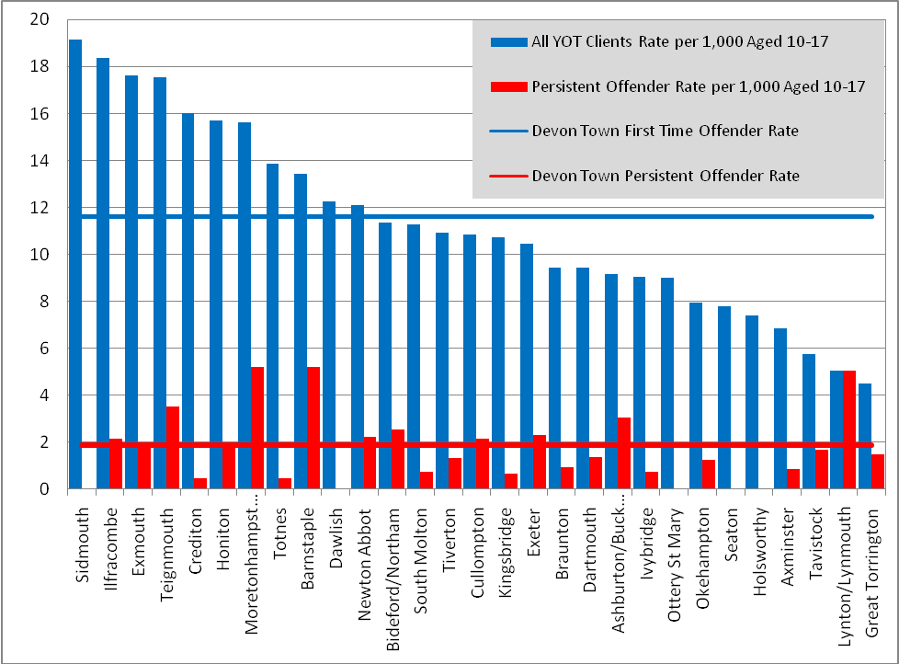
Source: DCC Youth Offenders Team, 2009

The table below shows the number of youth offenders living in Devon as a proportion of the youth population (aged 10-17). The population is calculated using the FHSA 2008 population estimates, which are based on GP registrations. This rate, of course, is only a reflection of convicted youth offenders and, as such, could be as much a reflection of variations in detection rates as it is in variation in the distribution of offenders.

Table 70: First Time and Persistent Youth Offenders (rate per 1,000 aged 10-17) by District 2008

Area | First Time Offender Rate /000 | Persistent Offender Rate/000
East Devon | 13.80 | 1.07
Exeter | 10.76 | 2.48
Mid Devon | 12.72 | 1.40
North Devon | 13.16 | 3.42
South Hams | 10.56 | 0.70
Teignbridge | 12.45 | 2.25
Torridge | 9.23 | 1.72
West Devon | 6.50 | 1.53
DCC Total | 11.62 | 1.87
Source: Devon Youth Offending Team 2008 and FHSA (2008)

Figure 27: First Time Youth Offender Rate (per 1,000 aged 10-17) 2007-2009 by Devon Ward

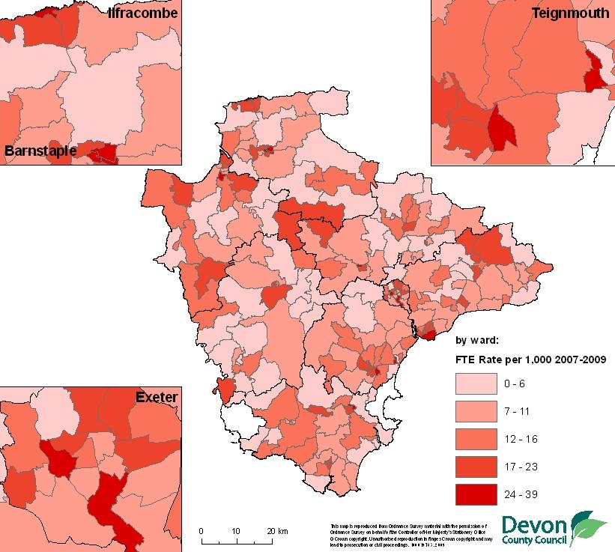
Source: Youth Offending Team, DCC and FHSA (2009),
ONS (2003 ward boundaries) (© Crown Copyright. All rights reserved. Devon County Council. 100019783 2009)

These individuals are likely to have a complex mix of needs including additional mental health needs. The prevalence rates of mental health problems in young people in contact with the criminal justice system which is at least three times as high as for those within the general population is estimated to range from 25 percent to 81 percent, with it being highest for those in custody (MHF, 2002).

Youth Anti Social Behaviour

Information on Youth Anti Social Behaviour in Devon (YSAB) represents a summary of a report by Strategic Intelligence using the latest available police data log. The police log data on YASB is taken from the log data on all Anti Social Behaviour (ASB) in Devon for the period 1st April 2007 to 31st March 2008. The data extracted for this profile has been that which falls into the categories, as indicated by the value in the field Tertiary Qualifier on the log, that broadly define rowdy, nuisance or inconsiderate behaviour. The actual identity of the perpetrator is not known so the age is based on the viewpoint of the reporting person. This introduces an element of subjectivity that it is not possible to counter.
- There were 31,231 incidents of ASB in 2007/08, of which 11,090 were identified as youth related
- The highest levels of Youth ASB were in Exeter, with 2,542 incidents (23% of the total), Teignbridge (1,998, 18%) and North Devon (1,657, 15%)
- West Devon (568, 5%) and Torridge (778, 7%) experienced the lowest levels
- Using the rate of incidents per head of population aged 10-17, Exeter still experienced the highest level of Youth ASB with a rate of 26.32 incidents per 100 head. This represented a relative level of 22% compared to the rates in each district
- North Devon remained at about the same level using this measure (17.15, 14%), Teignbridge showed a less significant level (16.05, 13%)
- West Devon and Torridge, districts with the lowest levels of population of aged 10-17, each showed a relative increase using this measure, showing levels of 9% and 10% respectively
- Using the IMD index, LSOAs in Band 1 experienced 3,091 incidents, approximately five times as many incidents as the number experienced by LSOAs in Band 9 (603)
- Using the IDACI index, LSOAs in Band 1 experienced 2,903 incidents, just under five times as many incidents as the number experienced by areas in Band 9 (597)

Appendices

Datasets planned for subsequent inclusion:

Demographic

Be Healthy
Dental Health
Physical Activity
Health Promotion
Smoking
Hospital Admissions

Stay Safe
Bullying
Accidental Injury and Death (PCT – excluding road)
Vulnerable Parents: Disabilities

Enjoy and Achieve
Attainment Gap – Gender, lowest 20%
Enjoying school
Parental engagement
Early Years provision

Achieve Economic Wellbeing
Childcare
Transport
Results at 19 for level 2 and 3
A-Level Results
Post-16 education
Achievement Post 18 (including General Population, University, Employment and NEET. Achievement of Care Leavers (do they have a transition plan, NEET, etc.) Achievement SEN – SEN to non SEN achievement and attainment gap)
Safe Housing

Make a Positive Contribution
Team around the child
Further Education – Exeter data

Abbreviations and Acronyms

AHC Income After Housing Costs in government poverty measure
BCS British Crime Survey
BHC Income Before Housing Costs in government poverty measure
BME Black Minority Ethnic
CAF Common Assessment Framework
CWI Child Wellbeing Index
CYPS Children and Young People’s Services
DAAT Drug And Alcohol Team
DCC Devon County Council
DCLG Department for Communities and Local Government
DCSF Department for Children, Schools and Families (www.dcsf.gov.uk/ )
DfE Department for Education
DLA Disability Living Allowance
DT/Pol diphtheria, tetanus, and polio vaccine
DTaP/IPV/Hib Diphtheria, Tetanus, pertussis/polio/Hib Vaccines
DWP Department of Work and Pensions
EHE Elective Home Education
FGM Female genital mutilation
FHSA Family Health Service Authority
FSM Free School Meals
HMP Her Majesties Prison
IDACI Income Deprivation Affecting Children Indices
ID 2007 Index of Multiple Deprivation 2007
IB/SDA Incapacity benefit/ severe disablement allowance
IS Income Support
IMD Index of Multiple Deprivation
JSA Job Seekers Allowance
KS Key Stage – School Tests, KS1 and 2 at primary and KS4 (GCSE) KS5 (A-level)
LLC Local Learning Community
LPSA Local Public Service Agreement
LSOA Lower Super Output Area
MenC Meningitis C Vaccine
MMR Measles, Mumps and Rubella vaccine
ONS Office for National Statistics (www.statistics.gov.uk/ )
NCHOD National Centre for Health Outcomes Development (www.nchod.nhs.uk )
NCSP National Chlamydia Screening Program (www.chlamydiascreening.nhs.uk )
NEET Not in Education, Employment or Training
NHS National Health Service
PANSI Protecting Adult Needs Service Information System (http://www.pansi.org.uk/ )
PC Pension Credit
PCV Pneumococcal conjugate vaccine
SEN Special Educational Needs

Devon Geographies

Figure 28: Map of Devon Geographies
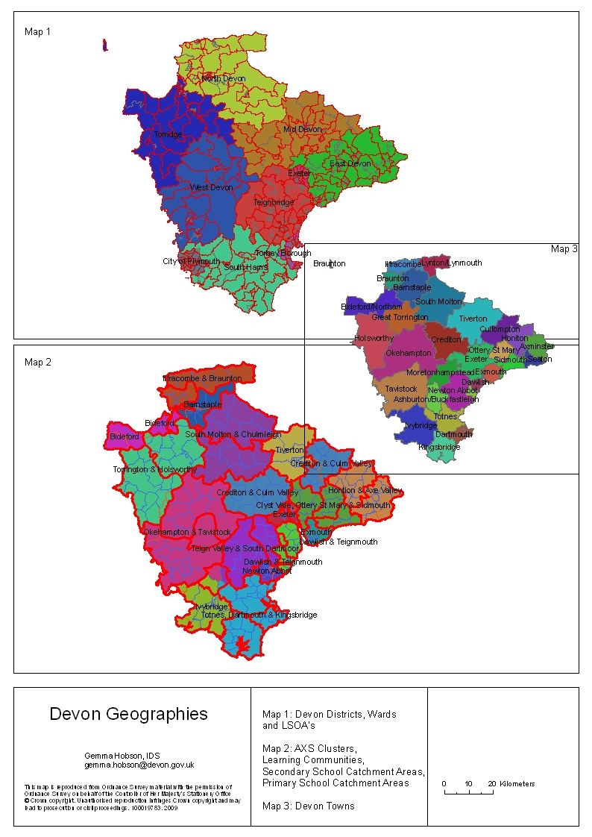
(© Crown Copyright. All rights reserved. Devon County Council. 100019783 2009)
Figure 29: Devon Geographies

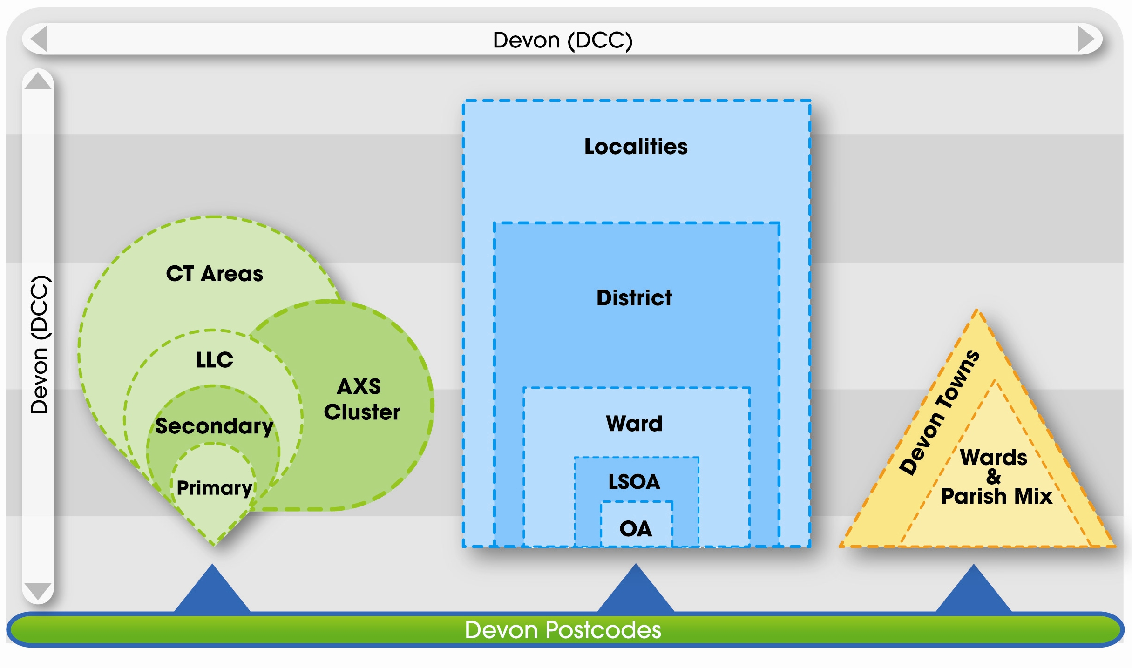
Source: DCC IDS

Statistical Neighbours

Comparisons with statistical neighbours will be available for some of the indicators used in this report

Table 71: Devon’s Closest Demographic Neighbours

Rank (1=Closest) | Name | "Closeness"
1 | Somerset | Extremely Close
2 | Shropshire | Extremely Close
3 | Suffolk | Extremely Close
4 | Cornwall | Extremely Close
5 | Dorset | Extremely Close
6 | Herefordshire | Extremely Close
7 | Gloucestershire | Very Close
8 | Norfolk | Very Close
9 | East Sussex | Very Close
10 | Worcestershire | Very Close

MOSAIC Group Descriptions, with hyperlink to detailed profile
Code | Public Sector Name | Private Sector Label | Link
A01 | Financially successful people living in smart flats in cosmopolitan inner city locations | Global Connections | DESC
A02 | Highly educated senior professionals, many working in the media, politics and law | Cultural Leadership | DESC
A03 | Successful managers living in very large houses in outer suburban locations | Corporate Chieftains | DESC
A04 | Financially secure couples, many close to retirement, living in sought after suburbs | Golden Empty Nesters | DESC
A05 | Senior professionals and managers living in the suburbs of major regional centres | Provincial Privilege | DESC
A06 | Successful, high earning couples with new jobs in areas of growing high tech employment | High Technologists | DESC
A07 | Well paid executives living in individually designed homes in rural environments | Semi-Rural Seclusion | DESC
B08 | Families and singles living in developments built since 2001 | Just Moving In | DESC
B09 | Well qualified couples typically starting a family on a recently built private estate | Fledgling Nurseries | DESC
B10 | Financially better off families living in relatively spacious modern private estates | Upscale New Owners | DESC
B11 | Dual income families on intermediate incomes living on modern estates | Families Making Good | DESC
B12 | Middle income families with children living in estates of modern private homes | Middle Rung Families | DESC
B13 | First generation owner occupiers, many with large amounts of consumer debt | Burdened Optimists | DESC
B14 | Military personnel living in purpose built accommodation | In Military Quarters | DESC
C15 | Senior white collar workers many on the verge of a financially secure retirement | Close to Retirement | DESC
C16 | Low density private estates, now with self reliant couples approaching retirement | Conservative Values | DESC
C17 | Small business proprietors living in low density estates in smaller communities | Small Time Business | DESC
C18 | Inter war suburbs many with less strong cohesion than they originally had | Sprawling Subtopia | DESC
C19 | Attractive older suburbs, typically occupied by families but with increasing singles and childless couples | Original Suburbs | DESC
C20 | Suburbs sought after by the more successful members of the Asian community | Asian Enterprise | DESC
D21 | Mixed communities of urban residents living in well built early 20th century housing | Respectable Rows | DESC
D22 | Comfortably off manual workers living in spacious but inexpensive private houses | Affluent Blue Collar | DESC
D23 | Owners of affordable terraces built to house 19th century heavy industrial workers | Industrial Grit | DESC
D24 | Low income families living in cramped Victorian terraced housing in inner city locations | Coronation Street | DESC
D25 | Town Centres of small market towns and resorts containing many hostels and refuges | Town Centre Refuge | DESC
D26 | Communities of lowly paid factory workers, many of them of South Asian descent | South Asian Industry | DESC
D27 | Multi-cultural inner city terraces attracting second generation settlers from diverse communities | Settled Minorities | DESC
E28 | Neighbourhoods with transient singles living in multiply occupied large old houses | Counter Cultural Mix | DESC
E29 | Economically successful singles, many living in privately rented inner city flats | City Adventurers | DESC
E30 | Young professionals and their families who have gentrified terraces in pre 1914 suburbs | New Urban Colonists | DESC
E31 | Well educated singles and childless couples colonising inner areas of provincial cities | Caring Professionals | DESC
E32 | Singles and childless couples in small units in newly built private estates | Dinky Developments | DESC
E33 | Older neighbourhoods increasingly taken over by short term student renters | Town Gown Transition | DESC
E34 | Halls of residence and other buildings occupied mostly by students | University Challenge | DESC
F35 | Young people renting hard to let social housing often in disadvantaged inner city locations | Bedsit Beneficiaries | DESC
F36 | High density social housing, mostly in inner London, with high levels of diversity | Metro Multiculture | DESC
F37 | Young families living in upper floors of social housing | Upper Floor Families | DESC
F38 | Singles, childless couples and older people living in high rise social housing | Tower Block Living | DESC
F39 | Older people living in crowded apartments in high density social housing | Dignified Dependency | DESC
F40 | Older tenements of small private flats often occupied by highly disadvantaged individuals | Sharing a Staircase | DESC
G41 | Families, many single parent, in deprived social housing on the edge of regional centres | Families on Benefits | DESC
G42 | Families with school age children, living in very large social housing estates on the outskirts of provincial cities | Low Horizons | DESC
G43 | Older people, many in poor health from work in heavy industry, in low rise social housing | Ex-industrial Legacy | DESC
H44 | Manual workers, many close to retirement, in low rise houses in ex-manufacturing towns | Rustbelt Resilience | DESC
H45 | Older couples, mostly in small towns, who now own houses once rented from the council | Older Right to Buy | DESC
H46 | Residents in 1930s and 1950s council estates, typically in London, now mostly owner occupiers | White Van Culture | DESC
H47 | Social housing, typically in 'new towns', with good job opportunities for the poorly qualified | New Town Materialism | DESC
I48 | Older people living in small council and housing association flats | Old People in Flats | DESC
I49 | Low income older couples renting low rise social housing in industrial regions | Low Income Elderly | DESC
I50 | Older people receiving care in homes or sheltered accommodation | Care for Pensioners | DESC
J51 | Very elderly people, many financially secure, living in privately owned retirement flats | Sepia Memories | DESC
J52 | Better off older people, singles and childless couples in developments of private flats | Childfree Serenity | DESC
J53 | Financially secure and physically active older people, many retired to semi rural locationg | High Spending Elders | DESC
J54 | Older couples, independent but on limited incomes, living in bungalows by the sea | Bungalow Retirement | DESC
J55 | Older people preferring to live in familiar surroundings in small market towns | Small Town Seniors | DESC
J56 | Neighbourhoods with retired people and transient singles working in the holiday industry | Tourist Attendants | DESC
K57 | Communities of retired people and second homers in areas of high environmental quality | Summer Playgrounds | DESC
K58 | Well off commuters and retired people living in attractive country villages | Greenbelt Guardians | DESC
K59 | Country people living in still agriculturally active villages, mostly in lowland locations | Parochial Villagers | DESC
K60 | Smallholders and self employed farmers, living beyond the reach of urban commuters | Pastoral Symphony | DESC
K61 | Low income farmers struggling on thin soils in isolated upland locations | Upland Hill Farmers | DESC
Link to Devon Town MOSAIC Profiles: http://www.devon.gov.uk/index/democracycommunities/improving_our_services/facts_figures_and_statistics/facts_and_figures/devontownmosaic.htm

References

NI116 Proportion of Children in Poverty, DWP 2010 http://www.hmrc.gov.uk/stats/personal-tax-credits/child_poverty.htm
Prevalence estimates of problem drug use and injecting drug use for each DAAT were calculated over a three year period up to 2006 by Gordon Hay and colleagues at Glasgow University on behalf of the Home Office these are then smoothed by the NTA to reflect the current population. For these estimates, problem drug use is defined as use of opiates and/or use of crack cocaine. The figures do not include use of powdered cocaine, amphetamine, ecstasy, or cannabis or the injection of drugs aside from opiates or cocaine.
DCLG (2010) Table 2 'Gypsy sites provided by Local Authorities and Registered Social Landlords in England, January 2010’ http://www.communities.gov.uk/housing/housingmanagementcare/gypsiesandtravellers/gypsyandtravellersitedataandstat/
Stonewall http://www.stonewall.org.uk/information_bank/faq/79.asp
Hunt, R and Jensen, J (2006) The School Report,The experiences of young gay people in Britain’s schools, Stonewall
Rivers, I (2000) Social exclusion, absenteeism and sexual minority youth
GIRES (2008) Guidance on Combating Transphobic Bullying in Schools, Home Office/GIRES 2008 http://www.gires.org.uk/transbullying.php
ONS (2007) Life expectancy at birth by health and local authorities in the United Kingdom 2004-06, http://www.statistics.gov.uk/statbase/Product.asp?vlnk=8841
National Compendium of Clinical Indicators, 2008 (supplied by Devon PCT)
NHS Information Centre for health and social care (2009) Percentage of live and still births <1500 and <2500 grams in 2008 http://www.nchod.nhs.uk/
Department of Health (2009) Tackling Health Inequalities: 10 Years On
Source: Health Survey for England 2006-8 (Devon smoking prevalence estimate) NHS Information Centre Statistics on Smoking 2009 Report (age breakdown of prevalence), 2001 Census (dependent children by age of adult estimate) combined with the current ONS mid-year
NHS (2009) Health of the Population Indicator NHS Feedback as at Q3 2008/09 Smoking at time of delivery
Health Protection Agency (2008) Sexually Transmitted Infections and Young People in the UK 2007
NCSP (National Chlamydia Screening Program) 2009 http://www.chlamydiascreening.nhs.uk/ps/data/data_tables.html
Department of Health (2004) Summary of Intelligence on Obesity, http://www.dh.gov.uk/prod_consum_dh/groups/dh_digitalassets/@dh/@en/documents/digitalasset/dh_4094976.pdf
ChiMat Healthy Schools Local Area Profiles http://yhpho.york.ac.uk/IADataServer/flash/ChiMarTier1Profile/atlas.asp?indicator=&InteractiveMapID=152&DrillDown2Click=False&GeographyTypeID=26&DrillUpAtlasID=&DrillDownAtlasID=&date=&config=&data=..%2f..%2fIAXML.asp%3fInteractiveMapID=152%26AtlasID=34%26GeographyTypeID=26%26IndicatorID=%26DrillUpAtlasID=%26DrillDownAtlasID=%26DrillDown=%26ParentGeographyTypeID=%26GeographyID=%26MetaPath=true%26StreamByTheme=false%26IsAtlas=true%26dummy=
Walker, A (Ed.), Flatley, J (Ed.), Kershaw, C (Ed.) and Moon, D (Ed.) (2009), ‘Crime in England and Wales 2008/09: Volume 1 Findings from the British Crime Survey and police recorded crime. Home Office Statistical Bulletin 11/09 Volume 1. http://www.homeoffice.gov.uk/rds/pdfs09/hosb1109vol1.pdf
Roe, S. and Ashe, J. (2008) Young people and crime: findings from the 2006 Offending, Crime and Justice Survey. Home Office Statistical Bulletin 09/08. http://www.homeoffice.gov.uk/rds/pdfs08/hosb0908.pdf
Finkelhor, D. and Dziuba-Leatherman, J. (1994) ‘Children as Victims of Violence: A National Survey’, Pediatrics Vol. 94, No. 4, pp. 413-420.
DCSF: GCSE Attainment by Pupil Characteristics, in England 2008/09 http://www.dcsf.gov.uk/rsgateway/DB/SFR/s000900/index.shtml
CIC Social Care Management and Performance Indicators 2009/10 Outturn http://staff.devon.gov.uk/cyps-referencedirectory-socialcare.htm
Department for Children, Schools and Families (2007). Elective Home Education. Guidelines for Local Authorities. London: DCSF. Available: http://www.dcsf.gov.uk/everychildmatters/publications/elective/
DfE: Pupil Absence in Schools in England: Autumn Term 2009 and Spring Term 2010 (52 sessions missed)
DfE: Permanent and Fixed Period Exclusions from Schools in England 2008/09 http://www.dcsf.gov.uk/rsgateway/DB/SFR/s000942/index.shtml
ONS, Office for National Statistics, Health Statistics Quarterly
ONS (2011) Estimated prevalence of teenage mothers 2007, 2008 & 2009 (Estimates are derived from a DfE model using ONS VS2 births data by LA adjusted for parity)
Teenage Pregnancy Unit (2004) Long term consequences of teenage births for parents and their children
SWPHO – Number of repeat abortions aged under 19 (2007)
Hidden talents: re-engaging young people (Local Government Association/Centre for Social Justice, July 2009)
Careers South West (2009) Young People Not in Education, Employment or Training National and Local Perspectives, September 2009
Careers South West (2009) Young People Not in Education, Employment or Training National and Local Perspectives, September 2009
The Children’s Society (2009) A Good Childhood: Searching for Values in a Competitive Age
Meltzer H., Gatward R., Goodman R. and Ford T. (2000) Mental Health of Children and Adolescents in Great Britain, London: The Stationery Office. Summary report available at http://www.statistics.gov.uk/downloads/theme_health/KidsMentalHealth.pdf
Office for National Statistics, 2009, Mortality Statistics: Deaths registered in 2008 table 5.19 http://www.statistics.gov.uk/downloads/theme_health/DR2008/DR_08.pdf
Hawton, K. and James, A., 2005, Suicide and deliberate self harm in young people, British Medical Journal 330:891-894.
Young People’s Substance Misuse Treatment Essential Elements, NTA London 2005 – www.nta.nhs.uk
Murphy., R. and Roe., S. (2007) Drug Misuse Declared: Findings from the 2006/07 British Crime Survey, Home Office Statistical Bulletin, October 2007
Devon DAAT Young People’s Substance Misuse Needs Assessment 2010/11
Secondary Uses Service Commissioning Data Set, National Health Service, 2010
Health and Social Care Information Centre (2009) Adult psychiatric morbidity in England, 2007: Results of a household survey http://www.pansi.org.uk/
Health and Social Care Information Centre (2009) Adult psychiatric morbidity in England, 2007: Results of a household survey http://www.pansi.org.uk/
NTA (National Treatment Agency) (2009) Drug Strategy Priorities Supplementary Data: Devon (1st July 2008 to 30th June 2009)
NHS NTA Smoothed Prevalence Estimates (these are based on Hay G., Gannon M., MacDougall J., Millar T., Eastwood C., McKeganey N. 2007. Estimates of the prevalence of opiate use and/or crack cocaine use (2005/06) South West Region. Glasgow: Centre for Drug Misuse Research.)
Sainsbury Centre for Mental Health (2007) www.scmh.org.uk
Melzer, D. Inequalities in mental health: ‘A systematic review’ in The research findings register, Summary No. 1063. London: Department of Health (2003)
Health and Social Care Information Centre (2009) Adult psychiatric morbidity in England, 2007: Results of a household survey http://www.pansi.org.uk/
Quality Care Commission (2009) Supporting disabled parents: A family or a fragmented approach? http://www.cqc.org.uk/_db/_documents/Dis_parents6.pdf
Social Care Institute for Excellence (2006) Supporting disabled parents and parents with additional support needs. London: Social Care Institute for Excellence. http://www.scie.org.uk/publications/knowledgereviews/kr11.pdf
Emerson, E. and Hatton. C, (2004) Estimating Future Need/Demand for Supports for Adults with Learning Disabilities in England, Institute for Health Research, Lancaster University. http://www.pansi.org.uk/
Health Survey for England, 2001, edited by Madhavi Bajekal, Paola Primatesta and Gillian Prior.http://www.pansi.org.uk/
Murray, J and Farrington D (2005) Parental imprisonment: Effects on boys’ antisocial behaviour and delinquency through the life-course. Journal of Child Psychology and Psychiatry 46:1269–1278.
It is estimated that during 2005, 160,000 children had a British national parent in prison at some time. Based on the resettlement survey Niven, S. and Stewart D. 2005 ‘resettlement outcomes on release from prison in 2003’ Home Office Research findings no. 248; Home Office; London., which showed the average number of children per prisoner was 0.87. This figure was multiplied by the number of British nationals who were in custody at some point during the year. Some prisoners were in custody more than once during the year and therefore will have been counted twice.
Cawson, P., Wattam, C., Brooker, S. and Kelly, G. (2000) Child maltreatment in the United Kingdom: a study of the prevalence of child abuse and neglect. London: NSPCC. http://www.nspcc.org.uk/Inform/publications/Downloads/childmaltreatmentintheUKexecsummary_wdf48006.pdf
CIC Social Care Management and Performance Indicators 2009/10 Outturn
DCSF (2010) Research into Private Fostering, Research Report DCSF-RR229 March 2010
UNCHR, United Nations High Commissioner for Children (1994) Refugee Children: Guidelines of protection and care.
DCSF: Children Looked After in England (including adoption and care leavers) year ending 31 March 2009 FSR (3rd set of additional tables.(Local Authority tables LAA11:LAG4)) extract from table LAA13 http://www.dcsf.gov.uk/rsgateway/DB/SFR/s000878/index.shtml
Forced Marriage Fact Sheet. Government Equalities Office
Together we can end violence against women ad girls: strategy. HM Government
Female Genital Mutilation (FGM) Fact Sheet. Government Equalities Office
WHO (2008) Eliminating Female genital mutilation: An interagency statement, OHCHR, UNAIDS, UNDP, UNECA, UNESCO, UNFPA, UNHCR, UNICEF, UNIFEM, WHO
FORWARD FGM Information Pack http://www.forwarduk.org.uk/key-issues/fgm
Safeguarding Children Abused through Domestic Violence – Draft for Consultation, August 2009, Devon County Council
Reder P and Duncan S (1999), Lost innocents. A follow-up study of fatal child abuse. London, Routledge.
Home Office (2010) Crime in England and Wales 2009/2010 http://rds.homeoffice.gov.uk/rds/crimeew0910.html
Home Office (1999) Domestic Violence: Findings from a new British Crime Survey self-completion questionnaire, Home Office Research Study 191, London: Home Office
Children’s Trust Housing Steering Group (2008) An Evaluation of LPSA Priority Seven: Preventing homelessness among vulnerable young people (DRAFT DOCUMENT).
DCLG, Department for Communities and Local Government (2008) Statutory Homelessness in England: The experiences of families and 16-17 year olds. Homelessness Research Summary Number 7, 2008, March 2008
DCLG, Department for Communities and Local Government (2008) Statutory Homelessness in England: The experiences of families and 16-17 year olds. Homelessness Research Summary Number 7, 2008, March 2008
Mental Health Foundation (2002) The Mental Health Needs of Young Offenders - Volume 3 (Issue 18) 2002.http://www.mentalhealth.org.uk/publications/?EntryId5=39426&char=M (accessed 2008-08-24)
DCC Strategic Intelligence (2008) Youth Anti-Social Behaviour 1st April 2007 to 31st March 2008: Version 5, 4th September 2008

